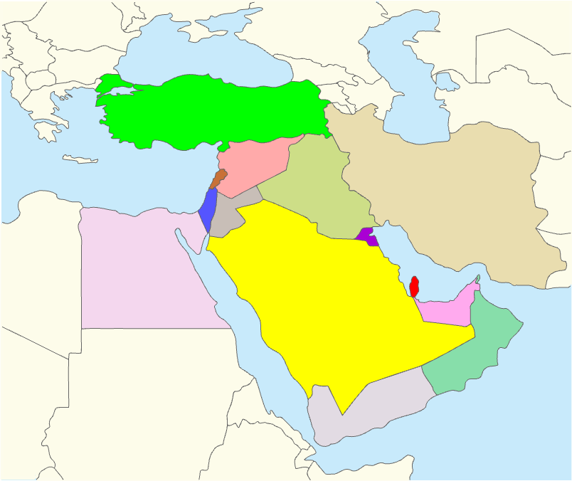 |  |  |  |  |  |  | Lorem Ipsum is simply dummy text of the printing and typesetting industry. Lorem Ipsum has been the industry's standard dummy text ever since the 1500s, when an unknown printer took a galley of type and scrambled it to make a type specimen book. It has survived not only five centuries, but also the leap into electronic typesetting, remaining essentially unchanged. It was popularised in the 1960s with the release of Letraset sheets containing Lorem Ipsum passages, and more recently with desktop publishing software like Aldus PageMaker including versions of Lorem Ipsum. It was popularised in the 1960s with the release of Letraset sheets containing Lorem Ipsum passages, and more recently with desktop publishing software like Aldus PageMaker including versions of Lorem Ipsum.  |. It was popularised in the 1960s with the release of Letraset sheets containing Lorem Ipsum passages, and more recently with desktop publishing software like Aldus PageMaker including versions of Lorem Ipsum. It was popularised in the 1960s with the release of Letraset sheets containing Lorem Ipsum passages, and more recently with desktop publishing software like Aldus PageMaker including versions of Lorem Ipsum.  Resolution for Map should be 150-200ppi
Insert your photo here  375 pixels wide x  500 pixels height  resolution: 72 -250 ppi  the photo must be clear at  100%-150% screen view.  Photo file size must be  150-250kb in size  If applicable, Quality should be 8-10 |  | 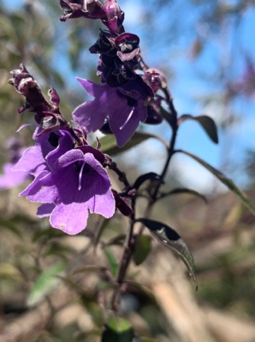
1 | Genus species  FAMILY  Common Name  XX | 2 | Genus species  FAMILY  Common Name  XX | 3 | Genus species  FAMILY  Common Name  XX | 4 |  | Genus species  FAMILY  Common Name  XX | 5 | Genus species  FAMILY  Common Name  XX
6 | Genus species  FAMILY  Common Name  XX | 7 | Genus species  FAMILY  Common Name  XX | 8 | Genus species  FAMILY  Common Name  XX | 9 | Genus species  FAMILY  Common Name  XX | 10 | Genus species  FAMILY  Common Name  XX
11 | Genus species  FAMILY  Common Name  XX | 12 | Genus species  FAMILY  Common Name  XX | 13 | Genus species  FAMILY  Common Name  XX | 14 | Genus species  FAMILY  Common Name  XX | 15 | Genus species  FAMILY  Common Name  XX
16 | Genus species  FAMILY  Common Name  XX | 17 | Genus species  FAMILY  Common Name  XX | 18 | Genus species  FAMILY  Common Name  XX | 19 | Genus species  FAMILY  Common Name  XX | 20 | Genus species  FAMILY  Common Name  XX

