Title  Insert your photo here  675 pixels wide x  800 pixels height  resolution: 72 -250 ppi  the photo must be clear at  100%-150% screen view.  Photo file size must be  150-250kb in size | 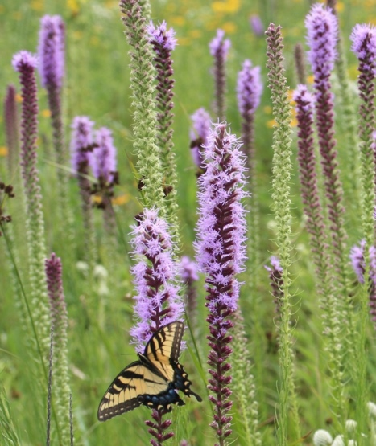
 | 1 | Genus species  FAMILY  Common Name  XX | 2 | Genus species  FAMILY  Common Name  XX | 3 | Genus species  FAMILY  Common Name  XX
Title

Title | 4 | Genus species  FAMILY  Common Name  XX | 5 | Genus species  FAMILY  Common Name  XX | 6 | Genus species  FAMILY  Common Name  XX

Title

Title | 7 | Genus species  FAMILY  Common Name  XX | 8 | Genus species  FAMILY  Common Name  XX | 9 | Genus species  FAMILY  Common Name  XX
Title

Title | 10 | Genus species  FAMILY  Common Name  XX | 11 | Genus species  FAMILY  Common Name  XX | 12 | Genus species  FAMILY  Common Name  XX

Title

Title | 13 | Genus species  FAMILY  Common Name  XX | 14 | Genus species  FAMILY  Common Name  XX | 15 | Genus species  FAMILY  Common Name  XX
Title

Title | 16 | Genus species  FAMILY  Common Name  XX | 17 | Genus species  FAMILY  Common Name  XX | 18 | Genus species  FAMILY  Common Name  XX

