STUDENT ACTIVITY: Fighting infection card game

Activity idea

In this activity, students play a card game to explore how two types of immune cells help to fight viral infections.

By the end of this activity, students should be able to:
- explain that different viruses infect different cells to cause disease
- explain the two main ways the immune system stops viruses from replicating
- explain the relationship between influenza and the lung, and rotavirus and the gut.

Introduction/background notes
What you need
What to do
Cards
Card combinations

Introduction/background

Viruses are infectious agents that replicate inside living cells.

Note that we don’t call viruses living organisms – they are not alive, given that a virus is only a bundle of DNA or RNA packaged in a coat of protein.

This can be demonstrated with several short strips of paper (the genetic code) inside a plastic vial such as a medicine pottle (the protein coat). Viruses are able to enter living cells (pop the ‘virus’ into a plastic bag ‘cell’) and take over the cell machinery to replicate the DNA or RNA and make more protein coats, in order to increase in number. They then either burst out of the infected cell or migrate into next door cells and replicate in there.

There are many different viruses that cause disease in humans (influenza, rotaviral diarrhoea, hepatitis virus, rubella, measles, mumps). Viruses have specific proteins on their surface that allow them to attach to specific cells. For example, the influenza virus attaches to cells of the respiratory tract (in lungs, nose and throat), while rotavirus attaches to cells in the gastrointestinal tract (gut).

The immune system has to work fast to stop the viruses replicating – if they lose the race, the viruses cause a lot of cell death and destruction, which could make the infected person very weak (or perhaps kill them).
The immune system has two main ways to stop viruses replicating. Remember viruses can only increase in number (replicate) inside cells of the infected person.

- B cells make an antibody against a specific pathogen (disease-causing organism) providing a protective layer over the body’s cells. This layer prevents viruses such as rotavirus or influenza from attaching to the cell and the antibody binds up the virus to a useless clump. Different B cells make different antibodies, so that an antibody that protects against rotavirus invasion does not protect against influenza invasion.

- Killer T cells destroy virus-infected cells. Different killer T cells have different targets and will only kill cells infected with one virus type each. For example, a killer T cell that kills rotavirus-infected cells cannot kill influenza virus-infected cells.

This game can be played with a small group or as a class with individuals carrying cards and moving about the room.

What you need

- Playing cards – colour copy and laminate several sets of cards. If used as a class activity, more cards will be required in this order – rotavirus, B cell rotavirus, killer T cell rotavirus, gut cell, gut cell, influenza virus, B cell influenza virus, killer T cell influenza virus, lung cell, lung cell.
- Paper clips – 2x the number of cell cards (gut and lung) used
- Adhesive dot labels – 2 colours, about 16–20 of each
- Copies of the card combinations, which gives instructions for necessary actions

What to do

- Prepare the playing cards by printing out the pages of sheets and cutting up the cards. Also prepare the macrophage dumpster card.

- To play the card game in a group or individually:
- Divide one set of cards into two piles or into two small bags/bowls so they can be taken one at a time without looking. The two piles are the non-moving cells (sessile) i.e. gut and lung cells and the remainder (viruses, B cells and killer T cells).
- The first person takes one card from each pile and examines them. Together, the group looks at the card combinations and discusses what action is necessary.
- After taking the necessary action, place the two cards in separate discard piles. (The cards will be used again in repeated rounds.)
- The next person takes a card from each group and examines them. Continue as above.
- Once the two piles of cards are finished, mix the cards up in their piles (or return to bag) and begin again.
- After going through the cards five times, turn up the cards and look to see how successful the viruses were in this infection.
- If a card must be removed from play, it is placed on the macrophage dumpster pile.

- To play the card game as a class activity:
- Give each student a card. Those students holding virus cards are given adhesive dots (8–10 each, with different colours for different viruses). Those students holding B cell cards are also given six paper clips.
- Those who represent sessile cells are to remain in one place (around the edge of the room). All other cardholders are to move around to interact randomly with these cells.
- The moving group each go to a sessile cell and they show each other their cards.
- With as little volume as possible, they decide on a course of action using the card combinations, complete it and the moving person sets off to find a new cell.
- If the action requires a card to be removed from play, the person sits down.
- Continue to allow approximately five interactions per person.

- Consider what would happen if there were
- more virus cards
- more B cell cards
- more killer T cell cards.

- It may be possible to add extra cards and see what happens in a repeat game.

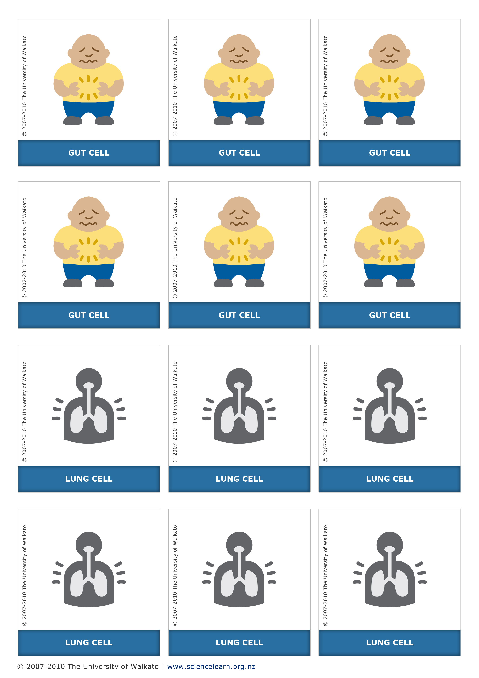
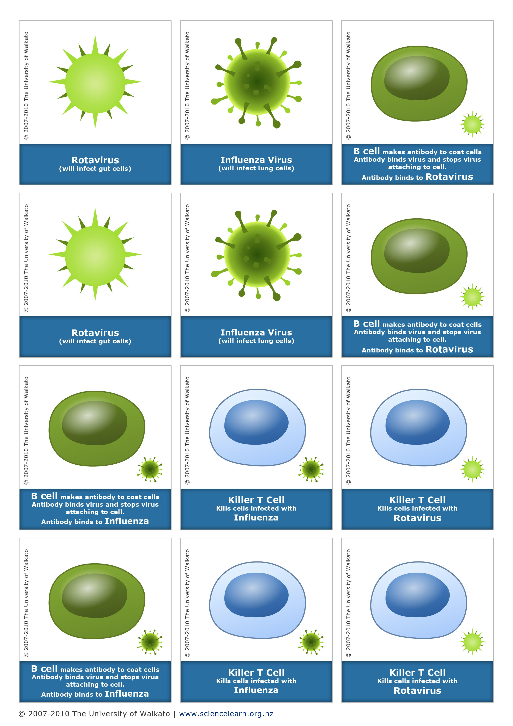

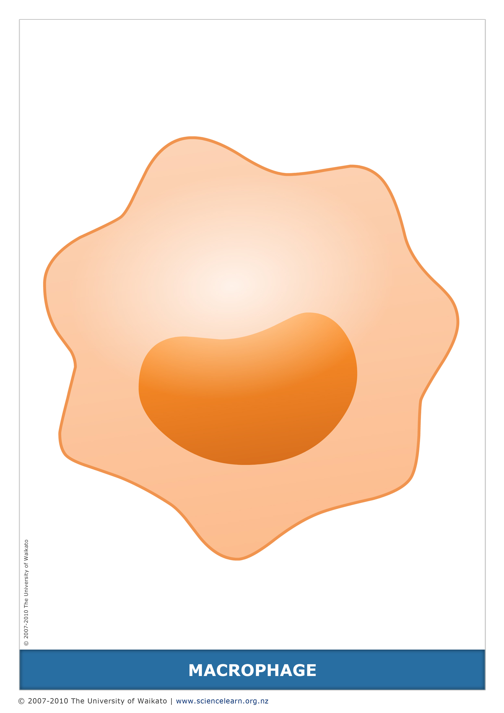
Card combinations

Card combination | Action
B cell + virus target cell  (e.g. B cell rotavirus + gut cell) | Slip a paper clip on the cell card (antibody) – target cell can no longer be infected.
virus + virus target cell  (e.g. rotavirus + gut cell) | Attach an adhesive label dot to the target cell card (overhang the dot so it can be removed) – a target cell can be infected repeatedly but following a 3rd infection, the target cell must be removed from play.
virus + antibody protected target cell  (e.g. rotavirus + gut cell that has previously seen B cell rotavirus) | Target cell remains in play.  Virus card removed from play.
virus + non-target cell | No action.
killer T cell + uninfected cell | No action.
killer T cell + target infection  (e.g. killer T cell rotavirus + rotavirus infected gut cell) | Infected target cell removed from play.

