**ACTIVITY: Gravity and satellites: true or false?**

**Activity idea**

In this activity, students use a simple true or false interactive or paper-based tool to categorise facts. This activity could be used as a formative activity to gather students prior knowledge and understanding. Use it as an opportunity to engage in discussion with your students and to highlight common [alternative conceptions about gravity](https://www.sciencelearn.org.nz/resources/294-alternative-conceptions-about-gravity) and satellites.

By the end of this activity, students should be able to:

* clarify some of their current thinking about gravity and satellites
* provide evidence to support their current views
* debate ideas with others who hold different views that may challenge their current thinking
* investigate some key concepts around gravity and satellite orbits.

Introduction/background notes

What you need

What to do

Extension ideas

Student handout: True or false?

True or false? – sample answers

**Introduction/background**

Gravity is a complex topic. Research has shown that students develop intuitive ideas and beliefs about natural phenomena such as gravity and space. Students tend to interpret new information from the viewpoint of their existing ideas and beliefs. Unless students have a chance to identify their current conceptions, they may be reluctant to change these ideas.

Before carrying out this activity with your class, it is recommended that you read the teacher resource [Alternative conceptions about gravity](https://www.sciencelearn.org.nz/resources/294-alternative-conceptions-about-gravity). This resource highlights some of the more common misunderstandings students may hold about gravity and space. It may also help to read the article [Gravity and satellite motion](https://www.sciencelearn.org.nz/resources/268-gravity-and-satellite-motion).

This activity can be used at the beginning of your teaching programme to determine students’ prior knowledge. Students can use the graphic organiser individually and print off the results if you wish to use it as a pre-test.

It is recommended that these questions become the basis of class discussions so that alternative or incorrect conceptions are not reinforced.

**What you need**

* Copies of the student handout True or false? or [interactive version](https://www.sciencelearn.org.nz/drag_and_drops/11-gravity-and-satellites-true-or-false-graphic-organiser)
* Access to the articles [Gravity and satellite motion](https://www.sciencelearn.org.nz/resources/268-gravity-and-satellite-motion), [Natural satellites](https://www.sciencelearn.org.nz/resources/271-natural-satellites) and [Artificial satellites](https://www.sciencelearn.org.nz/resources/269-artificial-satellites).

**What to do**

1. Allow students sufficient time to complete the student handout True or false? or complete [online](https://www.sciencelearn.org.nz/drag_and_drops/11-gravity-and-satellites-true-or-false-graphic-organiser), (note that this can be saved or printed out for future reference).
2. Invite students to share their ideas with the class. Encourage discussion giving students a chance to argue their case for each of their answers.
3. Allow students time to research any statements they are unsure about. This research could be web-based or using printouts of the articles [Gravity and satellite motion](https://www.sciencelearn.org.nz/resources/268-gravity-and-satellite-motion), [Natural satellites](https://www.sciencelearn.org.nz/resources/271-natural-satellites) and [Artificial satellites](https://www.sciencelearn.org.nz/resources/269-artificial-satellites).

**Extension ideas**

* If you have an interactive whiteboard with voting capability, you could set this up as an anonymous voting activity as a useful way to gauge the understanding of the class.
* Ask students to rewrite the false statements so that they read true. Discuss as a class.

**Student handout**

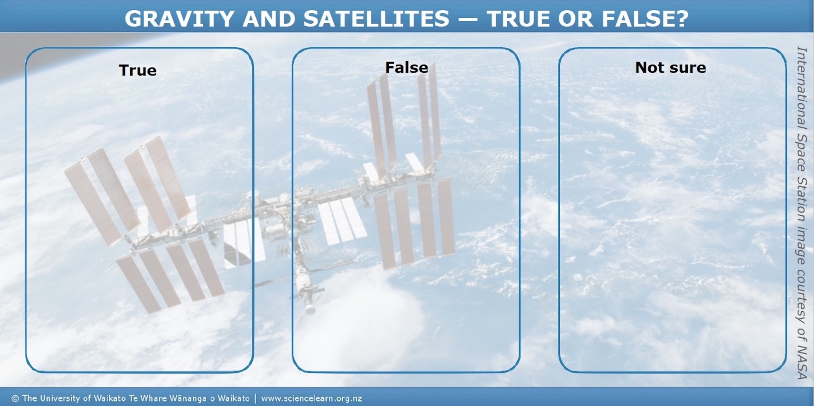

**Student handout: True or false? statements**

|  |  |  |
| --- | --- | --- |
| **Statement** | **True or false?** | **Comment** |
| 1. There is no gravity in space. |  |  |
| 1. Gravity only affects things on Earth. |  |  |
| 1. The Moon is a satellite. |  |  |
| 1. Astronauts appear weightless because there is no gravity in space. |  |  |
| 1. Gravity only works on falling objects. |  |  |
| 1. Gravity keeps the International Space Station in orbit around the Earth. |  |  |
| 1. All objects – even people – are attracted towards each other by gravity. |  |  |
| 1. A 1 kg mass dropped from a 100 km high tower would float away. |  |  |
| 1. Gravity keeps the Moon orbiting around the Earth. |  |  |
| 1. A 1 kg mass dropped from a 30 km high tower would fall straight down. |  |  |

**True or false? – sample answers**

|  |  |  |
| --- | --- | --- |
| **Statement** | **True or false?** | **Comment** |
| 1. There is no gravity in space. | F | Gravity doesn’t disappear just because someone or something leaves the Earth’s surface. Every object in the Universe is being attracted towards every other object by the force of gravity. There is nowhere you can go in the Universe where gravity is not acting. |
| 1. Gravity only affects things on Earth. | F | Gravity is a force that attracts all objects towards each other. The Moon and the Earth are attracted towards each other – this is why the oceans’ tides rise and fall. The Earth and Sun are attracted to each other – this is why the Earth orbits the Sun. |
| 1. The Moon is a satellite. | T | A satellite is an object that revolves around a planet. Satellites can be natural, such as the Moon orbiting the Earth. Satellites can also be artificial, such as the International Space Station or a GPS satellite. |
| 1. Astronauts appear weightless because there is no gravity in space. | F | Astronauts appear to be weightless for the same reason that a person on a trampoline feels weightless when in the air. There is still the same amount of gravity acting, but there is no floor pushing upwards on the astronaut, so the weight force cannot be felt. |
| 1. Gravity only works on falling objects. | F | Gravity acts whether an object is moving or not. Gravity is the force of attraction between all masses. Objects stay where they are – hanging on a wall or sitting on a shelf – because of balanced forces. |
| 1. Gravity keeps the International Space Station in orbit around the Earth. | T | The International Space Station is an artificial satellite in a low Earth orbit. It travels at a speed of 27 000 km/hr. This speed, combined with Earth’s gravity, keeps the ISS moving around the Earth in a circular motion (an orbit). |
| 1. All objects – even people – are attracted towards each other by gravity. | T | Isaac Newton was the first to come up the idea that all objects are attracted towards each other. Even people are attracted towards each other by gravity, but this force is so small that it is not noticeable. Gravity only becomes noticeable if one of the objects has a lot of mass, such as the Earth. |
| 1. A 1 kg mass dropped from a 100 km high tower would float away. | F | At 100 km, the object would officially be in space, yet the weight force of gravity would be nearly the same as it is at the surface of the Earth. The 1 kg object would fall downwards toward the centre of the Earth. |
| 1. Gravity keeps the Moon orbiting around the Earth. | T | The Moon is moving in a horizontal direction. Gravity force attracts it to the Earth. The Moon (or any other satellite with sufficient speed) will travel so far that, as it curves toward the Earth, it will miss the Earth altogether. At just the right speed, the Moon (or other satellite) will move around the Earth in a circular motion known as an orbit. |
| 1. A 1 kg mass dropped from a 30 km high tower would fall straight down. | T | At an altitude of 30 km, the object would be above 99% of the Earth’s atmosphere but the weight force of gravity would be nearly the same as it is on the surface of the Earth. |