**STUDENT ACTIVITY: How small is that?**

**Activity idea**

In this activity, students fill a matchbox (or other small container) with tiny items to gain a greater appreciation of the tiny size of crab larvae and the relatively huge distances they swim to navigate their way back to their reef.

By the end of this activity, students should be able to:

* understand the tiny size of crab larvae
* appreciate the relatively huge distances they swim to navigate their way back to the reef from the open sea
* calculate the proportional distance we as humans would need to swim to accomplish a comparable feat.

Introduction/background

What you need

What to do

**Introduction/background**

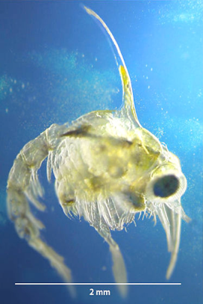

Fish and crab larvae floating in currents in the open water several kilometres from shore need to find their way back to the reef in order to settle on the reef and metamorphose into the adult form.

Larval crabs are attracted to the sound of a healthy reef and will use this to find their way home.

That crab larvae can use these sounds to navigate their way from the open sea back to shore seems a marvellous feat. It is even more extraordinary when we consider the size of the crab larvae and the distances they swim to arrive back at the reef. Crab larvae are only millimetres long, and they navigate from several kilometres offshore.

Put proportionally in human terms, an average 11-year-old student is approximately 130 cm – that’s 650 times the height of crab larvae at 2 mm.

If the crab larvae swim in from 5 km offshore, that’s equivalent to an 11-year-old swimming 3,250 km or swimming:

* from Auckland to Sydney and halfway back or
* from Auckland to Invercargill and back twice or
* from Wellington to the Chatham Islands and back twice or
* from Wellington to Picton and back 23 times or
* 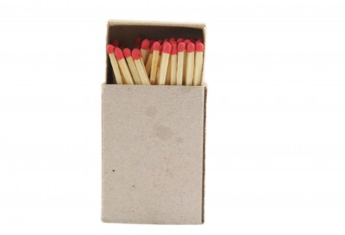from Christchurch to Fiji or
* from Dunedin to Stewart Island and back three times.

That’s a lot of swimming!!!

**What you need**

* Copies of or access to the article [Crabs finding home](https://www.sciencelearn.org.nz/resources/569-crabs-finding-home)
* One matchbox any other small container (such as a raisin box) for each student – they all need to be the same size and preferably no larger than a matchbox
* A world map
* A calculator per student or per pair of students

**What to do**

1. As a class, read and discuss the article [Crabs finding home](https://www.sciencelearn.org.nz/resources/569-crabs-finding-home).
2. Set the challenge where students have one week to fill their container with as many tiny things as possible and explain the rules:

* Only one of each item is allowed (for example, only one grain of sand).
* No creatures that are still alive.
* No living creatures that you have killed or squashed to put into your container.
* The container must close without strain.

1. At the end of the week, have the students count how many items they have in their container. (Set it up as a competition and declare a winner if this is appropriate.)
2. Discuss the size of larval crabs (2 mm).
3. Have each student find an item about 2 mm long in their matchbox.
4. Discuss how many times taller an average 11-year-old (1,300 mm) is than a crab larva (650 times).
5. Discuss the distances the larvae swim from offshore to their home reefs (5 km).
6. Discuss how far an 11-year-old would have to swim to be proportionally the same distance (5 km x 650 = 3,250 km).
7. Use a world map and calculators (with teacher assistance depending on year level) for students to calculate the comparable distance they would need to swim.