TEACHER RESOURCE: Alternative conceptions about
water’s states of matter

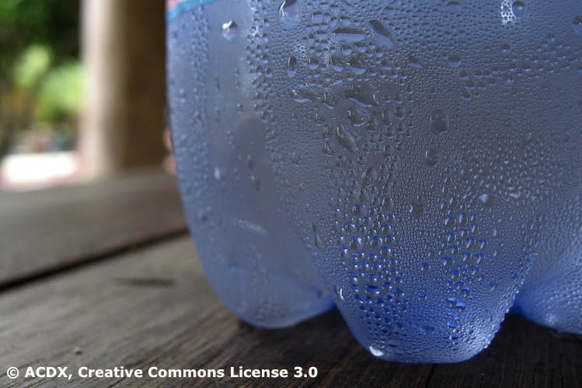
Students do not arrive in the classroom as blank slates. They’ve been exposed to the world around them and may have created their own explanations for how the world works.

Educational research shows that, as students learn more about their physical environment, they tend to interpret any new information from the viewpoint of these existing ideas and beliefs. These existing ideas and beliefs may be significantly different from accepted scientific viewpoints (Palmer, 2001).

Osborne (1981) writes, “We believe that children’s non-scientific ideas are not loosely held, isolated misconceptions but are part of a firm and self-consistent viewpoint. If we wish to modify children’s views to make them more scientific then it would appear to us that we need to focus children’s attention very clearly on the differences between their views and the scientific viewpoint.”

Fries-Gaither (2008) states, “Some of the misconceptions regarding states and changes of matter can actually be viewed as part of a developmental process. As children age, they are better able to understand states of matter, particularly the more abstract concept of a gas. Students also develop over the years a better understanding of the conservation of matter like water.”
This resource introduces common student alternative conceptions about changes and states of matter as they relate to water. It is important that teachers are aware of these during a sequence of lessons so students have a chance to begin changes in their thinking as the sequence progresses.
Simply telling the student the correct answer will not lead to lasting change. Research has found that children are capable of holding parallel explanations for scientific events – one explanation for the classroom and a second for the ‘real world’. It is suggested that students are given time and the opportunity to conduct repeated hands-on experiences for conceptual change to occur.
Student’s view | Scientist’s view | Teaching points
Water in an open container (or a puddle on the concrete or bench) is absorbed by the container or concrete, disappears or dries up and becomes air. | Water in an open container or on a non-porous surface evaporates, changing from a liquid to a gas. | Place the same amount of water in two identical jars. Mark the water levels with a felt pen. Cover one jar with a lid and leave the other open. Put them in a sunny place. Observe the water levels over a day or two and discuss changes as water evaporates from the open jar.  Pour a small amount of water on a paved surface. Place a clear plastic lunchbox over the puddle. Observe every 30–60 minutes as condensation forms on the box.
Steam is hot air. | Steam is water vapour. | Use a hair dryer to direct hot air at a cool metal object (i.e. saucepan). Repeat the activity by holding a cool object (i.e. second saucepan) above a boiling jug. Observe and discuss where the water condensing on the saucepan has come from.
Steam that is no longer visible becomes air. | Water vapour droplets are often too small to be seen with our eyes.  As water vapour condenses in the air, it becomes visible as tiny water droplets. | Ask students to breathe out. Do they see steam/water vapour in their breath? Repeat by breathing out on a mirror or other shiny surface to view condensed water droplets. Students can also cup their palms directly in front of their mouths, breathing out several times onto their palms. Even though they cannot see the water vapour, they can feel it if they hold their palms to their cheeks.
Condensation is when air becomes a liquid. | Water vapour in air condenses when it comes in contact with a cool surface. | Remove the labels from two tins of fruit. Leave one tin at room temperature. Chill the other. Observe what happens to the metal surfaces when they sit side by side in a humid area.
Condensation on the outside of a container is water that seeps out of the container walls. | Water vapour in air condenses when it comes in contact with a cool surface. | Freeze juice or another coloured liquid into ice cubes. Place the ice cubes in a covered jar. Observe the colour of the water condensing on the jar’s surface.
Water only evaporates from lakes or oceans. | Water evaporates from bodies of water as well as from puddles, spills, plants and animals. | Tie a plastic bag around a leafy branch or shrub growing in full sun. Leave it for a day. Observe the condensation inside the bag. Ask students to breathe out several times onto their hands to feel the water vapour inside of them. Perform a vigorous activity. Discuss the origins of the sweat on their bodies and where it goes when it dries.

References

Fries-Gaither, J. (2008). Common misconceptions about states and changes of matter and the water cycle. Retrieved from http://beyondpenguins.ehe.osu.edu/issue/water-ice-and-snow/common-misconceptions-about-states-and-changes-of-matter-and-the-water-cycle

Osborne, R., Schollum, B. and Hill, G. (1981). Learning in Science Project. Force, friction, gravity: Notes for teachers. Working paper no. 33. University of Waikato.

Osborne, R. and Freyberg, P. (1985). Learning in science – the implications of children’s science. Hong Kong: Heinemann.

Palmer, D. (2001). Students’ alternative conceptions and scientifically acceptable conceptions about gravity. International Journal of Science Education, 23(7): 691–706.

