**HEI MAHI: He pangakupu**

**Te kaupapa**

I konei ka hāpaingia tahitia e te ākonga tōna mōhio ki te reo Māori me tōna mōhio ki te hekaheka ki te whakaoti i tētahi pangakupu.

Hei te otinga o tēnei mahi, te tikanga kua āhei te ākonga:

* te whai i ngā tīwhiri me te whakakī i te pangakupu
* te whakamahi i ngā rauemi ipurangi e hāngai ana hei kimi i ngā kupu e ngaro ana i te pangakupu.

**He kōrero mā te kaiako**

## Whakataki/whakamārama whānui

Hoatu te pangakupu ki ngā ākonga hei mātātaki i a rātou. Kei ngā rauemi e whai ake nei ētahi pārongo whaitake hei āwhina i a rātou:

* [Tēnei mea te hekaheka](https://www.sciencelearn.org.nz/resources/2663-tenei-mea-te-hekaheka)
* [Ngā hurihanga ora o te hekaheka – ngā pua atua me ētahi atu hanga](/resources/2665-nga-hurihanga-ora-o-te-hekaheka-nga-pua-atua-me-etahi-atu-hanga)
* [Ngāi hekaheka – pai mai, kino mai, anuanu mai](/resources/2667-ngai-hekaheka-pai-mai-kino-mai-anuanu-mai)

## Ngā mea e hiahiatia ana

* Me whai wāhi ki ngā rauemi tuihono mō te hekaheka
* He tauira o te pangakupu hei whakakī

## Ngā whakautu

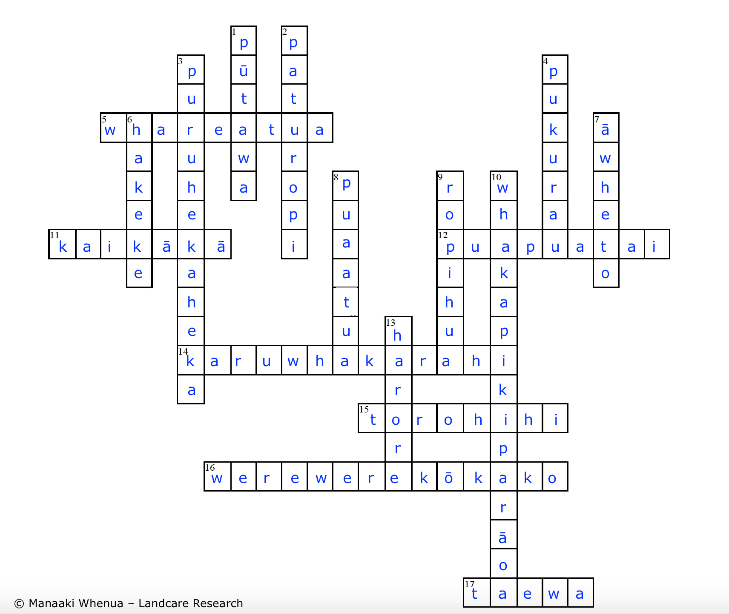

**He kōrero mā te ākonga**

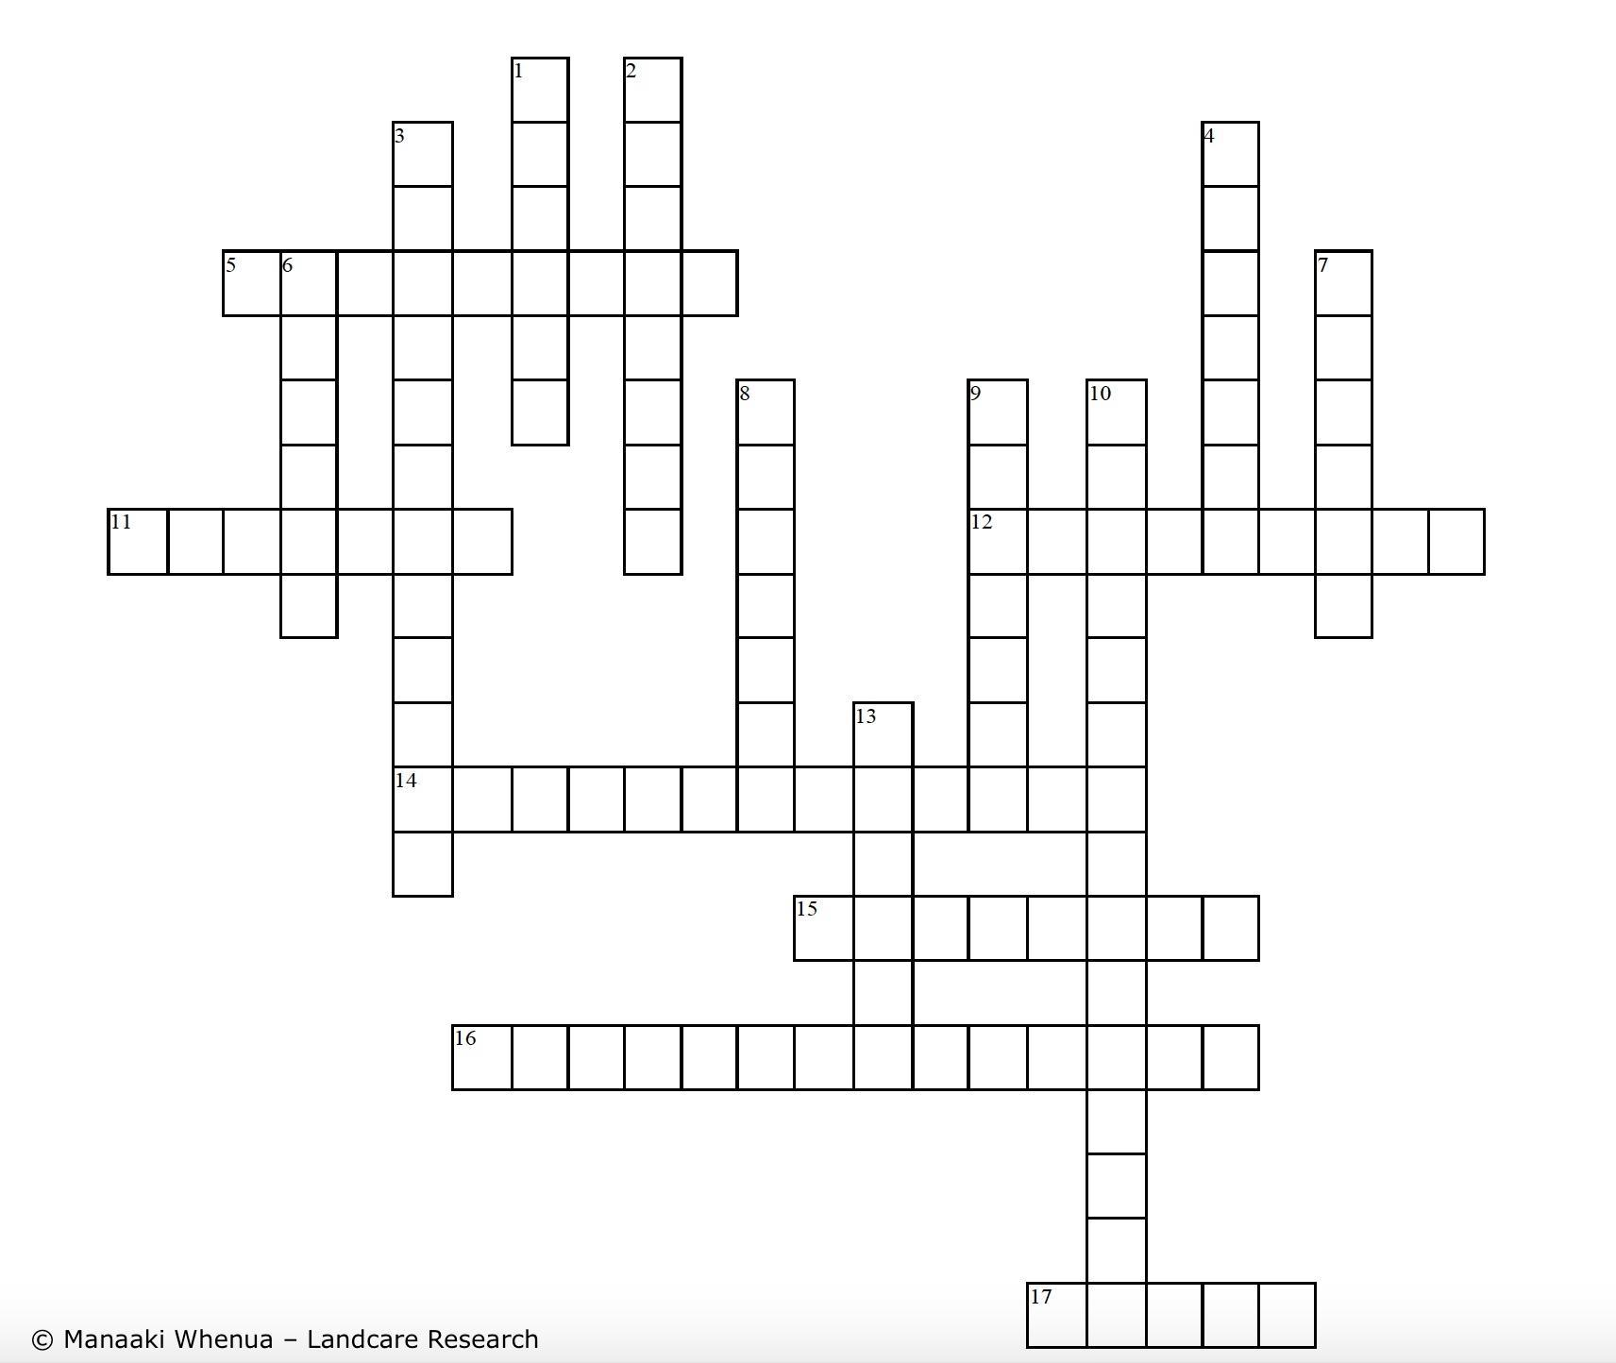

**WHAKAPAE**

5. Tētahi hekaheka āhua rite ki te kete

11. He tōtara kua ngaua e tētahi hekaheka

12. Tētahi o ngā pihi-haunga

14. He taonga e kitea ai ngā mea tino iti

15. Te wāhanga hekaheka ka tupu ki te rapu kai, he io tarapī tokomanga te āhua

16. He hekaheka kikorangi

17. Tetāhi huawhenua nui ka ngaua e te hekaheka

**WHAKARARO**

1. He hekaheka pai hei kawe ahi

2. He momo rongoā

3. Kia roa te parāoa e noho ana, ka pēnei

4. He hekaheka rite ki te pōro te āhua

6. He hekaheka rite ki te taringa te āhua

7. He hekaheka hei tā moko

8. Ka kawea e te hau ki wāhi kē

9. Te wāhanga ka whakaputa pua atua

10. Te mahi a te īhi

13. He hekaheka nui, he kai