**ACTIVITY: Investigating waves and energy**

**Activity idea**

In this investigation, students work with slinkies to explore longitudinal and transverse waves. They have the opportunity to establish the relationship between frequency and wavelength and understand how energy is related to the frequency and amplitude of a wave.

By the end of this activity, students should be able to:

* draw and label longitudinal and transverse waves
* describe the relationship between frequency and wavelength in a wave
* describe how energy relates to frequency and amplitude of a wave.

# For teachers

## Introduction/background

The articles [Waves and energy – wave basics](https://www.sciencelearn.org.nz/resources/2680-waves-and-energy-wave-basics) and [Waves and energy – energy transfer](https://www.sciencelearn.org.nz/resources/2681-waves-and-energy-energy-transfer) provide background information for this investigation. Please refer to these articles for diagrams and explanations.

Students will work in groups of three or four to make waves with slinkies (springs) on a hard surface floor or long bench. A metal slinky works best for this investigation, although a plastic slinky will work if metal cannot be found. One student will hold each end of the slinky and stretch it out slightly.

Care should be taken not to overstretch the slinky, as it will not go back to its original shape if stretched too far.

## What you need

* A slinky for each group
* Tape
* A timing device (cell phone or stopwatch)
* Measuring device (tape measure or metre stick)

## Teaching suggestions

*Making longitudinal waves and transverse waves*

* Watch the video [Demonstrating longitudinal and transverse waves](https://www.sciencelearn.org.nz/videos/1857-demonstrating-longitudinal-and-transverse-waves). It illustrates how to make the two types of waves.
* Students will notice that, when they send a single wave (one back and forth motion) down the slinky, it will bounce back along the slinky. This is a reflection of the wave – the same phenomenon that occurs when light strikes a mirror or sound echoes off of a wall.
* Encourage students to make both longitudinal waves and transverse waves on the slinky and describe what is happening to a single point on the slinky as the wave passes. It may be useful to stick a small piece of tape on one coil of the slinky to make this observation easier. It is also interesting to watch what happens to a single wave as it bounces back and forth on the slinky. It will gradually decrease in amplitude as it travels. This is what happens to sound and light waves as they travel long distances.

*Making transverse wave patterns*

* Transverse waves are much easier to observe than longitudinal waves. It is easier to see differences in amplitude (height) in a transverse wave than it is to see the degree of compression in a longitudinal wave. Therefore, the remainder of this investigation will use transverse waves.
* It is difficult to make many observations of a single wave as it moves along the slinky, so use the reflections to produce standing waves on the slinky. Making standing waves takes a little practice – basically the person at one end of the slinky produces a steady stream of transverse waves and moves faster or slower until a pattern is formed on the slinky.
* Challenge the students to make the following [standing wave patterns](https://www.sciencelearn.org.nz/images/3740-wave-patterns) (while staying the same distance apart):

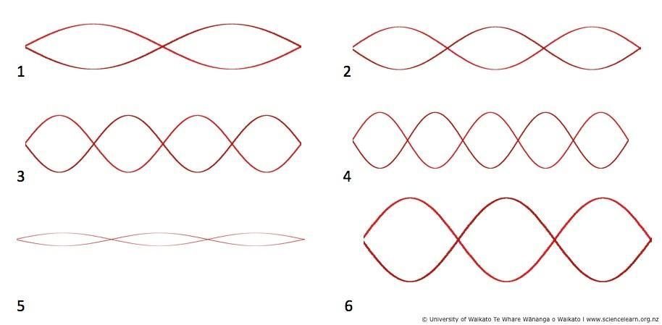

* Begin by asking the students to make pattern 1 – a single full wave. The wavelength of pattern 1 is the distance between the students. In patterns 2, 5 and 6, the wavelength is shorter because there are 1.5 waves, and the wavelength of pattern 4 will be the shortest.
* To measure the frequency of patterns, have the students measure the time it takes for the person making the wave to move their arm back and forth once. A single observation will be difficult to measure because it is so fast. Two different approaches can be taken to improve the data. Students can take multiple short measurements and average the results (which will be difficult for very short times), or they can time multiple waves and divide the time by the number of waves counted. The time it takes to make one wave is called the period of a wave – 1/period is the frequency of the wave and has the unit hertz (Hz). For example, if you measure the period of a wave at 0.50 seconds, the frequency of the wave is 1/0.50 seconds or 2.0 Hz.
* You may wish to ask older students to measure the wavelength (length of one full wave) and frequency for patterns 1 through 4.
* Other patterns can be made and data collected. The students will notice that the longer the wavelength, the higher the frequency. Careful students may notice the frequency of pattern 3 is exactly twice that of pattern 1. The formula in physics that describes the relationship between frequency and wavelength (on the same media) is:

frequency x wavelength = a constant value

The constant value is the speed of the wave.

For example, if the students are 2.0 metres apart and measure the frequency of pattern 1 to be 2.0 Hz, the speed of the wave is:

2.0 Hz x 2.0 metres = 4.0 metres/second

If desired, the speed can be confirmed by measuring the time it takes for a single short wave to travel along the spring.

*Waves and energy*

* In this investigation, the students are providing the energy to make the waves. Ask which pattern (1–4) is easiest to make. They will likely conclude that it is much easier (takes less energy) to make pattern 1 than pattern 4. They have to move back and forth much faster (higher frequency) to make pattern 4 than pattern 1. This illustrates the relationship between frequency and energy: **the** **higher the frequency, the higher the energy.**
* Now ask students to make patterns 5 and 6. You will notice that the wavelength and frequency is the same, and only the amplitude is different. Ask students to consider the amount of energy needed to make patterns 5 and 6. They will likely conclude that it is easier (you have to move your arm less) to make pattern 5 than pattern 6. This illustrates the relationship between energy and amplitude of a wave: **the higher the amplitude, the higher the energy.**

## Alternative conceptions

Students have difficulty visualising a longitudinal wave such as sound. The diagram below may help explain how a sound wave looks when compared to a transverse wave with the same wavelength. Here, the dots represent air particles.

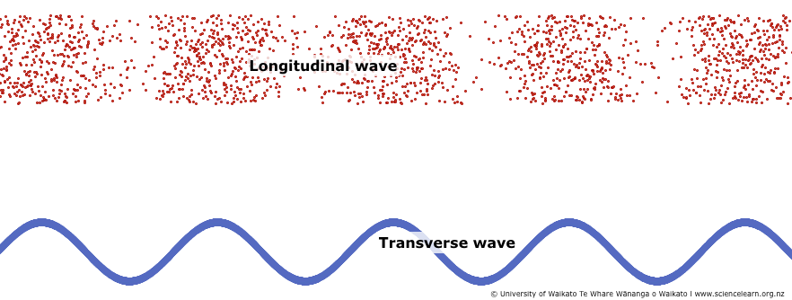

## Extension ideas

Students may want to make more patterns, including a 0.5 wave pattern (like a jump rope) – the frequency x wavelength = speed relationship will work for any wavelength.

The speed of a wave on a spring depends on the stiffness of the spring. Students may want to stretch their spring further and observe that the waves travel faster on stiffer media.