**ACTIVITY: Literacy opportunities using Fred the Thread**

**Activity idea**

This activity outlines several ways educators can use Robert Hoare’s poem to promote basic literacy skills and support scientific thinking.

By the end of this activity, students should be able to:

* use literacy skills to locate information in the text
* identify scientific concepts and specialist vocabulary in the text
* discuss the purpose and audience for the poem and associated articles
* make comparisons between the different texts.

**For teachers**

***Introduction/background***

Using science as the context to teach literacy skills enables teachers to create cross-curricular opportunities and create valuable teaching space within a crowded curriculum.

The English and science curriculum strands both:

* encourage the reader to explore how texts are shaped for different purposes and audiences
* encourage the writer to use particular conventions to shape texts for different purposes and audiences
* promote the understanding and use of topic-specific vocabulary
* promote the choice of vocabulary to communicate precise meanings
* encourage learners to make and support inferences from text/observations.

With thoughtful planning, educators can integrate science with literacy to enhance learning in both areas.

***Resources to support this activity***

This is an open-ended activity with a variety of options to support learners working at different levels within the curriculum. It offers a number of suggestions and uses the following resources:

* [Fred the Thread – a poem](https://www.sciencelearn.org.nz/videos/1858-fred-the-thread-a-poem) (video)
* [Fred the Thread](https://www.sciencelearn.org.nz/resources/1434-fred-the-thread) (article)
* Text version of the video Fred the Thread – a poem and article Fred the Thread (student handout)
* [Fred the Thread](https://www.sciencelearn.org.nz/videos/752-fred-the-thread) (video)
* [Naming Fred](https://www.sciencelearn.org.nz/videos/757-naming-fred) (video)

***About the author***

Dr Robert Hoare is an invertebrate systematist with Manaaki Whenua – Landcare Research. He is a lepidoptera specialist (moths and butterflies) and a poet. The poem featured in this activity comes from Robert’s book *Six-legged Things and Scaly Wings: An anthology of New Zealand insect verse (mostly about moths)*.

***General pedagogical suggestions***

* Watch the video [Fred the Thread – a poem](https://www.sciencelearn.org.nz/videos/1858-fred-the-thread-a-poem) two or three times so that students become familiar with some of the language and sentence structure that Robert uses.
* Consider using the student handout, which contains the written verse, for students to follow along or read aloud with Robert.
* Create a vocabulary list of both scientific and interest words and phrases.
* Read through the [Fred the Thread](https://www.sciencelearn.org.nz/resources/1434-fred-the-thread) article with students and/or watch the science videos [Fred the Thread](https://www.sciencelearn.org.nz/videos/752-fred-the-thread) and [Naming Fred](https://www.sciencelearn.org.nz/videos/757-naming-fred) so students become familiar with factual information about the *Houdinia flexilissima* species.
* Be explicit about your objectives. Clarify when you are working to build science understanding and when you are exploring literacy and language features.

***Suggested activities to promote science understanding***

* Examine a stanza (or stanzas) from the poem for factual versus fanciful statements. For example, in the first stanza, Fred is an orange-red colour and does live in *Sporadanthus* stems, but he is not thinner than a cotton thread.
* Identify which stanzas are associated with Fred in his larval stage and as an adult. Identify the words that provide the clues to the life stages.
* Identify the stanzas that describe Fred’s adaptations for living inside the narrow *Sporadanthus* cane rush stem.
* View and compare images of [Fred the caterpillar](https://www.sciencelearn.org.nz/images/1733-fred-the-larva) with a [red admiral caterpillar](https://www.sciencelearn.org.nz/images/546-red-admiral-caterpillar). Note similarities and differences in the caterpillars and their adaptations. (Use the articles [Fred the Thread](https://www.sciencelearn.org.nz/resources/1434-fred-the-thread) and [Butterfly defence mechanisms](https://www.sciencelearn.org.nz/resources/507-butterfly-defence-mechanisms) to learn more about the adaptations.)
* Use the student handout to explore similarities and differences in the language used in the poem and in the science article. Discuss the purpose of each piece of writing and the intended audience.

***Suggested activities to promote literacy***

* Explore the physical structure of the poem such as:
  + rhyming patterns and strategies
  + the number of syllables per line
  + the effects these patterns and strategies create.
* Identify words or phrases that:
  + create scientific meaning
  + create and sustain interest
  + promote humour
  + explore feelings rather than scientific facts.
* Use critical thinking to:
  + identify the key ideas/messages in the poem
  + identify how the author conveys these ideas
  + identify the intended audience and purpose.
* Develop fluency and expression in oral reading by:
  + identifying some of the ways in which the author demonstrates fluency and expression while reading the poem – voice and inflection, speed, pauses etc.
  + practising reading aloud with the video.

**For students**

**Fred the Thread**

By Robert Hoare

I have a friend (his name is **Fred**)

He’s thinner than a cotton thread

His colour is an orange-red

He doesn’t feed on jam or bread

But *Sporadanthus* stems instead.

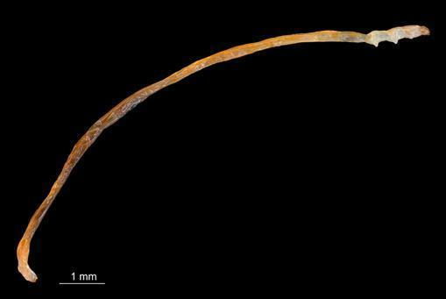

Such narrow tunnels must he tread

He needs a hinge inside his head

To give his jaws the room to shred

The food that is his home and bed

And stop himself from dropping dead.

Now when our friend is fully fed

And knows the time has come to shed

His final skin, a sense of dread

Begins to filter into **Fred**:

How fast, he thinks, the time has sped!

And what a sheltered life he’s led!

He hopes he’ll have some outdoor cred

And won’t be thought of as inbred.

He sloughs his skin from A to Zed

And there’s a pupa in his stead!

Three weeks have passed, and it’s incred-

ible to see the adult **Fred**,

A mothy person born and bred

To look like that on which he’s fed.

He shows an admirable ded-

ication to his art, his sed-

entary posture leaving ed-

ucated mothmen ruby-red,

The effort of locating **Fred**

Causing a rush of blood to head

Resulting in potential med-

ical emergency and bed

With cooling drink and favourite Ted

Until delirium has fled. 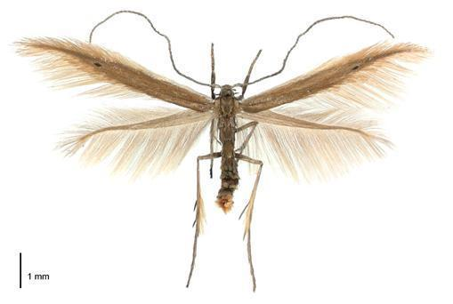

To summarise, he’s **Fred the Thread**,

He’s red and has a hing-ed head

His head is used to shred his bed,

His bed’s the food on which he’s fed,

His bed is red and I am led

To think the redness of the **Fred**

Reflects the bedness of the red

I mean the redness of the bed—

The bed he shreddeth with his head

Until the **Fred** is fully fed

And sheds the skin he has to shed

To flee the bed that must be fled

To lead the life that must be led

To woo the wife that must be wed

To father further **Freds of Thread**.

Then **Fred** can smile and drop down dead.

I’ve said the things I wanted said

**Fred the Thread**

Fred the Thread is the caterpillar of a native moth (*Houdinia flexilissima*) and is quite possibly the world’s thinnest caterpillar.



Fred was found following studies conducted by Dr Corinne Watts of Manaaki Whenua – Landcare Research investigating the natural ecosystem of peat bogs in the Waikato. Peat bogs are mined for use in horticulture (peat is widely available in most local garden centres) but also constitute a unique ecosystem. Dr Watts carries out this research to ensure that peat mining does not destroy the bogs.

In order to do this, she needed to understand the plants and animals that help maintain the peat. Her investigations started with the cane rush (*Sporodanthus ferrugineus*), which is one of the plants that helps form peat. While looking for insects that live with the plant, she found a very small, thin, orange caterpillar – nicknamed Fred the Thread.

***Hard to see***

Finding Fred the Thread was quite difficult. While these caterpillars can grow to around 2 centimetres long, living in the stem of the plant means they remain very thin throughout their caterpillar stage – only 1 millimetre or so wide. This makes them very hard to see, so finding such a thin caterpillar amongst the vast numbers of stems of cane rush took patience and a very good eye. When the caterpillar was found, it was so small that it needed to be studied under an electron microscope.

***The detective hunt was on***

The caterpillar had never been identified before, so Dr Watts decided to consult with other scientists at Manaaki Whenua – Landcare Research to see if they could identify this species. She first showed the caterpillar to Dr Robert Hoare, an expert on native moths. He had never seen anything like it and didn’t think it was likely to be a moth species. An expert on beetles said it wasn’t a beetle, and an expert on flies said it wasn’t a fly.



***What was this caterpillar?***

Dr Hoare and Dr Watts decided to raise a caterpillar and see what happened. Very carefully, they gathered caterpillars from the stems of the cane rush and transferred them to plastic bags. They were then fed and reared through until an adult moth eventually emerged – a very, very, tiny adult moth. Each adult is less than half a centimetre long with a wingspan of only 12 mm. Partly because of their small size, scientists were unaware of the existence of the moth and its caterpillar until this research was done.

***Let’s call it…***

Because the scientists had discovered a new species, they were allowed to name the species. The caterpillar was sufficiently novel that a new species and a new genus name were needed. They gave Fred the scientific name *Houdinia flexilissima*.

The genus name (*Houdinia*) is a Latin derivation of the name Houdini. The caterpillar reminded the scientists of Harry Houdini, a famous escape artist of the early 20th century, who was very good at getting out of tight spaces, much like Fred the Thread, who was also very good at avoiding detection by scientists for a long time.

The species name (*flexilissima*) refers to Fred the Thread’s amazing flexibility. Living in the very small tubules within the plant means there is not a lot of room to move. Fred pulls himself through the plant by his head, and a hinge allows him to drag his body through the plant as he eats. Also, when the caterpillars are removed from the plant stems, they are very soft and flexible.

***Fred the Thread is special***

The plants Fred eats and calls home are currently under threat through the mining process and as bogs are drained for use as pasture. The research conducted by Dr Watts and Dr Hoare has helped identify the ecological importance of these habitats, and Dr Watts is now trying to work with commercial companies to ensure that these habitats are fully restored and conserved for future generations of Freds.