**ACTIVITY: Pendulums – collecting and using data**

**Activity idea**

In this investigation, students will measure the period of pendulums of varying lengths, plot the data on a graph and use the graph to estimate the period of two new pendulums – one with a length between two of their collected data points and one from a much longer pendulum.  
  
By the end of this activity, students should be able to:

* collect and interpret data
* construct a graph from collected data
* use a graph to interpolate between two data points
* use a graph to extrapolate a value beyond measured data points.

# For teachers

***Interpolation and extrapolation***

During this activity, students investigate the period (time for one complete back and forth swing) of a pendulum and graph the results. They then use their graph to predict the lengths of mystery pendulums. The first mystery pendulum should be a length that is between two of the data points the students have collected. They will have to interpolate – estimate a value between two known values – between two of their collected points to estimate the length of the mystery pendulum. The example below shows a graph of distance and time data. The red points indicate the data collected, and a light grey line is drawn through the data points.

***Example of using a graph to interpolate and extrapolate***

To estimate the distance associated with the time of 140 seconds, find 140 seconds on the y-axis, follow this value over to the line and drop down to the associated distance on the x-axis, which in this example is 12 metres. This process of estimating the value of data between two collected data points is called interpolation.

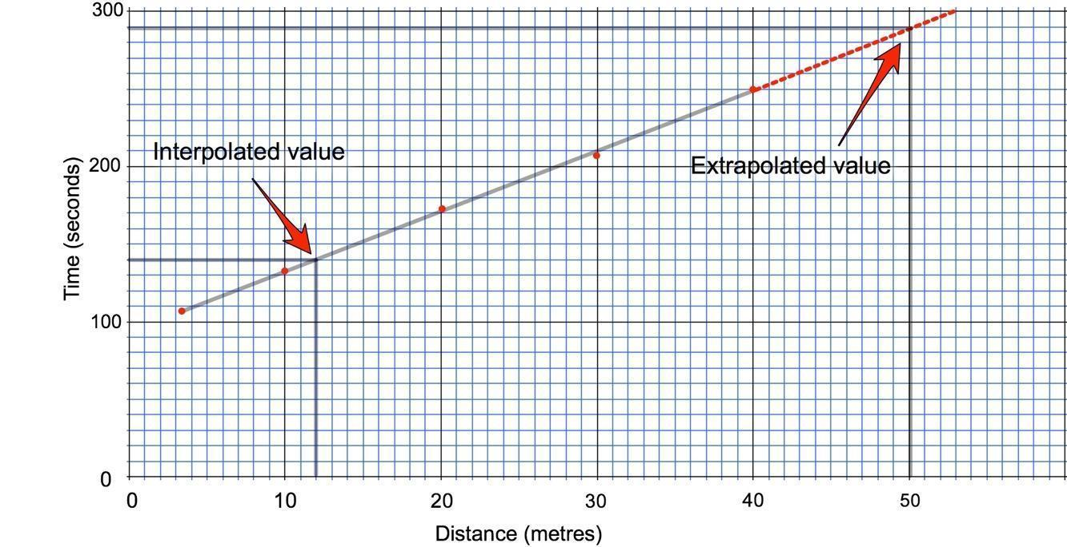

Extrapolation is estimating the value for something that is beyond the data collected. To estimate the distance for 290 seconds, which is well beyond the data collected, extend the line (red dotted line). Find the time value of 290 on the y-axis and follow over to the extended line. Then drop down to read the value of 50 metres on the x-axis.

Interpolation and extrapolation are more obvious when the data plotted form a straight line. The length versus period data for a pendulum form a curve when plotted on regular graph paper. However, they do form a straight line when plotted on log-log graph paper. You will notice that the spacing of the lines on log-log graph paper gets smaller as you go across or up the page. This allows certain non-linear relationships to produce straight lines when plotted. The graph paper provided has the x-axis and y-axis already labelled with values for the experiment. The interpolation and extrapolation process described works the same on log-log paper as on regular graph paper.

***Measuring the length of the pendulum***

Students should collect data for a series of pendulum lengths. The length should be measured from the point where the string bends at the top down to the *centre* of the pendulum fob. Accurate length measurements are important. The time for one swing (back and forth) can be quite short and difficult to time accurately. To increase the accuracy of the measurement, multiple swings can be timed. In this example data set, 10 swings were recorded for each measurement, and the resulting time was divided by 10 to find the period for one swing.

|  |  |  |
| --- | --- | --- |
| **Length (cm)** | **Time for 10 swings (sec)** | **Period (sec)** |
| 10 | 6.59 | 0.659 |
| 20 | 9.06 | 0.906 |
| 40 | 12.64 | 1.264 |
| 60 | 15.60 | 1.560 |
| 80 | 17.94 | 1.794 |
| 100 | 20.51 | 2.051 |

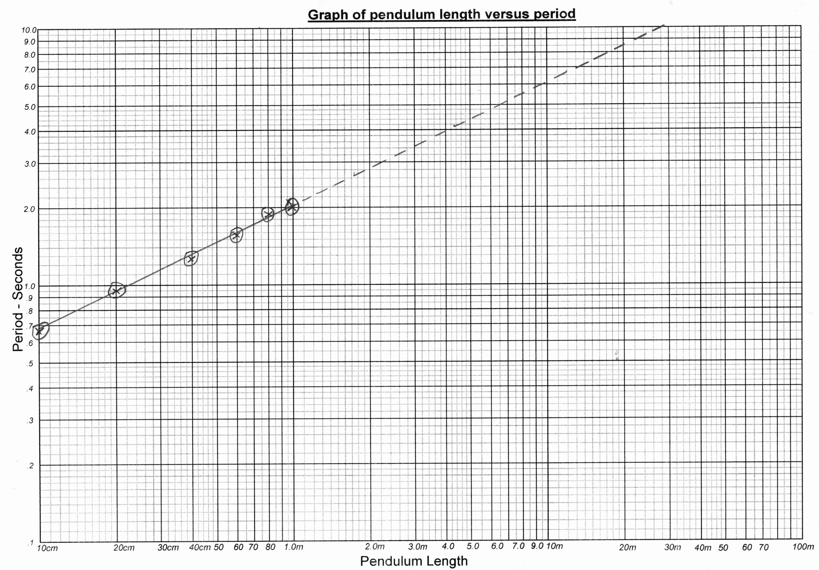

This graph uses an x to locate the data point, and each point is circled to make the points easy to see when the line is drawn. A straight line should be drawn through the data so that it goes as close to all of the points as possible. Often some points are slightly above or below the line. A solid line is drawn in the region between the first and last point and a dotted line extended beyond the end of the data.

When students have the graphs, they are able to estimate the length of any pendulum they encounter.

***Equipment required for each group***

* Length of string approximately 1.5 m
* Heavy washer or fishing weight to use as a pendulum fob
* Peg or binder clip
* Ruler or measuring tape,
* Stopwatch or timing app (the clock on most mobile phones has a stopwatch mode)

***Procedure***

1. This investigation requires students to work in groups of two or more. The students will need to set up a pendulum that can be adjusted from 10 cm up to 1 metre in length. Clipping the string to a chair on a desktop may work well, or using a metre stick to bridge two chairs and clipping the pendulum to the centre of the metre stick also works.
2. Specify specific pendulum lengths for students to use (see example data set above for a suggestion). This will allow you to set up a mystery pendulum with a length between two values the students measured. The exact lengths you select will depend on how the pendulums are set up in your classroom, but values between 10 cm and 2 m will all work.
3. Show the students the materials and an example set-up. Ask them to time the period by using 10 swings and fill out the data table and plot their data on graph paper.
4. To practise interpolation, challenge them to estimate the length of the mystery pendulum.
5. To practise extrapolation, it is fun to set up the longest pendulum possible. Students will be able to use their graphs to estimate the lengths of pendulums almost 30 metres long!

**Extensions**

There are a number of YouTube videos of Foucault’s pendulum in Paris. Foucault used a great pendulum similar to this 67metre long pendulum to demonstrate that the world rotates around an axis. The pendulum swings back and forth for many hours while the world literally turns around under it. Students can use the videos below to time the period of Foucault’s pendulum and use their plots to estimate the length.

<https://www.youtube.com/watch?v=K9OS5qY0x2I>

<https://www.youtube.com/watch?v=Xhyr7C1hO7k>

<https://www.youtube.com/watch?v=wmvgirYNLhM>

You may wish to have students make plots on regular graph paper first to observe for themselves that the data forms a curve rather than a straight line, then introduce the log-log paper to solve the problem.

This investigation is primarily about graphing and interpreting data on a graph. The pendulum is a relatively easy system to work with. If students are curious about the pendulum itself, the physics behind a pendulum is relatively simple. The formula that describes the relationship between length and period of a pendulum is:

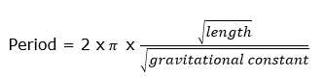

where $π$ = 3.1415 and the gravitational constant = 9.806 metres/second2

Students can rearrange this equation to solve for length.

**Data table**

|  |  |  |
| --- | --- | --- |
| **Length (cm)** | **Time for 10 swings (sec)** | **Period (sec)** |
|  |  |  |
|  |  |  |
|  |  |  |
|  |  |  |
|  |  |  |
|  |  |  |
|  |  |  |
|  |  |  |

**Log-log graph paper**

