**ACTIVITY: Make a hologram-like projector**

**Activity idea**

In this activity, students use a sheet of acetate to make a transparent, four-sided pyramid. The pyramid’s sides act as four mirrors, situated at 45° angles on a smartphone or tablet screen, and create a hologram-like projector.

By the end of this activity, students should be able to:

* use a template to construct an open pyramid
* use the four reflective surfaces on the pyramid to view a 3D display
* begin to use scientific terms including ‘reflection’ and ‘angle’
* make changes to the pyramid (and local environment) as needed to improve the specular reflection and 3D display.

# For teachers

## Introduction/background

**Light basics**

Light is a form of energy produced by a light source. Light can come from incandescent sources (a light bulb filament, the Sun or a flame) or luminescent sources (LEDs, computer screens and glow worms).

Regardless of how light is produced, light travels in a straight line until it hits something else. Once light hits another surface, lots of things can happen to it, but in this activity, we will focus on the reflection of light.

Learn more about light in the articles [Light basics](https://www.sciencelearn.org.nz/resources/171-light-basics) and [Reflection of light](https://www.sciencelearn.org.nz/resources/48-reflection-of-light).

**Hologram projectors**

Creating an actual hologram requires the use of a laser to bounce (reflect) light off mirrors and is not something we usually do in a classroom setting due to equipment and safety issues. However, we can create a 3D projection that looks similar to a hologram.

In this activity, students make a transparent, four-sided pyramid. The pyramid’s sides act as four mirrors, situated at 45° angles on a smartphone or tablet screen. The screen and pyramid become a hologram projector. When used with a holographic animation video, moving 3D images (holograms) appear inside the pyramid.

The pyramid template comes in two sizes. Use the smaller size to create a projection on a smartphone and the larger size to create a projection on a tablet.

Use a photocopier to print the template onto overhead projector transparencies or print the template and ask students to use a felt pen and ruler to copy the design onto the transparency/clear binding cover.

Overhead projector transparencies and clear binding covers are available from stationery supply stores. The student handout provides a link to a YouTube video. Many other videos are available, simply do an online search for ‘3D holographic video’.

## What you need

* Acetate sheet(s) – for example, overhead projector transparency or clear binding cover
* Copies of the template
* Access to a photocopier or laser printer
* Smartphone or tablet
* Access to YouTube video
* Scissors
* Felt pen
* Ruler

## Teaching suggestions

1. Begin by exploring the information and the images in the article [Reflection of light](https://www.sciencelearn.org.nz/resources/48-reflection-of-light).
2. Look at the image [Types of reflection](https://www.sciencelearn.org.nz/images/45-types-of-reflection) either online or in the student handout. Discuss the titles, scientific vocabulary, directionality of the arrows and the types of surfaces.
3. Look at the image Activity set-up and direction of reflection in the student handout. Discuss whether the reflection is specular or diffuse. (It is specular because the light reflects from a smooth surface. Students may require help making comparisons between the two diagrams. The specular reflection in the first diagram shows multiple arrows, while there is only one arrow in the activity set-up. The two diagrams also show the light coming in from different directions, although both are reflecting at 45° angles.)
4. Follow the student instructions to construct the pyramid.
5. The projection works best in a darkened room. Some faces of the pyramid may work better than others, so try rotating the phone or tablet.
6. If students have difficulty seeing a 3D image, encourage them to troubleshoot their design. Some reasons may include the pyramid is on an angle due to imperfectly cut edges or folds, the room is too light, the student is viewing the pyramid from an incorrect angle.

# For students

These images show the direction of light as it reflects off a surface.

Image: Types of reflection

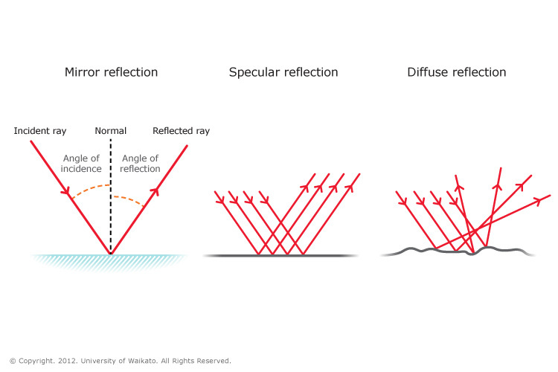

Image: Activity set-up and direction of reflection

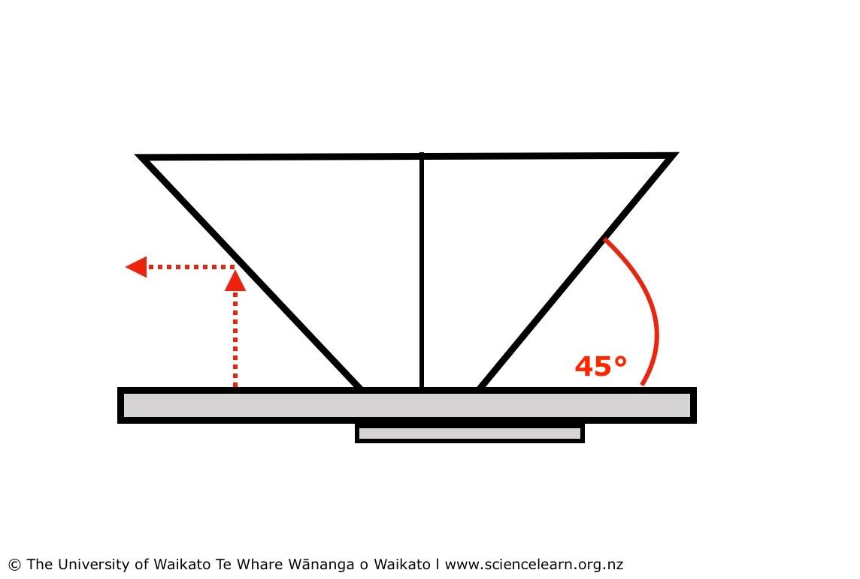

## What to do

1. Choose the size of the template depending on whether you are using a smartphone or a tablet – small template for smart phone, large template for tablet.
2. Carefully cut along the solid black lines.
3. Carefully use scissors or a craft knife to cut the slot.
4. Place a ruler along the dotted lines, and use the scissors to score the acetate. This will help you fold the sides of the pyramid.
5. Crease and fold the sides.
6. Insert the tab into the slot.
7. Adjust the corners. Loosen or squeeze them so that each corner forms a 90° angle.
8. Invert the pyramid and place it on a flat surface. The pyramid should sit level with the surface. If it doesn’t, consider whether you need to trim (cut) the acetate or reshape the folds so you have 90° angles.
9. Find and play the video [HoloQuad Holographic Video Compilation 3D Mobile Cell Phone Hologram Videos MMD](https://www.youtube.com/watch?v=nLAAym_0TGA) (<https://www.youtube.com/watch?v=nLAAym_0TGA>).
10. Lay the smartphone or tablet on a flat surface. Place the inverted pyramid in the centre of screen.
11. The light from the screen reflects from the pyramid face at 45° angles. Consider where to place your line of vision to catch this reflection.
12. If you do not see a 3D image forming in the centre of the pyramid, consider what you might need to do to make the projector work.

## Pyramid template

Use the small template when using a smartphone.

## 

## Use the large template when using a tablet.

## 