**ACTIVITY: Investigating shadows**

**Activity idea**

In this set of activities, students use play and exploration to learn about introductory Physical World concepts about light. Students also have the opportunity to design simple investigations and learn how science works as an introduction to the nature of science.

By the end of these activities, students should be able to:

* discuss the relationship between the shape of an object and the shape of its shadow
* demonstrate that an object needs to be between a light source and a surface for a shadow to form
* offer an explanation about shadows being the absence (lack) of light
* demonstrate how to change the size and shape of a shadow by repositioning the light source.

# For teachers

## Pedagogical information

Light is a complex topic. As a physical phenomenon, it is mentioned in all eight levels of the New Zealand Curriculum (NZC), so there is certainly scope for exploration and learning throughout a student’s time at school.

The suggested experiences in this resource are designed for curriculum levels 1 and 2. They are underpinned by the NZC Nature of Science ‘Investigating in science’ aim: Students will extend their experiences and personal explanations of the natural world through exploration, play, asking questions, and discussing simple models.

Rather than set out prescribed instructions, this resource will identify key science concepts and ways in which students can explore, experience and build their understanding of [light and shadows](https://www.sciencelearn.org.nz/resources/2771-light-and-shadows).

***Recognising students’ alternative conceptions***

Children naturally and instinctively develop their own ideas about how things work. These self-developed concepts make sense to the individual but may be scientifically inaccurate. It is helpful to know some of the alternative conceptions students may hold. Awareness helps educators to identify them when they surface in discussions and provides an opportunity to scaffold change.

It takes time to change alternative conceptions. Research shows that students can hold multiple conceptions – their own explanation and a school explanation – at the same time. The article [Alternative conceptions about light](https://www.sciencelearn.org.nz/resources/63-alternative-conceptions-about-light) and statements and sample answers in the Word document for the activity [Light and sight: true or false?](https://www.sciencelearn.org.nz/resources/60-light-and-sight-true-or-false) highlight some common misconceptions and suggestions to help students change their conceptions.

***Engaging discussion and deepening understanding***

While students are exploring and playing with light and shadows, use the opportunities to ask questions and engage in discussion to:

* check prior knowledge about light and shadows
* check for (and challenge) alternative conceptions
* develop content vocabulary
* develop, consolidate or extend thinking
* encourage communication, comparison and analysis between individuals and groups
* look for opportunities for students to design simple investigations to answer questions.

***Building science knowledge requires multiple experiences over time***

Students will build their science understanding about light (and shadows) from year to year. Concepts often build sequentially.

The New Zealand Ministry of Education resource [Building Science Concepts Book 9: *Shadows: Effects of the Absence of Light*](https://scienceonline.tki.org.nz/What-do-my-students-need-to-learn/Building-Science-Concepts/Titles-and-concept-overviews/Shadows-Effects-of-the-Absence-of-Light) lists the likely sequence:

* The shape of an object determines the shape of its shadow.
* An object is always between a light source and the surface on which its shadow forms.
* Light travels in straight lines outwards from its source.
* A shadow is the relative absence of light.
* The angle at which light strikes an object or surface determines the size and shape of the shadow.

## Ideas for teaching key science concepts about light and shadows

The concepts are summarised at the end of this document.

**Concept 1: The shape of an object determines the shape of its shadow**

1. Go outside on a sunny day and look at shadows made by objects – students, structures, living things and other items. 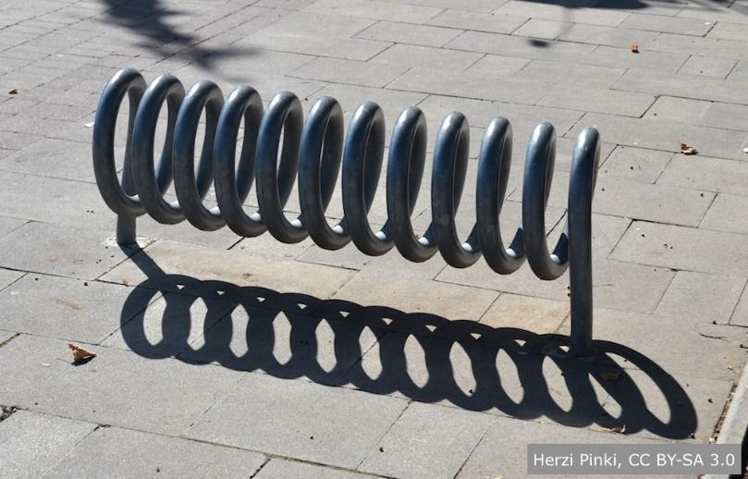

* Observe objects and their shadows. Discuss the shapes and changes to the shapes due to movement.
* Observe whether the objects and shadows touch and the point at which they touch.
* Encourage students to speculate on what causes shadows that are not immediately obvious – overhead power lines and clouds are two examples – and how/why they have come to this conclusion.
* Encourage students to use shadows to identify small features such as whether a classmate is wearing shorts or if their hair is loose or tied in a ponytail.
* Play games in which students try to step on their own or other people’s shadows. Can they make their shadow shake hands with someone without actually touching the other person?
* Encourage students to ask a question about the shape of an object and its shadow for someone to investigate and answer.

1. Use a strong torch, lamp or an overhead projector indoors to experiment with shadows.

* Using a light source behind where students are seated, create shadows on the wall, whiteboard or screen using a variety of objects. See if students can identify them by the shape of their shadows.
* Change the orientation of the objects and discuss the effects on the shadows.
* Move the objects away from or closer to the light source and discuss the effects on the shadows.

1. Look for shadows indoors – fluorescent lights and natural light coming in through the windows create shadows, but they may take a bit more observation to find and to identify.
2. Display images of shadows from sites like [Wikimedia Commons](https://commons.wikimedia.org/wiki/Category:Shadows) for students to identify. Encourage students to justify their answers.

**Concept 2: An object is always between a light source and the surface on which its shadow forms**

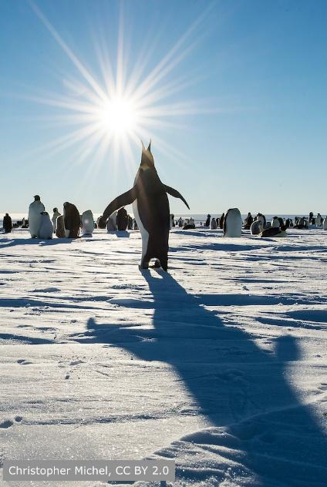

1. While outdoors:

* Ask students to consider the position of their shadow and the position of the Sun. (Remind children that looking at the Sun is very dangerous. They can glance at the sky, but they should not look directly at the Sun.)
* Ask students to stand in the shadow of a building or other large structure. Discuss why they do or do not cast a shadow.
* Experiment with areas of dark shade (close to a building) and light shade (dappled sunlight due to vegetation or when a cloud obscures the Sun).

1. While indoors, use a light source such as a torch to make shadows of objects on a surface or screen.

* Place a piece of card between the light source and the object. Discuss the outcome on the original shadows. Observe whether a new shadow is formed by the card.
* Place the piece of card behind the light source. Discuss the outcome.
* Remove the light source and discuss the effect on the objects, the card and the screen.

**Concept 3: Light travels in straight lines outwards from its source**

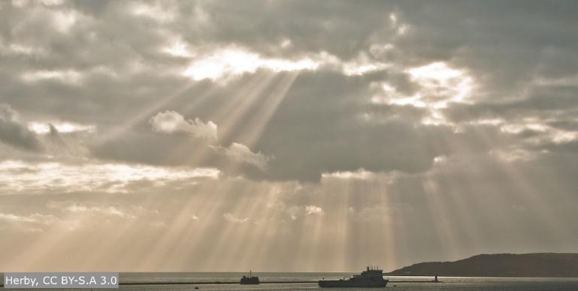

1. Shine a torch on the wall. Observe the direction in which the light is pointing (travelling). Move the torch and observe the effects on the direction of the light.
2. Shine a torch behind an object to create a shadow on a wall. Move the torch so that it shines on the side of the object. Observe the effect on the shadow. Is the shadow still on the wall or has it moved? Continue to move the torch to make multiple observations about the direction of the light.
3. Challenge students with the question: Does sunlight travel to places other than the Earth? Position students around a candle, using it as a model of the Sun and themselves as other planets.

**Concept 4: A shadow is the relative absence of light**

1. While outdoors:

* Investigate shadows in bright sunlight and in shady spots. Discuss the relationship between the intensity of the light source and the darkness or lightness of the shadow.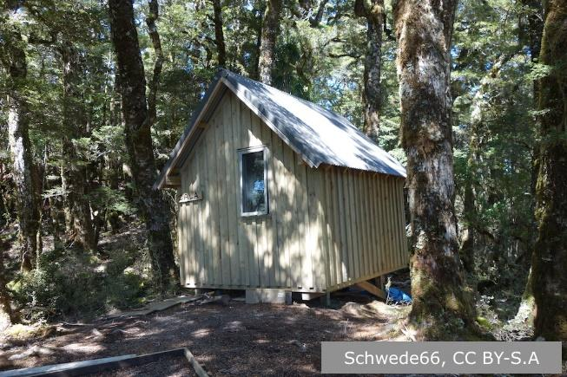
* Investigate changes to the intensity of shadows by photographing the shadow of an object at the same time each day for several days. Note whether it is sunny, medium cloud or heavy cloud cover. Compare the shadows in the photos. Are some lighter or darker than others? Ask why we need to take the photos at the same time each day?

1. While indoors:

* Investigate shadows using overhead lights as the light source. Shadows cast directly under the lights are darker and more definite compared to shadows cast between the lights.
* Investigate shadows with the overhead lights turned off. Large windows allow indirect sunlight to enter the room. Look for shadows – are they lighter or darker in different parts of the room?

**Concept 5: The angle at which light strikes an object or surface determines the size and shape of the shadow**

1. While outdoors: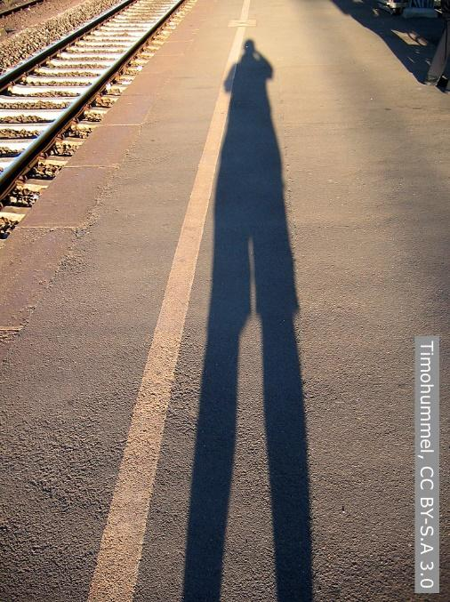

* Determine the position of the sun in the sky.
* Working in pairs, use chalk to draw around the feet of a student, then trace around the person’s shadow.
* Return twice during the day. Students stand in the outline of their feet while a partner traces around the new shadow.
* Discuss the relationship between the Sun’s position in the sky to the size and shape of the shadow.
* Encourage students to design an investigation to determine whether the same thing happens with structures such as playground equipment, fences or trees. Use a camera to document the shadows.
* Make a sundial.
* Use the activity [Investigating shadows and the position of the Sun](https://www.sciencelearn.org.nz/resources/2773-investigating-shadows-and-the-position-of-the-sun) to look at why the Sun’s position changes during the day.

1. While indoors:

* Use a torch to investigate the angle of light and the size and shape of an object’s shadow.
* Move the torch in different ways – from the side and in an arc over the object, rotating around the object, viewing from a distance, from close up etc. This image demonstrates how shadows change when the light source moves in an arc over the object.

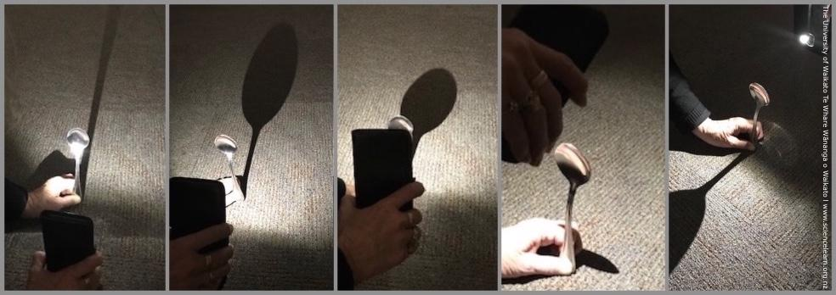

* Observe the effect of other light sources. It is possible for an object to have more than one shadow. Light from a window and light from a torch can both create shadows of an object at the same time. The shadow caused by light from the window stays the same, while the shadow caused by the torch will change as the torch is moved.

