**INVESTIGATION: Measuring the acceleration of gravity (g)**

**Investigation idea**

In this investigation, students will measure distance and time in order to calculate the acceleration of a falling object.

By the end of this investigation, students should be able to:

* describe two ways to calculate the average speed of an object
* distinguish between speed and acceleration
* calculate acceleration.

# 

# For teachers

## Introduction/background

All objects fall at the same acceleration when dropped near the Earth’s surface, as long as wind resistance is not a factor. The acceleration of gravity (g = 9.807 m/s2) is a fundamental physical constant. Using simple equipment and an easy-to-use time-measuring smartphone app, students can take simple measurements and calculate g.

This investigation uses a marble falling from a shelf and an app to precisely measure the time between two sounds. The software was created at the 2nd Institute of Physics of the RWTH Aachen University and is available for free download. The main website is: <https://phyphox.org/>. The smartphone software is available for both Android and iOS phones. The acoustic stopwatch is located in the timers section of the software.

To use the acoustic stopwatch, simply press the start button. The software will “listen” for a sound. When a sound is detected, the timing will start. When a second sound is detected, the timing will stop.

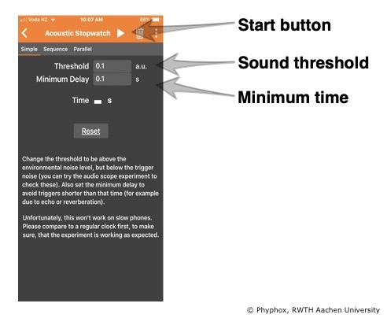

To adjust the level of sound needed to trigger the stopwatch, adjust the sound threshold. If it triggers at too soft a sound, raise the value.

Sometimes the first sound may echo or be detected as two sounds. Setting the minimum delay will stop the software from listening for a second sound for some minimum amount of time. The default is 0.1 seconds. This does not affect the total time measured – it just prevents early false stops.

This investigation allows for some pre-planning with your students:

* What shelf could we use. How do we measure it?
* How do we keep ourselves safe when setting up the investigation at this height? (A consideration for younger students.)
* Is the position of the acoustic stopwatch important? Where is it most effective?
* Discuss the pros and cons of doing this investigation as a whole class or small groups. (Smaller groups may be too noisy for the device to pick up the correct sound.) This presents an opportunity to discuss scientific methods and controls. Try different methods and then refine the one method you will use to gather data.
* Encourage students to make predictions about what may happen.

## What you need

* A marble or similar falling object
* Two flat rulers
* A device with timing software app
* Shelf or another reasonably tall object (around 2 metres)
* Tape measure

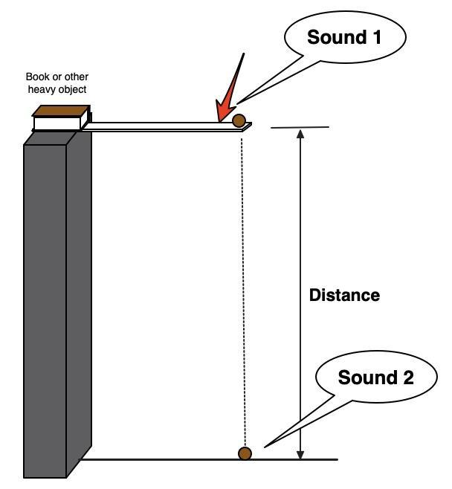

***Set-up***

To set up the experiment, a marble or other small object is placed near the end of a flat ruler on top of a shelf or other tall object above a hard floor. You will need to hold the ruler in place with a heavy object like a book. Deliver a sharp blow to the side of the ruler near the marble to knock the ruler out from under it, allowing the marble to fall to the floor.

The sound made when striking the ruler starts the acoustic stopwatch, and the sound made when the marble strikes the floor stops it. It is important that the marble simply falls when the supporting ruler is struck. If the ruler is struck at a distance from the marble, the ruler may flex and the marble can fly up a short distance, thus invalidating the results.

***Calculations***

Acceleration is defined as the change in speed divided by the time:

1. *acceleration = final speed – initial speed*

*time*

We know when the marble started its fall to the floor, it was not moving, so the initial speed is 0 metres/second. We don’t yet know how much it sped up before it got to the floor, so we have to calculate the speed just as it hits the floor.

We will calculate this final speed in two steps. First, we can easily calculate the marble’s average speed on the trip to the floor. Average speed can be defined as:

2. *average speed = distance travelled*

*time*

To calculate the final speed, we use another definition of average speed – this time one that combines initial speed and final speed:

3. *average speed = initial speed + final speed*

*2*

or rearranged to solve for final speed:

*final speed = average speed x 2 – initial speed*

Now, knowing the final speed, initial speed and time, we can calculate acceleration.

Example:

initial speed = 0 m/s

distance = 2.11 metres

time = 0.659 seconds

average speed = 2.11 metres

0.659 seconds

= 3.20 m/s

final speed = 3.20 m/s x 2 – 0 m/s

= 6.40 m/s

acceleration = 6.40 m/s – 0 m/s

0.659 seconds

= 9.71 m/s2

This value is quite close to 9.807 m/s² (within 1%), the accepted value for the acceleration of gravity.

***Teaching suggestions***

This can be done by student groups or as a whole-class investigation with one experimental set-up and each student group doing individual timing. You may wish to just use the process of setting up and gathering data as a teaching tool and leave the calculations by just using the time it takes for the marble to fall. You may like to vary the height (distance) the marble falls.

***Experimental tips***

The distance of the fall will influence the accuracy of the calculation of g, and very short distances (less than 1 metre) will result in very short times and imprecise results.

It is also important to repeat the experiment several times and take an average of several measurements, perhaps even a class average. It is likely that a stray sound will cause some of the measurements to be false. If a group of students obtains times such as 0.659 s, 0.671 s, 11.323 s and 0.643s, it is important to discuss whether or not they should use the 11 second data point in their average or reject it as an error. (An errant data point like this is called an outlier, and specific statistical tests are used to reject such points in scientific data.)

***Scientific emphasis***

By participating in this investigation, students are able to directly measure one of the fundamental constants – the acceleration of gravity.

Students can also learn about the importance of repeating measurements:

* Why do the results differ?
* Why is it important to have a standardised method?
* How do you calculate the average across multiple measurements?
* Why is calculating an average important?

Through this investigation, students can develop the [science capabili](http://scienceonline.tki.org.nz/Science-capabilities-for-citizenship/Introducing-five-science-capabilities)ty ‘Gather and interpret data’.

***Further teaching and learning ideas***

* The acceleration of gravity is the same for all objects falling near the surface of the Earth as long as air resistance does not play a major role. Some students may think that heavier objects will fall faster. Have students make predictions of the value of g for a number of different sized objects.
* The timer used in this experiment is very accurate. The position of the phone in this experiment will get slightly different results because the sounds take a little time to get from where they are produced to the phone. Where should the phone be placed to give the most accurate results?
* Can students think of a way to measure the speed of sound using this software?