**ACTIVITY: Investigating shadows using transparent,   
translucent and opaque materials**

**Investigation idea**

In this set of investigations, students explore objects made from materials that are transparent, translucent and opaque and the effect this has on their shadows.

By the end of these investigations, students should be able to:

* discuss observations about objects in their environment
* discuss observations about shadows formed by these objects
* make comparisons between objects and their shadows
* identify why some objects (like windows) are transparent, while others are translucent
* begin to use content vocabulary.

# For teachers

## Introduction/background

Shadows form when light cannot pass through an object. Objects that are opaque form definite shadows, which are usually solid or near solid. In intense light, the shadows also appear dark and definite.

Transparent materials let most of the light pass through. Translucent materials allow some light to pass through. Transparent and translucent objects still form shadows, but they may be faint, fuzzy or coloured.

This set of investigations encourages students to identify objects that are opaque, transparent and translucent. In addition, students are encouraged to observe the objects’ shadows and make connections between the characteristics of the objects and the characteristics of their shadows.

***Pedagogical information***

Shadows, as physical phenomena, are more complex than they first seem. Careful observation reveals some interesting characteristics regarding shape, intensity, definition and more.

Content vocabulary may be advanced for young learners – words like intensity, definition, opaque and translucent are unlikely to be everyday words at NZC levels 1 and 2. Alternative, age-appropriate words like ‘see-through’ are suitable substitutions.

It is recommended that you use the resource [Investigating shadows](https://www.sciencelearn.org.nz/resources/2772-investigating-shadows) to provide introductory experiences and explanations. The knowledge gained through these initial observations may allow students to observe light and shadows more deeply and begin to examine the role materials play in creating shadows. It is also recommended that you read the article [Alternative conceptions about light and shadows](https://www.sciencelearn.org.nz/resources/2783-alternative-conceptions-about-light-and-shadows) to become of aware of common misconceptions and how to scaffold change.

***Suggested activities***

Rather than set out prescribed instructions, this resource identifies ways in which students can explore, experience and build their understanding of different materials and whether or not light can travel through them, and how this affects their shadows.

1. Gather a selection of objects that are opaque, translucent and transparent. Use a torch for indoor exploration or take the objects outside for observation in strong sunlight. Observe and discuss what happens when light shines on the objects.

* 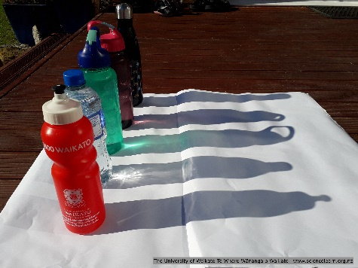Does the light shine through each object?
* Do some of the objects let more light shine through than others? How can you tell?
* Do some objects block the light from shining through? How can you tell?
* Are the shadows the same or different?
* Are the shadows dark with definite edges or are they fuzzy?
* Do the shadows have colour?

Divide the objects into three groups with student-chosen labels. Students must justify their groups and labels. You may need to repeat this activity a few times to arrive at groups of opaque, translucent and transparent (or similar words). Alternatively, prompt students to group by the types of shadows formed, then discuss the objects/materials.

1. Look at the image [Shadows and intensity](https://www.sciencelearn.org.nz/images/4004-shadows-and-intensity).

* Do the parts of the shadow all look the same or are there differences?
* What parts of the shadow are created by the different parts of the lantern?
* Why do you think some parts of the shadow look different?
* What materials are used in the lantern? What effect does this have on the shadow?

1. Explore the school environment for examples of objects that are opaque, translucent and transparent.

* What materials are the objects made from?
* Why are classroom windows transparent, while toilet or office windows are translucent?

1. Use jars of dye to investigate opaqueness, translucence and transparency. (Use lidded jars to keep things tidy.) Place the jars on a light surface or white paper. Use a strong torch indoors or strong sunlight outdoors to observe the light shining through the jars and the shadows it creates.

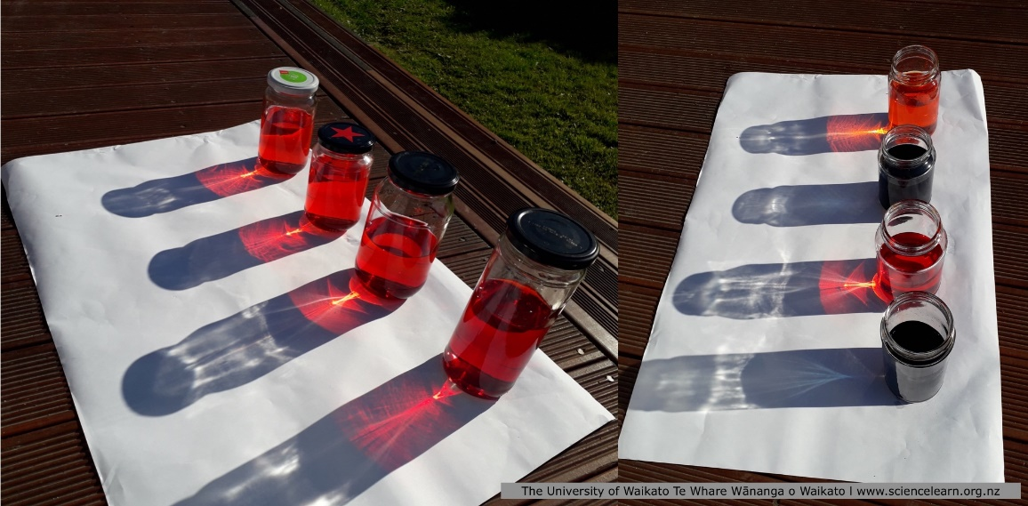

Consider doing an introductory demonstration and then encouraging students to design their own investigations, complete with predictions and results. Discuss fair testing. The jars in these images are different sizes, but each contains 250 ml of water. In the image on the left, the dye concentrations range from weak to strong. In the image on the right, the dyes are different colours.

* Use increasing dye concentrations of a single colour.
* Use different colours of dye.
* Wrap a cylinder of paper around the jars.
* Wrap a narrow strip of paper around the middle of the jars.

1. Create and observe suncatchers. Cut shapes from cellophane and coloured paper. Arrange them on a laminating sheet and seal.

* What types of shadows do the different shapes make?
* Are they the same size and colour as the shapes used in a suncatcher?
* Are some shadows more distinct than others?
* Are some shadows fuzzy?
* Do some shadows have colours other than grey?
* Does the material (paper or cellophane) affect the type of shadow?

1. Experiment with food wrappings: plastic wrap, greaseproof paper, waxed paper and aluminium foil. Encourage students to design their own investigations about the properties of the wrappings and how this affects their shadows