**ACTIVITY: Investigating sound wave resonance**

**Activity idea**

In this investigation, students will use a short length of pipe, container of water and sound source (tuning fork or smartphone app) to investigate resonance. They will measure the distance between resonance points and calculate the speed of sound.

By the end of this investigation, students should be able to:

* describe a standing wave
* use measurements in a formula to calculate the speed of sound.

# For teachers

## Introduction/background

In this investigation, students will find the wavelength of a pure tone of known frequency using a length of tubing and a water bath. They will then use the relationship between frequency, wavelength and velocity to calculate the speed of sound.

A pure tone (sine wave) of a known frequency is played into the open end of a tube. The length of the tube is adjusted by raising and lowering it into a water bath. When the length of the air cavity is the right length to accommodate 0.25, 0.75, 1.25, 1.75 etc. waves, the sound will resonate in the cavity and become very loud. If you measure the distance between two adjacent loud spots, you can calculate the wavelength of the wave. Once the wavelength is known, the speed of sound in the classroom can be found using this formula:

speed of wave = wavelength x frequency

The set-up for this investigation involves a piece of pipe long enough to accommodate at least 1.25 waves for the sound frequencies you choose to measure. If you choose high-frequency tones (1,000–1,500 Hz), a 300–400 mm tube will be long enough.

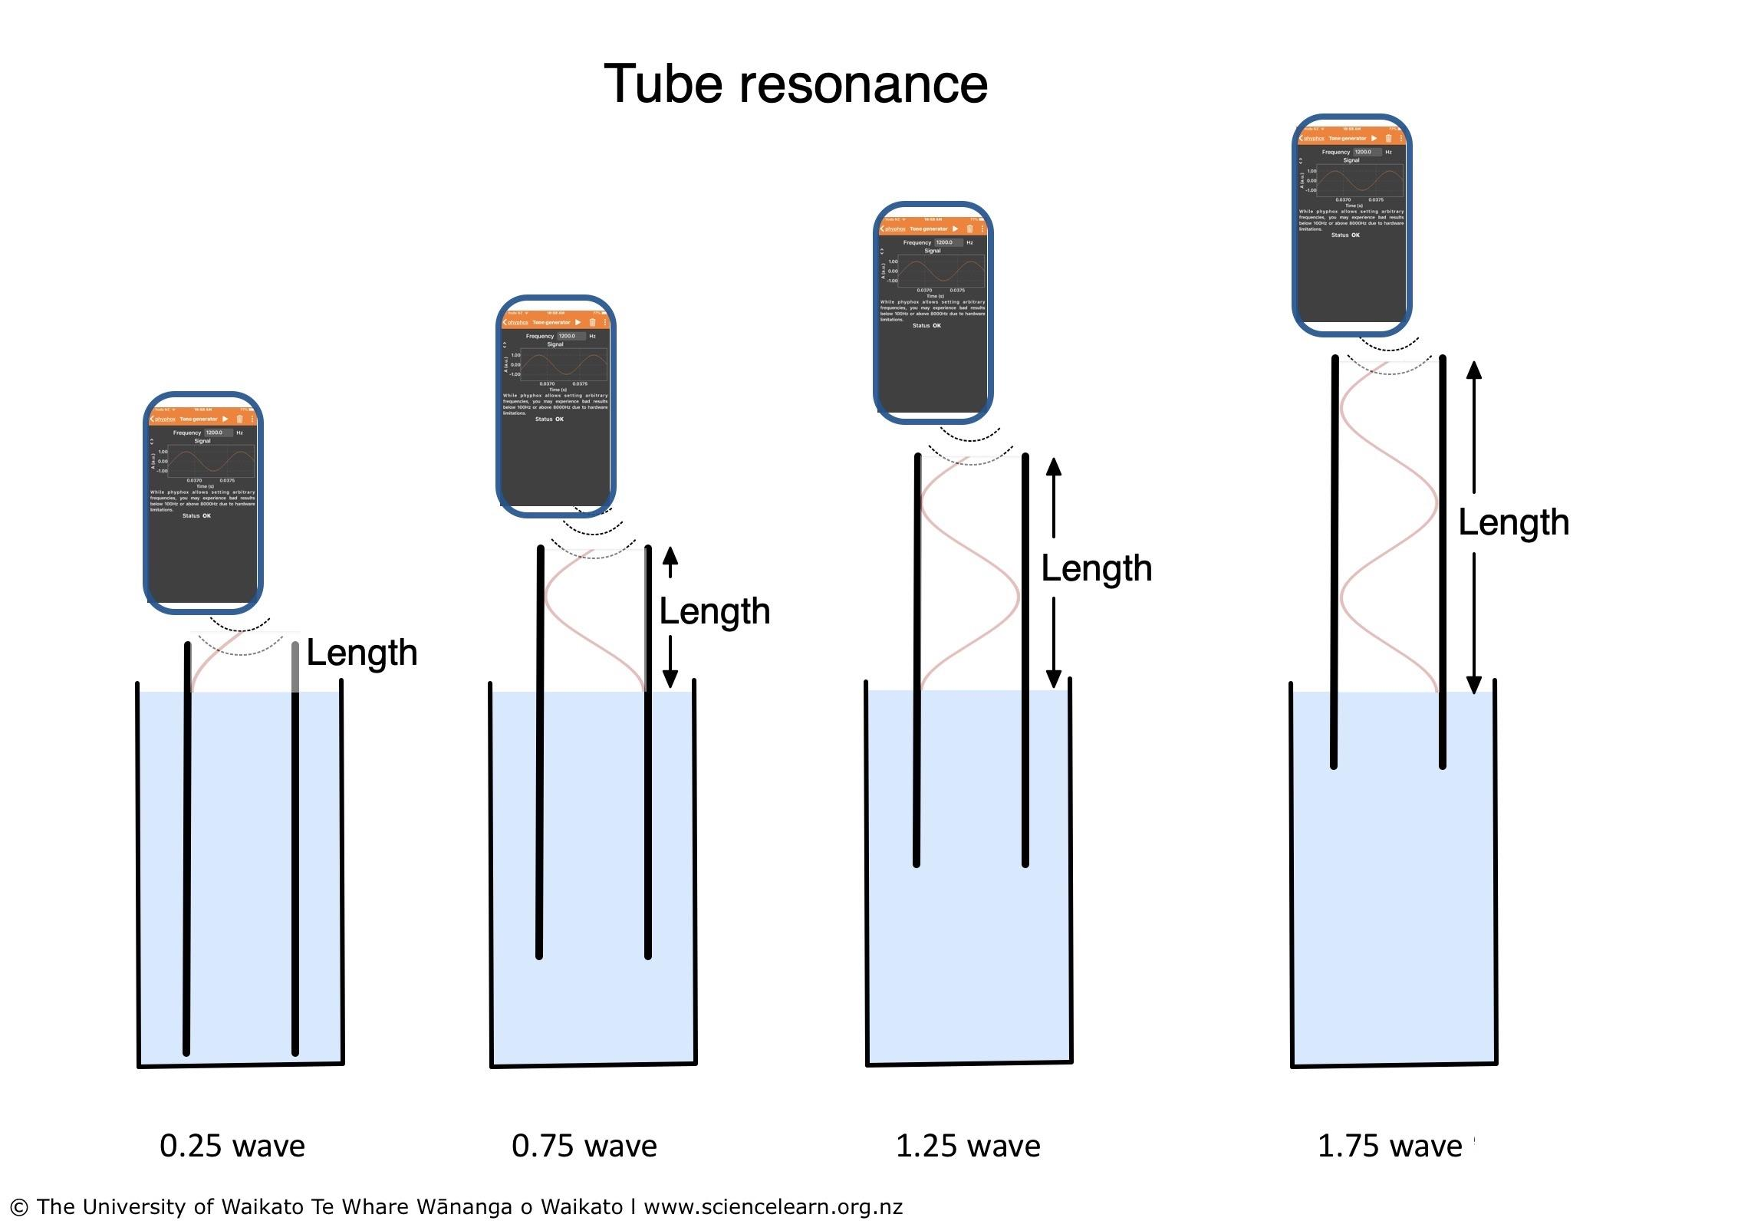

The first 0.25 wavelength resonance point should not be used by itself because the actual endpoint of the first wave is a small distance outside of the tube, depending on the tube diameter. However, the distance between any two resonance points is exactly 0.5 of a wavelength. Students should therefore measure the distances between resonance points rather than the full absolute distance to the end of the pipe (see *Further teaching and learning ideas*).

There are many sound-generating smartphone apps available for iOS and Android phones. The software provided by <https://phyphox.org/> (Tone Generator) is an excellent choice. This experiment will work with plastic or metal pipe of reasonably small diameter (30–70 mm).

A smartphone app that will generate specific frequencies is convenient. However, there is no reason this experiment cannot be done with tuning forks.

If you choose to use tuning forks you will need to be sure to have pipe lengths (and water baths) that will be long enough. For example, a 440 Hz tuning fork has a wavelength of approximately 0.772 metres. In order to hear the first three resonance points, you would need a pipe nearly 1 metre long. Higher-frequency tones allow the use of much shorter pipes.

The exact wavelength depends on temperature and slightly on humidity, so use this table only as a guide to help select the length of pipe.

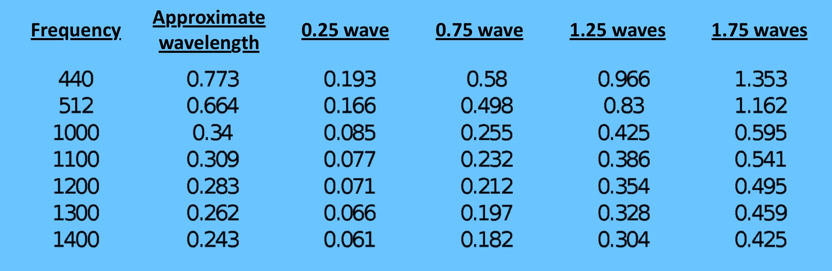

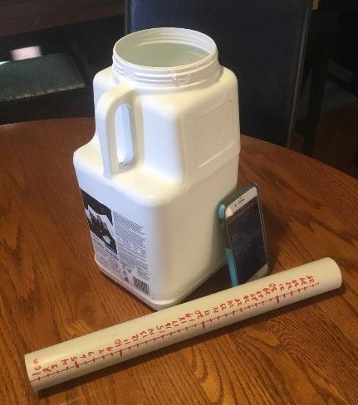

## What you need

* Sound-generating device (tuning forks or smartphone tone generation app)
* Length of plastic or metal pipe (minimum length 300 mm)
* Water bath

## Teaching approach

It is quite easy to hear the resonance points (as demonstrated in the video [Demonstration of tube resonance](https://www.sciencelearn.org.nz/videos/1905-demonstration-of-tube-resonance)). You may wish to have students use several different frequencies and multiple trials at each frequency to improve their results.

***Scientific emphasis***

By participating in this investigation, students are able to use an indirect method to measure the speed of sound.

Students can also learn about the importance of repeating measurements:

* Why do the results differ?
* Why is it important to have a standardised method?
* How do you calculate the average across multiple measurements?
* Why is calculating an average important?

Through this investigation, students can develop the [science capabili](http://scienceonline.tki.org.nz/Science-capabilities-for-citizenship/Introducing-five-science-capabilities)ties ‘Gather and interpret data’ and ‘Interpret representations’.

***Further teaching and learning ideas***

The first resonance point (0.25 wave) is influenced by the diameter of the pipe. The correction is:

speed of sound = frequency x wavelength + (1.6 x diameter of pipe)

Students may wish to test out this formula to determine if it successfully corrects the first resonance point. You may wish to ask them to speculate why the diameter of the pipe would only affect the first point.

It is possible to produce a resonance in a tube that is open at both ends. Students may wish to play different tones into the pipe to find the resonance of the full length of the pipe.