**ACTIVITY: Measuring the speed of sound**

**Activity idea**

In this investigation, students will measure distance and time in order to calculate the speed of sound.

By the end of this investigation, students should be able to:

* calculate the speed of sound
* explain why we see a lightning bolt before we hear the thunder.

# For teachers

## Introduction/background

We have all experienced the delay between seeing an event and hearing the sound from the event – the delay between seeing a lightning bolt and hearing the clap of thunder or sitting in the stands of a cricket game and seeing the batter strike the ball and hearing it a short time later. That delay is caused by the difference between the speed of light and the speed of sound. Light travels so fast (~300,000,000 metres per second) that, when compared to the relatively slow speed of sound (~340 metres per second), the light outruns the sound, even over relatively small distances.

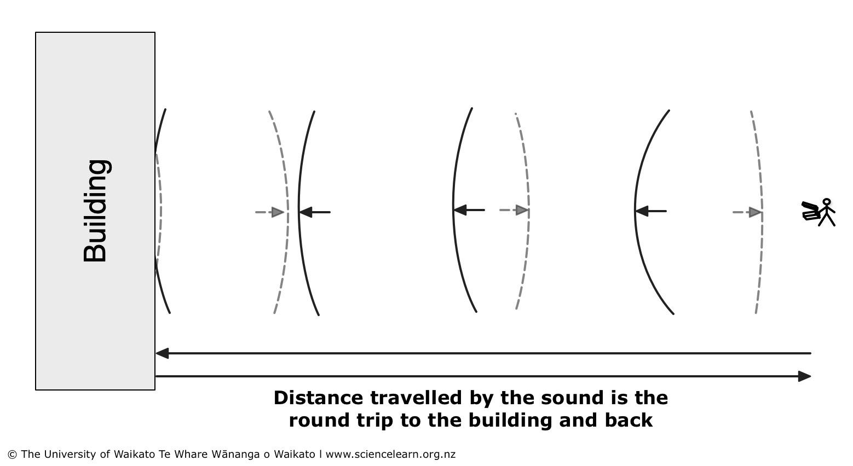

## What you need

* Sound-making device such as a clapper or drum
* Device with timing software app
* Outdoor space of at least 150 metres with a building at one end
* Tape measure or measuring wheel

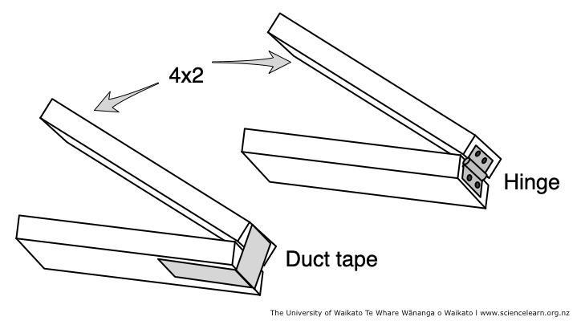

***Making a clapper***

A simple clapper made of two 90x45 mm (4x2) boards can be constructed by attaching a hinge or duct tape to the boards as shown. The clapper is then snapped together to create a sharp, loud and clear sound.

***Measuring the distance***

The actual distance from the clapper to the echo surface (building) will need to be measured. Many schools have a distance measuring wheel that is used for measuring distances in athletics, which can be used to accurately measure the distance.

Another approach is to have the students devise a plan to measure the distance by measuring the length of their stride and pacing it out. The entire class average will usually give a very accurate result.

Sound travels quite fast, and delays are difficult to time precisely over short distances. Bouncing the sound off a building and timing the sound of the echo effectively doubles the distance.

***Measuring the time***

The time for a sound to travel 150 metres and the echo to return will be less than 1 second. Timing using a stopwatch or standard timer on a phone will be challenging. To make the timing more accurate, two approaches can be followed.

*Approach 1*

One suggestion is to use software that has been developed for this purpose. The software precisely measures the time between two sounds. It was created at the 2nd Institute of Physics of the RWTH Aachen University and is available for free download. The main website is <https://phyphox.org/>. The smartphone software is available for both Android and iOS phones. The acoustic stopwatch is located in the timers section of the software.

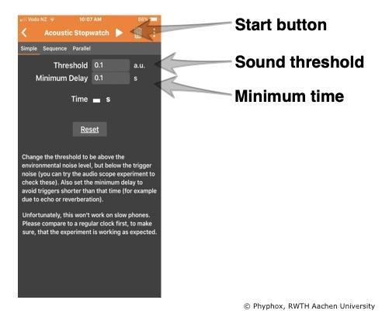

To use the acoustic stopwatch, simply press the start button. The software will ‘listen’ for a sound, and when a sound is detected, the timing will start. When a second sound is detected, the timing will stop.

To adjust the level of sound needed to trigger the stopwatch, adjust the sound threshold. If it triggers at too soft a sound, raise the value.

Sometimes the first sound may echo or be detected as two sounds. Setting the minimum delay will stop the software from listening for a second sound for some minimum amount of time. The default is 0.1 seconds. This does not affect the total time measured – it just prevents early false stops.

This approach allows for some pre-planning with your students:

* Is the position of the acoustic stopwatch important? Where is it most effective?
* The sound threshold value will be critical in this experiment. Students will need to be quiet between the claps to prevent false triggers.
* False triggers will occur in this experiment. How can students compare results to determine whether their timing was the result of a sound and echo or a false trigger?

*Approach 2*

Another way to do this experiment is to time multiple echoes using a stopwatch or smartphone timer. The person making the sound with the clapper listens for the echo and makes another clap just as the echo arrives. Continue until a large number of echoes can be timed. The students can find the time of one echo by dividing the time recorded by the number of claps.

This approach works best if the person doing the clapping simply keeps going and the students start timing precisely at the first clap and stop timing after a certain number of claps later (say 10 or 20).

Working in pairs, students will need to plan a procedure to record results as the investigation continues.

***Calculations***

Speed is defined as the distance travelled divided by the time or mathematically:

speed of sound = sound distance

time

## Teaching suggestions

This investigation works well in groups of three – one person doing the clapping, one doing timing and the third recording the results. Everyone can be involved in the distance measurement. If your school has a distance measuring wheel, you may still decide to have the class measure the distance by pacing and comparing your results with the wheel to illustrate the concept that simple methods can produce accurate results.

***Experimental tips***

You may wish to try both approaches and compare the results of one that involves high-tech software and another that uses simple methods to achieve the same result.

It is also important to repeat the experiment several times and take an average of several measurements, perhaps even a class average. It is likely that a stray sound will cause some of the measurements to be false. If a group of students obtains times such as 0.951 s, 0.973 s, 0.328 s and 0.943 s, it is important to discuss whether or not they should use all of the data points in their average or reject the 0.328 s point as an error. (An errant data point like this is called an outlier, and specific statistical tests are used to reject such points in scientific data.)

***Scientific emphasis***

By participating in this investigation, students are able to directly measure the speed of sound.

Students can also learn about the importance of repeating measurements:

* Why do the results differ?
* Why is it important to have a standardised method?
* How do you calculate the average across multiple measurements?
* Why is calculating an average important?

Through this investigation, students can develop the [science capabili](http://scienceonline.tki.org.nz/Science-capabilities-for-citizenship/Introducing-five-science-capabilities)ty ‘Gather and interpret data’.

***Further teaching and learning ideas***

* Challenge the students to use their results for the speed of sound to create a simple formula to estimate the distance to a lightning strike based on the number of seconds between the flash of lightning and the sound of thunder.
* The timer used in this experiment is very accurate. The position of the phone in this experiment will get slightly different results because the sounds take a little time to get from where they are produced to the phone. Where should the phone be placed to give the most accurate results?
* The speed of sound is affected by several environmental factors. Challenge students to find how the speed of sound is affected by temperature, air pressure and humidity. Using some or all of those factors, how accurate was your determination of the speed of sound?