**ACTIVITY: Label the insect**

**Activity idea**

In this activity, students use online and/or paper resources to identify and label some of the physical characteristics of insects using two well known native insects – the chorus cicada and the tree wētā.

By the end of this activity, students should be able to:

* identify and label some of the key physical characteristics of insects
* use literacy skills to learn about the physical characteristics and associated terminology
* make comparisons between the cicada and tree wētā.

# For teachers

## Introduction/background

Scientists classify living things into groups based on their shared characteristics. Insects are one of the largest and most diverse animal classes on Earth. There are more than a million known species, yet they all share common physical characteristics. This activity is an introduction to some of the key physical characteristics that separate insects from other animals such as spiders or woodlice (slaters).

Use the [Label the cicada](https://www.sciencelearn.org.nz/labelling_interactives/9-label-the-cicada) and [Label the wētā](https://www.sciencelearn.org.nz/labelling_interactives/8-label-the-weta) interactives to identify the key characteristics of insects. The article [Insects – physical characteristics](https://www.sciencelearn.org.nz/resources/2842-insects-physical-characteristics) provides background information about these characteristics.

There are differences between the two interactives:

* The cicada interactive has a label for wings. This label has been excluded from the wētā interactive because wētā are wingless.
* Both insects have compound eyes, exoskeletons and spiracles but the interactives may not feature each of the labels.

The activity provides practice with the science capability ‘Interpret representations’.

***Questions to deepen student thinking***

Questions regarding the insects and their characteristics:

* What are the similarities between the cicada and wētā?
* What are the differences?
* How do you think the differences affect the way the insects live, move or defend themselves?
* Can you name other insects that have these characteristics?
* Would we be able to use these labels on another bug like a spider or a slater? Why or why not?

Questions regarding the science capability ‘Interpret representations’:

* What do these images tell us about insects?
* When you compare the two images, the cicada and wētā appear to be the same size. Do you think this is true? Why or why not?
* The cicada interactive has a label for wings, but this is missing on the wētā interactive. Why do you think this is missing?
* The wētā interactive has a label for spiracles, but the cicada interactive does not. Does this mean that wētā don’t have spiracles? How do you know?
* Are there things that have been left out of the interactives? What are they?

## Alternative conceptions

Students may consider that all ‘creepy crawlies’ are insects. Although the animals may share characteristics such as segmented bodies or exoskeletons, there are other characteristics that rule them out. For example:

* spiders have four pairs of legs and two body sections
* slaters have seven pairs of legs
* millipedes have multiple segments, each bearing a pair of legs, with large species having up to 93 pairs
* earthworms lack many insect characteristics – the confusion is often due to the worm-like appearance of some insect larvae such as maggots or caterpillars.

Students may also find it difficult to understand that insects are animals.

## Extension ideas

* Photograph insects in the local environment. Zoom in on the photos and identify the visible physical characteristics.
* Insects have bilateral symmetry. Provide an image or line drawing that has been cut in half vertically. Students can sketch the other half and add labels.
* Source images of an insect and a spider (or slater or millipede) and compare the similarities and differences in physical characteristics.

**Label the wētā**

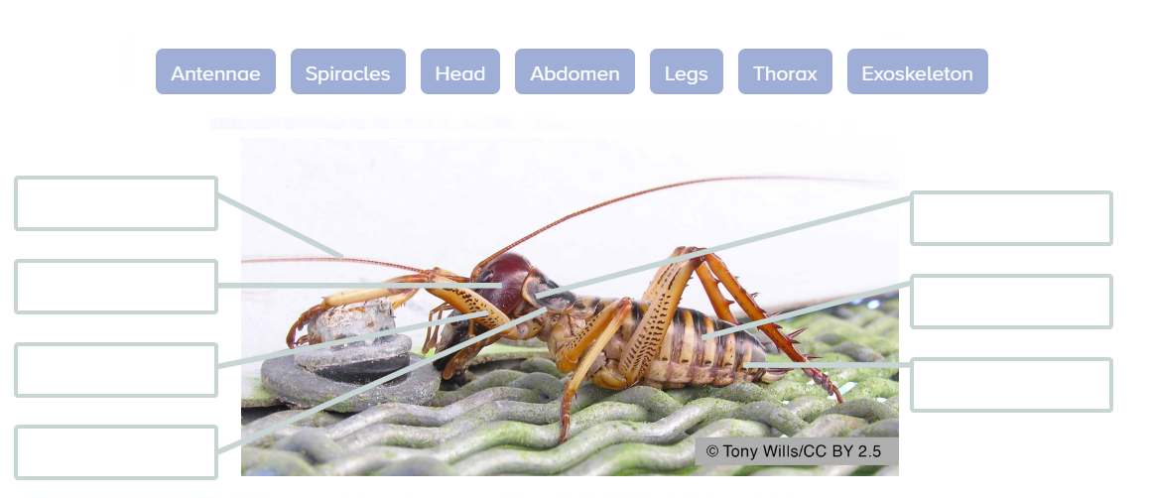

|  |  |
| --- | --- |
| **Label** | **Description** |
| abdomen | The rear section of an insect. It has 9–11 segments. |
| antennae | A single pair sit at the front of the head. Used as sensors. |
| exoskeleton | The hard outer covering to protect and support the body. |
| head | The fore (top) section of the body. |
| legs | Three pairs of jointed legs. One pair may be ideal for digging or leaping. |
| spiracles | Openings for gas exchange, one pair on each abdomen segment. |
| thorax | The mid-section made up of three segments, each with a pair of legs. |

**Label the cicada**

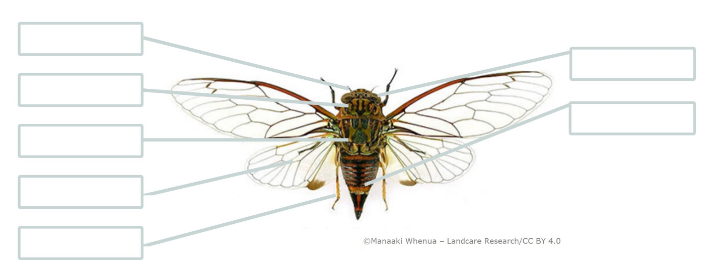

|  |  |
| --- | --- |
| **Label** | **Description** |
| abdomen | The rear section of an insect. It has 9–11 segments. |
| antennae | A single pair sit at the front of the head. Used as sensors. |
| compound eyes | Made up of lots of lenses, provide a wide field of view. |
| head | The fore (top) section of the body. |
| legs | Three pairs of jointed legs. One pair may be ideal for digging or leaping. |
| thorax | The mid-section made up of three segments, each with a pair of legs. |
| wings | Two pairs (fore and hind) attached to the thorax. |

**Label the wētā – answers**

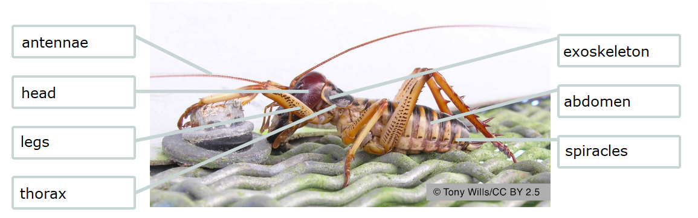

**Label the cicada – answers**

