**ACTIVITY: Follow the water droplet**

**Activity idea**

In this cross-curricular activity, students visualise themselves as a drop of water in the water cycle. The activity includes visual and written literacy components.

By the end of this activity, students should be able to:

* begin to use appropriate content vocabulary
* discuss aspects of water movement through the water cycle
* offer explanations about the cyclical nature of the water cycle
* identify the various changes of state that occur as water moves through the water cycle
* recreate portions of the water cycle using visual or written literacy.

# For teachers

## Introduction/background

The water cycle contains complex interactions between the atmosphere and the land. This activity encourages students to place themselves in the water cycle and imagine the types of interactions they might have as a water droplet.

While planning how to use this activity, consider students’ abilities and prior knowledge. While it is ideal to use content vocabulary, some of the terms and the processes might be more appropriate for older students.

## What to do

1. Use a [water cycle diagram](https://www.sciencelearn.org.nz/image_maps/36-dynamic-and-complex-the-global-water-cycle) to review components of the water cycle. Discuss:

* names
* positions (in the atmosphere, on the land, under the land)
* whether the water is in solid, liquid or gaseous form
* the directions of the arrows and what they tell us.

1. Read the story in the student handout. Ask students to create images in their minds as they listen to the story being read to them.
2. Challenge students to create their own versions of the story either in a short story format or in a video planning format using the storyboard template. Choose a theme such as:

* a raindrop on a kawakawa leaf
* the lawn sprinkler – a theme park for water droplets
* milking the cows.

1. Use the student handout as a word bank.

## Extension ideas

The student handout is a Word document and can easily be edited. Consider choosing a portion of the story and:

* remove key vocabulary to create a close reading activity
* remove surface features such as capital letters and punctuation for students to replace
* remove phrases to make the sentence open-ended for students to finish, for example: “Maybe we would land on a leaf in a tree, in which case we would probably …”

# For students

You may be familiar with how water is always cycling around, through and above the Earth, continually changing from liquid water to water vapour to ice.

I could really begin this story anywhere along the cycle, but I think the ocean is the best place to start, since that is where most of my water buddies are.

Imagine that you are a drop of water – like me. Come on a journey with me!

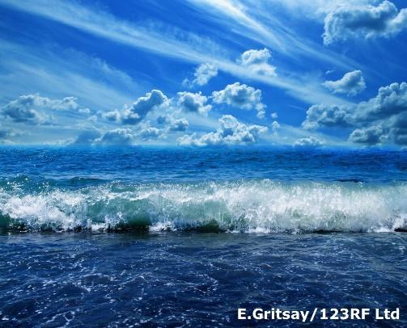If we wanted to stay in the ocean, we shouldn’t have been sunbathing on the surface of the sea. The heat from the Sun found us, warmed us and evaporated us into water vapour. We rose (as tiny, tiny bits of water) into the air and continued rising until strong winds grabbed us and took us hundreds of kilometres until we were over land. There, warm updrafts coming from the heated land surface took us in our tiny form of water vapour up even higher where the air is quite cold.

When we got cold, we changed back into liquid or a drop of water (the process is called condensation). If it was cold enough, we would have turned into tiny ice crystals, such as those that make up cirrus clouds. We gathered around tiny particles of dust, smoke and salt crystals to become part of a cloud.

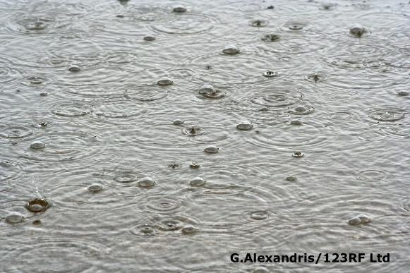

After a while, we combined with other drips to form a bigger drop and fell to the Earth as precipitation (rain). As we get bigger and heavier, Earth’s gravity helped to pull us down to the surface. Once we started falling, there were many places that we could go. Maybe we would land on a leaf in a tree, in which case we would probably evaporate and begin the process of heading for the clouds again. If we missed a leaf, there are still plenty of places to go.

We could land on a patch of soil or in a paddock. In this case, we might sink into the ground to begin the journey down into an underground aquifer as groundwater. We would continue moving – mainly downhill – as groundwater, but our journey might end up taking tens of thousands of years until we find the way back out of the ground.

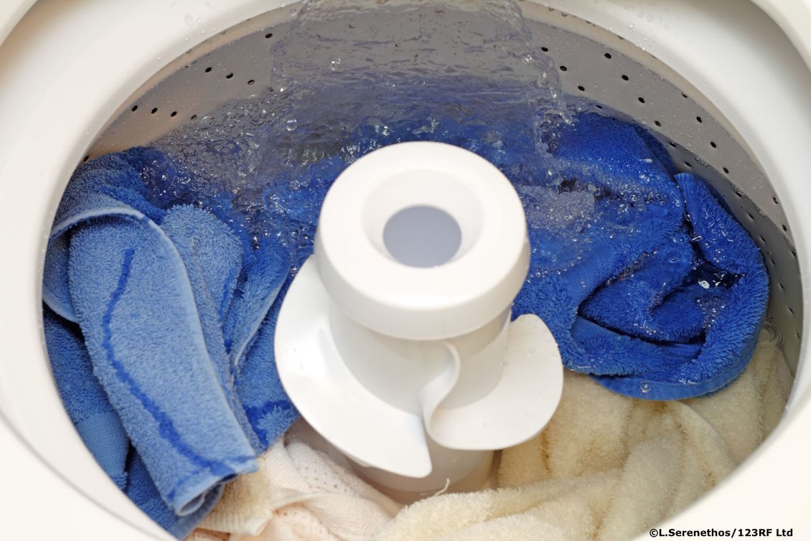Then again, we might be pumped out of the ground via a water well and be sprayed on crops, where we will evaporate, flow along the ground into a stream or go back down into the ground. Or from the well, we could end up in a baby’s drinking bottle or be sent to the laundry. From these places, we go back either into the air or down wastewater pipes. Wastewater in towns and cities is treated and often returned to rivers or other water bodies. For people who use septic tanks, the treated water goes into groundwater.

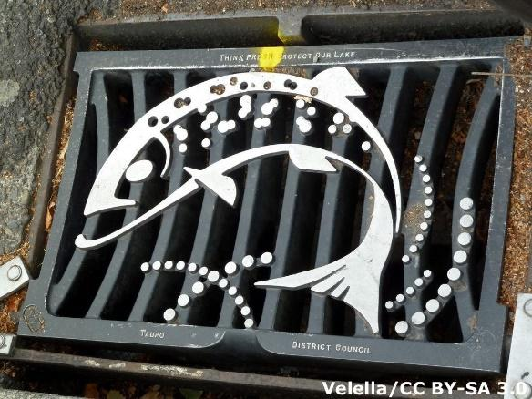But we might be land-lovers. Plenty of precipitation ends up staying on the Earth’s surface to become a part of surface water. If we land in an urban area, we might hit the roof of your house and go down the gutter and your driveway to the kerb. If a dog or cat doesn’t lap us up, we will run down the kerb into a stormwater drain and end up in a small stream. It is likely the stream will flow into a larger river, and we will begin our journey towards the ocean.

If no one interferes, our trip will be fast (speaking in ‘drip time’) back to the ocean or at least to a lake where evaporation could again take over. But with 5 million people here needing water for almost everything, there is a good chance that we will get picked up and used before we get back to the sea.

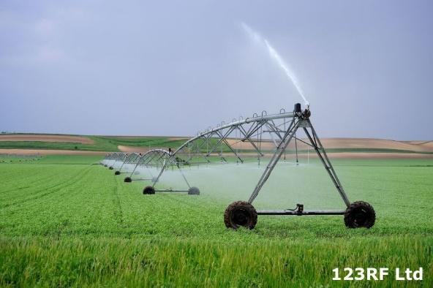A lot of surface water is used for irrigation – imagine flying through the air on the jet spray of an irrigator – and by industries to cool their machinery. From there, we might go into the cooling tower to be evaporated. Talk about a quick trip back into the atmosphere as water vapour!

But maybe a town pumped us out of the river and into a water tank. From here, we could go on to help wash your dishes, fight a fire, water the tomatoes or – shudder! – flush your toilet. Maybe the local steel mill will grab us, or we might end up at a fancy restaurant washing the lettuce or mopping the floor.

The possibilities are endless – but it doesn’t matter to me, because eventually I will get back into the environment. From there, I will again continue my cycle into and then out of the clouds, this time maybe to end up in your water glass!

## Storyboard template