ACTIVITY: Water cycle models

Activity idea

In this activity, students draw a representation of the water cycle onto resealable bags. The bags are placed in a sunny location and enable students to model how the Sun’s energy and the force of gravity drive aspects of the water cycle.

By the end of this activity, students should be able to:
- draw some of the features of the water cycle
- discuss the role of the Sun in the water cycle
- discuss the role of gravity in the water cycle
- make predictions about what might happen with their model
- explain how their model is similar/different to the actual water cycle.

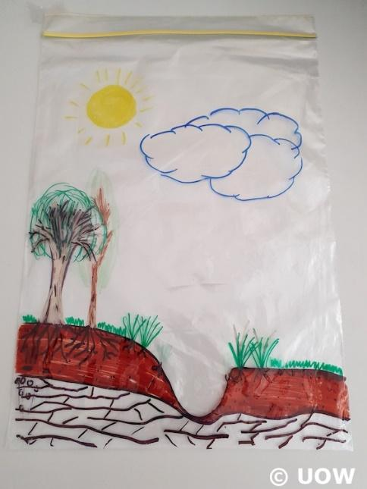
For teachers

Introduction/background

In science, a model is a representation of an idea, an object, a process or a system. Models are often used when it is difficult to see or experience the real thing. Although we live in the middle of the water cycle, it is difficult for students to see aspects of it in action because they either happen underground or involve invisible processes (transpiration and evaporation) and gravity – a non-contact force.

The Sun provides the energy that drives the evaporation and transpiration stages of the water cycle – when liquid water becomes gaseous water vapour. We can see evidence of this happening when we put a container over grass or leaves, but we don’t see the process itself. (Note that what we do see on the container is condensation – water back in its liquid form.)

The pull of gravity drives the stages of precipitation, run-off, infiltration and groundwater flow. We can observe precipitation, run-off and infiltration, but groundwater flow and discharge happens below the ground and out of sight.

Learn more in the article The water cycle.

This activity allows students to observe aspects of the water cycle and to compare their models with what actually happens in nature.

If you plan to make multiple models, secure string across a set of windows and use pegs or clips to hang the models. Make the string as taut as possible so the models don’t sag. Alternatively, use skirt/trouser hangers to hang large models.

What you need

- Water cycle image or interactive
- Resealable plastic bags – 25 x 35 cm or similar for large models or sandwich bags for smaller models
- Permanent markers
- Tape, pegs, foldback clips or metal clip clothes hangers
- Water
- Sunny window location
- Gravel (optional)

What to do

- Draw models of the water cycle on the resealable bags and include:
- the Sun
- clouds
- vegetation – including roots
- surface water (stream, lake or ocean)
- groundwater
- arrows (optional).

- Place a layer of gravel in the bag to represent an aquifer (optional).

- Seal most of the bag before adding water.

- Add enough water so the stream, lake or ocean is partially filled.

- Seal the bag.

- Place the model in a sunny window.

- Make predictions about what might happen with the model.

- Observe what happens during the day as the water heats up.

- Compare the similarities and differences between the model and what really happens outside.

Questions to deepen student understanding

Questions while viewing the water cycle image or interactive:
- Which processes (parts) of the water cycle involve the atmosphere?
- Which processes of the water cycle take place on the land?
- Which processes of the water cycle happen under the land?
- Which processes can we see when we stand outside and look around?
- Which processes are we unable to see when we stand outside and look around?
- Which processes are driven by energy from the Sun?
- Which processes are affected by gravity?
- Why do we need to place our model in a sunny window?
- What do you think will happen in our water cycle model?
- What do you observe happening throughout the day?
- What are some similarities between what really happens outside and what is happening in our model?
- What are some differences between the real water cycle and our model?

Alternative conceptions

The article Alternative conceptions about water’s states of matter outlines common alternative conceptions students may hold about water – particularly water in its gaseous form. It is important to be aware of alternative conceptions so educators can aid students to change their thinking.

Extension ideas

These models also aid understanding about the water cycle:
- Building a water cycle
- Constructing an aquifer model

