**ACTIVITY: Build a model water catchment**

**Activity idea**

In this activity, students use everyday materials to simulate water flows in a catchment.

By the end of this activity, students should be able to:

* discuss the role of relief (mountains, hills, valleys and flat areas) in water flow
* observe and compare slope steepness and velocity of water flow
* observe and discuss the role of tributaries to larger streams and rivers
* observe and discuss the connections between surface water systems (streams, rivers, lakes)
* compare their model catchment with their local water catchment area
* discuss the similarities and differences between a model catchment and a real catchment area
* discuss why scientists use models.

# For teachers

## Introduction/background

A water catchment area is land that is bounded by natural features such as hills or mountains, from which all surface water, run-off water and groundwater flows to the lowest point in the landscape. Catchments influence the biodiversity and ecology of stream and river systems.

The article [Water catchments](https://www.sciencelearn.org.nz/resources/2873-water-catchments) and the interactive [Water flows and catchments](https://www.sciencelearn.org.nz/image_maps/89-water-flows-and-catchments) provide information about catchment areas and how rivers change as they flow from an upper catchment – the headwaters – to the lower catchment – where the river leaves the catchment at a single point or outlet. The resources also explain the influence of catchments on water quality.

The activity [Mapping my local water catchment](https://www.sciencelearn.org.nz/resources/2886-mapping-my-local-water-catchment) provides students with a virtual two-dimensional experience of water catchments. This activity offers a follow-on three-dimensional experience of water catchments. Students can build smaller catchments using a lunchbox or a larger model outdoors.

The activity provides a useful context to discuss models in science – why scientists use them, the similarities and differences between the model and a real catchment and the benefits and drawbacks of using a model.

## What you need

For a small model:

* Plastic lunchbox or similar
* Sheet of aluminium foil (or soft plastic) about twice the length of the lunchbox
* Paper or plastic cup with holes in the bottom to act as a cloud
* Jug of water
* Food colouring or dye (optional)
* Sand

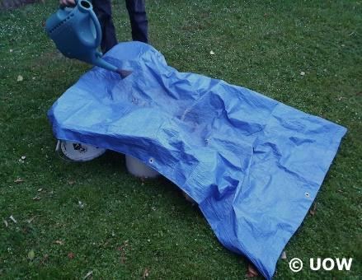

For a large model:

* Materials to build slopes (boxes, upturned buckets)
* Large plastic sheet or tarpaulin
* Watering can or hose with a spray nozzle to act as rain
* Small leaves
* Sand
* Outdoor space or sandpit

## What to do

1. Use the Hub resources mentioned above to learn about catchments – their shapes, how they change from upper catchment areas to lower catchment areas and some of the content vocabulary students may need to use while building and observing their models.
2. If applicable, go outdoors to observe the local environment. Note the location of hills or mountains that surround your local area as well as valleys or flat areas, depressions and hollows and areas where there is surface water like lakes, streams, rivers, wetlands or estuaries.
3. Create water catchment models. If you build a large catchment outdoors, consider taking advantage of natural slopes in the school or create a slope in the sandpit or use buckets to create hills and valleys. Alternatively, students can work indoors to create smaller individual catchments.
4. Encourage students to include steep and gentle slopes, flat areas and hollows or depressions.
5. Use a cup, watering can or hose to ‘rain’ on the catchment. Observe where the water goes. Move the water source so it rains in different parts of the catchment and observe the water flows.
6. With the large model, place a small leaf at the top of a steep slope. Observe how quickly the leaf moves when it rains. This simulates water velocity.
7. Place a leaf on gentler slopes and/or in a lake. Observe how the leaf moves when it rains.
8. With either model, sprinkle a small amount of sand over the model and observe what happens when it rains. This simulates erosion.

## Questions to deepen student understanding

* Which direction does the water flow?
* Where does the water flow?
* Are there places where the water stops flowing? Where are they?
* What water connections form within the catchment? (Consider whether there are small streams – tributaries – that become larger streams or rivers and lakes.)
* How does water velocity change in the catchment?
* What changes do you observe when there are several clouds ‘raining’ on the model or when you increase the amount of water coming from the hose?
* How does your model compare to your real water catchment area? What are the similarities or differences?
* What could we add to this model to make it more like a real catchment?
* Why have we created a model of a catchment rather than observing a real water catchment area?
* Why do scientists use models rather than the real thing?
* Do you think water scientists who study water catchments should visit the catchments? What might they learn/observe in a real catchment that is different to what we’ve learned/observed with our model?