**ACTIVITY: Monitoring stream health**

**Activity idea**

In this activity, students use a variety of water quality indicators to gather data about a local stream.

By the end of this activity, students should be able to:

* measure physical factors including clarity, temperature and pH
* measure the water velocity of the stream flow
* collect and sample macroinvertebrates living in the stream
* assess the stream habitat
* use the data they’ve collected to consider potential actions they can take to improve the stream habitat and water quality.

# For teachers

## Introduction/background

Stream health monitoring and assessment is a hands-on look at a freshwater ecosystem. It involves the measurement of water quality indicators and observations of the physical and biological features of a local waterway. This activity provides a snapshot in time. As part of an ongoing project, assessing stream health indicators checks whether a local aquatic ecosystem is improving or declining. It also provides feedback on whether riparian planting or other actions are effective in improving water quality.

Regional councils may have stream health monitoring and assessment kit (SHMAK) equipment available for community use. Contact your local council for information on how to borrow a kit and whether the council can offer assistance with monitoring. The resources in Rivers and Us – including this activity – are aligned with the NIWA SHMAK resources.

Prior to monitoring, ensure students are familiar with the concept of a water catchment and why we monitor for water quality. The article [Rivers and us – an introduction](https://www.sciencelearn.org.nz/resources/2882-rivers-and-us-introduction) has links to articles, interactives and activities that provide background information. The activity [Wai words](https://www.sciencelearn.org.nz/resources/2888-wai-words) is particularly useful, as it has content vocabulary that will be used while monitoring.

***Health and safety considerations***

Activities involving water are inherently dangerous. Please consider health and safety aspects such as safe access to the stream, changes to water flow due to heavy rain prior to the event, vegetation (for example, native carex ‘cutty’ grasses) and cell phone coverage. [Land, Air, Water Aotearoa (LAWA)](https://www.lawa.org.nz) has information about the swimmability of local rivers and streams, along with things to consider – such as toxic algae and proximity to wastewater outlets – before going into the water.

***What to monitor***

This activity uses seven indicators of stream health: temperature, invertebrate sampling, water flow, pH, water flow – velocity, conductivity and visual habitat assessment.

Choose the indicators you wish to monitor, giving consideration to equipment availability and student abilities.

There are various ways to access monitoring instructions and information:

* The interactive [Stream health monitoring and assessment](https://www.sciencelearn.org.nz/image_maps/94-stream-health-monitoring-and-assessment) has text, images and video to explain why to conduct these tests.
* The student handout has monitoring instructions and a data recording sheet. The handout is in Word. Edit it to remove indicators that you will not be using or to modify the text to meet student or instructional needs.
* The following PDFs include equipment lists, monitoring methods, discussion and reflection questions:
* [Freshwater Monitoring – Clarity Tube](https://static.sciencelearn.org.nz/documents/files/000/000/811/original/Freshwater_monitoring_%E2%80%93_Clarity_tube.pdf?1582927698)
* [Freshwater monitoring – Periscope Viewer](https://static.sciencelearn.org.nz/documents/files/000/000/815/original/Freshwater_monitoring_%E2%80%93_Periscope_Viewer.pdf?1582927985)
* [Freshwater Monitoring – pH](https://static.sciencelearn.org.nz/documents/files/000/000/816/original/Freshwater_monitoring_%E2%80%93_pH.pdf?1582928077)
* [Freshwater Monitoring – Temperature](https://static.sciencelearn.org.nz/documents/files/000/000/818/original/Freshwater_monitoring_%E2%80%93_Temperature.pdf?1582928158)
* [Freshwater monitoring – Conductivity](https://static.sciencelearn.org.nz/documents/files/000/000/812/original/Freshwater_monitoring_%E2%80%93_Conductivity.pdf?1582927750)
* [Freshwater Monitoring – Water Flow – Velocity](https://static.sciencelearn.org.nz/documents/files/000/000/819/original/Freshwater_monitoring_%E2%80%93_Water_flow_%E2%80%93_Velocity.pdf?1582928198)
* [Freshwater Monitoring – Macroinvertebrate Identification Sheet](https://static.sciencelearn.org.nz/documents/files/000/000/814/original/Freshwater_monitoring_%E2%80%93_Macroinvertebrate_Identification_Sheet.pdf?1582927945)
* [Freshwater Monitoring – Macroinvertebrate (Bug) Sampling](https://static.sciencelearn.org.nz/documents/files/000/000/813/original/Freshwater_monitoring_%E2%80%93_Macroinvertebrate_%28Bug%29_Sampling.pdf?1582927816)
* [Freshwater Monitoring – Bug Food and Stick Races](https://static.sciencelearn.org.nz/documents/files/000/000/810/original/Freshwater_monitoring_%E2%80%93_Bug_food_and_stick_races.pdf?1582927643)
* [Freshwater Monitoring – Habitat Assessment](https://static.sciencelearn.org.nz/documents/files/000/000/830/original/Freshwater_Monitoring_%E2%80%93_Habitat_Assessment.pdf?1583271962)
* [Freshwater Monitoring – Stream Health Monitoring Data Recording Sheet](https://static.sciencelearn.org.nz/documents/files/000/000/817/original/Freshwater_monitoring_%E2%80%93_Stream_Health_Monitoring_Data_Recording_Sheet.pdf?1582928121)

## What you need

* Clarity tube with bung and magnets or underwater periscope and black disc viewer
* pH indicator kit
* Test tube with bung
* Thermometer
* Conductivity meter
* An orange or similar object that floats
* Tape measure
* Stopwatch
* Nets – 2 or more
* Buckets – 2 or more
* Pipettes – cut off the tips to create wider mouths
* White sorting trays or light-coloured tote trays – 2 or more
* Invertebrate (bug) boxes or white ice cube trays – 2 or more
* Magnifying glass – 2 or more
* Macroinvertebrate identification sheets – 2 or more
* Student handout with stream monitoring instructions and data recording sheet – 1 per group

## Teaching suggestions

The stream health monitoring activities work best when done in small groups. Consider a rotation of groups through the activities. When organising activity placement along the streambed, check the monitoring methods for each indicator – for example, if it requires a straight portion of the stream or if it is important for the substrate/water clarity to be undisturbed.

## What to do

1. Use the resources (as suggested in [Rivers and us – an introduction](https://www.sciencelearn.org.nz/resources/2882-rivers-and-us-introduction)) to equip students with background understanding to know why they are monitoring water quality in their local environment.
2. Use the student handout with stream monitoring instructions and data recording sheet to conduct the monitoring activities.
3. Record the results on the data recording sheet.

## Extension ideas

Water quality monitoring is often the first step to students or the community taking action with a restoration project. The articles [Planning for change](https://www.sciencelearn.org.nz/resources/2542-planning-for-change) and [Planting stream edges](https://www.sciencelearn.org.nz/resources/2543-planting-stream-edges) have good advice regarding the next steps. The articles are also in te reo Māori: [Te whakamāherehere i ngā panonitanga](https://www.sciencelearn.org.nz/resources/2575-te-whakamaherehere-i-nga-panonitanga) and [Te whakatō otaota ki ngā tapa kōawa](https://www.sciencelearn.org.nz/resources/2576-te-whakato-otaota-ki-nga-tapa-koawa).

# For students: Stream monitoring instructions and data recording sheet

Follow the steps below to measure the indicators of stream health and record the results on the stream health monitoring data recording sheet.

***Freshwater monitoring – water clarity***

Equipment:

* Clarity tube with cap and magnets or underwater periscope and black disc viewer
* Tape measure

If your stream is very turbid (<0.5 m visibility), use a clarity tube – it is more precise and safer. Visual clarity is strongly influenced by stream flow so it is very changeable and should be measured regularly.

*Water clarity measurement using a clarity tube*

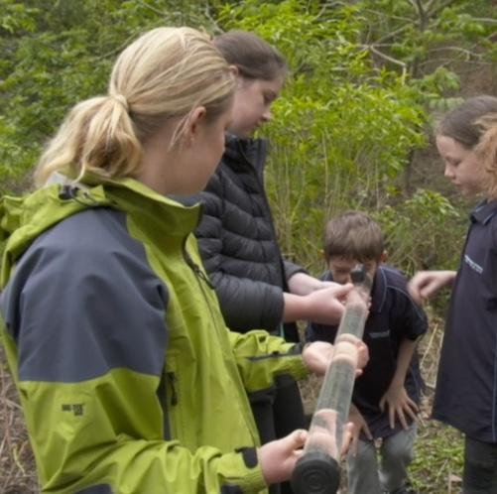

1. Place the clarity tube upstream from you into the main stream flow. If it is not safe to enter the stream, collect at least 2 litres of water in a bucket. Take care not to disturb the streambed.
2. Add the magnet to the inside of the tube and the matching magnet to the outside of the tube.
3. Fill the tube to the very top to keep air bubbles to a minimum and replace the cap.
4. Hold the tube horizontally. Have a second person hold the end of the tube. If there is a small bubble in the tube, make sure it is at the cap end rather than the viewer end.
5. Look through the viewing end, down the length of the tube towards the black cap.
6. A third person slowly slides the magnet away from the viewing end. Keep sliding until it is no longer visible.
7. Using the numbers on the outside of the tube, measure the distance from the viewing end of the tube to where the magnet has stopped. Record the number at the front end of the magnet as y1 on the recording sheet.
8. Slowly move the magnet back towards the viewing end until it just reappears. Record the distance as y2 on the recording sheet.

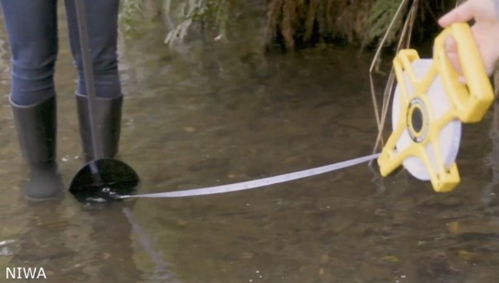

*Water clarity measurement using a periscope viewer*

1. One person holds the black disc just below the water's surface either upstream or across the stream from the viewer.
2. Attach the tape measure to the black disc. Pull the tape to the viewer and wait for any disturbed sediment to settle.
3. Place the periscope just below the water surface. Look into the viewer box, with the top snug against your face. Allow time for your eyes to adjust until you see the black disc.
4. Carefully walk downstream or across the stream until you can no longer see the black disc.
5. Measure the distance between the viewer box and the disc.
6. Record the number as y1 on the recording sheet.
7. Slowly walk towards the disc until it just reappears and measure this distance as y2.

The visual clarity is the average of these two distances – y1 and y2.

visual clarity = $\frac{y1 + y2}{2}$

Record the visual clarity measurement on the data recording sheet.

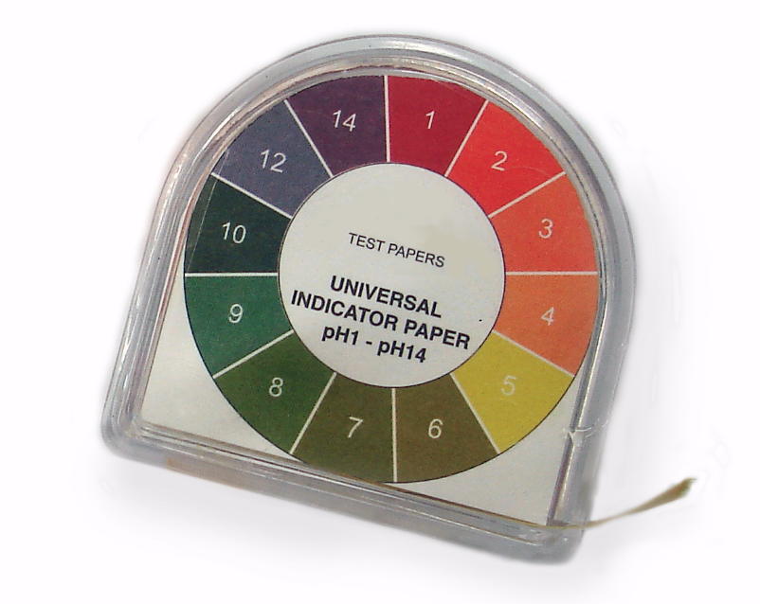

***Freshwater monitoring – pH***

Equipment:

* pH indicator kit
* Test tube with bung

1. Rinse the tube several times in the flowing water.
2. Fill the tube upstream from you.
3. Follow the directions on the pH indicator kit.
4. Record your result on the data recording sheet.

***Freshwater monitoring – temperature***

Equipment: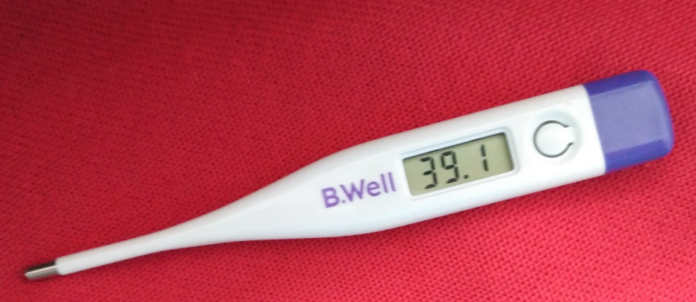

* Thermometer

1. Holding the thermometer at the top, place it in flowing water upstream from you.
2. Keep it in the water for at least 1 minute.
3. Either read the temperature immediately upon removal or read it underwater.
4. Record the result on the data recording sheet.

***Freshwater monitoring – conductivity***

Equipment:

* Conductivity meter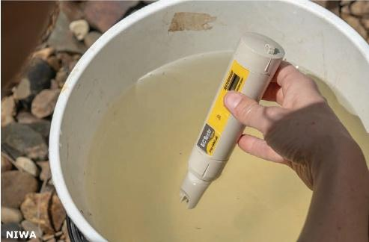
* Bucket

1. Rinse the bucket with stream water.
2. Fill the bucket with stream water to be tested.
3. Remove the cap from the bottom of the probe.
4. Switch it on and check that it reads 0 while held in the air.
5. Place the probe in the water sample. Ensure the water does not go above the grey line as this can damage the instrument.
6. Wait for a few seconds for the reading to stabilise.
7. Record the result on the data recording sheet.

***Freshwater monitoring – water flow – velocity***

Equipment:

* An orange (or similar item that floats and won’t harm the environment if it gets lost)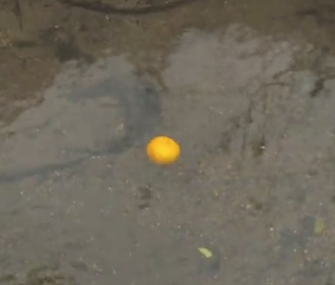
* Tape measure
* Net
* Stopwatch

1. Choose a section of the stream that is reasonably straight of similar width for at least 10 m and free from obstacles.
2. Use the tape measure to measure 10 m.
3. Two people stand as marker points at each end of the 10 m stretch.
4. A third person who will release the orange stands in the centre of the stream above the upstream marker point. This needs to be far enough so that the orange is floating with the water flow as it passes the starting point.
5. A fourth person stands at the starting point with a stopwatch to begin timing as the orange floats past.
6. Stop the watch at the 10 m mark downstream.
7. Catch the orange.
8. Record the result on the recording sheet.
9. Repeat this two more times, recording each result on the recording sheet.
10. Find the average float time: add the three times together and divide by 3. Record the average on the data recording sheet.
11. Water velocity is measured in metres per second.

Velocity = $\frac{distance (metres)}{time (seconds)}$

Velocity = $\frac{10 m}{average time}$

1. Record the velocity on the data recording sheet.

***Freshwater monitoring – macroinvertebrate (bug) sampling***

Equipment:

* Net
* Bucket
* Pipettes
* White sorting trays or tote trays
* Invertebrate (bug) boxes or white ice cube rays
* Magnifying glass
* Macroinvertebrate identification sheet

1. Place the net into the water flow so that anything disturbed or uncovered will flow into it. Make sure the seams of the net are on the outside so that organisms are not caught in them.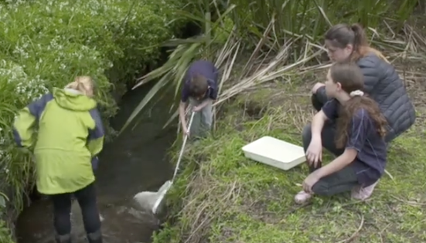
2. Use a variety of methods to dislodge invertebrates:

* Keeping your hands in the water, lift up and rub small rocks or sticks to dislodge invertebrates into the net.
* Gently kick the stones in streams with a stony substrate while holding the net downstream.
* Run the net along the sides of the stream under the vegetation in streams with soft or silty substrates.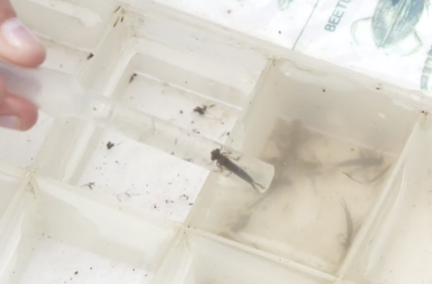

1. After a few minutes of hunting, turn the net into a bucket half-filled with stream water.
2. Decant (pour) the bucket contents into the sorting trays.
3. Wait a few minutes for the invertebrates to start moving.
4. Use the pipettes to gently take the invertebrates from the trays.
5. Sort them into the bug boxes.
6. Use the macroinvertebrate identification sheet to identify the creatures that you’ve found.
7. Also note the pollution tolerance index number – the coloured number – for each of the creatures.
8. Record this information on the data recording sheet.
9. Carefully return the invertebrates to the stream.

***Freshwater monitoring – macroinvertebrate identification sheet***

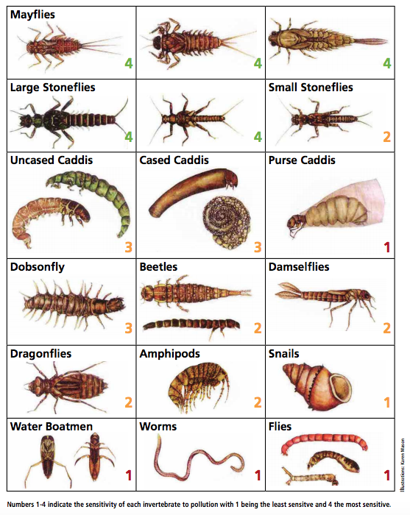

***Freshwater monitoring – Bug food and stick races***

Equipment

* Collection of sticks from the area – 30 cm x 1 cm in size if possible
* Tape measure

1. Select a safe section of the stream – ideally about 20 m or more in length.
2. Collect sticks of a suitable size – 30 cm x 1 cm.
3. Observe the availability of sticks and leaves near the stream – sources of organic matter.
4. Space yourselves at equal intervals across the stream forming a starting line.
5. Release the sticks and observe their progress. Watch how they move and what they get caught on.
6. The winner – from a bug’s perspective – would be the stick that gets trapped first!

***Freshwater monitoring – habitat assessment***

1. Use your observations skills and the data you’ve collected to complete the visual habitat assessment – SOSMART on the data recording sheet.
2. Do an observational drawing of the stream on the data recording sheet.

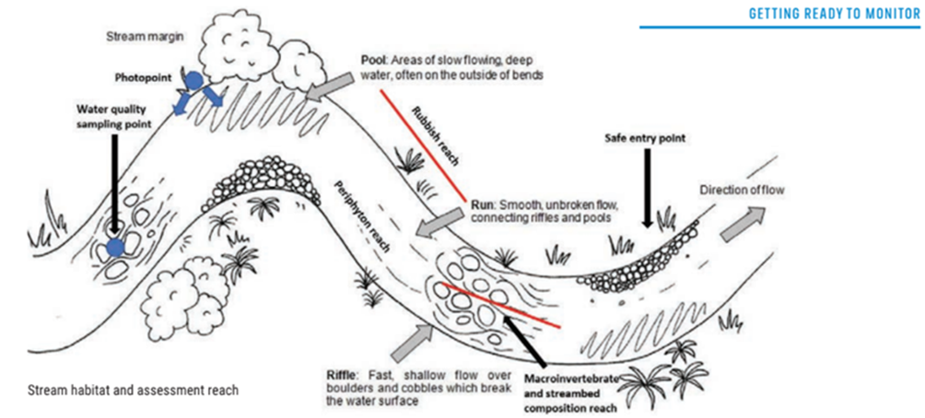

1. Use this information and your observations from the bug food and stick races to score the habitat assessment level 1 and level 2 factors on the data recording sheet.

***Stream health monitoring data recording sheet***

**Names __________________________________________________**

**Date _____________**

Use this to record the data you collect.

**Physical factors**

|  |  |
| --- | --- |
| **Physical factor** | **Measurement result** |
| **Clarity**  y1 = ______ y2 = ______  y1 + y2 ÷ 2 = _____ |  |
| **pH** |  |
| **Temperature** |  |
| **Conductivity** |  |

**Water flow – velocity**

|  |  |
| --- | --- |
| **Velocity measurement** | **Result** |
| **1.** |  |
| **2.** |  |
| **3.** |  |
| **Total** |  |
| **Average time (total ÷ 3)** |  |
| **Velocity (distance ÷ time)** |  |

**Invertebrate (bug) sampling**

Record the number of invertebrates found in the stream. Take note of the pollution tolerance number – 4 being the most sensitive and 1 being the least sensitive.

|  |  |  |
| --- | --- | --- |
|  |  |  |
| Number found: | Number found: | Number found: |
|  |  |  |
| Number found: | Number found: | Number found: |
|  |  |  |
| Number found: | Number found: | Number found: |
|  |  |  |
| Number found: | Number found: | Number found: |
|  |  |  |
| Number found: | Number found: | Number found: |
|  |  |  |
| Number found: | Number found: | Number found: |

**Visual habitat assessment – SOSMART**

Record your observations:

**S**mell (of the water)

**O**bstructions (restricting the water flow)

**S**treambed (anything covering the streambed)

**M**argin or bank (stability, erosion, vegetation)

**A**ppearance of the water (clarity, colour)

**R**ate of flow (fast or slow)

**T**op surface of the water (bubbles, algae)

**Visual habitat assessment – observational drawing of the stream**

Make an observational drawing of the stream. Include and label:

* the photopoint – this should be at the same location, direction and frame each visit
* water quality (i.e. clarity) sampling point
* a safe entry point, which may change
* riffles – fast, shallow water flows that break the water surface
* runs – smooth unbroken water flow
* macroinvertebrate sampling area
* stream bed composition area
* direction of the water flow.

|  |
| --- |
|  |

**Habitat assessment level 1 and 2 factors**

|  |  |  |  |  |  |  |
| --- | --- | --- | --- | --- | --- | --- |
| **Level 1 factors – in the stream** | | | | | | |
| **Habitat factors** | **Score** | | | | | |
| **Excellent**  **8/7** | **Good**  **6/5** | **Fair**  **4/3** | **Poor**  **2/1/0** | **Score** | |
| Cover in the stream | Lots of different types of cover, including snags and logs under the water, undercut banks, cobbles and rocks of different sizes. Lots of plants overhanging and in the stream. | Up to half of the stream has cover of snags, logs, cobbles or rocks. Some plants overhanging and in the stream. | Less than a third of the stream has cover from snags, logs, cobbles or rocks. Not a lot of plants overhanging and in the stream. | There is very little or no cover provided in the stream and no plants overhanging or in the stream. The stream may have been cleared or altered by humans. |  | |
| The flowing water | Stream has lots of different sized pools and riffles (water running over rocks, cobbles etc.) of different widths and depths. Stream has both bends and straight parts. | Good variety of riffles, pools, bends and straight runs in the stream. The riffles and pools are of different widths and depths. | A few riffles and pools with some differences in depth of the stream. | The stream has very little variety with not much differences in stream depth. |  | |
| The stream bottom | The gravel, cobbles and rocks on the bottom of the stream are up to 1⁄4 covered with fine sediments. | The gravel, cobbles and rocks on the bottom of the stream are between 1⁄4 and  1⁄2 covered with fine sediments. | The gravel, cobbles and rocks on the bottom of the stream are between 1⁄2 and 3⁄4 covered with fine sediments. | The gravel, cobbles and rocks on the bottom of the stream are more than 3⁄4 covered with fine sediments. |  | |
| **Level 2 factors – on the banks** | | | | | | |
| **Habitat factors** | **Score** | | | | | |
| **Excellent**  **4** | **Good**  **3** | **Fair**  **2** | **Poor**  **1** | **Score** | |
| **Left** | **Right** |
| Protection of the banks | More than 90% of the banks are covered with many different types of plants. | Between 70–90% of the banks are covered with different types of plants. | Between 50–70% of the banks are covered with only a few types of plants. | Less than 50% of the banks are covered with plants. |  |  |
| How stable the banks of the stream are | The stream bank is stable with little or no erosion seen. | Stream bank appears stable, some evidence of past erosion that may now have new plants growing. | Stream bank unstable and examples of erosion easily seen. | Unstable stream bank that may crumble when walked on. |  |  |
| Plants present on the stream banks | Many different types of plants grow in an area at least 20 m wide back from the stream. | Plants cover between 10–20 m back from the stream. Some signs of human disturbance. | Plants cover only 5–10 m back from the stream. Signs of a lot of human disturbance of the vegetation. | Plants cover less than 5 m back from the stream. |  |  |

|  |  |
| --- | --- |
| Add up the total scores for each of the factors. | Use the range below to assess the stream habitat rating of your site. |
|  |  |

**Our stream rating is _______________**