**Activity answers**

**Thinking about rubbish – answers**

|  |  |
| --- | --- |
| **Quickest to decompose** | **Time it takes to decompose** |
| paper | 2–5 months |
| cotton t-shirt | 6 months |
| orange peel | 6 months |
| tree leaves | 1 year |
| wool sock | 1–5 years |
| tin can | 50–100 years |
| aluminium can | 80–100 years |
| glass bottle | 1 million years |
| Styrofoam cup | 500 years – forever |

**Label the landfill diagram – answers**

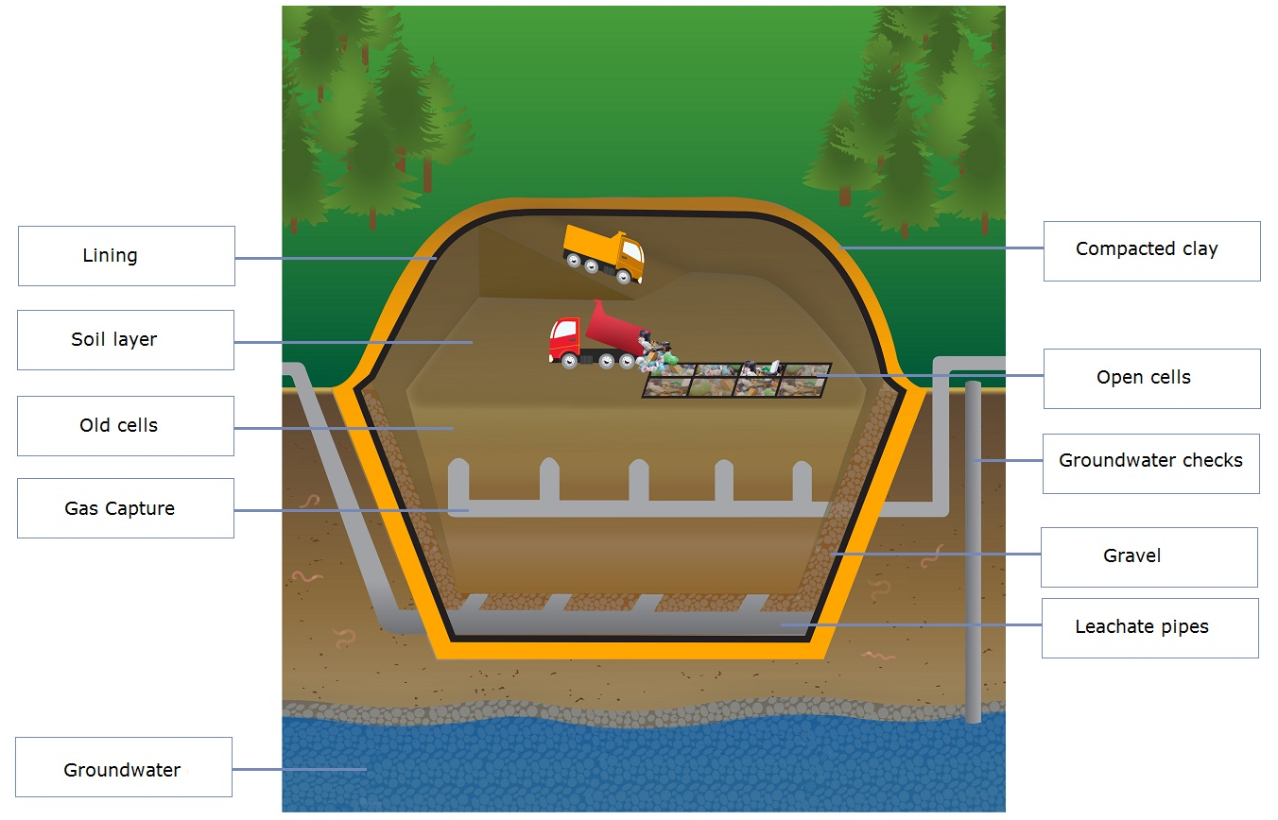

**Match the component to the description – answers**

|  |  |
| --- | --- |
| **Landfill component** | **Function description** |
| Lining | Heavy mats line the landfill walls and/or cells. |
| Open cells | Larger landfills have cells that are filled progressively. When a cell is full, a new cell is opened. |
| Soil layer | In large landfills, soil is used as a daily cover. |
| Old cells | When a cell is full, it is capped and work begins to restore the area. |
| Compacted clay | Clay forms a layer that won’t leak, much like a plastic liner. |
| Gravel | Pea-sized gravel is placed over the linings on the bottom and slopes of the landfill and/or each cell. |
| Leachate pipes | Plastic pipes collect leachate – liquid that filters through waste. Leachate is pumped out and treated. |
| Groundwater | Special systems drain the groundwater. |
| Groundwater checks | Groundwater around the landfill is regularly checked and tested to make sure the system is working. |
| Gas capture | Wells are dug into cells to release gases that form. |