**Thinking about landfills**

Modern landfill systems have changed a lot from the days of tips or dumps.

Many of Aotearoa’s landfills have special designs to:

* protect the surrounding environment
* allow for environmental monitoring
* catch methane gas for reuse
* catch and treat leachate (the liquid that leaks through the rubbish).

**Thinking about words**

There are lots of different places our rubbish can end up. Think about the words in the table below. Write or draw what you think these words mean and what happens to the rubbish we put there.

|  |  |  |  |  |
| --- | --- | --- | --- | --- |
| **landfill** | **tip** | **transfer station** | **recycling centre** | **roadside** |
|  |  |  |  |  |

**Thinking about rubbish**

Put these items into the order in which you think they will decompose (break down) if left outside and how long you think it will take. The first one is done for you.

|  |  |
| --- | --- |
| **Quickest to decompose** | **Time it takes to decompose** |
| paper | 2–5 months |
|  |  |
|  |  |
|  |  |
|  |  |
|  |  |
|  |  |
|  |  |
|  |  |
|  |  |

glass bottle tree leaves paper tin can aluminium can

wool sock orange peel cotton t-shirt Styrofoam cup

**Old ways of doing things**

Talk to someone in your family (your koro or nana, for example) about how they used to deal with their rubbish. Write down a few of their memories.

**Looking at the landfill diagram**

Look at the landfill diagram on the next page. Use the diagram to help you answer these questions.

1. Why do you think the diagram is drawn like this?
2. How does the diagram accurately (or inaccurately) portray a landfill?
3. What do you think are the advantages of using a diagram like this?
4. What do you think are the drawbacks of using this type of diagram?
5. Is the diagram drawn to scale? Does it matter?
6. What do you think is left out of the diagram?

**Label the landfill diagram**

Use the labels at the top of this diagram to identify the components of a landfill system.

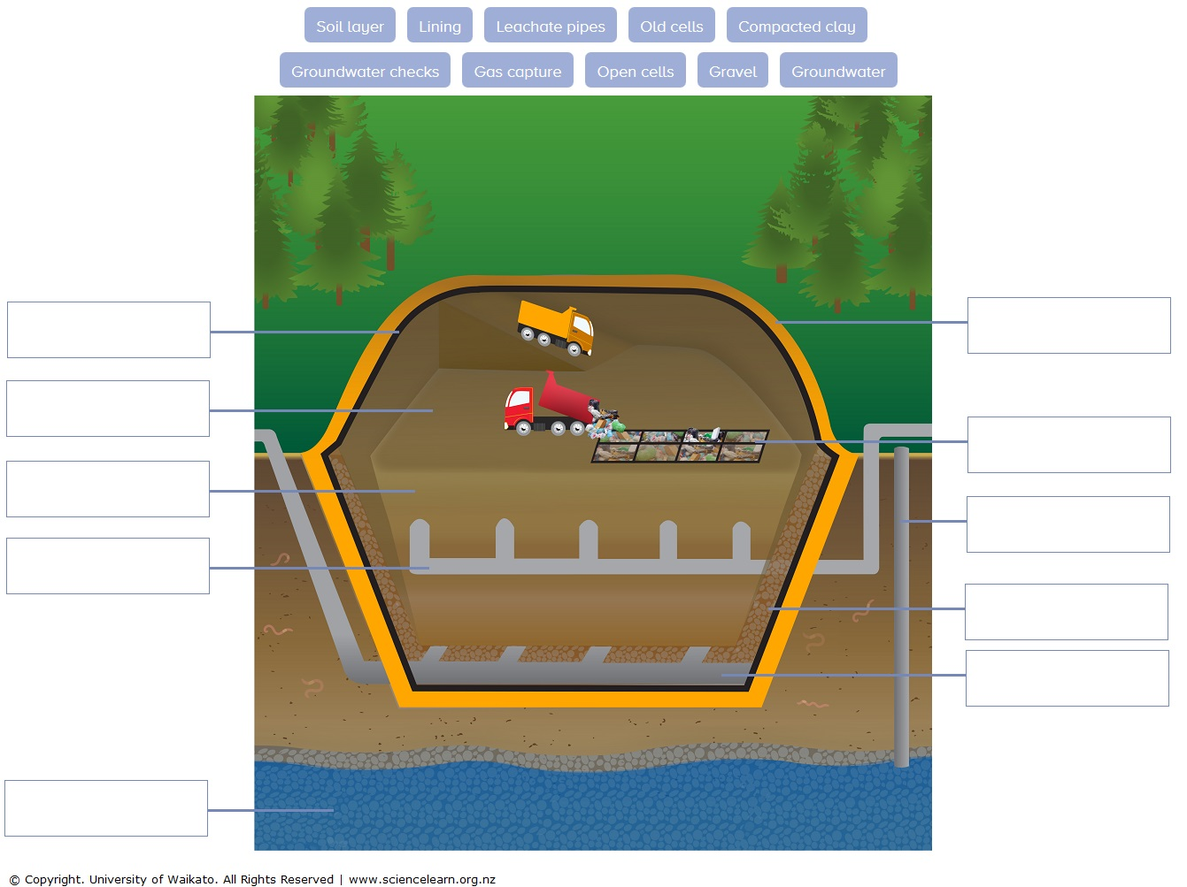

**Match the component to the description**

Draw arrows to show the connections.

|  |  |  |
| --- | --- | --- |
| **Landfill component** |  | **Function description** |
| Soil layer |  | Heavy mats line the landfill walls and/or cells. |
| Lining |  | Larger landfills have cells that are filled one after the other. When a cell is full, a new cell is opened. |
| Gravel |  | In large landfills, soil is used as a daily cover. |
| Gas capture |  | When a cell is full, it is capped and work begins to restore the area. |
| Leachate pipes |  | Clay forms a layer that won’t leak, much like a plastic liner. |
| Open cells |  | Pea-sized gravel is placed over the linings on the bottom and slopes of the landfill and/or each cell. |
| Old cells |  | Plastic pipes collect leachate – liquid that filters through waste. Leachate is pumped out and treated. |
| Groundwater |  | Special systems drain the groundwater. |
| Compacted clay |  | Groundwater around the landfill is regularly checked and tested to make sure the system is working. |
| Groundwater checks |  | Wells are dug into cells to release gases that form. |