**Looking at plants**

Our world is full of plants! Some are big, like kōwhai, and some are small, like the flower in the picture below. Big or small, most plants have the same parts:

flower leaf stem roots

Write the name of each part in the picture.

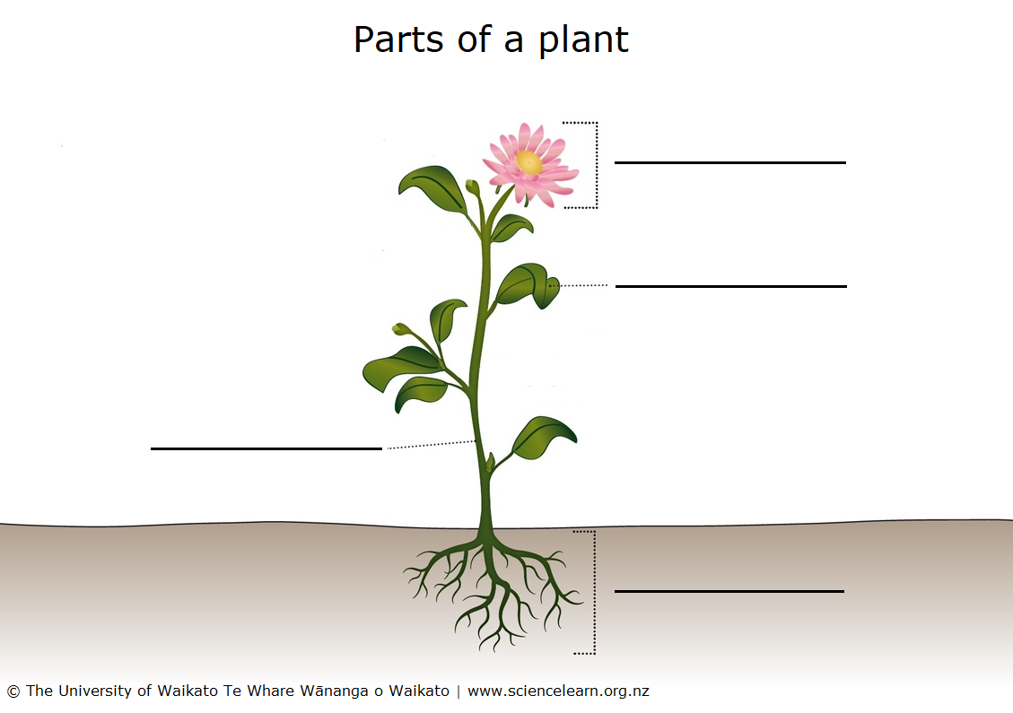

Draw a plant with **3** flowers, **10** leaves, a stem and roots.

|  |
| --- |
|  |

**Looking at leaves**

Plant leaves have three main jobs:

* They turn sunlight into food.
* They take in carbon dioxide and release oxygen during daytime.
* They release water that the plant does not need.

Leaves have lots of different shapes. We can describe their shapes with words we know.

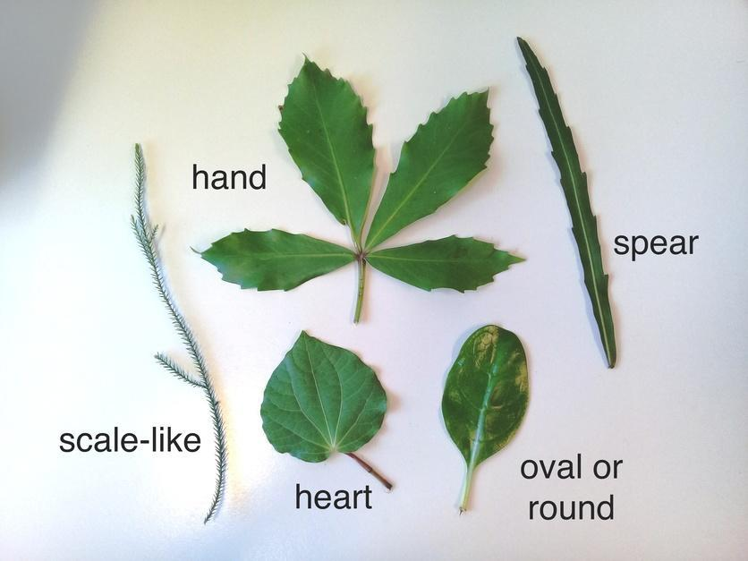

Go outside on a leaf hunt. (Ask an adult to help you pick the leaves. This keeps you and the plants safe.)

Bring the leaves indoors and put them into groups. Here are some ideas:

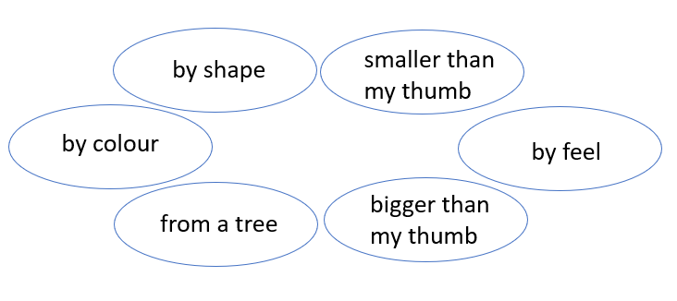

You can change the groups. Use a title to label each group. Take photos of your groups if you can.

**Measuring leaves**

1. Split your leaves into 2 equal groups.
2. Split your leaves into groups of 5 each. How many groups can you make?
3. Choose 10 leaves and put them in order from smallest to largest.
4. Use a ruler to measure lines of:

* 1 cm
* 5 cm
* 10 cm

See if you can find leaves the same length as each line.

**Leaf art**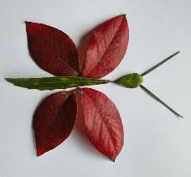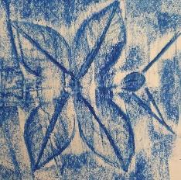

Use your leaf collection to make leaf art.

Make a leaf rubbing using crayons.

What else can you do with leaves?

**Plant word search**

|  |  |
| --- | --- |
| plant  leaf  stem  root  colour  size  shape  tree  flower |  |

**An investigation**

Leaves balance the water in a plant by opening and closing small holes on the underside of the leaves. The holes are called stomata. Opening the holes lets water evaporate. We can’t see this while it is happening, but we can observe what happens after 2 or 3 days. Look at the picture below:

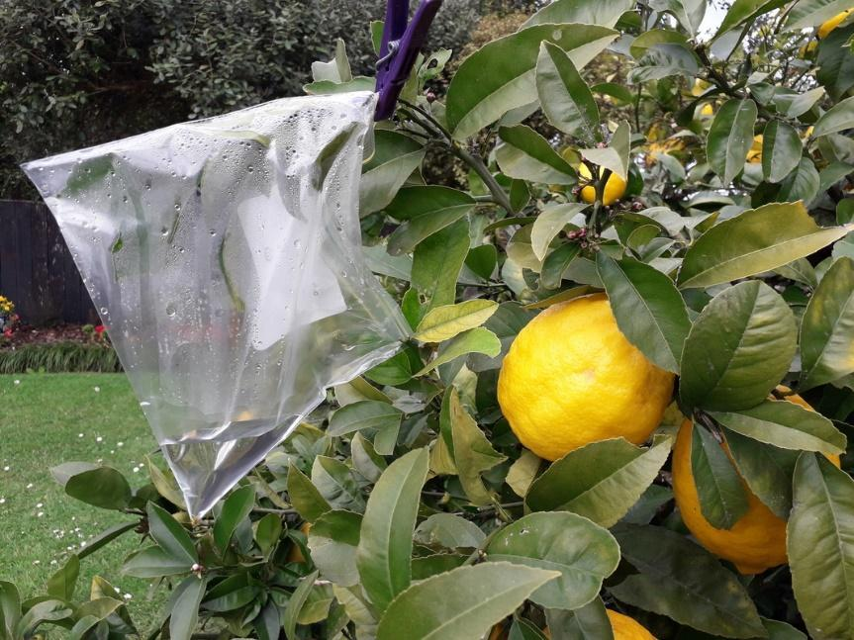

Can you see the water in the bag? This came from the leaves! You can try this too.

1. Find a plant that gets lots of sunshine.
2. Put a plastic bag around some of the leaves.
3. Use a peg to seal the bag.
4. Leave the bag for 2 or 3 days.
5. Watch to see what happens.
6. Draw pictures to show what happens.
7. Describe what you think is happening.

|  |  |
| --- | --- |
| **Day one – before** | **A few days later – after** |
|  |  |