**Looking at seeds and fruits**

A seed will produce a plant with the same type of flower, fruit and seeds.

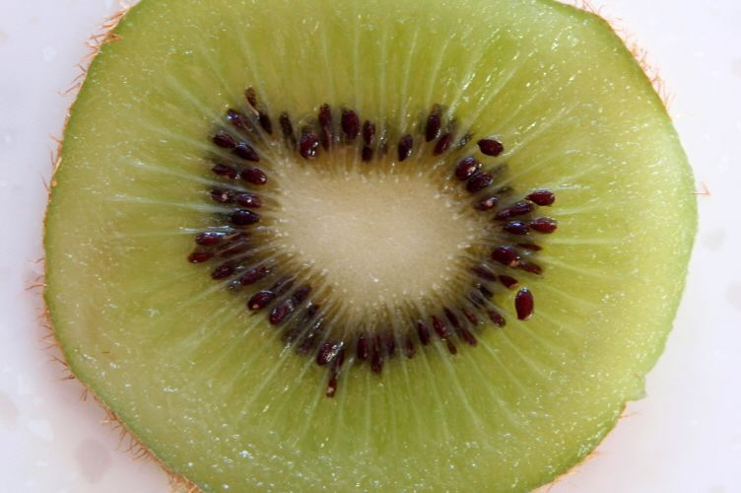

For example, a kiwifruit seed produces a kiwifruit vine, which produces kiwifruit blossoms that grow kiwifruit containing kiwifruit seeds.

**Matching and grouping**

Cut up the picture cards.

1. Match the fruit, vegetable or nut with the seed that is inside it.
2. Group the cards in different ways. For example:

* fruits
* vegetables
* nuts
* seeds I eat
* seeds I don’t eat

**Seed adventures**

Go outside and look for plants that are making seeds – like dandelions, flowers or grasses.

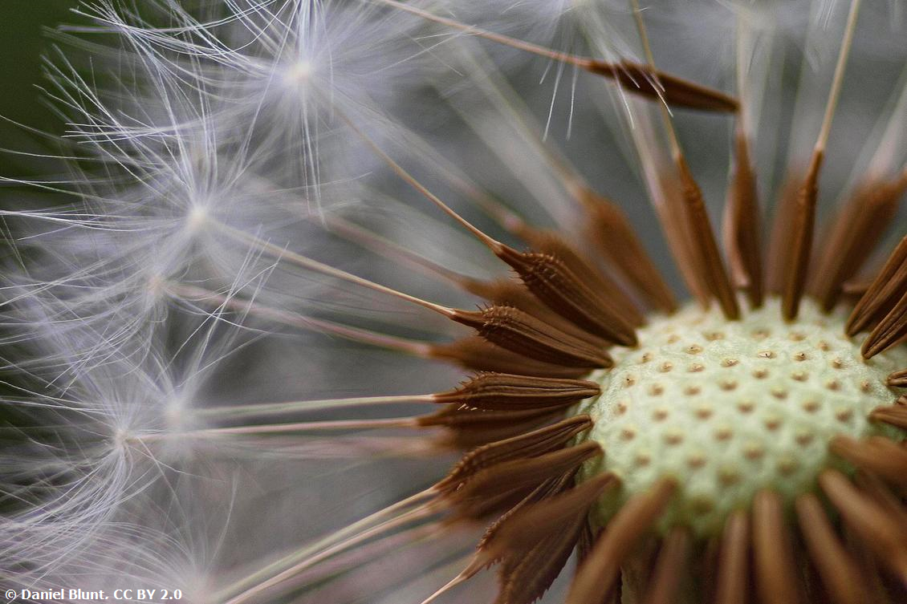

1. Make your own set of cards by gluing or taping the plant to a piece of paper and the seed to another. See if someone in your whānau can match the seeds with the plants.
2. Look at how the seeds move away from the plant to find a new place to live. See if you can find examples of seeds that:

* float with the wind – like dandelion or swan plant seeds
* are eaten by animals or humans – like fruit or seeds on native trees
* get stuck to animal fur or our clothes – like grass seeds.

1. Draw a cartoon or write a story about a seed that flies away, gets stuck on a dog’s fur or is in an apple in a lunch box.

* What adventures does the seed have while travelling?
* Does it grow into a new plant?

1. Bring one of the seeds inside. Draw a plant life cycle. Include drawings of:

* the seed
* the plant it grows into
* the flower the plant produces (you might need to guess this part)
* arrows that show the steps.

**Words, words and more words**

1. Find these words about seeds and fruits.

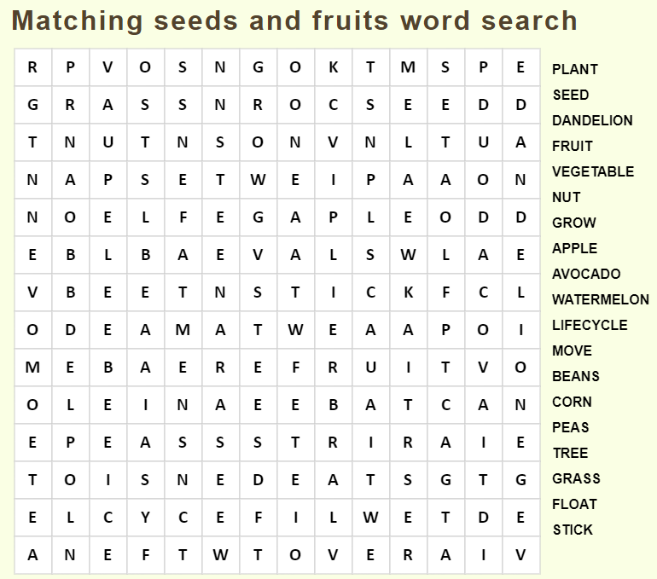

2. Use 5 of these words in the longest (or silliest) sentence you can write!

3. Write a word that rhymes.

|  |  |  |  |
| --- | --- | --- | --- |
| **Word** | **Rhyme** | **Word** | **Rhyme** |
| plant | can’t | bean |  |
| nut |  | tree |  |
| grow |  | seed |  |
| float |  | pea |  |

**Picture cards**

