**ACTIVITY: Interpreting representations using climate data**

**Activity idea**

In this activity, students observe and interpret graphs from the Ministry for the Environment and Stats NZ’s *Our atmosphere and climate 2020* report. The activity includes discussion questions to help students understand the ways in which the representations present information.

By the end of this activity, students should be able to:

* develop literacy and numeracy skills for interpreting information from graphs
* identify the components of a graph
* discuss the purpose of the graph.

# For teachers

## Introduction/background

Visual representations are useful for developing, clarifying and communicating scientific knowledge. They can be used to help with concept development, show relationships or make abstract ideas easier to conceive.

Each type of visual representation has literacy and numeracy components that students may need support to understand. The science capability ‘Interpret representations’ encourages students to think about how data is presented, what the representation tells us and how it gets the message across.

The Ministry for the Environment and Stats NZ’s *Our atmosphere and climate 2020* report uses a variety of graphs, maps and figures to present numerical data. These representations provide a lot of information in a concise format. The manner in which they are set out is designed to communicate information about the data and make an impact.

This activity uses questioning techniques to develop skills needed to interpret representations and to consider how the representation presents the message. The questions refer to the graphs in the student handout. However, they are transferable to most other visual representations.

## Questions to deepen student understanding

Use the following questions to support students to develop literacy and numeracy skills when viewing and interpreting graphs, charts and other visual representations.

1. What does the title say? (The title summarises the purpose of the graph/representation.)
2. What does the x-axis say? (The x-axis is the horizontal line that defines the base of the plot area. It represents labelled categories such as years, amounts or rates of change. The axis title identifies the units of measurement and may provide additional information that could be helpful with interpretation. Note: not all visual representations have an x-axis or y-axis.)
3. What does the y-axis say? (The y-axis is the vertical line that usually defines the left or right side of the plot area. The y-axis often has a numerical scale marked by intervals. The axis title identifies the units of measurement and may provide additional information that could be helpful with interpretation.)
4. What does the data say? (The data is the information presented in the graph/representation.)
5. Is there a source that says where the information comes from?
6. How can you find out if the source is reputable?
7. What does the legend say? (The legend is below the plot area. It provides information to further aid interpretation and understanding.)
8. How is colour used to present information?
9. What conclusions can you draw from the data?
10. How might the way the data is displayed influence your conclusions?
11. What has been (or might have been) left out of the graph/representation?
12. What other information might you need to understand the graph/representation? (For example, what defines a heatwave day?)
13. Where can you find the information that might fill in these gaps?

# For students

These graphs are from the Ministry for the Environment’s *Our atmosphere and climate 2020* report.

* What information do they present?
* How is the information presented?
* What are some of your interpretations?
* Do you have all of the information you need to understand them?
* If not, where might you be able to find it?

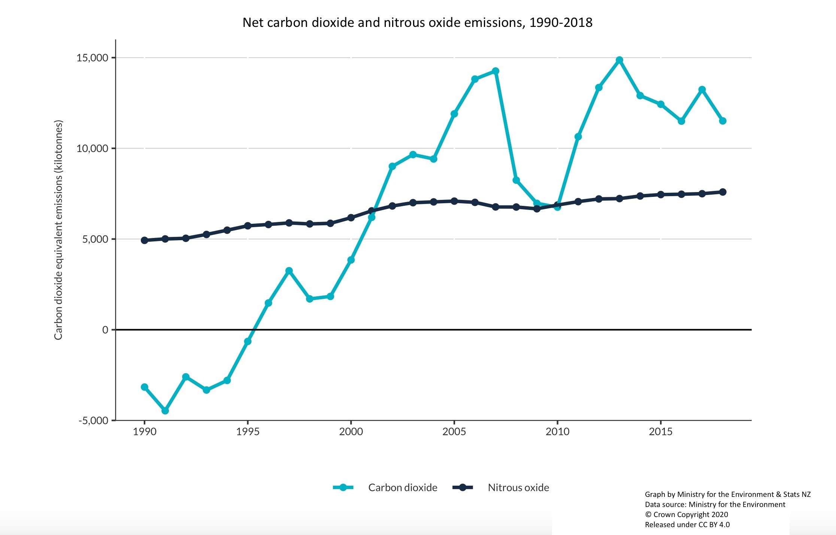

Before 1996, land use, land-use change, and forestry removed and stored more carbon dioxide than was emitted. (Land-use change is the conversion of land from one purpose to another.)

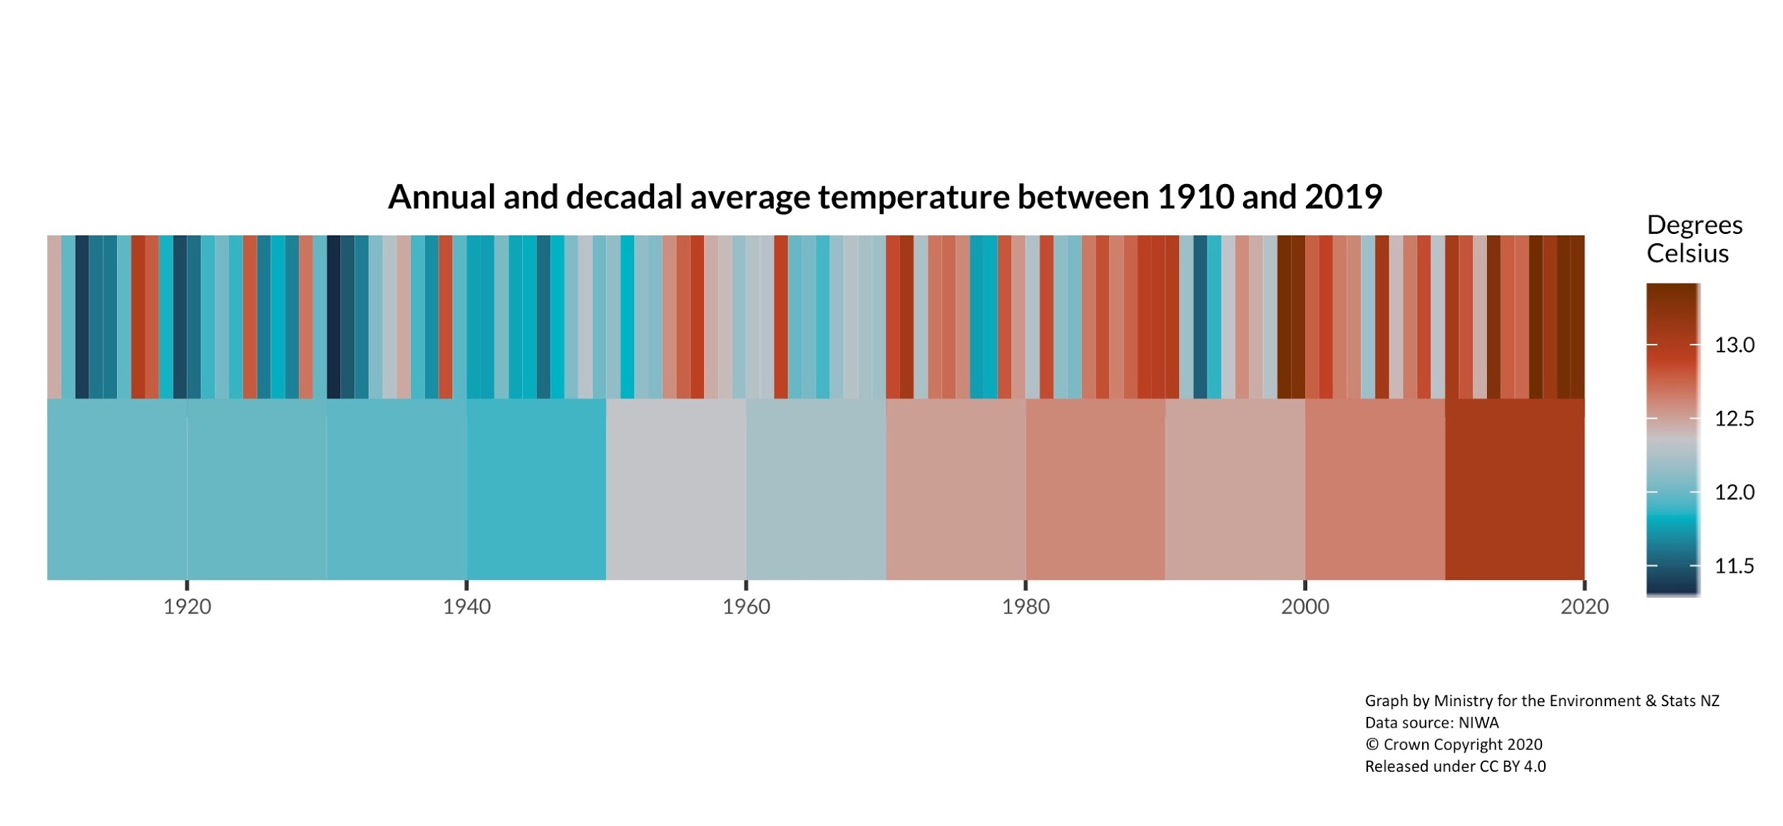

2010–19 was New Zealand’s warmest decade since 1909. Note: the stripes on the top row show the annual average temperature for a year. Stripes on the bottom row show the average temperature by decade.

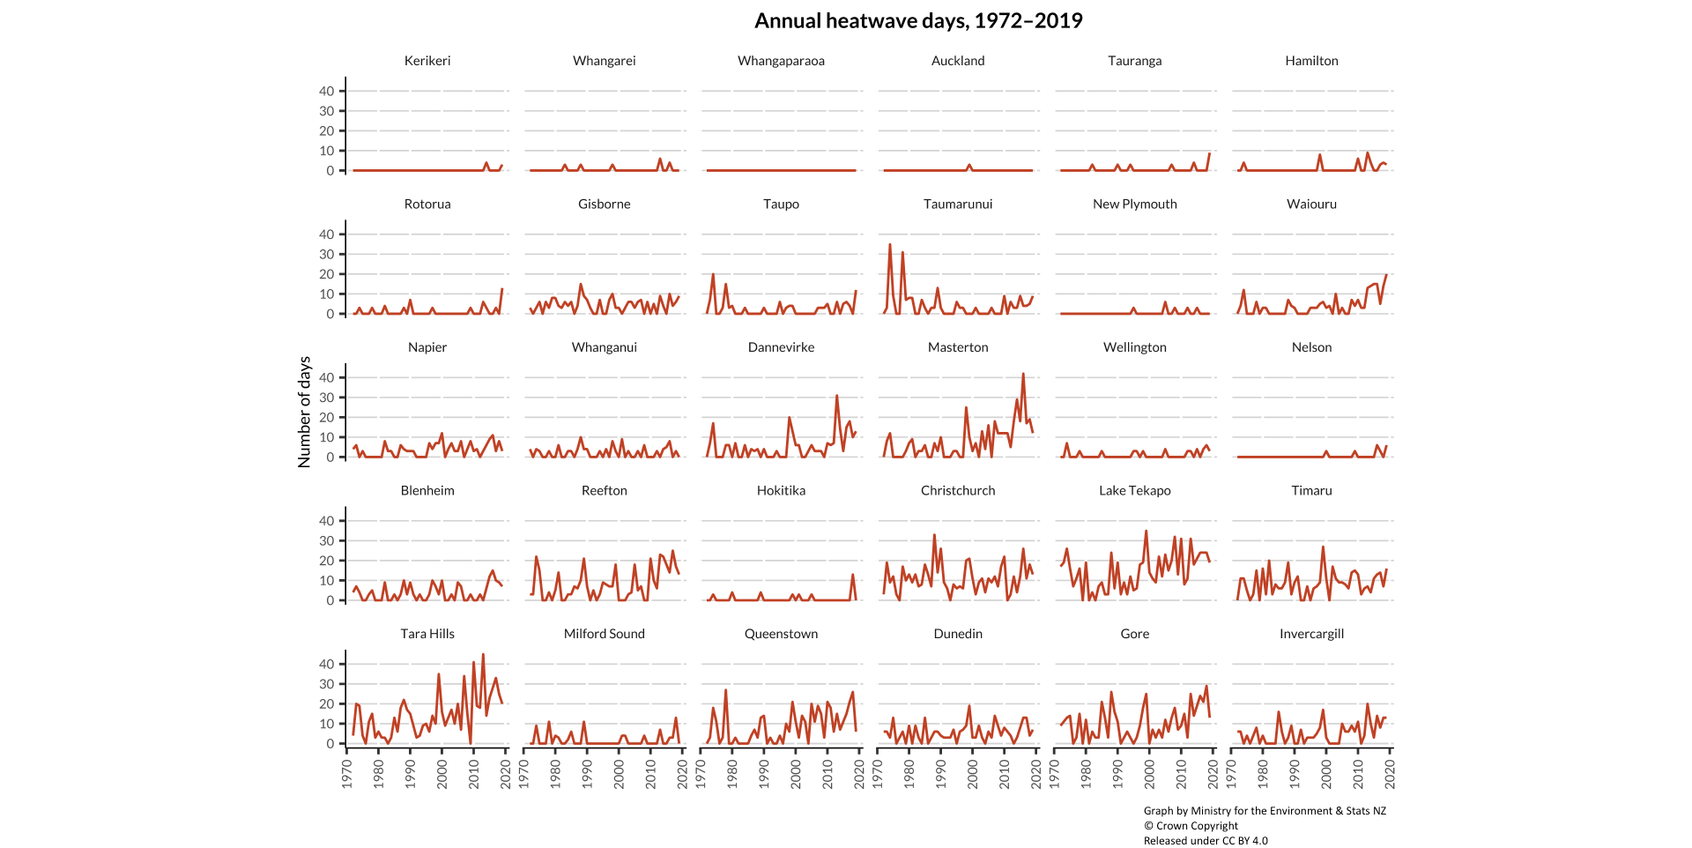

Heatwaves were more common at South Island sites for 1972–2019.