**ACTIVITY: Differences between weather and climate**

**Activity idea**

In this activity, students use an interactive or paper-based Venn diagram to illustrate similarities and differences between weather and climate. The Venn diagram can also be used as a starting point to investigate the factors that influence weather and climate.

By the end of this activity, students should be able to:

* describe the similarities and differences between weather and climate
* discuss some of the factors that influence weather and climate.

# For teachers

## Introduction/background

Although weather and climate are closely related, they are not the same thing. The chief difference between weather and climate is time.

The article [Weather and climate](https://www.sciencelearn.org.nz/resources/2966-weather-and-climate) explains both concepts as well as influences and variations due to natural and human factors.

## Teaching suggestions

Watch the video [Climate versus weather](https://www.sciencelearn.org.nz/videos/1994-climate-versus-weather). Use the video transcript to identify key terms students may need to know to understand the underlying concepts. Read the cards used in the Venn diagram to ensure students are familiar with the terms.

Ask students to complete the interactive or paper-based version of the Venn diagram. This can be used as a discussion starter or used for formative or summative assessment.

This table provides the Venn diagram answers.

|  |  |  |
| --- | --- | --- |
| **Weather** | **Weather and climate** | **Climate** |
| Day to day | Can vary | Year to year |
| 3 days | Can be local | 3 decades |
| Hot day | Can be regional | Hot summer |
| Changes quickly |  | Changes slowly |
| Wear a raincoat |  | Own a raincoat |

Use the discussion questions to deepen student thinking and understanding.

***Discussion questions***

1. What does the term weather mean?
2. What does the term climate mean?
3. How are weather and climate related?
4. When you see a short-term or long-term forecast in the media, is it referring to weather or climate?
5. How do we measure the weather?
6. How do we measure the climate?
7. How does the weather change?
8. How do the mountains and ranges affect the weather?
9. Is the weather/climate where you live the same as the weather/climate where your whānau or friends live? What are some similarities and differences?
10. How does climate change?
11. Do the changes to climate happen quickly or slowly?
12. What is responsible for changes to weather?
13. What is responsible for changes to climate?
14. How do changes in the weather affect us?
15. How do changes in the climate affect us?

***Extension questions***

1. What causes natural short-term variations to the climate?
2. What causes natural long-term changes to the climate?
3. How are humans causing long-term changes to the climate?
4. Do changes in the weather affect the climate?
5. Do changes in the climate affect the weather?

# For students

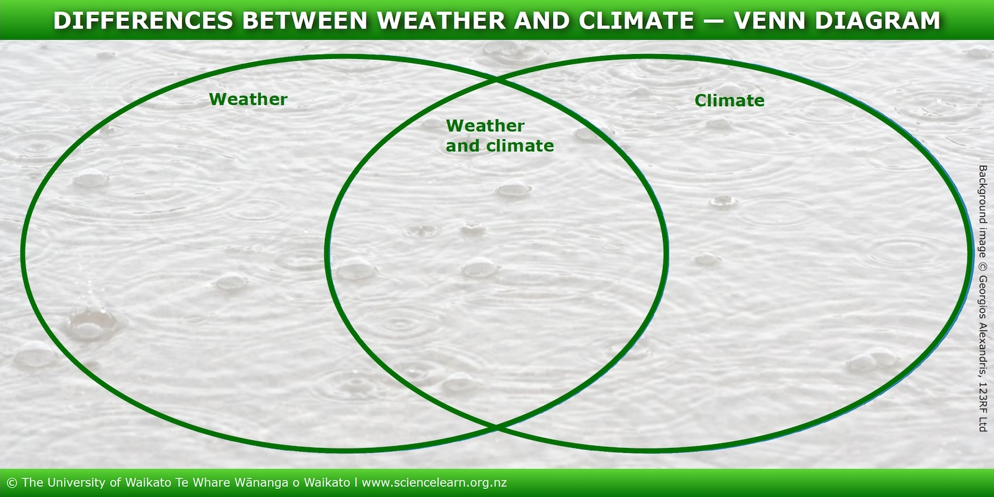

***Cards***

|  |  |
| --- | --- |
| Day to day | 3 days |
| Hot summer | Can be local |
| Own a raincoat | Wear a raincoat |
| Hot day | Changes slowly |
| 3 decades | Changes quickly |
| Can vary | Year to year |
| Can be regional |  |