ACTIVITY: Exploring with telescopes

Activity idea

In this activity, students learn about four different telescopes – radio, infrared, optical and ultraviolet – and how each uses different parts of the electromagnetic spectrum to view objects in space. Students then test their knowledge of telescopes with an online or paper-based quiz.

By the end of this activity, students should be able to:
- match the telescope with the part of the electromagnetic spectrum it is able to view
- discuss the benefits of using a particular telescope to view a particular type of space object
- choose a telescope that will help answer a question about a space object.

For teachers

Introduction/background

Much of the electromagnetic spectrum is invisible to our eyes. Telescopes detect different wavelengths of light from objects in space. Using telescopes to study the different wavelengths of light given off by objects in space allows astronomers to find out things such as what a space object is made of, how hot it is, how old it is, how it is changing and much more.

This activity uses two interactive resources to learn about types of telescopes and their uses in answering questions about various space objects – Space observatory and Which telescope?.

What you need

- Light and telescopes – article
- Detecting light in space – video
- The electromagnetic spectrum – interactive
- Space observatory – interactive
- Which telescope? – online quiz

Teaching suggestions

- Use Light and telescopes, Detecting light in space and The electromagnetic spectrum to introduce the topic or to refresh students’ background knowledge.

- Use the Space observatory interactive to learn about four different types of telescopes and how they work.

- Use this information to answer the questions posed in the online quiz Which telescope?. Alternatively, use the paper-based quiz in the student handout.

Extension suggestions

Some of the telescopic images in the quiz are composite images with false colouring. Composite images are created from a number of different images. For example: the supernova remnant Cassiopeia A was imaged using infrared data coloured red; visible data coloured yellow; and X-ray data in green and blue. The Serpens Constellation is a composite of images of different wavelengths in the infrared spectrum, with each of the 3 different wavelengths coloured blue, red or green. An example of a telescopic image from a single source is the optical telescopic image of Matariki.

Discuss why space agencies make composite images and/or why some images are all false colour – meaning they start out as black and white and are then coloured.
Quiz answers

- Radio telescope and optical telescope
- Infrared telescope and UV telescope
- The atmosphere blocks certain types of wavelengths
- Optical telescope
- UV telescope
- Infrared telescope
- Infrared telescope
- Radio telescope
- Optical telescope
- Radio waves

For students

The universe is full of amazing things, but we need help to see most of them. There are many types of light that our eyes cannot see, so we use instruments, such as telescopes, that can detect this hidden light. Find out how telescopes work and how scientists use them.

What to do

- Use Light and telescopes, Detecting light in space and The electromagnetic spectrum to learn about telescopes, light and electromagnetic waves.

- Use the Space observatory interactive to learn about specific types of telescopes and how they are used to view objects in space.

- Use the information from the Space observatory interactive to answer questions in the Which telescope? online quiz.

Which telescope? quiz

Test your knowledge of telescopes with this quiz. The Space observatory interactive has useful information about the telescopes featured in this quiz.

1 | Which telescopes are ground-based?  - Infrared telescope  - Radio telescope  - Optical telescope  - UV telescope
2 | Which telescopes are space-based?  - Infrared telescope  - Radio telescope  - Optical telescope  - UV telescope
3 | Why do some telescopes need to be in orbit rather than on Earth?  - The Sun is too bright  - They are cheaper to operate in space  - To prevent damage from the elements  - The atmosphere blocks certain types of wavelengths
4 | 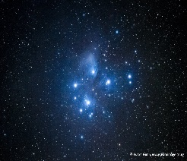  The Matariki star cluster (also called the Pleiades) only seems to have a few stars. Which telescope will give you a close-up view of visible light from these stars?  - Infrared telescope  - Radio telescope  - Optical telescope  - UV telescope
5 | 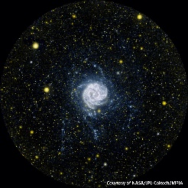  The distant Pinwheel Galaxy looks like a white disk in visible light. Are there other stars outside the disk? Which telescope do you need to show very hot, young stars that don’t give off much visible light?  - Infrared telescope  - Radio telescope  - Optical telescope  - UV telescope
6 | 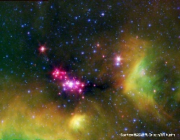  Are there any stars hidden behind the dense dust clouds in the constellation Serpens? Which telescope is best suited to seeing cool stars through dust clouds?  - Infrared telescope  - Radio telescope  - Optical telescope  - UV telescope
7 | 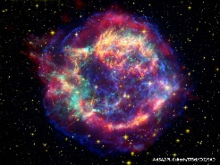  What does the shock wave from a supernova (exploding star) look like? Which telescope will you use to see heated dust giving off radiation with longer wavelengths than visible light?  - Infrared telescope  - Radio telescope  - Optical telescope  - UV telescope
8 | 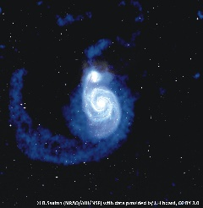  Are galaxies made only of stars, or do some contain material that does not give off visible light for heat? Which telescope will you use to detect very long wavelengths of radiation?  - Infrared telescope  - Radio telescope  - Optical telescope  - UV telescope
9 | 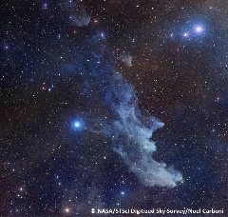  Why is one of the nebulae in Orion called the Witch Head? Which telescope will show you the shape of a dust cloud with visible light reflected off it?  - Infrared telescope  - Radio telescope  - Optical telescope  - UV telescope
10 | Which of the following waves are stars least likely to give off?  - Infrared waves  - Visible light waves  - Radio waves  - UV waves

