**ACTIVITY: Labelling the eye**

**Activity idea**

The human eye contains structures that allow it to perceive light, movement and colour differences. In this activity, students use online or paper resources to identify and label the main parts of the human eye.

By the end of this activity, students should be able to:

* identify the main parts of the human eye
* describe the functions of the different parts of the human eye.

# For teachers

## Introduction/background

The human eye contains structures that allow it to perceive light, movement and colour differences. Its delicate structures enable entering light energy to be converted to electrochemical energy. This stimulates the visual centres in the brain, giving us the sensation of seeing.

Use these resources to support your students’ learning about the human eye:

* [Sight](https://www.sciencelearn.org.nz/resources/1887-sight) – article
* [How the eye focuses light](https://www.sciencelearn.org.nz/resources/50-how-the-eye-focuses-light) – article
* [How the eye works](https://www.sciencelearn.org.nz/videos/11-how-the-eye-works) – video
* [The eye’s lens system](https://www.sciencelearn.org.nz/videos/13-the-eye-s-lens-system) – video
* [Label the eye](https://www.sciencelearn.org.nz/labelling_interactives/12-labelling-the-eye) – interactive

The [Label the eye](https://www.sciencelearn.org.nz/labelling_interactives/12-labelling-the-eye) interactive can also be used as a formative or summative tool for learning.

# For students

Use the labels at the top of the Label the eye diagram to identify the main parts of the human eye.

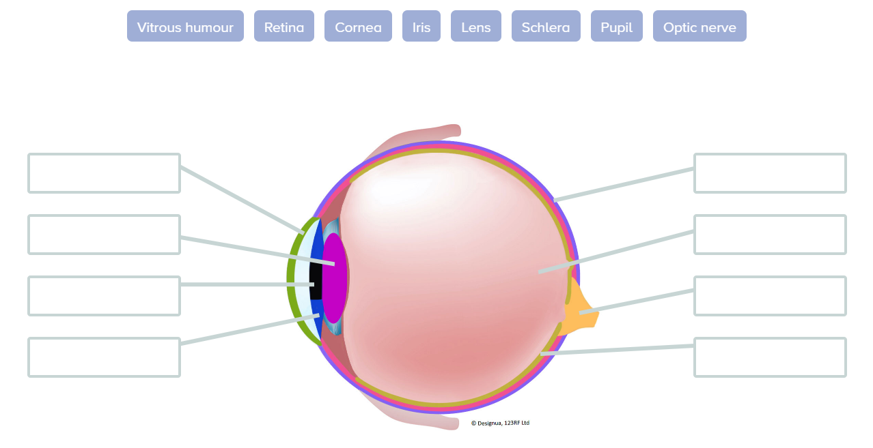

Use arrows to match the parts of the eye to the corresponding eye function description.

|  |  |
| --- | --- |
| **Component** | **Function description** |
| Vitreous humour | This fluid helps the eye hold its ‘spherical’ shape. The pressure of the vitreous humour helps to keep the retina in place. |
| Cornea | Lining inside the back of the eye that contains light-sensitive receptors. These rods and cones are where images are formed from the light rays entering the eye and convert them into electrical impulses. |
| Pupil | Clear capsule found behind the iris that bends the light rays entering the eye, forming a clear image on the retina. The fibres that hold the lens in place can change the lens shape. This is how eyes can focus on objects at different distances. |
| Lens | The coloured part of the eye with the pupil at the centre. It is a muscle that can adjust the pupil size so light can enter, forming a retinal image. |
| Iris | The outer layer of the eyeball is made of tough interwoven fibres. Muscles attach to it, allowing eye movement. |
| Retina | Thin clear mucous membrane that covers the front and inner surface of the upper and lower eyelids and makes eye movement and blinking easier. |
| Sclera | Nerve fibres that connect the retina and the brain. The optic nerve sends electrical impulses from the retina to the brain’s visual cortex. The image the brain receives is upside down, and the brain turns it up the right way. |
| Optic nerve | Dark space in the middle of the iris that enlarges and constricts depending on the brightness of light. |

**Activity answers**

