ACTIVITY: Measuring pasture mass

Activity idea

In this activity, students explore a few of the ways in which scientists and farmers measure pasture mass – the fresh weight in the paddock and the dry matter it produces.

By the end of this activity, students should be able to:
- use some of the terminology associated with measuring pasture mass
- talk about why farm managers and/or scientists measure pasture mass
- use a quadrat cut to observe fresh pasture
- use a microwave to convert a fresh sample to dry matter
- use simple formulas to determine pasture mass – kgDM/ha for a local pasture or school field sample.

For teachers

Introduction/background

Pasture mass is the amount of pasture per hectare and is usually measured in kilograms of dry matter per hectare (kgDM/ha). Dry matter is the plant material left behind when the water in it is removed. Dry matter per hectare is a unit for measuring pasture production.

Farmers use a variety of methods to estimate pasture mass, from visual observation and assessment during a farm walk to more-sophisticated devices using apps and Bluetooth connectivity to the use of satellite imagery.

Those who manage research farms will use similar techniques for pasture and animal management, but scientists conducting on-farm research require high levels of accuracy, so their measurement protocols are different.

This activity uses a student handout to highlight methods of pasture measurement and a quadrat cut protocol to determine kgDM/ha for a local pasture or school field.

Ideally, this activity follows on from Observing pasture composition, which uses the Common pasture plant species interactive and a simple quadrat to become familiar with what’s growing in a pasture.

What you need

- 50 cm x 50 cm quadrat
- Sturdy scissors or shears
- Ice cream containers for holding and/or sorting plant matter
- Digital scale
- Paper plate for drying plant matter
- Ceramic cup (with water)
- Microwave oven (find out any protocols around using the microwave for non-food purposes)

What to do

- Use the following resources to provide background information:
- Pasture plants (and the media within the article)
- Dairy research methodologies
- Dairy farming – key terms

- Use the student handout to learn about methods for measuring pasture mass.

- Use the quadrat cut protocol to collect plant material.

- Follow the instructions to measure the fresh weight and dry the vegetation.

- Use the formulas to determine %dry matter and kgDM/ha.

- Use these questions to deepen student understanding:
- Why do farmers and farm managers need to calculate kgDM/ha?
- Why do experienced farmers and farm managers need to use tools to calibrate or validate their ‘eyeball technique’?
- What are the benefits and disadvantages of the measuring tools mentioned in this activity information?
- Why do scientists conducting on-farm feed research require more-precise methods of pasture management?
- Why is it important to use several quadrat cuts across a pasture rather than using a single sample?
- What differences might there be between quadrat cuts taken from a pasture and the school sports field? What causes these differences?
- How does pasture mass change throughout the year?
- Why is this knowledge important to farmers, managers and scientists?

Extension ideas

If pasture is readily available, consider monthly or seasonal monitoring to observe how pasture mass changes throughout the year. Keep records to aid discussions about conditions that affect pasture production.

For students

Knowing what plants are growing in a pasture – and the quantity of growth – is important to farmers and scientists. Farmers need to know how quickly pasture is growing and how much forage is available for grazing. This enables farmers to make informed pasture management decisions.

Scientists conducting on-farm trials also need this information but often at more-precise levels of detail. This handout looks at some of the techniques and equipment used in measuring pasture mass – the fresh weight in the paddock and the dry weight after it is cut.

Measuring pasture

There are several tools available for measuring pasture. The cheapest and simplest is a sward stick, which resembles a ruler that is calibrated to provide estimates of pasture growth for each season. The sward stick is useful on hilly pastures.

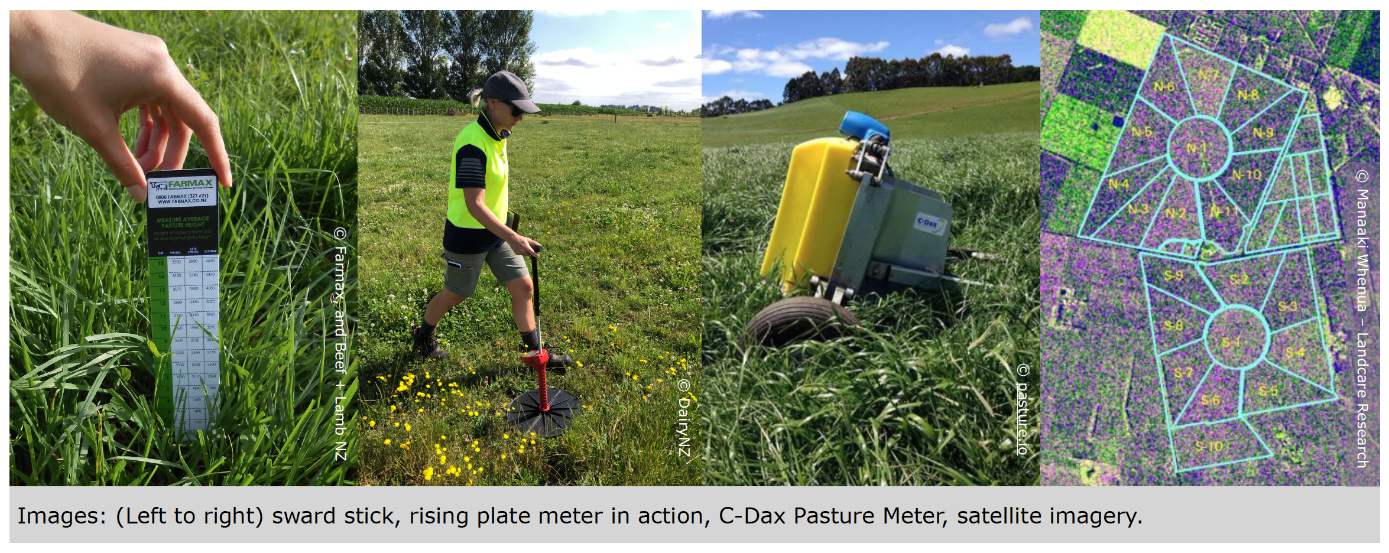

The rising plate meter measures the compressed height of pasture in 0.5 cm increments. The user walks across a paddock and uses an up and down motion to place the plate on the pasture. For best results, the sward stick and rising plate meter require multiple samples taken randomly across each paddock.

The C-Dax Pasture Meter is a tow-along device. It uses infrared light sensing to make multiple measurements per second, which are then averaged out across the paddock.

Satellites are another way to monitor pasture growth. When a satellite is able to capture a clear image of the farm, it is analysed and uses colour variations to show pasture cover.

Each of the measuring tools provides data that needs to be assessed. Fresh pasture measurements are usually converted to kilograms of dry matter per hectare (KgDM/ha). Dry matter is the plant material left behind when the water in it is removed.

A dairy cow at the peak of her production consumes around 18 kg of dry matter (around 100 kg of fresh pasture weight) per day. A ewe with a single lamb consumes 2–3 kg of dry matter per day.

Very precise pasture measurements

When scientists require more-precise pasture measurements, they use quadrat cuts. A quadrat is a square of a set size placed on top of the pasture. A scientist will use multiple quadrats across the paddock to get a representative selection of what plants are growing and the quantity of plant matter.

The vegetation in small quadrats is cut using pasture shears, while larger quadrats are cut with an electric mower/harvester. The vegetation is collected, separated and measured by hand and dried in an oven. It is a slow process to measure individual paddocks, so this is usually done by the science sector rather than by farmers.

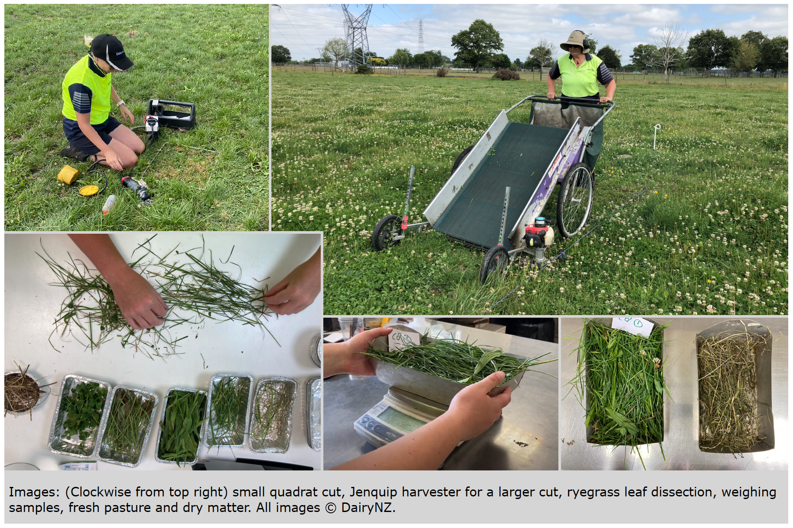

Making similar scientific measurements at school

You can use a quadrat cut to measure pasture mass. If pasture is not available, you can use a grassy field at the school. The procedure is the same but the results may be quite different. Pastures are planted with high-growth plant cultivars and are left to grow between grazing events. School fields are regularly mowed, so they are likely to have less biomass.

What you need

- 50 cm x 50 cm quadrat
- Sturdy scissors or shears
- Ice cream containers for holding and/or sorting plant matter
- Digital scale
- Paper plates for drying plant matter
- Ceramic cup (with water)
- Microwave oven (find out any protocols around using the microwave for non-food purposes)

What to do

- Toss the quadrat onto the pasture/field to establish a random location.

- Use the scissors or shears to cut the vegetation as close to the ground as possible.

- Place the vegetation into an ice cream container and take it inside.

- Remove and discard any dead material or soil from the vegetation.

- Weigh the fresh vegetation and record the weight.

- Measure out a 200 g representative subsample of the vegetation. (If the sample is less than 200 g, use the entire sample.)

- Spread out the subsample on a paper plate.

- Put the sample into a microwave oven along with the cup of water. (This helps to protect the microwave.)

- Microwave on high for 5 minutes. Remove the sample and weigh it. (If the sample is less than 200 g, heat for a shorter time, for example, 2 or 3 minutes.)

- Continue microwaving the sample at 1-minute intervals until there is no change in weight.

- Record the dry weight.

- Determine the percent dry matter (%DM) by dividing the dry weight by its fresh weight.

Dry weight (g) ÷ fresh weight (g) = decimal/percentage

For example: 32 g ÷ 200 g = 0.16 or 16%

- Use this information to determine the pasture mass: kilograms of dry matter per hectare (kg/DM/ha). (Note: 40 is used as the multiplier because a 50 cm x 50 cm quadrat is 0.25 m² and 0.25 m² x 40,000 = 1 ha.)

Fresh weight (g) x dry matter percentage (decimal form) x 40 = kgDM/ha

For example: 320 g x 0.16 x 40 = 2,048 kgDM/ha

- Record the pasture mass – kg/DM/ha.

If other people have made a quadrat cut, compare the results.

