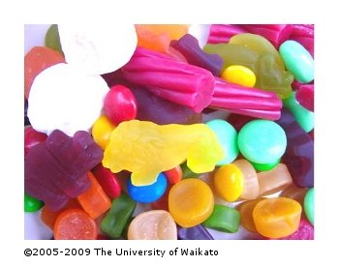
Modelling DNA
In this activity, students use lollies to construct a DNA model in order to model a point mutation.
DNA molecules are hard to visualise. You can make a DNA model out of lollies, toothpicks and florist wire.

What you will need
- lollies (as supplied by your teacher)
- toothpicks
- florist wire

Instructions
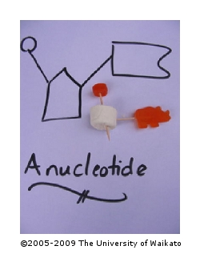
- Decide in your group which lollies will be the bases (remember there are four sorts of these), the phosphate groups and the sugar.
- Use the toothpicks and florist wire as bonds to hold parts together, just like in the real DNA molecule. A DNA molecule has two strands – how will you join the strands?
- The base sequence for your DNA molecule will be:
ATGATTACAAG
TACTAATGTTC
- Can you twist your molecule into the double helix shape?
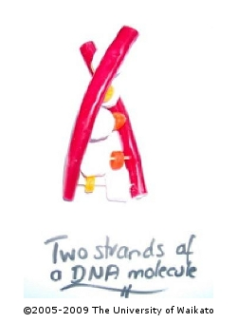
- A mutation is a change in the DNA sequence. Make just a little mutation in your model – this is a point mutation where only one base has been changed. Find the mutation in the sequence below then make this molecule.
ATGAATACAAG
TACTAATGTTC
- When you have made your model of a DNA molecule, sketch it into your books or use your phone or tablet to photograph it.

