ACTIVITY: Investigating movement and sound with a pūrerehua

Activity idea

In this activity, students create pūrerehua to investigate the relationship between movement and sound.

By the end of this activity, students should be able to:
- experiment with movement and sound
- begin to discuss the relationship between movement and sound
- design and create a model of a pūrerehua
- use the pūrerehua to create sound
- discuss differences in the sounds created by pūrerehua made of different materials
- retell some of the cultural aspects of pūrerehua.

For teachers

Sound is a form of energy. For sounds to be produced, something needs to move. For example, when we clap our hands, the movement of our hands striking each other creates vibrations. The vibrations travel through the air, cause the air particles to bump into each other and carry the sound in all directions. If we are close enough, our ears act as receivers to pick up the sounds.

The pūrerehua is a traditional Māori musical instrument. It gets its name from the sound made by the wings of the pūriri moth. Traditionally, a pūrerehua is made from bone, wood or stone and it is shaped like a blade. The sound it creates can travel for long distances. Some iwi used pūrerehua to call for rain. Others used them to communicate with people around them or in the heavens. Still others used them to farewell people who had died. When someone swings a pūrerehua, the pūrerehua twists and rotates as it moves through the air, causing vibrations. The pitch changes depending on how fast the pūrerehua is swung. Swinging it slowly produces a lower pitch and swinging it rapidly produces a higher pitch.

In this activity, students are encouraged to work with a variety of materials to create models of pūrerehua. The goal is to hear and compare the differences in sound made by the different instruments.

Note: Pūrerehua models become projectiles if they break free. Careful attention must be paid to knots at both ends of the string. Secure the string to the pūrerehua with a few overhand knots. Make and knot a loop at the other end of the string for users to slip around their wrists. Educators can carefully demonstrate their pūrerehua indoors, but students should work with theirs outdoors and at a distance from each other.

What you need

- 30 cm ruler with a hole at one end
- String
- Cardboard
- Ice cream containers/lids
- Harakeke (flax) leaves and stems
- Scissors
- Glue
- Craft knife
- Hammer and large nail

Teaching suggestions

Check students’ prior knowledge/experiences with pūrerehua. Look at images of pūrerehua – this one is from Te Papa. Discuss the cultural aspects of the pūrerehua and its traditional uses.

Discuss the relationship between movement and sound, then demonstrate it by using a ruler. Attach a piece of string to the hole of the 30 cm ruler. Spin the ruler on the string then swing the ruler, listening to the sound it makes while twirling in the air. Encourage students to observe how the ruler spins as the string rotates.

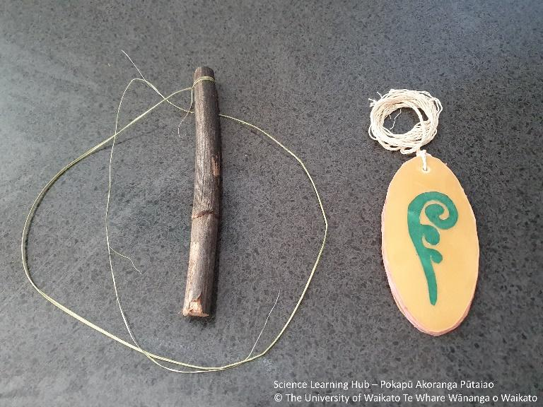
Use the various materials to create pūrerehua. For example, the pūrerehua in the image are made from a harakeke stem and leaf fibres and plastic from an ice cream container. If you use harakeke, check with local protocols when harvesting harakeke.

Students can create their own designs using oval shapes. Cut out 3–4 layers and glue them together. When dry, carefully use a craft knife to cut notches in the sides of the pūrerehua to create grips for the string. Alternatively, use a large nail to create a hole. Attach the string, using secure knots. Make a loop at the end of the string for the user to hold.

Students can decorate their model pūrerehua with kōwhaiwhai patterns, koru or other motifs.

Experiment with the pūrerehua. Listen for differences in sounds between the various models. Each model will create sound, but pūrerehua made from plastic appear to be most effective in creating the deep whirring sound most often associated with pūrerehua. Get the pūrerehua to spin on the string first before swinging it.

Experiment with the speed of twirling the pūrerehua, and listen for differences in sound. Investigate the effect of the length of the string or whether you spin the pūrerehua before swinging it, and listen for differences in sound.

