ACTIVITY: Hiding in plain sight – native freshwater fish

Activity idea

In this activity, students explore some of the adaptations fish use for camouflage.

By the end of this activity, students should be able to:
- describe why fish use camouflage
- explain some fish camouflage adaptations.

Introduction/background notes
What you need
What to do
Student handout: Hiding in the water
Fish template

Introduction/background

Introduce the idea of fish camouflage by creating simple fish shapes and hiding them on newspaper.

Students then read about different adaptations fish have for camouflage and discuss these before hiding their own fish.

What you need

- Newspaper with lots of text
- Different coloured paper
- Student handout: Hiding in the water
- Fish template (optional)
- Clear plastic sheets for making transparent fish (optional)
- Simple map of the classroom

What to do

  - Before the lesson, cut out 12 fish – 3 fish from each coloured paper and 3 fish from one sheet of newspaper – and glue them to a second piece of newspaper, hiding the newsprint fish as well as possible. Tape the newspaper to the wall where it will be easily viewed by all students and cover the newspaper before the students enter the room.

  - Tell the students that their job is to count as many fish as they can in 20 seconds.
Uncover the paper and start timing. After 20 seconds, cover the paper again.
  - Ask the students how many fish they found and what they looked like – did any of them find the newspaper fish?

  - Move the newspaper to a window and hold it up to the light. Begin a discussion on which fish will be the last ones eaten and why.

  - Look at the student handout Hiding in the water.

  - Talk about fish camouflage, and discuss how some of the fish that students are familiar with show some of these listed adaptations. Additional information about freshwater fish and their habitats is presented in this interactive.

  - Ask students to work in groups and create a fish that will be placed in plain view in the classroom but designed to be camouflaged. They need to decide on a good location for their fish, and it should be a minimum size of 150 mm x 50 mm. (Students could use the Fish template for this.)

  - Tell each group when they can hide your fish without other students seeing. Remind them it must be in plain sight and cannot be hidden.

  - When all fish are hidden, allow 2–3 minutes for the fish hunt. Have students mark on a map of the classroom where each fish is placed. The team who has the best-hidden fish (fewest times seen) wins a prize.

  - Discuss the fish adaptations for hiding in the classroom with the class.
Student handout: Hiding in the water

Unlike living in the jungle where trees can provide shelter, animals in the water need to be able to hide from predators – or their prey – without the aid of objects. Having a body form that blends in with its surroundings is definitely beneficial if you want to avoid being eaten.

Some of the approaches for hiding in the water are described below:

Small size
Tuna/eels are small for a long period of time while they are young, allowing the elvers (young eels) to hide away among rocks and hollows to avoid predation.

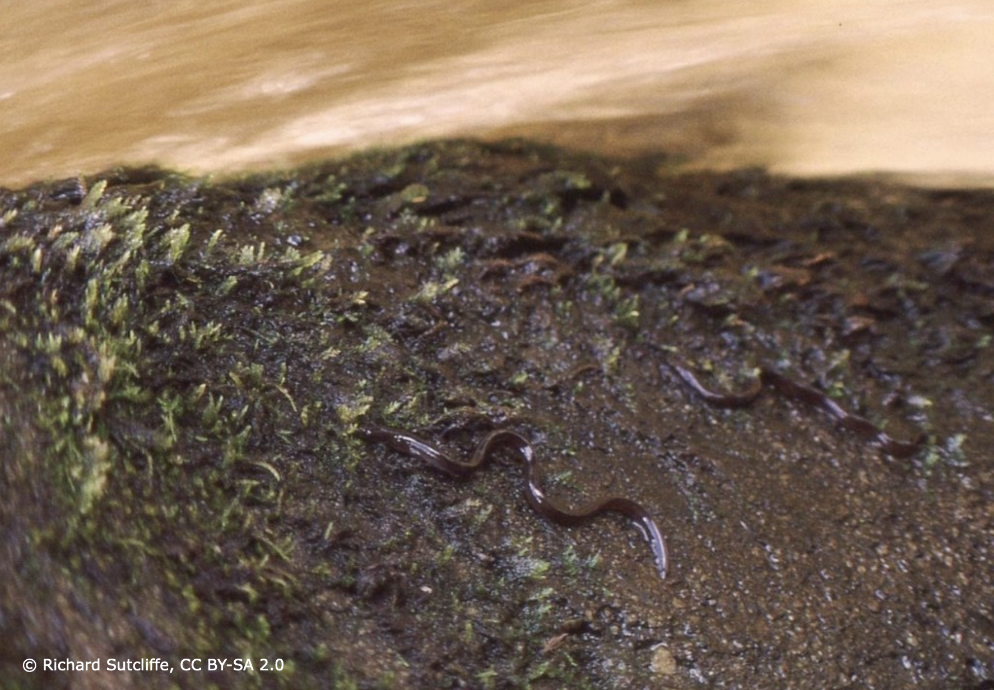

Disruptive coloration
Torrentfish show banding along the side of the body, which is a form of disruptive camouflage. They live in shallow, fast flowing rapids with rocky and stony riverbeds. The strong contrast of the banding helps the fish merge with the contrasting stones and rocks.

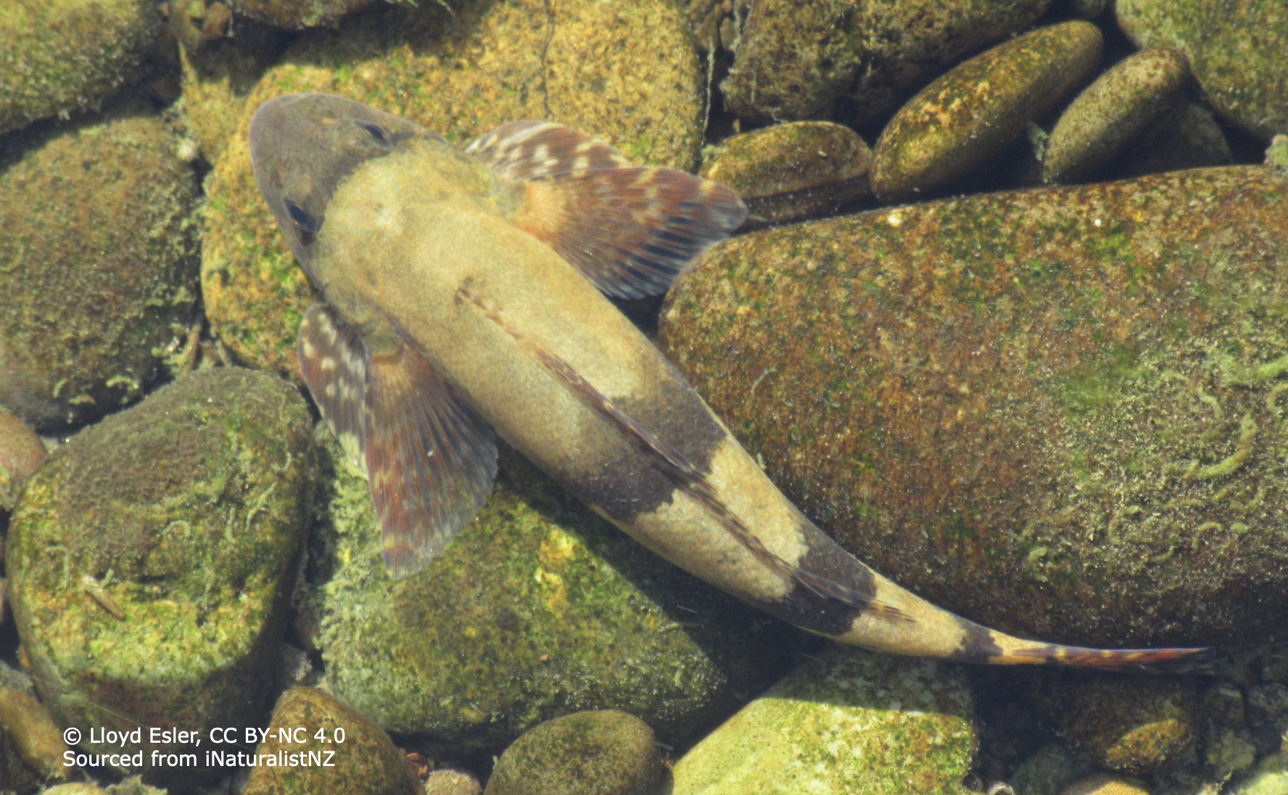
Mimicry of surroundings
Some fish are coloured and shaped to appear as though they are a part of their surroundings. Good examples of this are flat fish such as the black flounder, which is directly derived from its marine cousin. Usually found around estuaries, harbours, the sea and lower rivers, it has been found far inland on occasion.

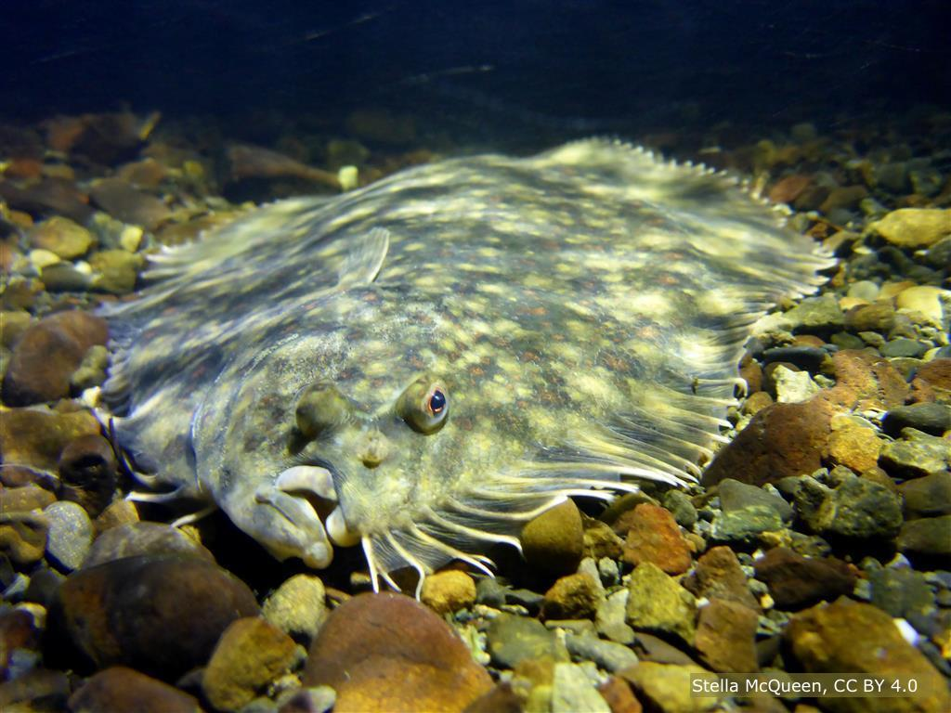

Many of our other native fish have colouring and patterns that mimic their environment – this giant bully has also buried itself to add to the camouflage!

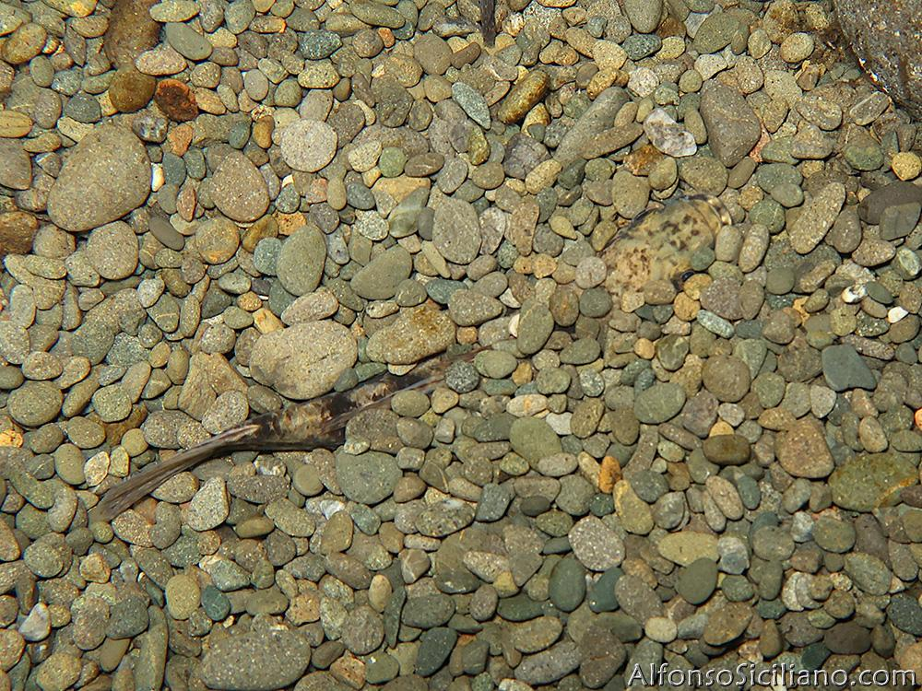

Schooling behaviour
Whitebait is a term for the juvenile form of five native fish species that school together as they approach estuaries and rivers. When a predator attacks a school of whitebait, the confusion of fish means that many will escape. Whitebait have other camouflage tools as well – they are small and transparent.

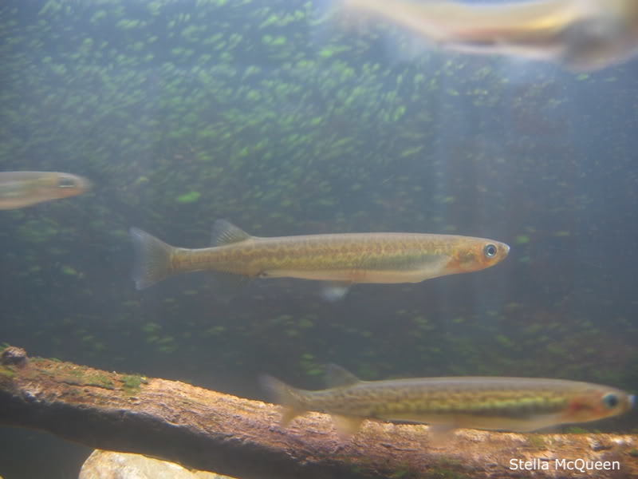

Countershading
Freshwater fish may move from the river or lake-bed into the water column to feed on floating food or insects flying over the surface. Some of these fish are darker on the dorsal (top) surface of their body and are lighter on the underside of their body, like this adult inanga. This is called countershading. From above, the fish looks dark like the river or lake-bed, whilst from below, the fish matches light coming down from above. This type of camouflage is not strong in New Zealand native freshwater fish as many of them are nocturnal, where the light levels have less importance.

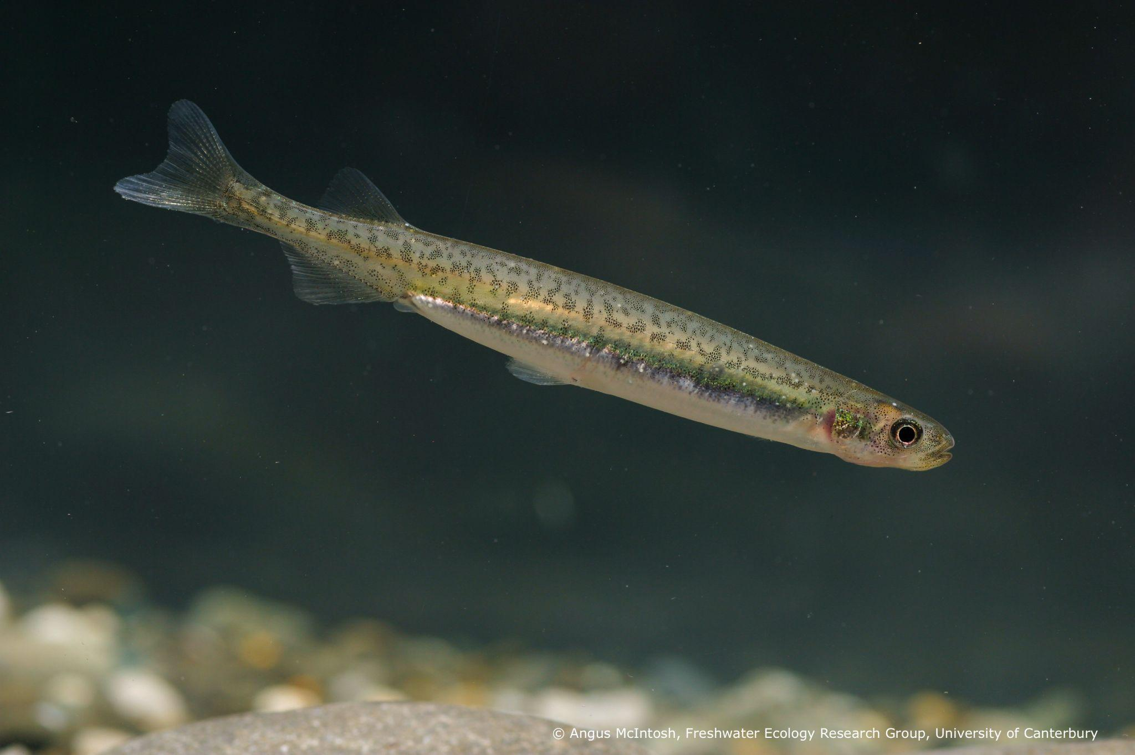
Bioluminescence
Some ocean fish emit light – bioluminescence – in a way that mimics light coming from the surface. None of our freshwater fish use bioluminescence for camouflage, however the freshwater limpet Latia produces a bioluminescent slime thought to startle and distract predators.

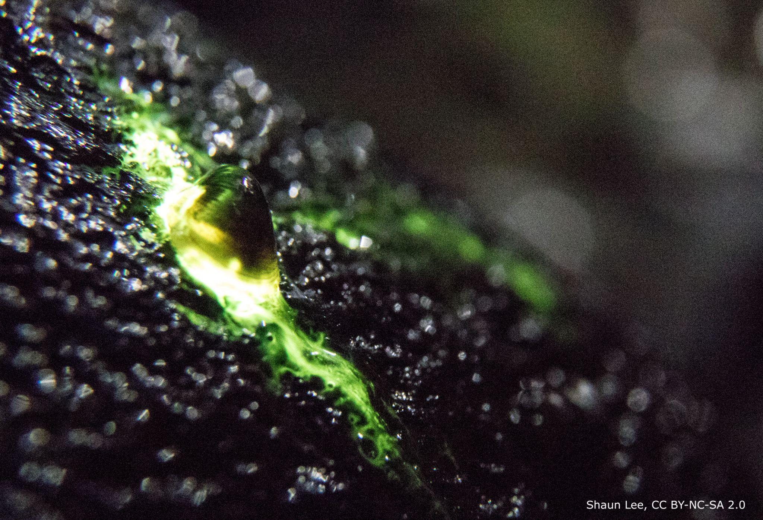

Transparent fish
The transparent animal in the photo below is a glass eel – a stage in life of a freshwater eel (Anguillidae) – between the larval and elver stages. Being transparent, glass eels are very difficult for predators to see. As they get older, they develop more colouration and become more benthic.

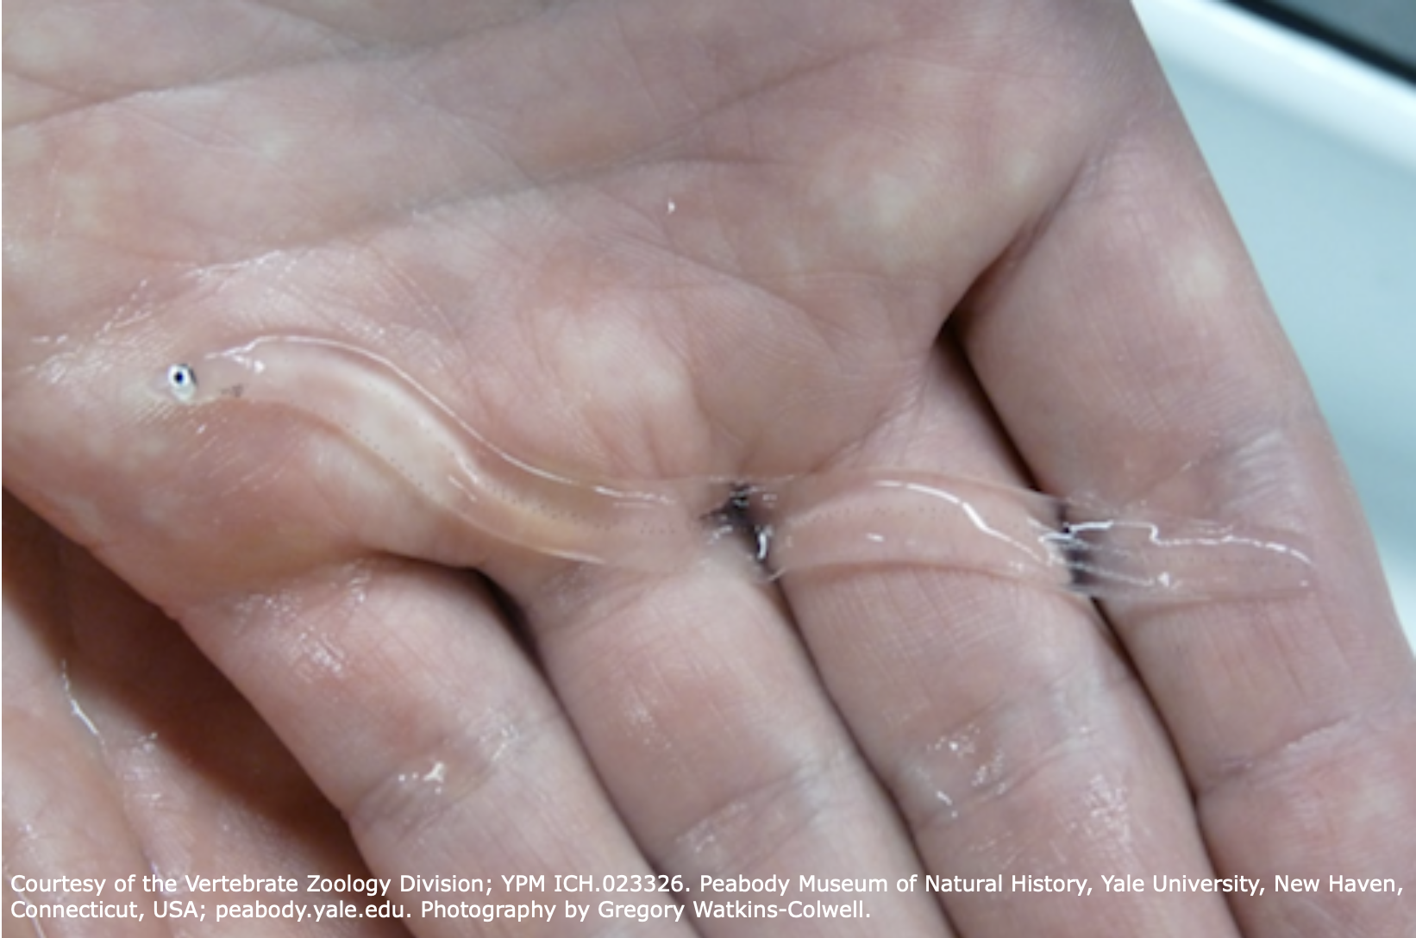
The native freshwater fish version of this activity was developed by Krysia Nowak, an educator with the Department of Conservation’s Taupō for Tomorrow.

Fish template

