**ACTIVITY: Balloons and air density**

**Activity idea**

In this activity, students explore the relationship between air density and volume by observing how air in a plastic bottle expands when immersed in hot water and then contracts when the bottle is placed in cold water.

By the end of this activity, students should be able to:

* draw a diagram showing what they observed during the activity
* use the diagram to provide supporting evidence for their explanation of the phenomena
* begin to understand that heat is a form of energy and that molecules with more energy occupy more space
* begin to understand that increasing volume does not always equate to more particles of matter.

# For teachers

## Introduction/background

Air behaves in the same way as a fluid. It flows and spreads into spaces that are not already occupied. However, air can be compressed, as when a tyre is pumped up, and it can also expand.

This activity enables students to observe that the same amount of air can take up different amounts of space depending on the temperature or energy of the air molecules. Like all states of matter, the higher the temperature, the faster the particles in air move.

Refer to the article [Building Science Concepts: The air around us](https://www.sciencelearn.org.nz/resources/3084-building-science-concepts-the-air-around-us) for useful background information. Consider doing the activity [Investigating the push of air](https://www.sciencelearn.org.nz/resources/3082-investigating-the-push-of-air) prior to this activity, as it may help students visualise how air, which is invisible, takes up space.

***Science capabilities and key competencies***

The activity supports the development of the science capabilities and competencies as students:

* draw diagrams to show their thinking
* engage in discussion with peers using evidence to support their position
* critique their own ideas and/or the ideas of others in terms of their validity and applicability.

Throughout the discussion, teachers are encouraged to support critical student thinking and use questioning to develop increased use of evidence and scientific reasoning. Students may also develop questions to research and check their thinking and understanding.

## What you need

* 2 litre plastic PET bottle
* 2 buckets
* Hot water
* Cold water
* Ice
* Balloon (blow it up a few times to stretch the skin)
* Thermometer – optional

## Teaching suggestions

This is an easy activity to set up in the classroom and enables students to engage in using evidence to support their thinking.

## What to do

1. Prepare one bucket with sufficient hot water to immerse approximately half of the bottle.
2. Prepare the other bucket with the same amount of cold water and ice cubes.
3. Hold up the bottle and discuss what is inside it.
4. Place the balloon on the top of the empty plastic bottle. Have students make a sketch of how the balloon appears.
5. Holding the bottle upright, push the bottle down into the bucket of hot water and observe what happens to the balloon. Hold the bottle down until the balloon stops inflating. (Watch for signs of deformation of the plastic bottle – this can be an exciting distraction while waiting for the balloon to inflate.)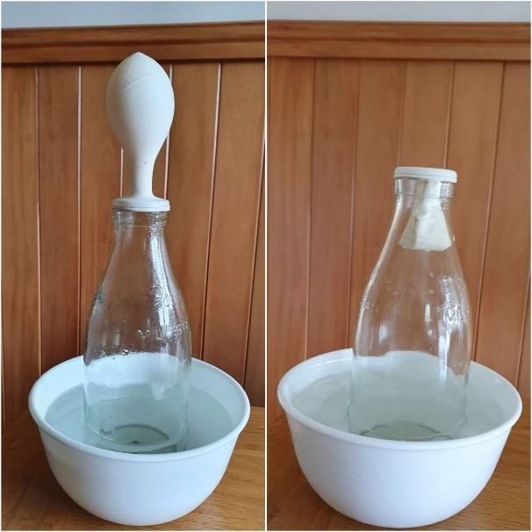
6. Remove the plastic bottle from the hot water bucket. Have students make a second sketch of the balloon’s appearance.
7. Place the bottle in the bucket of cold water and observe what happens to the balloon.
8. Remove the plastic bottle from the bucket and have students make a sketch.
9. Have students compare the sketches, adding labels and/or explanations of what has happened.

## What to look for

* Are students aware that, although air is invisible, it’s actually made up of gases like oxygen, carbon dioxide and nitrogen?
* Are students aware that, although the bottle appears to be empty, it is actually full of air?
* Can students begin to discuss how heat energy is transferred from one object to another, including the air?
* Can students begin to discuss how gases expand as they heat up?
* Are students able to link the inflation of the balloon with the expansion of air/gases?
* Can students begin to discuss that heat energy is transferred away from the air in the bottle and the balloon once it is immersed in cold water?
* Are students able to link the deflation of the balloon with the contraction of air/gases?
* Are students able to make predictions about what would happen if the bottle is put into hot water again?

***Alternative conceptions***

Students may think the heat from the water is blowing up the balloon rather than transferring energy to the air molecules, which results in the air molecules occupying more space.

***Extension ideas***

1. Building on the idea of molecules with extra energy occupying more space, students could use drama to model this – see [Drama in the microworld](https://www.sciencelearn.org.nz/resources/774-drama-in-the-microworld).
2. Students could consider what the variables are in this activity and explore the impact of altering these. Use the following questions to help shape the investigation:

* What are the variables in this activity?
* What can I measure to evaluate the impact of any changes in variables?
* What do I predict will happen if a particular variable is changed?
* How can the results be recorded?
* What sort of data display can be constructed to share findings?

Exploring the variables offers excellent opportunities to develop science capabilities of gathering and interpreting data, using evidence, critiquing evidence, interpreting representations and engaging with science.

Student investigations could focus on these things:

* How big can we inflate the balloon?
* How do we measure the size?
* How much heat is transferred to the inside of the bottle?
* How might that be measured?
* What is the smallest depth of immersion that is needed to inflate the balloon?
* Is the time of immersion more important or less important than the depth? What do we need to do to find out?

Getting answers to questions such as these would require careful recording of data and careful experimental design – developing great science process skills.