**ACTIVITY: Investigating the push of air**

**Activity idea**

In this activity, students investigate the ‘push’ of air.

By the end of this activity, students should be able to:

* discuss how air is invisible yet we can still observe how it takes up space
* identify situations in which air acts as a physical barrier
* make careful observations of phenomena
* make inferences based on their observations
* draw diagrams showing what they noticed during the activities (optional)
* use the diagrams to provide supporting evidence for their explanation of the phenomena (optional).

**For teachers**

***Introduction/background***

For students to make sense of phenomena, it is important that they have the opportunity to collect their own data through hands-on exploration. These experiences form the basis of what science educator Ali Bull refers to as a [library of experiences](https://www.nzcer.org.nz/research/publications/library-experiences). These experiences, while they may not be understood in their full scientific glory, support sense making by students. The challenge when working with students is to balance hands-on with minds-on. Air held in a space can create an invisible ‘push’. While wind is the ‘push’ of moving air, this series of activities helps students observe the presence of air and its push within other contexts. The article [Building Science Concepts: The air around us](https://www.sciencelearn.org.nz/resources/3084-building-science-concepts-the-air-around-us) provides useful background information.

***Science capabilities and key competencies***

This set of activities supports the development of the science capabilities as students:

* engage in discussion with peers using evidence to support their position
* critique their own ideas and/or the ideas of others in terms of their validity and applicability
* draw and utilise diagrams to show and explain the mechanism behind the phenomenon.

Throughout the discussion, teachers are encouraged to support critical student thinking and use questioning to develop increased use of evidence and scientific reasoning. Use of diagrams helps make interpretation of invisible phenomena easier with a concrete representation. Students may also develop questions for research to check their thinking and understanding.

As air is largely invisible, a succession of activities may be needed to offer multiple opportunities for students to see the effects of air pressure.

Use the images within this document as the starting point to create visual representations of the science concepts air takes up space and air has pressure. Students can annotate the images with labels and/or explanations of what is happening and why.

***Using diagrams to illustrate thinking***

Working with students to support them to develop diagrams that show their thinking, particularly around things that must be inferred rather than directly observed, is a really valuable science skill and makes student thinking transparent. This makes it easier for teachers to identify possible confusions as well.

Scientific diagrams have certain features – they are not art, and this can take pressure off some students. Diagrams are about showing what is noticed and the sense made of these observations combined with prior knowledge and/or research. Teachers can introduce these criteria as appropriate to student age and stage.

Criteria include:

* title
* drawn in pencil
* labels should be horizontal and easily read
* label lines should point to the centre of the structure being identified
* no crossing of lines if at all possible
* use a ruler to draw lines
* do not use arrows for label lines – arrows in science are a specialised tool that may show movement, and thickened arrows can represent magnitude and direction of forces
* two-dimensional drawing
* usually in black and white without shading or colouring in.

**Activity 1: Air is a barrier**

This enables students to observe through the sense of touch the phenomenon of the push of air. It demonstrates that air has pressure and it takes up space.

***What you need***

* Sealable plastic bags or balloons
* Small toys

***What to do***

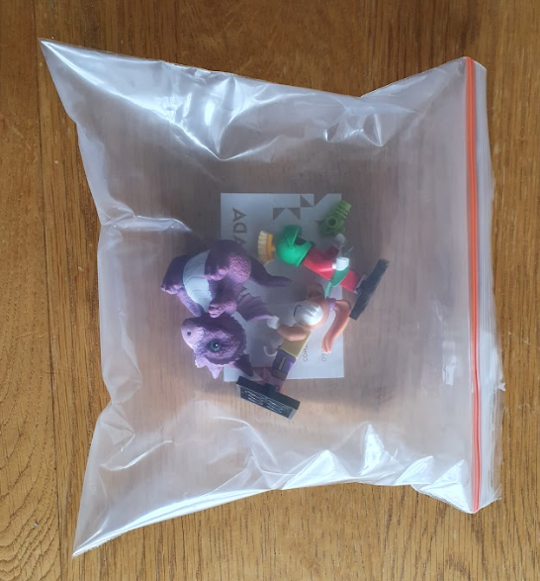

1. Insert a small toy into each bag.
2. Place the bags on a flat surface and get students to feel the toy through the plastic.
3. Inflate the plastic bags then seal.
4. Get students to repeat the ‘feeling’ exercise.
5. Discuss whether it is easier or harder to feel the toy when the bag has air in it and why this might be.
6. Create a diagram to show and explain the mechanism behind the phenomenon.

***What to look for***

* Can students explain what they feel before and after the bags are inflated?
* Can students explain why they cannot feel the toy (or how it feels different) when the bag is full of air?
* Can students explain how the air takes up space and acts as a barrier between the bag and the toy?
* Can students find examples of how we make use of air as a barrier in real life? (Airbags in vehicles, airbags in packing/courier boxes.)

**Activity 2: Keeping paper dry under water**

‘I notice, I think, I wonder’ is a really useful framework for activities like this that foreground some unexpected or discrepant event. Students learn to make careful observations and to attempt some inference that might make sense of what they observed and then may be able to develop an investigable question that might help them find out more. This framework also links to the science capabilities ‘Gather and interpret data’, ‘Use evidence’ and ‘Interpret representations’. It’s recommended you trial the activity before introducing it to your class.

***What you need***

* Plastic cup
* Piece of paper or paper towel
* Container of water
* Food colouring (optional)

***What to do***

1. Add food colouring to the water if desired. This enables students to make both visual and physical observations of the paper after the cup is inverted and dipped in the water.
2. Take a piece of paper or paper towel and scrunch it up loosely.
3. Place the scrunched up paper in the cup and gently press it down so it is at the bottom of the cup. It needs enough volume and enough friction for the paper to remain in the cup when it is inverted.
4. Invert the cup and carefully lower it into the container of water until the entire cup is submerged while keeping the cup inverted and vertical.
5. 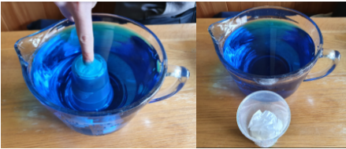Carefully raise the cup keeping it vertical. Still holding the cup upside down but out of the water, remove and observe the dry piece of paper.
6. Ask students to make observations. Asking them to begin their observations with ‘I see’ encourages them to make observations rather than inferences.
7. Once students have generated a rich set of observations, they have some information to use for making inferences. Ask them to begin their inferences with ‘I think’.
8. Consider repeating the activity if students have difficulty making inferences.
9. Using their observations and inferences, ask students to develop a diagram that summarises their observations and thinking.
10. Create a diagram to show and explain the mechanism behind the phenomenon.

***What to look for***

* Can students explain why the air could not escape from the inverted glass?
* Can students explain how the air forms a barrier between the water and the paper?
* Can students predict what might happen if the glass is tilted?
* Can students make the connection between air bubbles escaping from the glass and water beginning to fill the space once occupied by the air?
* Can students make the connection with the upright cup still holding a volume of air, even when it is out of the water?

***Questions to deepen student understanding***

* Why did the air not escape from the inverted glass?
* How did the air form a barrier between the water and the paper?

**Activity 3: Blow up a balloon in a bottle**

When providing demonstration lessons for students, discussion is key to students making scientific sense of the phenomenon. Below are some suggestions that might support students to do this either independently, in groups or with teacher guidance. It’s recommended you trial the activity before introducing it to your class.

***What you need***

* Balloon
* Plastic bottle

***What to do***

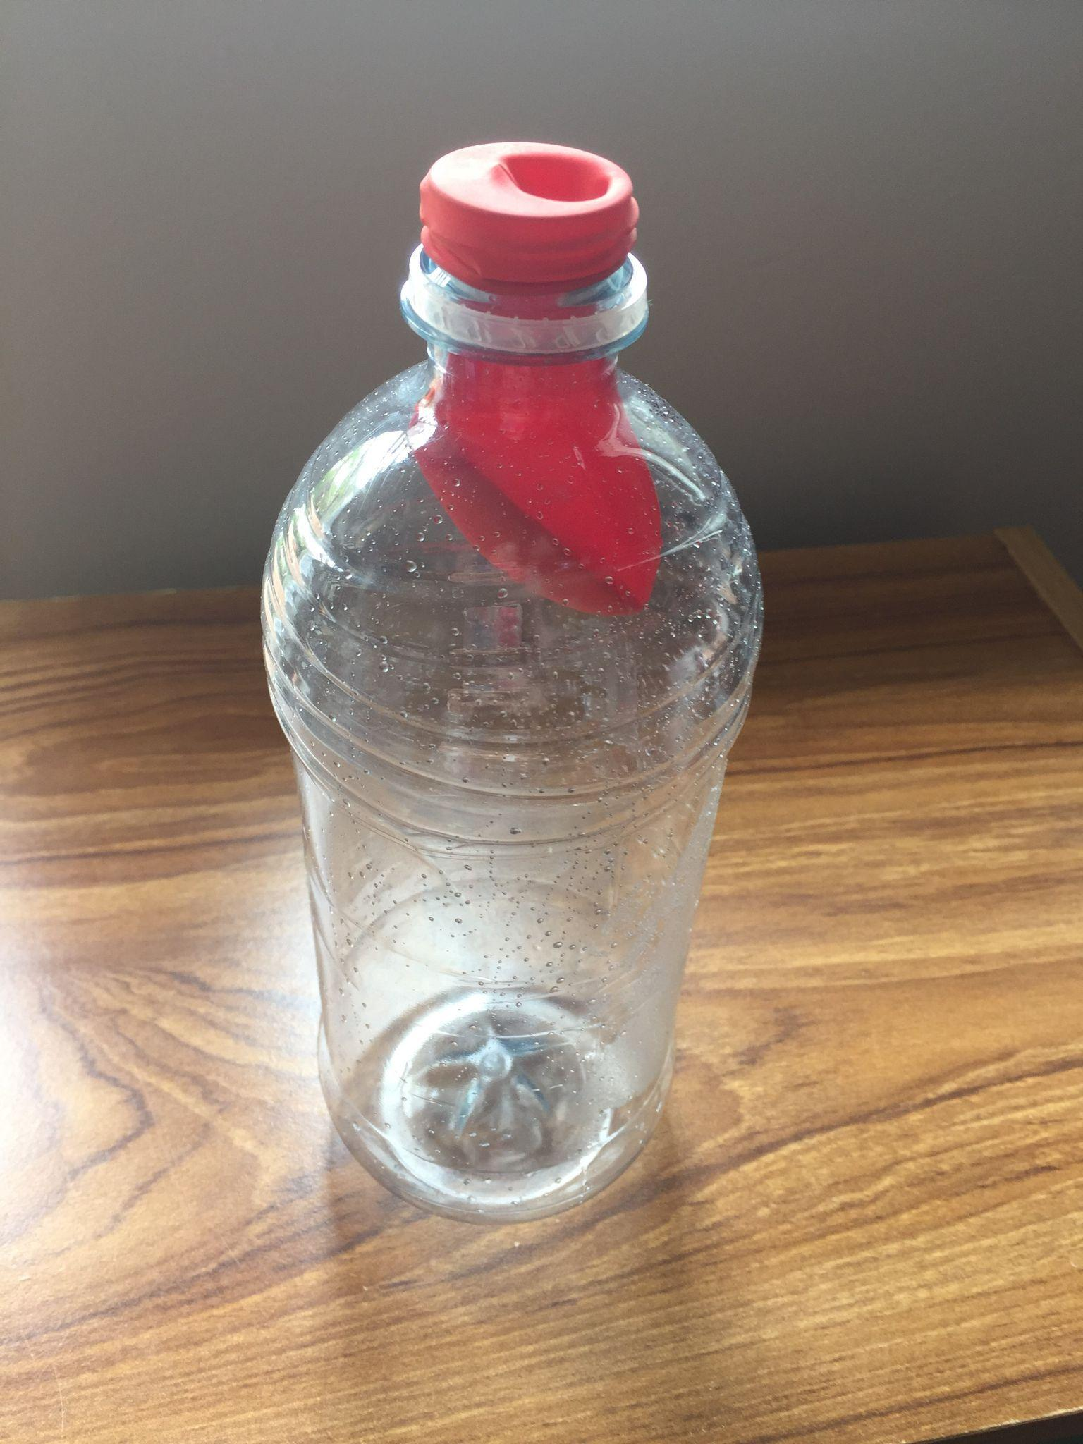

1. Lower the body of the balloon into the bottle.
2. Carefully fit the neck of the balloon over the mouth of the bottle.
3. Try to inflate the balloon or ask a student to attempt to blow the balloon up. For safety, only one person can touch the balloon with their lips. If resources are available, have multiple bottles and balloons for student use.
4. Ask students to form small groups to discuss what they think is happening.
5. Invite the groups to report their ideas to the class.
6. Ask the small groups to reconsider their responses, using information that they’ve heard from others.
7. Create a diagram to show and explain the mechanism behind the phenomenon.

***What to look for:***

* Can students explain that the bottle is already filled with air?
* Can students explain that the balloon seals the bottle and does not allow the air in the bottle to escape?
* Can students explain that there is no space for the balloon to inflate due to the air already in the bottle?
* Can students devise a solution to allow the air in the bottle to escape, allowing the balloon to inflate?
* Are students able to revise their thinking when they hear new ideas?
* Are students able to design another activity that will help them confirm their thinking?

If students are still unsure, repeat the activity. Use the following questions to support students to make scientific sense of what’s going on.

Before inserting the balloon, ask:

* What is in the bottle at the moment?
* What happens when we remove air from a drink bottle with a nozzle and prevent it from refilling with air? (The bottle collapses and the sides of the bottle crumple from the air pressure.)
* Can anything get in or out of the bottle once we place the balloon over the neck of the bottle? (The bottle is now a closed system.)
* If the bottle is already full of air when we add the balloon, can we add any more air to the inside of the bottle? (As the bottle is already full, once the balloon is in place, there is no way for air to escape and make room for the air within the balloon.)

***Extension idea***

Challenge students to make an adaptation to the bottle that allows the balloon to be inflated.

Invite students to draw a diagram of their adaptation showing how and why it works.

**Activity 4: Blow a small piece of paper into a bottle**

Once again, ‘I notice, I think, I wonder’ is a useful framework for this activity as it foregrounds an unexpected or discrepant event. It enables students to make careful observations, attempt inferences that might make sense of what they observed and develop an investigable question to find out more. Teacher questioning can be useful to guide student thinking.

This framework also links to the science capabilities ‘Gather and interpret data’, ‘Use evidence’ and ‘Interpret representations’.

It’s recommended you trial the activity before introducing it to your class.

***What you need***

* Small piece of paper, tightly balled
* Plastic bottle
* Devices to record and watch the demonstration (optional)

***What to do***

1. Scrunch the piece of paper tightly and place it in the neck of the bottle. 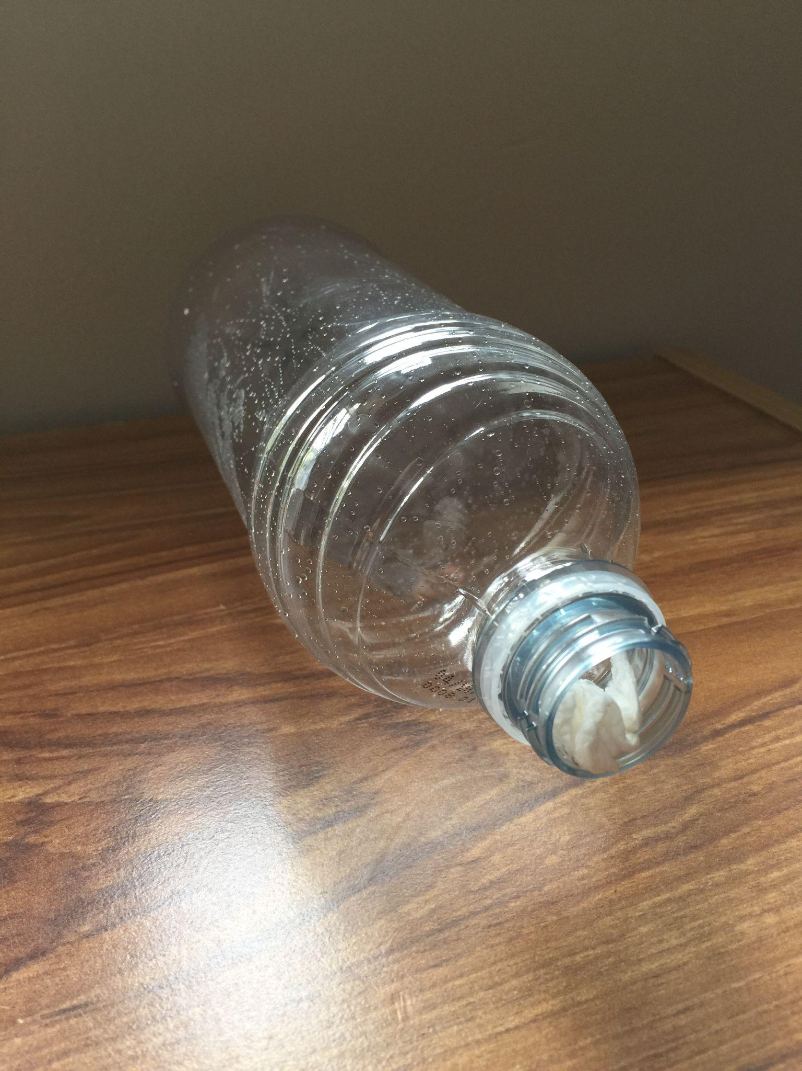
2. Try to blow the paper into the bottle.
3. If students are unable to see what is happening, consider filming the experience and watching it in slow motion.
4. Ask students to form small groups to discuss what they think is happening.
5. Invite the groups to report their ideas to the class.
6. Ask the small groups to reconsider their responses using information that they’ve heard from others.
7. Create a diagram to show and explain the mechanism behind the phenomenon.

***What to look for***

* Can students explain that the bottle is already filled with air?
* Can students explain that the pressure of the air within the bottle prevents the paper ball from entering the bottle?
* Can the students explain that, by blowing air into the bottle, some of the air in the bottle is displaced and dislodges the ball of paper?
* Can the students devise a solution to enable the paper ball to enter the bottle?
* Are students able to revise their thinking when they hear new ideas?
* Are students able to design another activity that will help them confirm their thinking?

If students are still unsure, repeat the activity. Use the following questions to support students to make scientific sense of what’s going on.

While setting up the activity, ask:

* When the paper is placed in the neck of the bottle, what is already in the bottle? (Air.)
* If the paper can be pushed in with a finger, why can it not be blown into the bottle? (The ongoing pressure of the air being blown at the neck of the bottle prevents the air already in the bottle from escaping and making ‘room’ for the paper to enter.)
* Does the strength of the puff change the behaviour of the piece of paper? (The bigger the puff, the bigger the jump of the paper out of the bottle.)
* If the paper is popping out of the bottle, where might the force for that movement be coming from? (Small amounts of the air being blown at the neck of the bottle are getting in and pushing air from within the bottle out.)
* How is that force generated? (See above.)

**Activity 5: Cushion of air**

This activity demonstrates that air has pressure and it takes up space.

***What you need***

* Sealable plastic bags or balloons
* Table or desk
* Student volunteers

***What to do***

1. Partially inflate the bags or balloons and seal them securely.
2. Use them to create a cushioning layer under an upturned table or desk.
3. Ask students how many people they think will be able to stand on the table before it collapses to the floor. Collect student predictions.
4. Try it out, adding one student at a time.
5. Create a diagram to show and explain the mechanism behind the phenomenon.

***What to look for***

* Can students explain what pushes the table towards the floor? (Gravity and the combined weight of the table and students on it.)
* Can students explain what holds the table off the floor? (The air is pushing back.)
* Can students explain and/or predict what will happen if the balloons/bags burst?
* Can students explain why this may happen?
* What other instances can students think of where the ‘push’ of air keeps things up. (Life rafts, floatation devices.)