**ACTIVITY: Living or non-living?**

In this activity, students use two online interactives or paper-based graphic organisers to explore their ideas about the characteristics of living things and the characteristics of animals. This activity can be done individually, in pairs or as a whole class.

By the end of this activity, students should be able to:

* describe the characteristics of living things
* describe the characteristics of animals
* classify things as living or non-living/animal or not, based on these characteristics.

[Introduction/background notes](#Introduction)

[What you need](#need)

[What to do](#Do)

[Extension ideas](#Extension)

[Answers](#answers)

[Images for classifying](#images)

Graphic organiser worksheets: [Living or not?](#living) and [Animal or not?](#animal)

**Introduction/background**

This activity has two separate graphic organisers:

* Living/non-living/not sure
* Animal/not an animal/not sure

In science, the broadest groupings are living and non-living. This may sound simple, but it is sometimes difficult to decide whether something is truly living or not.

All living things share life processes such as growth and reproduction. Most scientists use seven life processes or characteristics to determine whether something is living or non-living.

For more information, see the science ideas and concepts article [Characteristics of living things](https://www.sciencelearn.org.nz/resources/14-characteristics-of-living-things).

Visit the Science Continuum website for more information about common student alternative conceptions related to living things and classification.

[www.education.vic.gov.au/school/teachers/teachingresources/discipline/science/continuum/Pages/relationships.aspx](http://www.education.vic.gov.au/school/teachers/teachingresources/discipline/science/continuum/Pages/relationships.aspx)

**What you need**

* Access to the interactive graphic organisers [Living or not?](https://www.sciencelearn.org.nz/drag_and_drops/2-living-or-not) and [Animal or not?](https://www.sciencelearn.org.nz/drag_and_drops/4-animal-or-not) Or use the paper-based graphic organiser worksheets [Living or not?](#living), [Animal or not?](#ANIMAL) and the [images for classifying](#images).
* Access to the article [Characteristics of living things](https://www.sciencelearn.org.nz/resources/14-characteristics-of-living-things).

**What to do**

1. Allow the students sufficient time to complete the graphic organiser [Living or not?](https://www.sciencelearn.org.nz/drag_and_drops/2-living-or-not) either individually or in small groups on a computer. This can also be a whole class activity via an interactive whiteboard (IWB) or similar. If using a shared screen, encourage students to come up and move the image cards to the appropriate box and to move an image card if they do not agree with its position. Alternatively, use the paper-based version. Provide the [images for classifying](#images) (cut up into individual images) and ask students to place them in the appropriate box on the graphic organiser worksheet [Living or not?](#living)
2. If the students worked in small groups, bring them back together.
3. As a class, come up with a list of characteristics of living things. Revisit the interactive and give students the opportunity to revise their choices. Ask them to explain any changes. Use this time to address any alternative conceptions that arise.
4. If appropriate, allow students time to research any things/image cards they are unsure about. This research could be web-based or using a print out of the article [Characteristics of living things](https://www.sciencelearn.org.nz/resources/14-characteristics-of-living-things).
5. Repeat the steps above with the second interactive graphic organiser [Animal or not?](https://www.sciencelearn.org.nz/drag_and_drops/4-animal-or-not)

**Extension idea**

* Groups of students may like to gather a number of artefacts from around the classroom or playground and do a ‘live’ version of this activity with younger students. The older students will be responsible for explaining any incorrect answers to the juniors.

**Answers**

|  |  |  |
| --- | --- | --- |
| **Image** | **Living/Non-living** | **Animal/Not an animal** |
| Cow | Living | Animal |
| Fire | Non-living | Not an animal |
| Mushroom | Living | Not an animal |
| Grass | Living | Not an animal |
| Butterfly | Living | Animal |
| Whale | Living | Animal |
| Bicycle | Non-living | Not an animal |
| Frog | Living | Animal |
| Worm | Living | Animal |
| Teddy bear | Non-living | Not an animal |
| Girl | Living | Animal |
| Dog | Living | Animal |

**Images for classifying**

**­**

|  |  |
| --- | --- |
| **COW_10761032_l23RF_cropped** | **FIRE_9028217_l23RF_cropped** |
| **MUSHROOM_9329381_l23RF_cropped** | **GRASS_10516922_l23RF_cropped** |
| **BUTTERFLY_10119714_l23RF_cropped** | **WHALE_4901379_l23RF_cropped** |
| **BIKE_8686659_l23RF_cropped** | **FROG_10011482_l23RF_cropped** |
| **WORM_9712035_l23RF_cropped** | **BEAR_6650878_l23RF_cropped** |
| **GIRL_10055446_l23RF_cropped** | **DOG_8049409_l23RF_cropped** |

**Living or not?**

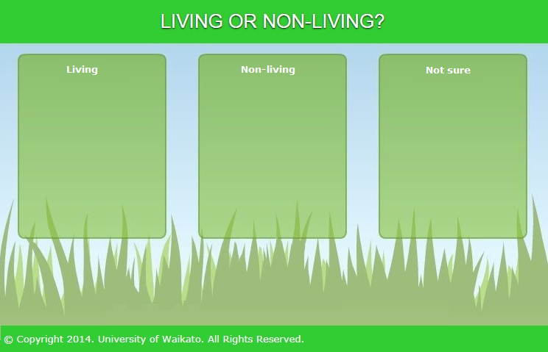

**Animal or not?**

