**ACTIVITY: Using absolute dating methods**

**Activity idea**

In this activity, students learn about four absolute dating methods and then test their knowledge with a quiz that matches materials in rock layers with the most appropriate method.

By the end of this activity, students should be able to:

* use Hub resources to build their knowledge of absolute dating methods
* use some of the content vocabulary associated with absolute dating methods
* identify some of the materials that scientists use as clues when choosing a method
* complete an online quiz to test their knowledge.

Introduction/background

What you need

Teaching suggestions

What to do

Quiz answers

Extension ideas

For students: Absolute dating rock layers – quiz

# For teachers

## Introduction/background

Scientists have a variety of methods to use when they try to date a rock or a rock layer. Scientists choose the method that best suits their material – they might use relative or absolute dating or a combination of methods, depending on the type of material they are working with and the precision they need.

Some methods place rocks in a relative time sequence, but if scientists need to know the actual dates of geological events, then absolute dating methods provide this type of information.

Examples of scientific fields that use dating methods include climate change research (dating [ice cores](https://www.sciencelearn.org.nz/videos/545-dating-ice-cores) and other [paleoclimate proxies](https://www.sciencelearn.org.nz/videos/1464-fossil-plants-as-paleoclimate-proxies)), [volcanic eruptions](https://www.sciencelearn.org.nz/videos/191-explaining-a-rock-core) and [archaeological sites](https://www.sciencelearn.org.nz/videos/1070-dr-fiona-petchey-s-research).

In this online activity, students learn about different absolute dating methods and then use their knowledge to choose the most appropriate method to date a rock layer. The student activity has a paper-based version of the quiz if you prefer to use it offline.

## What you need

* access to the articles [Absolute dating](https://www.sciencelearn.org.nz/resources/1486-absolute-dating), [Fission track and luminescence dating](https://www.sciencelearn.org.nz/resources/1487-fission-track-and-luminescence-dating) and [Ice ages unearthed](https://www.sciencelearn.org.nz/resources/1481-ice-ages-unearthed)
* access to the interactives [Absolute dating methods](https://www.sciencelearn.org.nz/image_maps/122-asolute-dating-methods) and [Relative rock layers](https://www.sciencelearn.org.nz/labelling_interactives/4-relative-rock-layers)
* access to the [Absolute dating rock layers – quiz](https://www.sciencelearn.org.nz/embeds/148-absolute-dating-rock-layers-quiz)
* Copies of the student handout.

## Teaching suggestions

## What to do

1. Use the text and media in [Absolute dating](https://www.sciencelearn.org.nz/resources/1486-absolute-dating), [Fission track and luminescence dating](https://www.sciencelearn.org.nz/resources/1487-fission-track-and-luminescence-dating) and [Ice ages unearthed](https://www.sciencelearn.org.nz/resources/1481-ice-ages-unearthed) to become more familiar with absolute dating methods, their strengths and weaknesses and when they are likely to be used. Use this time to discuss content vocabulary.
2. Encourage students to use the interactive [Absolute dating methods](https://www.sciencelearn.org.nz/image_maps/122-asolute-dating-methods), which succinctly describes how each of the methods works and the types of materials they use to establish an approximate date or age range.
3. Use the quiz to match information from the interactive with materials in the rock layers to choose the absolute dating method best suited for the sample.

## Quiz answers

|  |  |
| --- | --- |
| **Rock layer** | **Absolute dating method** |
| Layer 1: Mudstone | Fossil correlation |
| Layer 2: Mudstone | Fossil correlation |
| Layer 3: Thin layer of tephra | Fission track dating |
| Layer 4: Mudstone | Fossil correlation |
| Layer 5: Loess | Optically stimulated luminescence (OSL) |
| Layer 6: Old dunes with organic material | Radiocarbon dating |

## Extension ideas

The activity [Which dating method?](https://www.sciencelearn.org.nz/resources/1519-which-dating-method) asks students to look at a variety of research articles and videos on the Science Learning Hub and decide which dating methods are being used by the scientists. This activity supports the science capabilities ‘Use evidence’ and ‘Critique evidence’.

Explore the interactive [Relative rock layers](https://www.sciencelearn.org.nz/labelling_interactives/4-relative-rock-layers) to understand how land changes can alter the order of the rock layers. This demonstrates the importance of using other methods for dating the materials in each layer.

# For students: Absolute dating rock layers – quiz

Test your knowledge of absolute dating methods for the layers of rock in a cliff. Absolute dating methods give rocks an actual date or a date range in numbers of years. The method you choose will depend on the material present in each rock. We’ve numbered the rock layers 1–6. Layer 1 is the oldest.

If you are not sure about which method to choose, use the interactive [Absolute dating methods](https://www.sciencelearn.org.nz/image_maps/122-asolute-dating-methods) to find handy clues about each of the methods.

**Quiz**

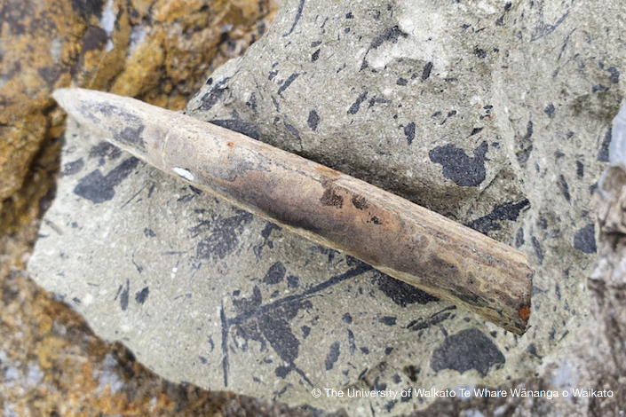**Layer 1:** Mudstone – sediments laid down in deep water. Fossils include the belemnite *Belemnopsis aucklandica*.

Which dating method is best for rocks with fossils in them?

* Radiocarbon dating
* Fission track dating
* Optically stimulated luminescence (OSL)
* Fossil correlation

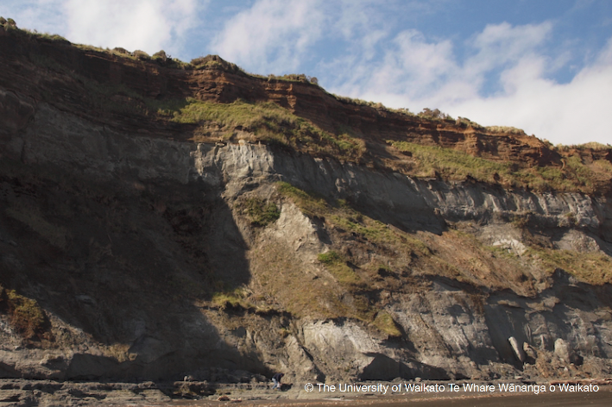**Layer 2:** Mudstone – sediments laid down in deep water. Fossils include *Astraea* (circular-saw shell).

Which dating method is best for rocks with fossils in them?

* Radiocarbon dating
* Fission track dating
* Optically stimulated luminescence (OSL)
* Fossil correlation

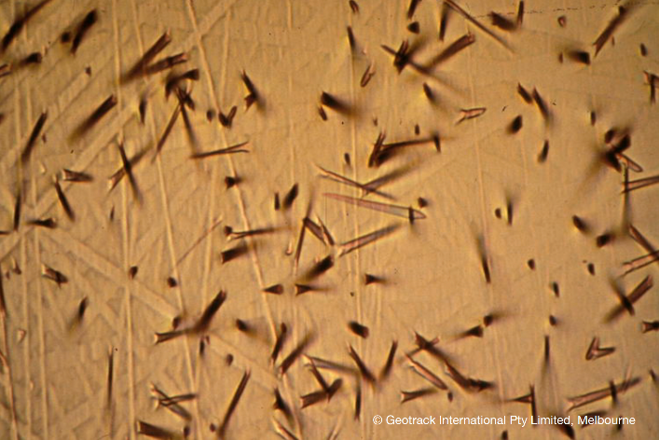**Layer 3:** A thin layer of tephra – a rock made of the ash from a volcanic eruption.

Which dating method is best for volcanic ash containing crystals of zircon?

* Radiocarbon dating
* Fission track dating
* Optically stimulated luminescence (OSL)
* Fossil correlation

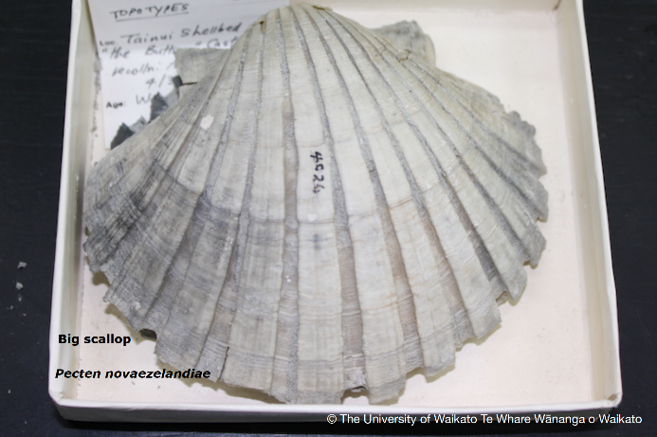**Layer 4:** Mudstone – sediments laid down in deep water. Fossils include oysters and a large scallop.

Which dating method is best for rocks with fossils in them?

* Radiocarbon dating
* Fission track dating
* Optically stimulated luminescence (OSL)
* Fossil correlation

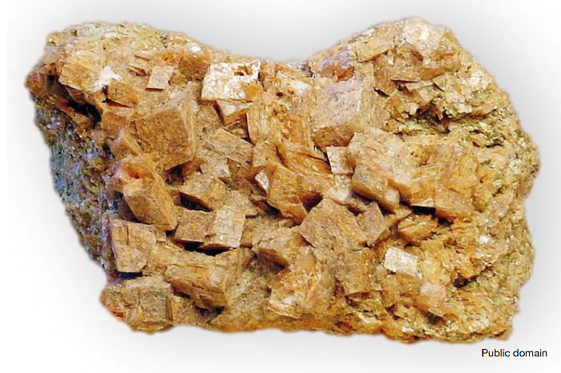

**Layer 5:** Loess – a rock made from very fine wind-blown dust. Contains feldspar crystals.

Which dating method is best for rocks with feldspar crystals buried in dust?

* Radiocarbon dating
* Fission track dating
* Optically stimulated luminescence (OSL)
* Fossil correlation

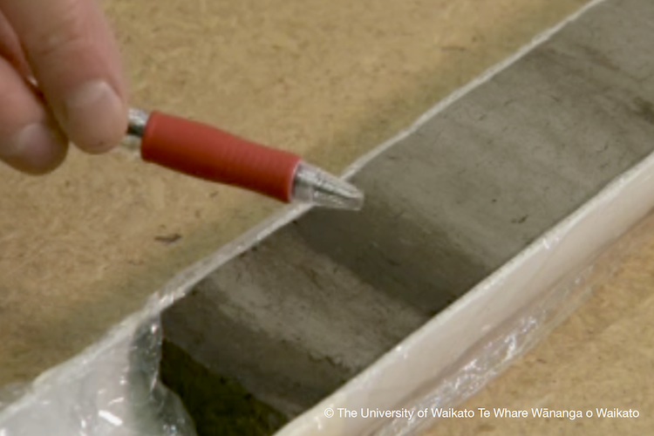**Layer 6:** The remains of old dunes formed from wind-blown sand. Pieces of wood were found near the bottom of this young layer.

Which dating method is best for organic material?

* Radiocarbon dating
* Fission track dating
* Optically stimulated luminescence (OSL)
* Fossil correlation