ACTIVITY: Interpreting observations from satellite images

Activity idea

In this activity, students are introduced to strategies and skills that scientists use to interpret satellite images. They use the skills to identify, discuss and interpret information from a selection of satellite images. The activity begins with simple strategies that support early learners and build in complexity.

By the end of this activity, students should be able to:
- observe images and make inferences about what they see
- use strategies including colour and prior knowledge to support their inferences
- build upon and combine strategies while observing images
- consider and discuss what the representations show and how the information is presented.

For teachers

During this activity, support students to make scientific observations while viewing satellite images. Scaffold student learning as they make their way through the strategies.

The activity has a number of ready-to-use images from NASA’s Visible Earth website. To encourage local curriculum learning, consider using this curation of New Zealand images to find images of interest for your local area.

Introduction/background

Satellite sensors make measurements using a variety of techniques. Some bounce radio waves off the surface of the Earth while others use light that is both visible and invisible to the human eye. Sensors that produce true-colour satellite images measure red, green and blue light wavelengths – light that we see with our eyes.

These images often resemble photographs but the process by which a satellite image is made is much more complex. Sensors that produce false-colour images use non-visible wavelengths, so the images look different to what we might expect. For example, forested land may be red rather than green.

Scientists involved in remote sensing observations choose true-colour or false-colour images to highlight the features that interest them. They use software packages to process the data themselves or use processed data from agencies like NASA or companies like Xerra.

This activity uses true-colour satellite images. The article Remote sensing and water quality provides information about lake colour and explains why we see so many different colours in lake and ocean water around New Zealand.

Engaging discussion and deepening understanding

While observing the images, ask questions and engage students to:
- develop content vocabulary
- develop, consolidate or extend thinking
- make comparisons between satellite images and other representations such as paper maps, navigation systems and online mapping tools
- consider how the images and representations display information
- consider why scientists or interested individuals use these types of representations
- make use of local knowledge, prior learning and expertise within the group to interpret and critique inferences
- encourage communication, comparison and analysis between individuals and groups.

Strategies for observation and interpretation

The following strategies are useful when interpreting satellite images:
- Use colour.
- Use map skills – orientation and scale
- Use prior knowledge
- Look for textures, patterns and shapes

The first strategy – use colour – is the most basic. The strategies become more complex as do the images used to practise the strategies. Consider which strategies are most appropriate for your learners. Each of the strategies is accompanied by an image and a series of questions. The questions used for each strategy can be built upon and used across the images.

What to do

Strategies for interpreting observations from satellite images uses images from NASA’s Visible Earth website. They were taken by satellites orbiting Aotearoa New Zealand. Accompanying each image is information about the satellite that collected the data and a link to the image and supporting article on the Visible Earth website. Each image also has a series of questions to help students interpret some of the information.

For optimal viewing, click the link to visit the website and use the download button on the Visible Earth website to display the image in full detail. With many of the images, you can click onto an area of the image to enlarge it for more detailed viewing.

Alternative conceptions

Many satellite sensors work by reflecting light from the surface of the Earth. Students may hold the conception that rough surfaces do not reflect light. Students have experience with reflectors being shiny things like mirrors, lakes or polished metal. Some do not consider that a rough object like a tree or a rock is reflecting light. The scientific view is that rough surfaces do reflect light, which is why we can see them and why satellites can see them.

Students may hold the conception that white light is pure and not a mixture of coloured light. The scientific view is that white light is a combination of all of the colours in the visible spectrum.

Students may hold the conception that visible light (the waves we can detect with our eyes) is the sole way of observing something. The scientific view is that visible light is a narrow portion of the electromagnetic spectrum (EMS). Scientific instruments like those used on satellites are able to use an extensive range of the EMS to study the Earth. Satellites use ultraviolet, microwaves, infrared and radio waves as well as visible light waves to gather data.

Extension ideas

Satellite sensors record data in multiple wavelengths that are combined to create colour images. Watch this short NASA video to see how this happens, how the images differ and why data specialists would choose to use different true-colour and false-colour images.

Satellites make measurements using a large portion of the electromagnetic spectrum. For example, satellites that measure atmospheric pollution and/or greenhouse gases use UV and short-wavelength infrared waves. Do a web search of satellite instruments to explore which EMS bands they sense.

Observe and interpret this false-colour image, which uses infrared light to show icebergs created by the 2011 Canterbury earthquake. Opening the image in .jpeg format displays the image on its own without annotation or explanatory text. Challenge students to use various strategies to interpret the image, then use the article text to verify their findings.
Strategies for interpreting observations from satellite images

Strategy 1: Use colour

True-colour satellite images look like photos taken from above. We can use colour to identify landforms, seasonal variations and changes to the landscape.

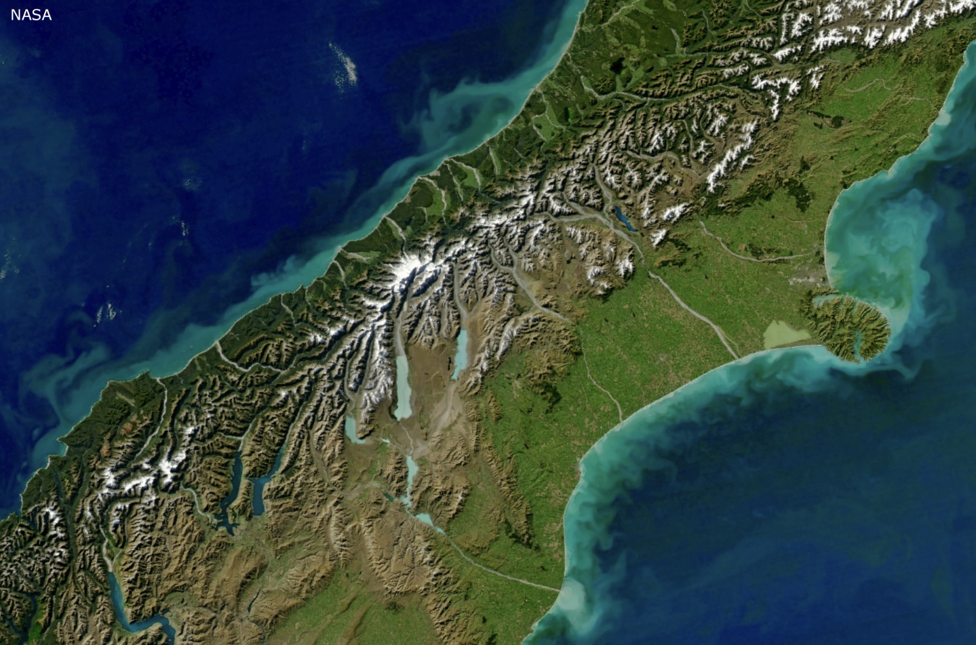

Turbid waters surround New Zealand – this image using data from May 2011 was taken by the Moderate Resolution Imaging Spectroradiometer (MODIS) on NASA’s Aqua satellite. The turquoise swirls along the coast are due to sediment carried into the water by heavy rains and phytoplankton blooms as a result of the nutrient-rich sediment. (This screenshot is of the middle of the South Island. The original image is of the whole of Aotearoa.)

Questions to practise observation and interpretation using colour:
- What colours do you see? What do you think the colours represent?
- Can you see water in the image? What clues tell you that it is water?
- Why are there different colours of blue? What do you think they represent?
- Can you see rivers in this image? What clues tell you that they are rivers?
- What colour are the rivers?
- Why are the rivers this colour? Are you surprised that they are not blue?
- What colour(s) is the ocean?
- Does the colour stay the same or change further away from the coast?
- Can you see areas that might be plants in the image?
- Which areas might be covered in pasture and which might be covered in native bush?
- How can you tell?
- What do you think the white colour represents? What are your reasons for this?
- Are there mountains in this image? What clues tell you that they are mountains?
- Why do you think satellites create true-colour images?
- Who might be interested in this image and how would they use the information?
Strategy 2: Use map skills – orientation and scale

Satellite images are similar to maps we use for navigation. Some images have a compass symbol to show orientation. The images below are both oriented so the top of the image represents north. Each image also has a scale so we can judge distances within the images.

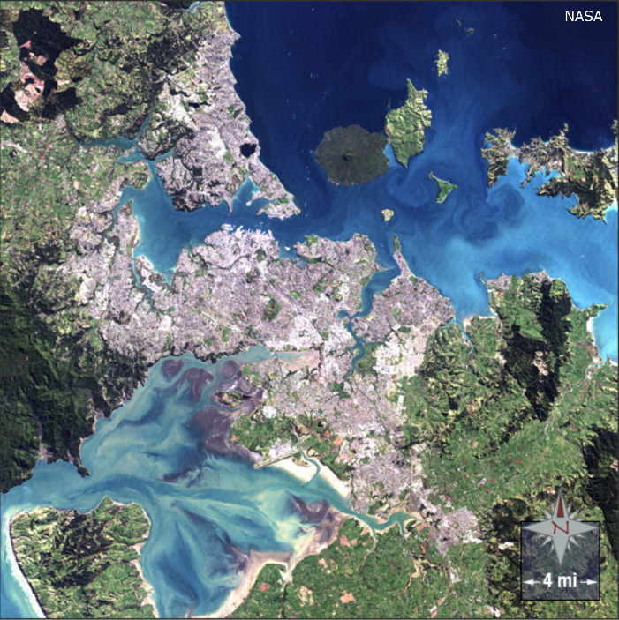  Auckland, New Zealand – this image using data from August 2002 was taken by the Landsat 7 telescope. It shows the urban areas for north and south Auckland. An image using current data would show the city’s expansion. The scale (in miles) shows the narrowness of the landmass. | 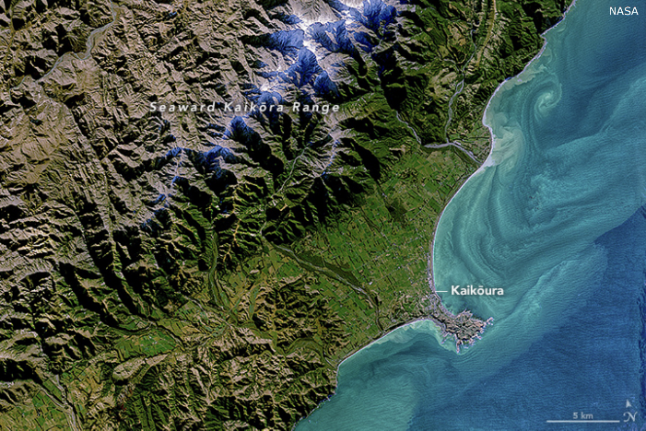  Coastal colour in New Zealand – this image using data from May 2021 was taken by the Operational Land Imager (OLI) sensor on the Landsat 8 satellite. It shows the variety of landforms in the Kaikōura region and the patterns of sediments swirling in the water next to the shore. The scale (in miles) can be used to show the size of Kaikōura Peninsula.

Questions to practise observation and interpretation using orientation and scale:
- What does each image use to show direction?
- Why do you think the images have this information?
- What limits the growth of each location’s eastern areas?
- Does the orientation help you see which direction the rivers flow?
- What does each image use to show distance?
- Why do you think the images have this information?
- How does this information help you make comparisons between the images?
- What are some questions that you can ask or statements that you can make using information from the images?
- What information are you able to gather and interpret by using what you’ve learned about colours?
- Who might be interested in these images and how would they use the information?

Strategy 3: Use prior knowledge

Prior knowledge about an area and its features helps to make inferences from observations. For example, now that we know how to use colour, we can talk about what we see on the land and in the sea. People familiar with the area might recognise the unique landform in the upper right-hand corner as Māhia Peninsula and identify this image as Hawke’s Bay.

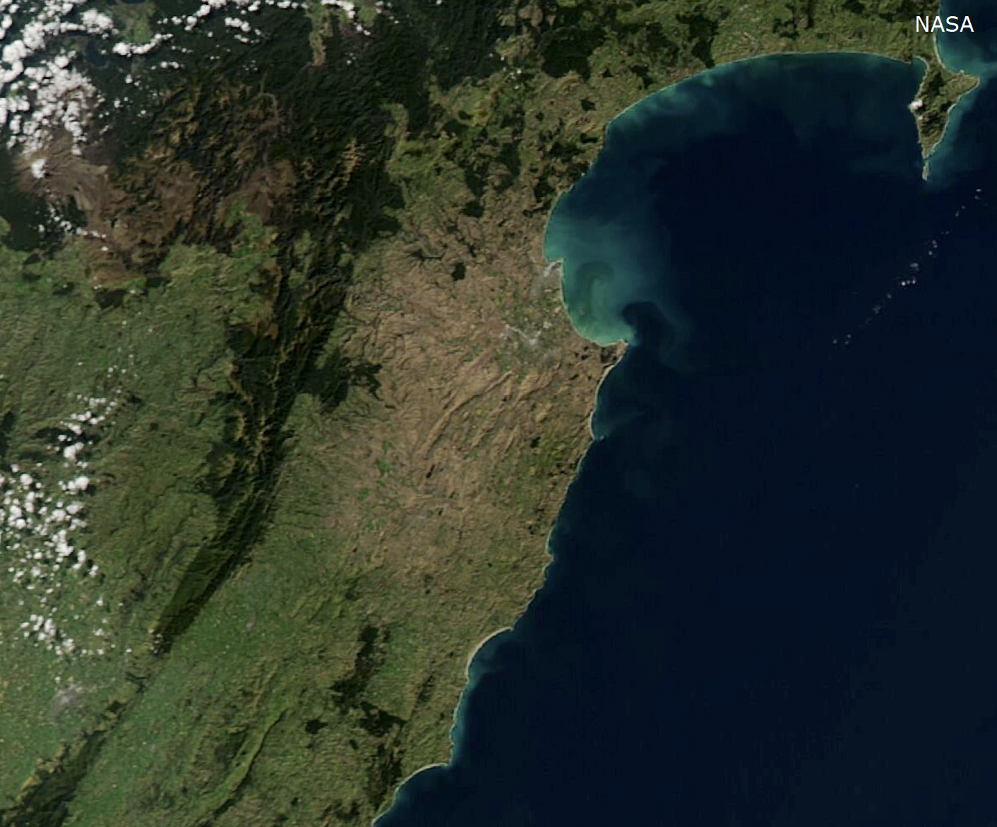

New Zealand browned by drought – this image using data from April 2020 was taken using the Moderate Resolution Imaging Spectroradiometer (MODIS) on the Aqua satellite. The NASA web page displays images from 2019 and 2020 and shows the extent of the drought in the Hawke’s Bay region. Note: The image on the web page is annotated with location names and shows orientation and scale.

Questions to practise observation and interpretation using prior knowledge:
- What do the colours tell us about this image?
- What do the landforms tell us about this image?
- How do the landforms help identify this location?
- Using prior knowledge about this location in the northeast of Aotearoa, do the white colours represent snow or clouds?
- What is your reason for this answer?
- How can you identify the areas affected by drought in this image?
- How can this image help scientists and others identify and track changes from year to year?
Strategy 4: Look for textures, patterns and shapes

Textures, patterns and shapes are useful when identifying landforms and land use. Mountainous areas have unique three-dimensional textures. Rivers are usually easy to identify by their shape or by the vegetation that often surrounds them. Farms usually have geometric shapes and are split by roads.

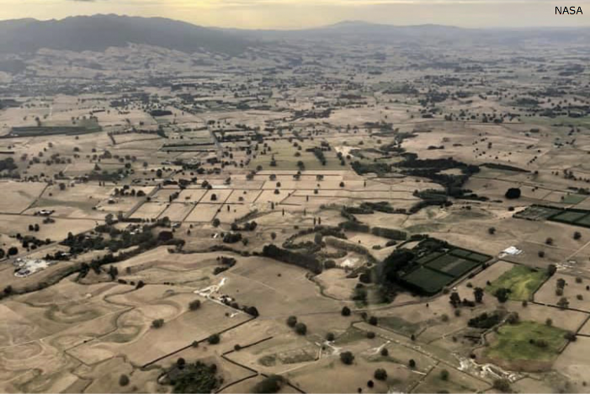  Waikato drought – this image using data from April 2020 was taken using the Moderate Resolution Imaging Spectroradiometer (MODIS) on the Aqua satellite. | 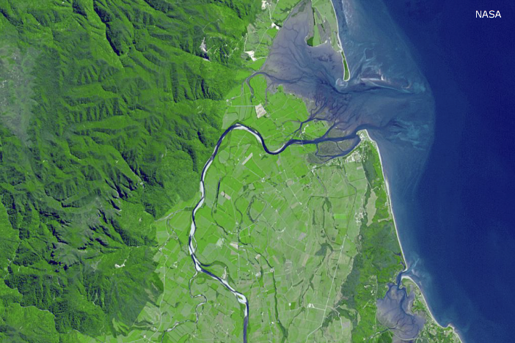  Farewell Spit, New Zealand – this image using data from February 2001 was taken using the Advanced Spaceborne Thermal Emission and Reflection Radiometer (ASTER) on the Terra satellite.

Questions to practise observation and interpretation using textures, patterns and shapes:
- Which landforms or objects have texture (so they look three-dimensional)?
- How does texture help you identify what is in the images?
- What patterns are in the images?
- What do you think the patterns show?
- What shapes do you see?
- How do you think these shapes were formed?
- Which of the shapes and patterns are natural?
- Which of the shapes and patterns are the results of humans?
- What are the reasons for your answers?
- What prior knowledge did you use to recognise textures, patterns and shapes in the images?
- Who might be interested in these images and how would they use the information?

