ACTIVITY: Validating remote sensing observations

Activity idea

In this activity, students use satellite images of their school or other well-known locations to practise the science capability ‘Gather and interpret data’. Comparing what they observe from space with what they directly observe on the ground enables students to explore the concepts of data validation and ground-truthing. Validation and ground-truthing are vital for ensuring the accuracy of the information we get from satellites.

By the end of this activity, students should be able to:
- observe a satellite image and describe what they see
- make inferences about what is in the image (predictions about what they cannot directly observe)
- observe the same location at ground level and describe what they see
- make comparisons between the observations to ensure a match with the satellite image/location and observed objects
- discuss whether their inferences are correct
- discuss how both sets of observations provide more-accurate detail when used together
- discuss the importance of validating and ground-truthing data provided by satellites. (optional).

For teachers

Introduction/background

Remote sensing satellites are continuously circling the Earth – providing data about methane emissions, animal populations and tectonic plate movements. Unlike humans out in the field with sample collection bottles, cameras or GPS receivers, the sensors are not in direct contact with what is being observed, so how do we know their observations are accurate?

Scientists validate satellite remote sensing data by comparing it with data they collect via direct observation and measurement. When they use data to test the accuracy of a scientific model, it is called ground-truthing. Data collected by remote sensing satellites is often processed by computer software models, so ongoing validation and ground-truthing are used to ensure and improve the accuracy of the information that satellites provide.

This activity helps students discover the benefits of using satellite and on-the-ground observations to build a more accurate picture (or model) of what is being observed. Careful teacher questioning can aid students in transferring this experience to more-abstract satellite measurement scenarios.

Real-life examples of validation and ground-truthing are found in these articles:
- Counting penguins from space
- Measuring methane from space
- Remote sensing and water quality
- Satellites measure sea ice thickness

Supporting the science capability ‘Gather and interpret data’

The activity also supports students’ understanding of the science capability ‘Gather and interpret data’ – exploring the differences between observations and inferences.

Observations are what students can see both in the satellite image as well as the actual items they observe on the school grounds. Inferences are the conclusions they draw from the observations. One way to separate observations from inferences is to begin observations with the words ‘I see’ and begin inferences with the words ‘I think’.
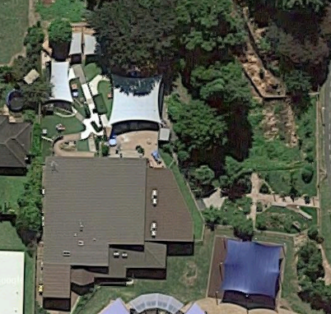
For example:
- In the satellite image, students observe (see) a white rectangle situated above the ground and they infer (think) that this is a shade sail. They may also infer that it covers playground equipment.
- While making on-the-ground observations, students observe (see) a wooden structure filled with sand and a white, rectangular object above it.
- Students’ on-the-ground observations have validated (proved) their inference that the white object is a shade sail and they have created a more detailed picture than the satellite image could offer.

This simplified process is similar to how (and why) scientists make field observations to validate (prove) the accuracy of satellite data.

What you need

- Copies of Observing a satellite image
- A screenshot of your school from the satellite function of Google Maps or similar (you can turn off the label option in satellite view)
- Devices to take photographs
- Paper for recording ideas

Teaching suggestions

Consider the developmental understanding of your students and challenge them appropriately. The handout Observing a satellite image is in Word format, so edit the document to include language and questions to suit your students.

Make this more manageable for younger students by choosing a limited number of areas to make on-the-ground observations. Some students may need to repeat this activity in a few scenarios to make the connection between a satellite view and a ground-level view.

Challenge older students by using a screenshot of a zoo or sports complex.

What to do

- Use Observing a satellite image to introduce the activity and to clarify the differences between observations and inferences. Work through the questions and generate ideas on how to gather additional data/evidence.

- Display a screenshot of your school or local area of interest.

- Work through the same set of questions in Observing a satellite image.

- Decide how students will collect information at ground level.

- Discuss how to locate and match up a two-dimensional image on a map to the three-dimensional location at the school.

- Move to the locations and collect information via photographs and/or written observations.

- Collate the data between the satellite image and the on-the-ground observations. Use some of the following questions to deepen understanding:
- What did you observe? Describe your observations.
- What have you been able to observe that the satellite was unable to record?
- How do you know that your observations are of objects in the satellite image?
- What evidence backs up your ideas that the observations match?
- Are your inferences about what you could see correct? Explain why you think this way.
- Are your inferences about what you couldn’t see correct? Explain why you think this way.
- Did combining the satellite data with the on-the-ground data give you a better understanding of your school (or chosen location)? How or why?
- When or why would it be important to gather the kind of information we’ve just gathered?
- How do your actions mirror those of scientists who collect data to inform or validate satellite algorithms? (optional)

Alternative conceptions

Young learners tend to perceive their surroundings from their own perspective – they have an egocentric frame of reference. It may be difficult for them to conceptualise the reciprocity of viewpoints from a two-dimensional map to three-dimensional objects.

Extension ideas

If you have access to a drone with photo capabilities, use images taken by the drone rather than online images.

Look for examples of data validation in one or more of the following articles:
- Counting penguins from space
- Measuring methane from space
- Remote sensing and water quality
- Satellites measure sea ice thickness

Observe the image Radar images of dairy pasture on two different days and discuss how students could validate the satellite pasture biomass data.

For students

Observing a satellite image

Remote sensing satellites create images used in online maps. We can gather accurate information from these images but some information remains hidden from us. In order to be absolutely certain, we need to gather more evidence than what the satellite image provides.

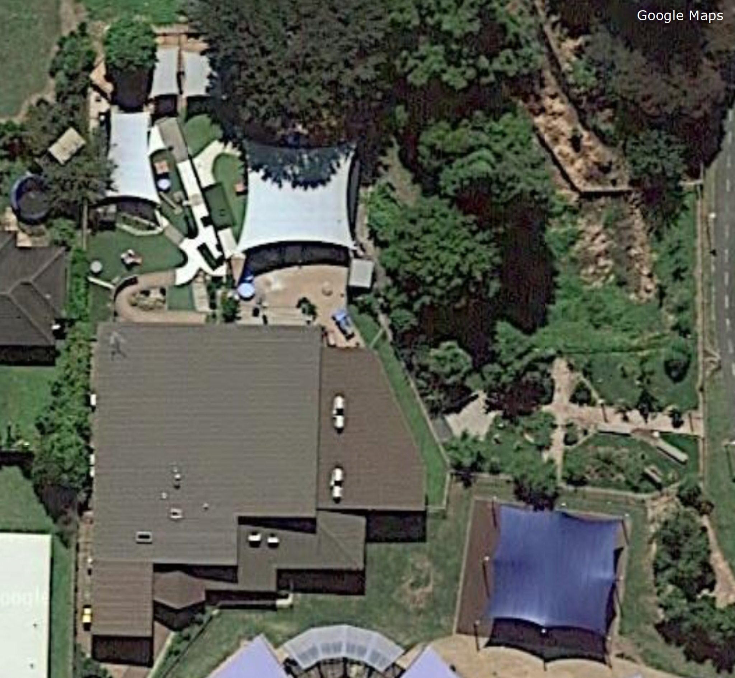

What to do

- Look closely at this satellite image and discuss what you observe. Begin your observations with the words ‘I see’.

- What are some of the objects in this image? Begin your ideas with the words ‘I think’.

- Are there objects in the image that you think are hidden? Why do you think that?

- Discuss what you see in the image with others.

- Discuss what you think is in the image (both seen and unseen) with others.

- What information do you agree with?

- What information do you disagree with?

- How would you be able to gather more evidence so that everyone is in agreement? Write down some of your ideas.

