**ACTIVITY: Analysing satellite data for albatross research**

**Activity idea**

This activity uses actual data from a Chatham Islands monitoring site gathered from a satellite image. It is part of a suite of activities that support the [Build a satellite](https://www.sciencelearn.org.nz/embeds/149-build-a-satellite) interactive. The activity supports students to engage with the science capabilities.

By the end of this activity, students should be able to:

* discuss why scientists monitor species like the toroa/northern royal albatross
* discuss the advantages and disadvantages of using satellites to monitor albatross
* use satellite images to engage with one or more of the science capabilities.

**For teachers**

***Introduction/background***

[Toroa/northern royal albatross](https://www.sciencelearn.org.nz/resources/3107-how-are-satellites-helping-albatross) spend about 85% of their time on the Southern Ocean. They only spend time on land to nest during the breeding season. Some of their nesting sites are in remote places near the Chatham Islands. Monitoring of albatross populations is crucial to the success of any conservation efforts, but these sites can be tricky to reach.

Using remote sensing via satellites has many advantages when it comes to monitoring species:

* The sensors are not in direct contact with what is being observed so the observations do not disturb the birds, nesting sites or other areas of interest.
* Fieldwork to monitor the species provides a single snapshot in time. Satellites are able to collect data much more frequently.
* The data collection involves much less risk as those undertaking the monitoring are not required to travel to the site or perch on sea stacks. (Sea stacks are steep, near-vertical columns of rock near the coastline.)
* There are cost savings associated with remote sensing.

It is still important to visit remote locations for fieldwork when possible. Scientists need to ground-truth (test the accuracy) of the satellite data. This means comparing information from a monitoring event with a satellite image. This helps to calibrate remote sensing data.

***Interpreting the satellite data***

The activity [Interpreting observations from satellite images](https://www.sciencelearn.org.nz/resources/3142-interpreting-observations-from-satellite-images) explores strategies that scientists and others use when making sense of satellite data:

1. Use colour.
2. Use map skills – orientation and scale.
3. Use prior knowledge.
4. Look for textures, patterns and shapes.

For example, with the satellite images used in this activity:

* colour provides visual clues about the terrain and the location of the albatross
* scale provides visual clues regarding the size of the sea stack and distance between birds
* prior knowledge of sea stacks helps with interpreting the images and understanding why monitoring access is difficult
* patterns and shapes are used to identify the albatross.

***Satellites and alternative conceptions***

How Earth observation satellites actually function may differ from how satellites appear to function in fictional media. Following are some alternative conceptions students may hold about satellites and the scientifically accurate concepts:

* Satellites are always overhead. In reality, satellites have orbits and they fly really quickly. Satellites in low Earth orbit travel about 28,000 km/h. Depending on the type of orbit, a satellite may only cover the same spot every few days or even every few weeks.
* People who operate satellites can ‘zoom’ the satellite’s instruments to see something in a higher resolution. In reality, satellites have a fixed view at a set resolution. Those who use the downloaded data may be able to magnify the image for a closer look.
* Satellites can see everything. In reality, satellites that take optical images (photographs) cannot see through the clouds so the images they take may not be of use to those monitoring what is under the clouds.
* Scientists can switch to other types of sensing like radar if clouds get in the way. In reality, this may be a possibility if the satellite carries multiple sensors or the scientist has access to different satellites that also monitor the location. In this scenario, radar (which can ‘see’ through clouds) would not work because a bird is too small for the radar signal to pick up.

Keep these in mind when discussing the satellite images so that students have the opportunity to alter their thinking.

***Satellite data and the science capabilities***

This activity enables students to build their understanding of the science capabilities. The most obvious capabilities are ‘Gather and interpret data’ and ‘Interpret representations’. However, students will also be critiquing and using evidence and engaging with science if they want to delve more deeply into toroa conservation. It may be helpful to choose the science capability you would most like to build and focus on this rather than trying to cover multiple capabilities.

***What you need***

* Access to the article [How are satellites helping albatross?](https://www.sciencelearn.org.nz/resources/3107-how-are-satellites-helping-albatross)
* Access to an online map such as [Google Maps](https://www.google.com/maps/@-43.642953,-179.9157241,1023742m/data=!3m1!1e3)
* Student handout Satellite data from a Chatham Islands albatross nesting site

***What to do***

1. Use the article [How are satellites helping albatross?](https://www.sciencelearn.org.nz/resources/3107-how-are-satellites-helping-albatross) to review information about albatross and why it is important to monitor their nesting sites.
2. Use [Google Maps](https://www.google.com/maps/@-43.642953,-179.9157241,1023742m/data=!3m1!1e3) to view the location of the Chatham Islands archipelago. Zoom in on the smaller outer islands and discuss how scientists might access these seabird habitats.
3. Discuss the advantages and disadvantages of using satellites to monitor albatross.
4. Use the prompting questions below to analyse the images taken from the Earth observation satellite and the data they provide.

*Gather and interpret data*

Use the image Looking at the island:

* What can you observe in the image of the island? Begin your observations with the words ‘I see’.
* What inferences can you draw? Begin your inferences with the words ‘I think’.
* What visual clues are there in the image to help your observations and inferences?

Use the image Looking at the data:

* What can you observe in the image of the albatross nesting site? Begin your observations with the words ‘I see’. (Discuss both images on the right-hand side.)
* What inferences can you draw? Begin your inferences with the words ‘I think’.
* What visual clues are there in the images to help your observations and inferences?

*Critique evidence*

Use the image Looking at the data:

* How was this data collected?
* How has the data been recorded? (How were the albatross identified?)
* How do we know the data is reliable?
* How confident are you that these are albatross and not rocks?
* How confident are you that these are albatross and not other seabirds?
* How can you (or someone else) find out if you are actually counting albatross?
* Do you think you’d get the same results the next time the satellite passes over this island?

*Use evidence*

Use the image Looking at the data:

* Who might be interested in using this evidence?
* How might the evidence help them?
* How would having images from this site over several seasons/years help the people who monitor albatross populations?

*Interpret representations*

Use the image Looking at the island:

* What type of representation is this?
* What purpose does this representation/image serve?
* Are there components to help you interpret the representation? What are they?
* Using the scale, how wide is the island from side to side? How long is the island from top to bottom?
* Is this data qualitative or quantitative?
* Is there information missing from this representation?
* Is there anything you’d like to know more about but cannot get the information from this image?

Use the image Looking at the data:

* What type of representation is this?
* What purpose does this representation/image serve?
* Why do you think there are two images on the right-hand side?
* Are there components to help you interpret the representation? What are they?
* Using the scale, how wide is the nesting site from side to side? How long is the nesting site from top to bottom?
* How far apart are the nests from one another?
* How many albatross/nests are in this location?
* Are there methods that you can use to help ensure the accuracy of your counting (for example, drawing grid lines or using a ruler)?
* Is this data qualitative or quantitative?
* Is there information missing from this representation?
* Is there anything you’d like to know more about but cannot get the information from this image?

*Engage with science*

* How important is this information?
* How can this information influence people’s decisions or actions?
* Now that you have this information, what might you do next?
* How can you get this information to the public?

1. Use the extension ideas below to extend students’ thinking or experiences in this area.

***Extension ideas***

Investigate whether there is an area of the school or neighbourhood that is of similar size to the island. (Google Maps has a scale at the bottom right-hand side of the screen. Zoom in or out until the scale matches the distance you’d like to compare between the island and a local area.)

The image in this activity is useful for counting the number of nesting sites but it doesn’t provide information about the habitat. The article [How are satellites helping albatross?](https://www.sciencelearn.org.nz/resources/3107-how-are-satellites-helping-albatross) mentions issues such as storms and heatwaves. Challenge students to find this information about the Chatham Islands climate. NIWA has information on [regional climatologies](https://niwa.co.nz/node/110344).

**For students:** **Satellite data from a Chatham Islands albatross nesting site**

***Looking at the island***

This is a [satellite image of a small island in the Chatham Islands archipelago](https://www.sciencelearn.org.nz/images/4892-satellite-images-of-an-albatross-breeding-site). The islands are breeding grounds for seabirds, including birds that are endemic to the Chathams. This island is of interest to scientists who monitor toroa/northern royal albatross. It is a known nesting site of the toroa.

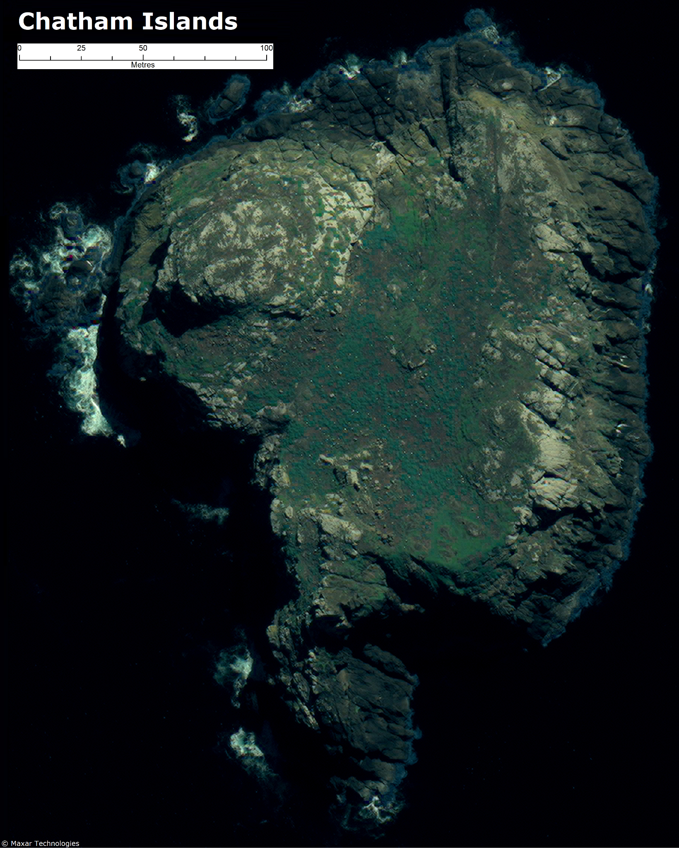

***Looking at the data***

Note: This set of images is also available to download as a [PDF](https://static.sciencelearn.org.nz/documents/files/000/001/155/original/Satellite_images_of_an_albatross_breeding_site.pdf?1655434584).

The images on the right are of a small area on the island. Some of the small white dots in the upper right-hand image are likely to be nesting toroa. The lower right-hand image has been annotated with red triangles to indicate identified nesting birds.

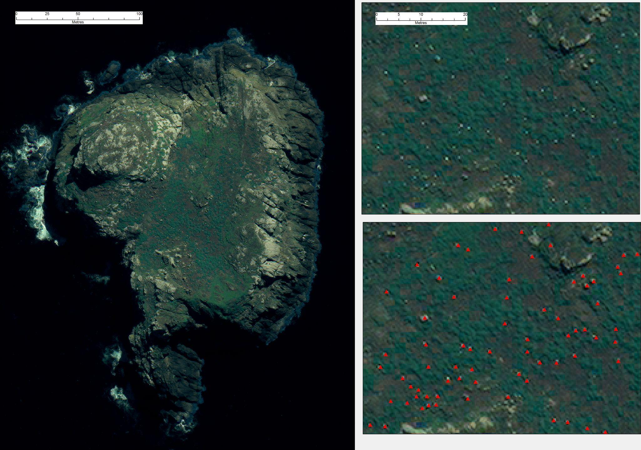

Data manipulation on satellite images from Fretwell, Peter & Scofield, R. & Phillips, Richard. (2017). [Using super-high resolution satellite imagery to census threatened albatrosses](https://onlinelibrary.wiley.com/doi/10.1111/ibi.12482). Ibis. 159. 10.1111/ibi.12482.