**ACTIVITY: Micro:bit and space projects**

**Activity idea**

In this activity, students will use micro:bit to investigate or model an idea about space.

By the end of this activity, students should be able to:

* code a micro:bit to access at least one of its sensors
* gather data from a real-world investigation using micro:bit
* discuss how they are modelling an idea about space.

# For teachers

## Introduction/background

Satellites and rockets are not easily accessible for most schools in New Zealand. Understandably, this can make experiencing space first hand somewhat difficult! However, without direct access to space-related technology, students can still carry out hands-on investigations. This activity explores how micro:bit can be used to investigate satellites and rockets.

***Investigating***

Scientists use a range of [ways of investigating](https://www.sciencelearn.org.nz/image_maps/111-ways-of-investigating-in-science) that align with the New Zealand Curriculum Nature of Science investigating strand. Pattern seeking and modelling investigations work well with micro:bit. (For more information about micro:bit and its capabilities, see the [Micro:bit home page](https://microbit.org/) and [introductory activities page](https://makecode.microbit.org/). The online micro:bit community features a huge range of resources for educators to explore.)

[Pattern seeking](https://www.sciencelearn.org.nz/videos/2062-pattern-seeking) involves observing and recording natural events or carrying out experiments where the variables can’t easily be controlled. In pattern seeking, it is still important to note and record variables or factors. The investigator needs to try to identify patterns that result from these variables.

[Modelling](https://www.sciencelearn.org.nz/videos/2068-modelling) can be used to help scientists understand how a process works, validate thinking, predict changes or explain ideas or a concept. Models are developed to better understand Earth’s processes like ocean currents or climate. More than one model can be used to explain different aspects of the same concept. For example, there are several models that help describe the structure of the atom.

***Micro:bit sensors – versions 1 and 2***

Micro:bit has a range of sensors that can be used to gather data about movement, light, temperature and magnetic fields. Older versions (V1) can be connected to headphones to produce sounds while the newer version (V2) can sense and play sounds without external speakers. This means that a micro:bit can be attached to a rocket, launched from a catapult or paired with plant-growing experiments, where gathering and interpreting data is important, or used to make interactive displays.

***Coding with micro:bit***

Micro:bit is coded using the [makecode.microbit.org](https://makecode.microbit.org/) platform and will run in the browser of any mobile device, Chromebook or laptop. The built-in simulator means students do not need micro:bits while creating the code – all coding can be simulated before sending to a micro:bit.

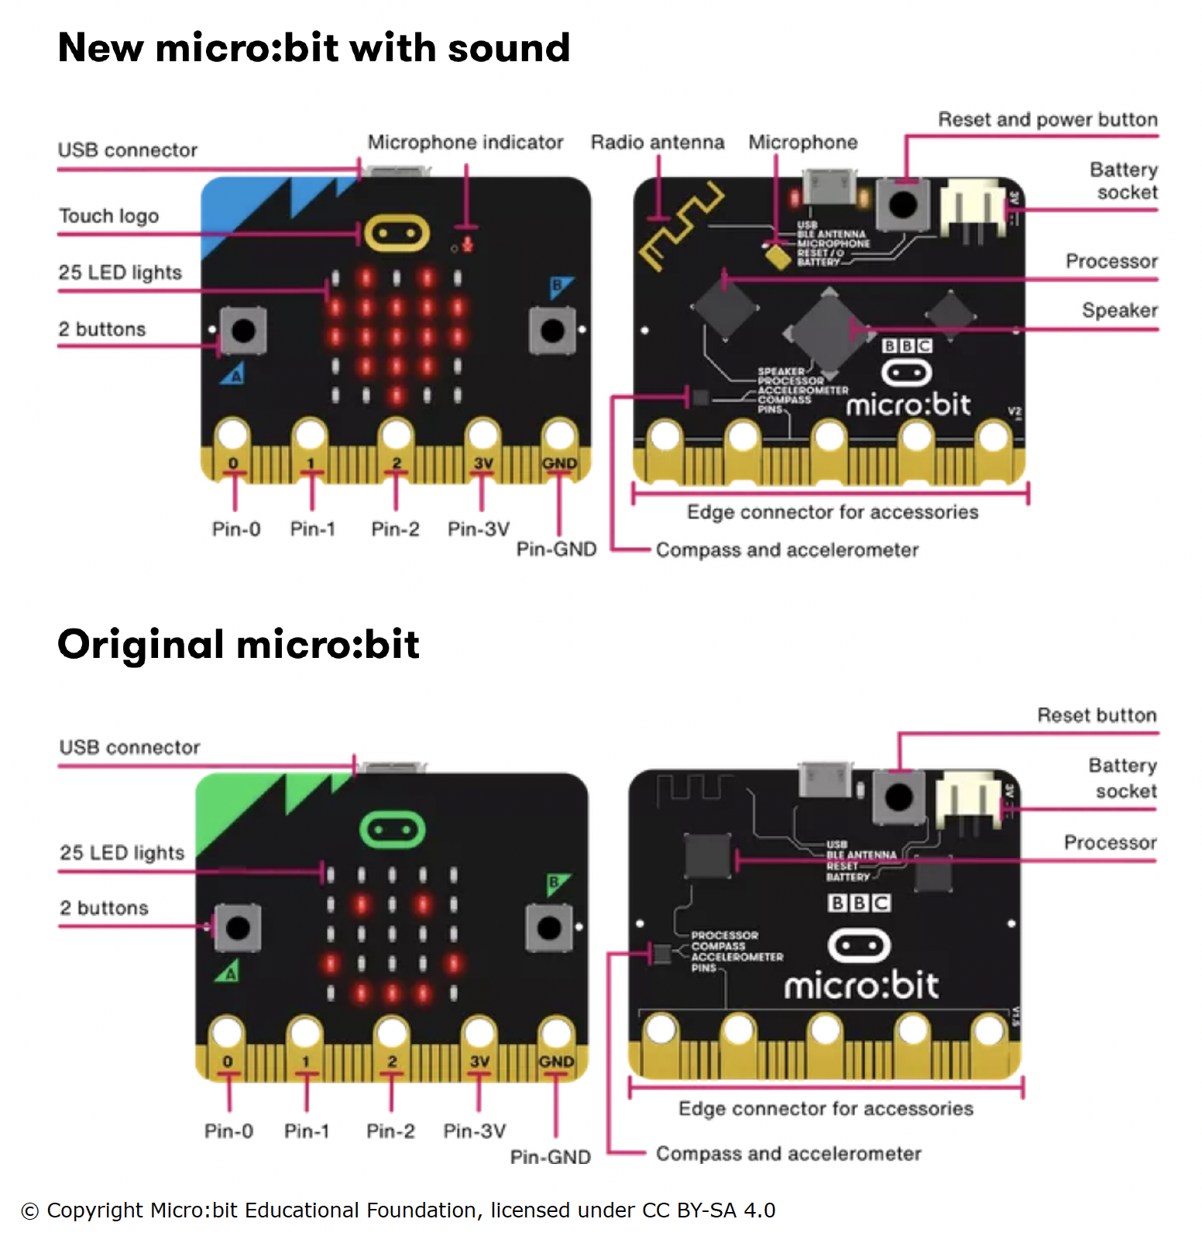

***Ideas for investigations using micro:bit***

**Water bottles and acceleration**

[Water bottle rockets](https://www.sciencelearn.org.nz/resources/406-water-bottle-rockets) are fun to make and enable students to investigate the variables that affect the height and distance travelled by the rocket. Use a micro:bit on the rocket to gather data about the rocket’s acceleration and send the information via radio to a second micro:bit on the ground. A step-by-step process to measure changes in acceleration as the bottle rocket lifts off and falls back to the Earth can be found [here](https://makecode.microbit.org/courses/ucp-science/rocket-acceleration). It is one of several science experiments on the [makecode.microbit.org](https://makecode.microbit.org/courses/ucp-science) website.

**Parachutes and deceleration**

Sometimes artificial objects are retrieved from space. In the case of objects that have safely decelerated in the upper atmosphere, this often means a period of freefall requiring a parachute when they are within the troposphere. Code and attach a micro:bit to a falling object to check the effectiveness of a parachute. The parachute designer might want to check the object’s temperature, the rate of deceleration, the fall time or the noise around the object. Students could be supported to flowchart a process like the one below and then use this to craft the algorithm for the micro:bit:

* The micro:bit is attached to or included in the craft.
* The micro:bit’s A button is pressed to start the measurement system.
* The craft is sealed and dropped from a height. The micro:bit senses the free-fall and starts the measurement system.
* When it lands and senses no movement for 3 seconds, the micro:bit stops sensing.
* The user reads out the readings by pressing the B button to cycle through each of the different values.

**CubeSat simulations**

CubeSats are used to hold [miniature autonomous laboratories](https://www.sciencelearn.org.nz/resources/3136-cubesats-crystals-and-microgravity). Growing food plants requires water, which is a precious resource on Earth but even more so in space! To test/simulate one aspect of growing food in space, use a micro:bit to record soil moisture levels. Step-by-step instructions to track soil moisture can be found [here](https://makecode.microbit.org/projects/soil-moisture) – it’s also from [makecode.microbit.org](https://makecode.microbit.org/courses/ucp-science).