**ACTIVITY: Build a 3D satellite model**

**Activity idea**

In this activity, students make a physical model of the satellite shown in the interactive [Build a satellite](https://www.sciencelearn.org.nz/embeds/149-build-a-satellite) interactive. Making a physical model will help students to see how parts of the satellite relate to each other and how those parts interact. Students will also consider why particular parts of the satellite are needed.

By the end of this activity, students should be able to:

* construct a simple model satellite made from light card using a template pattern
* explain why a satellite needs solar cell panels, an aerial and an outer casing for heat control.

## For teachers

## Introduction/background

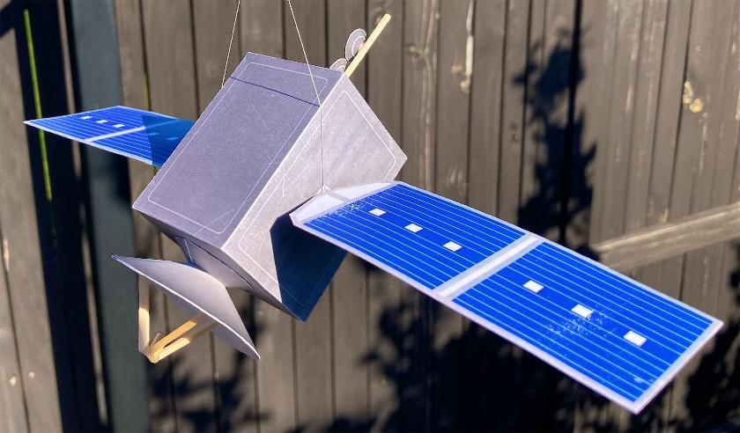

Satellites come in a range of shapes and sizes depending on their purposes and where they will be positioned in space. The satellite in the [Build a satellite](https://www.sciencelearn.org.nz/embeds/149-build-a-satellite) interactive is a generalised one and comprises a number of key components that most satellites need.

The 28 cm long satellite model in this activity is even more simplified since only four external components are visible: an outer casing for heat control that forms the body of the satellite, solar cell panels, an aerial and a radar dish.

The radar dish was chosen to be part of the model since it appears in the standard satellite image in the latter part of the interactive from the ‘select orbit’ section onwards.

Students can gain additional technological knowledge and technological practice skills in building the model such as learning to:

* follow detailed instructions
* accurately cut out a range of light cardboard shapes
* manipulate light cardboard into different shapes
* use a range of cutting and measuring tools safely
* use a range of glues and decide which glue is most suitable for different joins.

## What you need

* Wooden skewer (4 mm diameter)
* 4 x wooden match sticks
* A small piece of plasticine or Blu-Tack
* 30 cm ruler
* Scissors
* Sharp craft knife (to be used under supervision)
* Junior hacksaw or coping saw (to cut the skewer)
* Cutting board to protect table or desk
* Glue – fast-setting glue such as UHU, contact adhesive and/or hot glue gun and glue sticks
* [Model satellite template](https://static.sciencelearn.org.nz/documents/files/000/001/161/original/Build_a_3D_satellite_model_%E2%80%93_template_v3.pdf?1658467582) – printed or photocopied onto light cardboard
* Student handout: Make the satellite used in the Build a satellite interactive

## Teaching suggestions

The student handout: Make the satellite used in the Build a satellite interactive has detailed instructions how to make the model shown at the start of this document using a [template](https://static.sciencelearn.org.nz/documents/files/000/001/161/original/Build_a_3D_satellite_model_%E2%80%93_template_v2.pdf?1657683484).

Light card with a thickness of 225 gsm is recommended. Other thicknesses are available from 210 to 240 gsm and are thin enough to be used in printers and photocopiers.

1. Prepare the materials and tools needed for the number of models you plan students to construct. Have a few spares of the materials available in case students make mistakes.
2. Ask students to access the [Build a satellite](https://www.sciencelearn.org.nz/embeds/149-build-a-satellite) interactive (or display the interactive using a class data projector) and navigate the game to an image of the satellite with the radar sensor selected. Ask students to identify the components of the satellite that are visible from the outside. 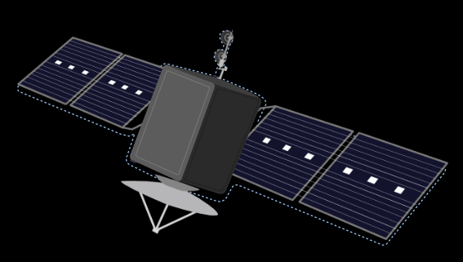
3. Start students in their construction of the model satellite after reminding them how to use the glue and tools safely.
4. While students are working, ask students to think about why the solar panels, aerial and satellite body are needed. They could do this especially when waiting for glue to dry or waiting for tools that other students are using. As a hint, you could direct students to the essential satellite components screen in the interactive. Tell them to hover their mouse over the three dots that appear when they mouse over a satellite component. This brings up a short explanation of what each component does. Graphical user interface, application

   Description automatically generated

## Extension ideas

* Some students might like to design their own optical camera to place on the satellite body instead of the radar dish. Refer to the interactive for an image of the camera.
* Some students might want to build a simple electrical circuit inside the satellite body to make one or two light emitting diodes (LEDs) light up on the satellite.
* “How might the satellite components work?” is a deeper question than “Why are they needed?” If you want to follow this up with your students, they could make internet searches such as “how do satellite solar panels work?” and “what heat control methods do satellites use?” The video [Solar cells](https://www.sciencelearn.org.nz/videos/859-solar-cells) is a good place to start.

## Construction alternatives

This construction, especially the use of fast-setting solvent-based glues can be challenging for some students, so here are a number of easier alternatives. (Make sure you trial making the model using the construction method you consider appropriate for your students.)

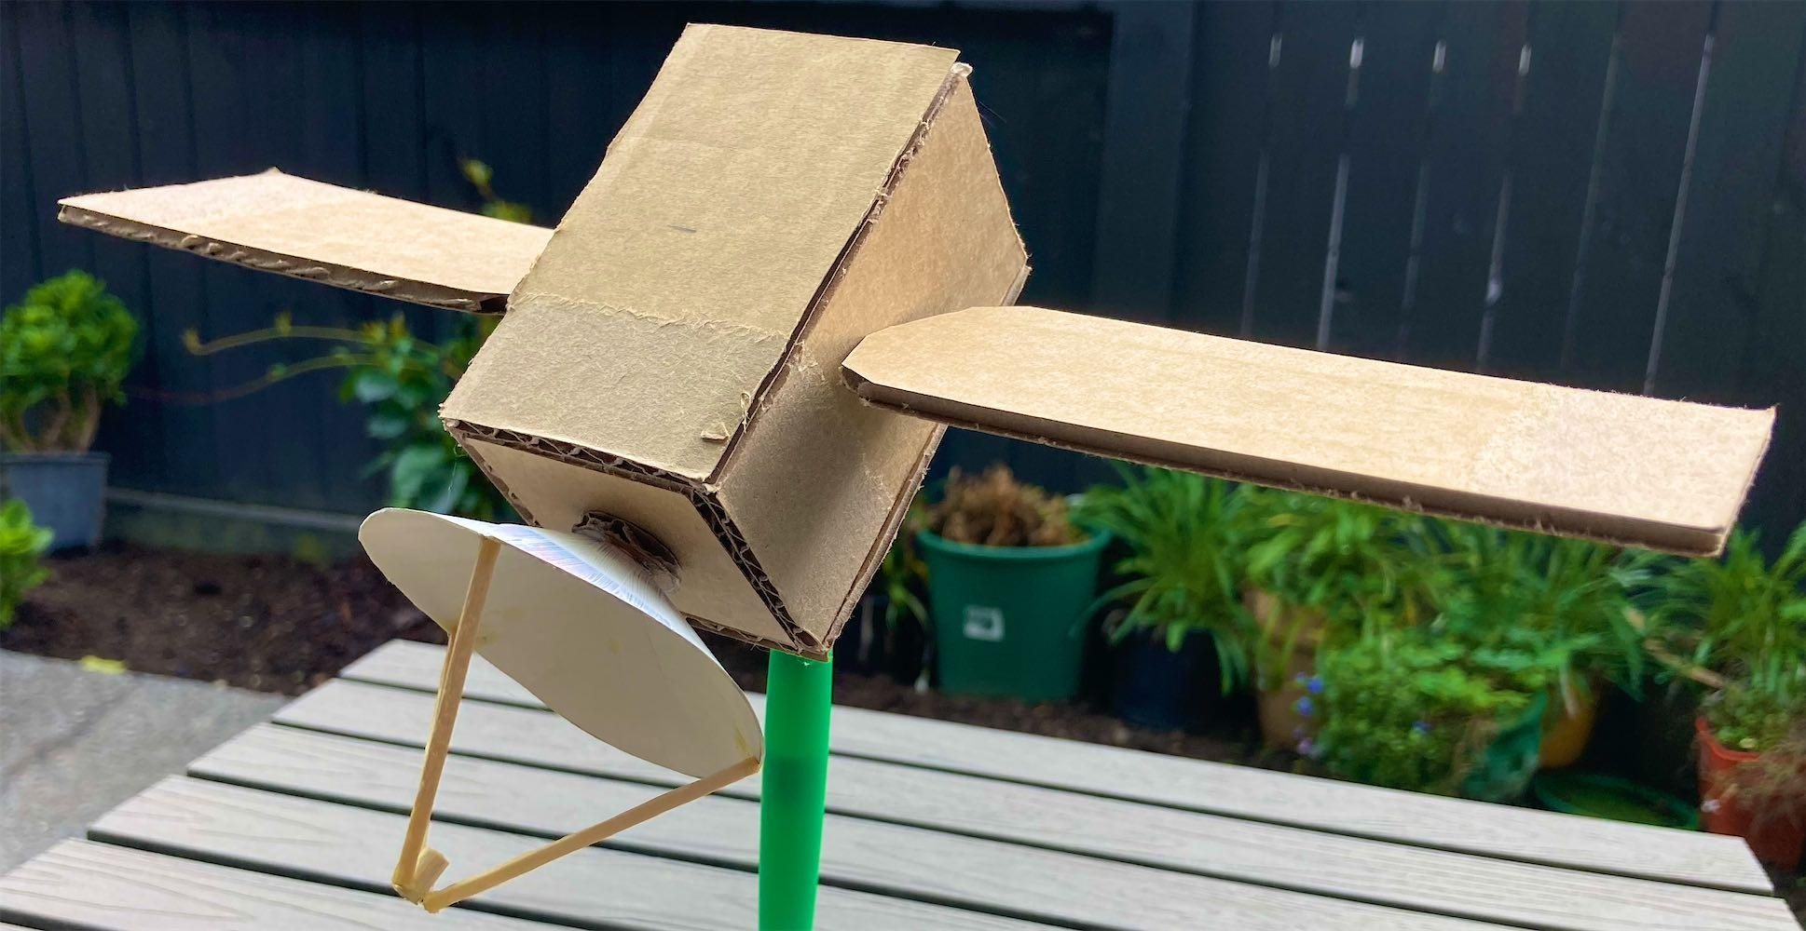

Use the template sheets as a guide to cut the body and solar panels from thin corrugated cardboard. Remember to allow for the thickness of the cardboard when cutting out panels for the satellite body. Hot glue can be used to stick the panels together and attach the solar panels to the ends of the skewer. The radar and aerial dishes can still be made from light card or even paper (since there are two layers glued together that give the dishes more strength). This image shows an early prototype using corrugated cardboard construction. The dish was made from cereal box cardboard.

Students could paint/decorate/personalise the model how they wish or use scissors to cut out the body panels and solar panels from template sheets printed on paper or very light card (160 gsm). Cut the tabs off the body panels as they would not be needed and cut along the dotted lines of the solar panels to separate the top and bottom of each panel. Students could then use a glue stick to attach these onto the corrugated cardboard surfaces before attaching the skewer and solar panels. Note: 160 gsm card is too flimsy to make the satellite body and solar panels by themselves.

Here is an alternative method to attach the solar panels that hides the skewer ends. Leave a gap around the centre of the solar panel when applying glue between the top and bottom and push panels together. Once the glue is dry, use the sharp end of the remaining short length of skewer to gently prise open the centre of the solar panel where the skewer in the body will attach. Push the solar panel onto the skewer end and gently squeeze the panel around the skewer end. Remove the solar panel off the skewer end. Squeeze a small amount of fast-setting glue down the cavity formed in the solar panel and immediately push the panel onto the skewer end. Adjust the panel to stick out at right angles from the satellite body. Hold in position until the glue sets. Repeat for the other solar panel making sure to align it with the first solar panel.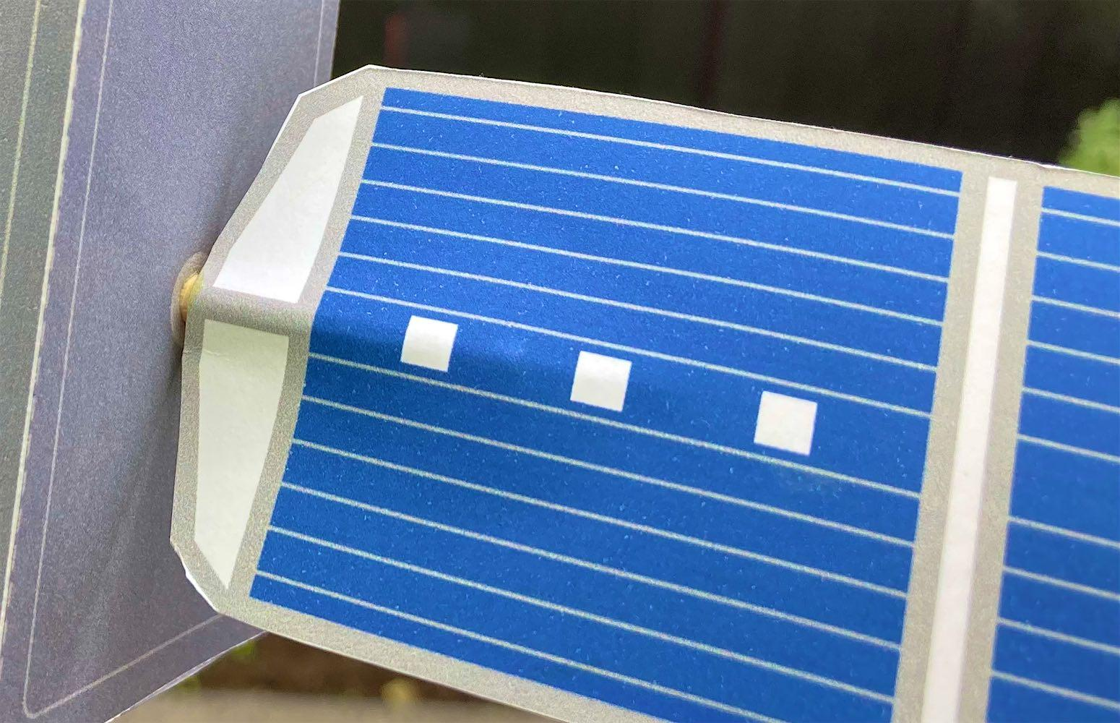

This image shows a detail of the aerial from the interactive. It is too complicated to use directly in this model so it has been simplified to two small dishes attached to a single post (a matchstick). You could get students to paint the matchsticks white in the aerial and the radar dish to be more in keeping with the satellite in the interactive. Students could paint the insides of the radar and aerial dishes silver. You may wish to simplify the arrangement of the three matchsticks and small skewer length on the radar dish by omitting the skewer and simply glueing the matchsticks together. The small skewer length represents the radar transmitter/receiver unit. 

To further simplify construction, you could prepare parts of the model before your teaching session such as pre-cutting the skewers into 11 cm lengths. The ends of each skewer should be made smooth using sandpaper to make it easier to push it through the holes in the satellite body.

# 

# For students: Make the satellite used in the [Build a satellite](https://www.sciencelearn.org.nz/embeds/149-build-a-satellite) interactive

***The satellite body***

(Satellite Template Sheet: 1)

1. Use scissors to carefully cut out the satellite body. (If you are allowed, use a ruler and a craft knife instead of scissors.)A picture containing stationary, envelope, businesscard

   Description automatically generated
2. Use the pointed end of the skewer to gently push a hole in the centre of each side panel of the body where marked. This hole should be the same size as the skewer because later the skewer will be pushed through the body using these holes.
3. Use the pointed end of the skewer to gently push a **small** hole in the centre of the top panel where marked. This hole needs to be small because it will later have a matchstick pushed into it.
4. Use a ruler and the pointed end of the skewer to score along the dotted lines (but not the dotted circle on the bottom) and along where each of the seven tabs meet the different body panels. This makes it easier to do the next step.
5. Fold the body at each of the five dotted lines and fold all the tabs. Make sure all folds have sharp creases. Check that folds are accurate by folding the sides together and seeing if they fit together neatly.
6. In turn, apply glue onto a tab and hold it to the inside of the panel it meets. The numbers show the order in which you should glue the tabs. Both tabs numbered 3 should be glued at the same time. All tabs numbered 4 should be glued at the same time.
7. If you want to, you can design your own logo or name for your model satellite, cut it out and glue it to the front or the back panel.

***The mount for the radar dish***

1. Carefully cut out the radar dish mount and bend the three tabs underneath. Gently bend the mount so that it forms a cone when the tab at the end of the semicircle slides under the other end.
2. Glue the two ends of the semicircle together.
3. Put glue on all three tabs and glue the mount to the bottom body panel using the dotted circle as a guide. Another method that gives a stronger join is to run a thin layer of glue along the bottom circular edge of the mount. Then place the mount on the dotted circle and hold it in place until the glue dries.

***The radar dish***

(Satellite Template Sheet: 2)

1. Cut out the outside dish. Gently bend the outside so it forms a cone when the tab at one end slides under the other end. This will look like a larger version of the radar dish mount. Apply glue to the tab and glue the ends together.Logo

   Description automatically generated
2. Cut out the inside dish. Gently bend the inside so it forms a dish when the tab at one end slides under the other end. Apply glue to the tab and glue the ends together.
3. Glue the inside to the outside to form the radar dish so it has three small circles on the inside and the darker grey printing on the outside. Using scissors, trim around the edge of the dish if the inside and outside have not quite matched evenly.
4. Run a line of glue along the circular upper edge of the radar dish mount and gently place the radar dish onto the mount so the dish sits up evenly and is not at an angle to the bottom panel. Hold until the glue sets.
5. Cut three matchsticks to 3 cm lengths. Form a tripod with the matchsticks by placing their ends into a lump of plasticine or Blu-Tack. Place the tripod on the radar dish and glue each matchstick end one-by-one on top of the three small circles on the inside of the dish.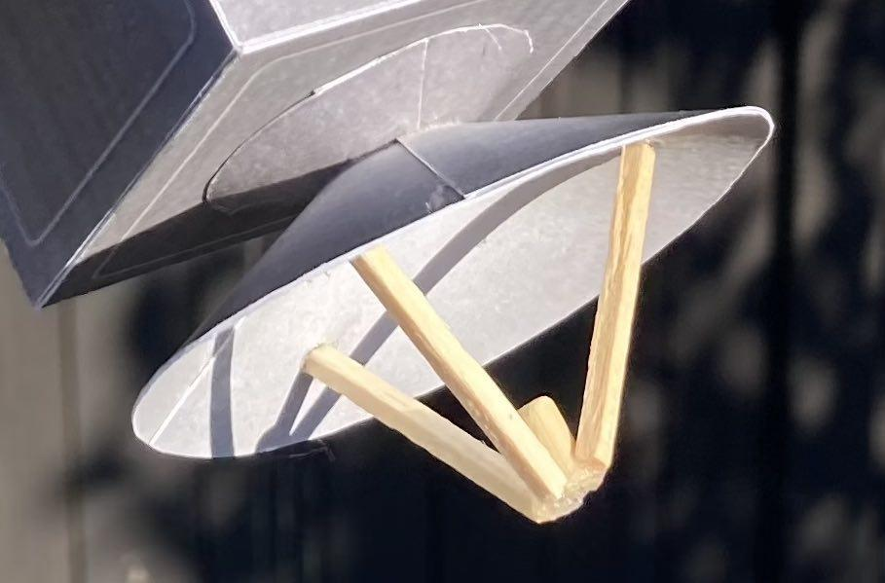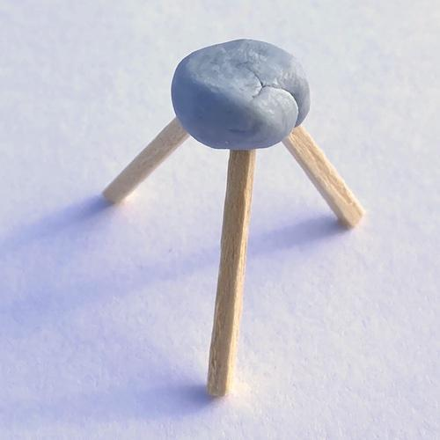
6. Remove the plasticine/Blu-Tack and glue the top ends of the matchsticks to a small 7 mm length of skewer (cut using the junior hacksaw).

***The solar panels***

1. Cut out both panels and score along the dotted lines between the top and bottom panels using a ruler and pointed end of the skewer.
2. Fold each top and bottom together. Open them again, apply glue to the inside and glue each top to its bottom.
3. carefully push the skewer into one hole on a side panel of the satellite body and out through the hole in the other side. Adjust the skewer until there is 3 cm sticking out from the side panel where the skewer was first inserted.A picture containing text

   Description automatically generated
4. Make a mark on the other pointy end of the skewer 3 cm out from the other side panel. Cut off the skewer at that mark using the junior hacksaw.
5. Run a generous line of glue along one of the 3 cm lengths of skewer making sure to keep the glue away from the side panel. Press the underside of one of the solar panels onto the glue so that the solar panel is at right angles to the side panel. Hold this until the glue has dried.
6. Repeat this with the second solar panel and length of skewer poking out of the other side panel. Make sure that this solar panel is aligned with the first one.

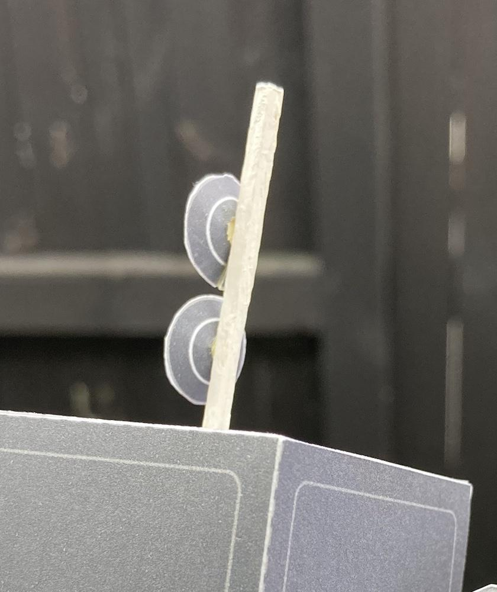

***The aerial***

1. Apply glue to the end of a matchstick and push it a few millimetres into the hole made earlier in the top body panel. Make sure the matchstick points out at right-angles from the top panel.
2. Cut out, bend and glue the inside and outside sections of the aerial dishes in the same way as you did for the larger radar dish.
3. Now glue each dish to the matchstick. Hold each dish in place until the glue is dry.

***Hanging your satellite***

1. Tie each end of a short length of string or thread to each side of the body where the solar panels are attached. Then tie a longer length to the middle of the first string and hang your satellite from some suitable support. You can rotate the satellite and then the solar panels so that their top surfaces face the Sun or some other light source.