**ACTIVITY: Make a model CubeSat and micro:bit sun sensor**

**Activity idea**

In this activity, students make a cardboard model of a 1U CubeSat and have the option to code a micro:bit single board computer to make it a sun sensor used in many satellites.

By the end of this activity, students should be able to:

* create a 3D model of a CubeSat
* appreciate the small size of a 1U CubeSat.

Students using micro:bit to make a simple sun sensor should be able to:

* code a micro:bit by copying the MakeCode program provided
* explain how they are modelling how a CubeSat can detect light shining on it
* modify the code to give numerical values of the light intensity shining on the micro:bit
* extend the model by suggesting ways the CubeSat can alter its position while finding which direction has the most light shining on it

**For teachers**

***The CubeSat model***

This is an imaginary CubeSat that has solar cells on four sides, a side with a camera lens in the middle (with unspecified technical shapes around it) and a side that contains the micro:bit sun sensor. The construction method, detailed below, has similarities with the satellite model construction in the activity [Build a 3D satellite model](https://www.sciencelearn.org.nz/resources/3161-build-a-3d-satellite-model).

Students can gain additional technological knowledge and technological practice skills in building the model, such as learning to:

* follow detailed instructions
* accurately cut out a range of light cardboard shapes
* use a range of cutting and measuring tools safely
* use a variety of glues and decide which glue is most suitable for different joins.

***The micro:bit sun sensor***

This is a very basic sun sensor that simply indicates the intensity of the light shining on the micro:bit’s 5 x 5 array of LEDs. If the micro:bit is squarely facing the Sun (or another light source to represent the Sun), the light reading will be at maximum. The code provided makes the micro:bit indicate the light reading in two ways:

* If button A is pressed, there will be a continuous series of brief tones with a frequency proportional to the light intensity – low tones when the micro:bit is facing away from the Sun and high tones when facing towards it.
* If button B is pressed, the LED array will display a vertical bar graph proportional to the light intensity. This can be hard to see when the micro:bit is facing a bright Sun but is easily seen as the micro:bit is rotated towards and away from the Sun.

A real sun sensor, such as the [MAUS CubeSat sunsensor](https://www.cubesatshop.com/product/maus-cubesat-sunsensor/), does not have to hunt for the Sun since it is able to determine the direction to the Sun as long as it is in the sun sensor’s field of view. The Wikipedia page [Sun sensor](https://en.wikipedia.org/wiki/Sun_sensor) explains how it operates. While the micro:bit, with its many sensors, is well suited for scientific use, we are using its light sensor for a technological purpose – to determine the Sun’s direction and so enable the satellite to orient itself into the desired attitude in space.

***What you need***

* Micro:bit devices (preferably version 2), 3.0 V battery packs, USB to micro USB cables
* Computers or tablets to build code and connect to the micro:bit using the USB cable
* 30 cm ruler
* Scissors
* Sharp craft knife (to be used under supervision)
* Cutting board to protect table or desk
* Glue – fast-setting glue such as UHU, a contact adhesive and/or PVA glue and hot glue gun and glue sticks
* [CubeSat template](https://static.sciencelearn.org.nz/documents/files/000/001/163/original/1U_CubeSat_template_v3.pdf?1658467469) – printed or photocopied onto light cardboard (three copies of the first sheet and one of the second sheet.)
* Student handout covering how to make a 1U CubeSat and code a micro:bit sun sensor
* [Micro:bit hex code file](https://static.sciencelearn.org.nz/documents/files/000/001/167/original/Microbit_sun_sensor_code_file.hex?1658105213) downloaded to the computer or tablet

***Construction alternatives***

The student handout has detailed instructions on how to make a 1U CubeSat as shown in the image at the start of this document. Light card with a thickness of 225 gsm is recommended. Other thicknesses are available from 210 to 240 gsm and are thin enough to be used in printers and photocopiers. Note**:** 160 gsm card is too flimsy to make the CubeSat body with any structural integrity. This construction, especially the use of fast-setting solvent-based glues can be challenging for some students so here are a number of easier alternatives. Make sure you have trialled making the model using the construction method you consider appropriate for your students.

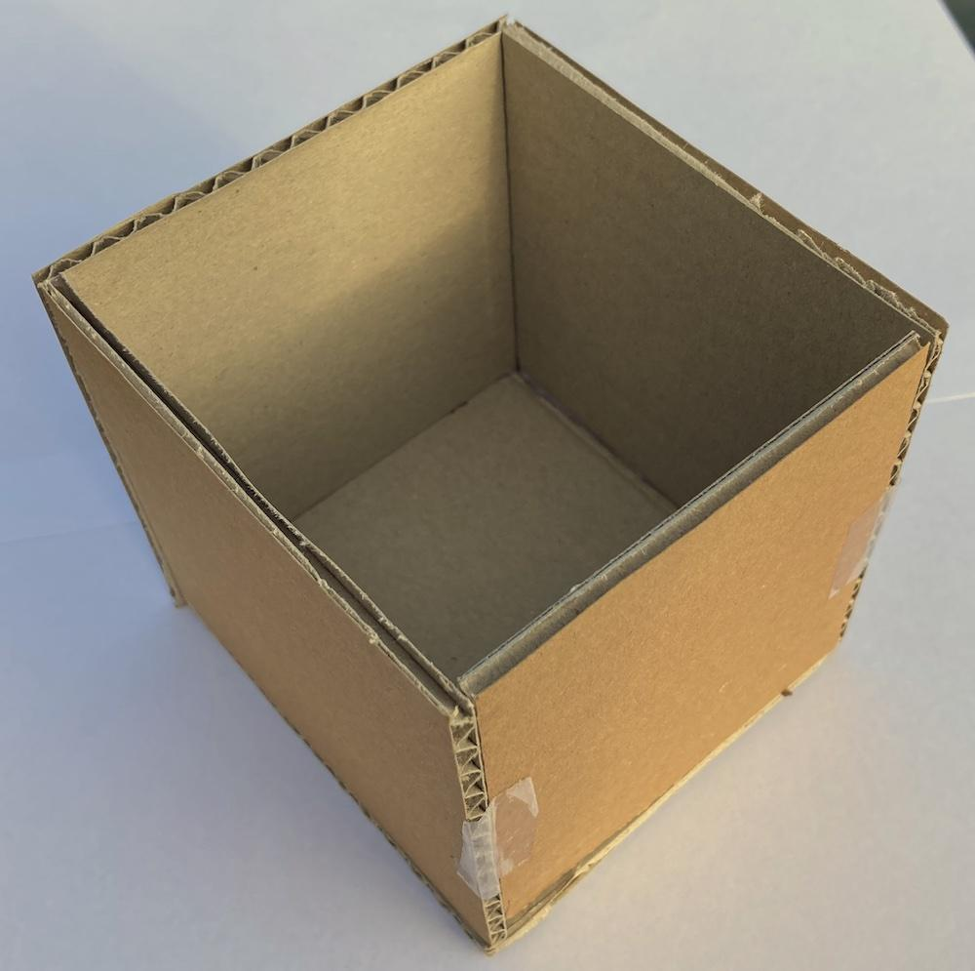

1. Cut six 10 cm x 10 cm panels from thin corrugated cardboard. Trim some of the panels to allow for the thickness of the corrugated cardboard so that the final dimensions are 10 cm x 10 cm x 10 cm when completed.

Hot glue can be used to stick the panels together or just use tape as shown. A micro:bit could be attached to the outside of the CubeSat with two or three blobs of hot glue, or simply taped and the battery put inside the CubeSat.

1. For a more solid attachment, the three pictures below show the use of short lengths of wood from a 4 mm diameter skewer pushed through the micro:bit’s 0 and GND holes and the cardboard and held fast by hot glue.

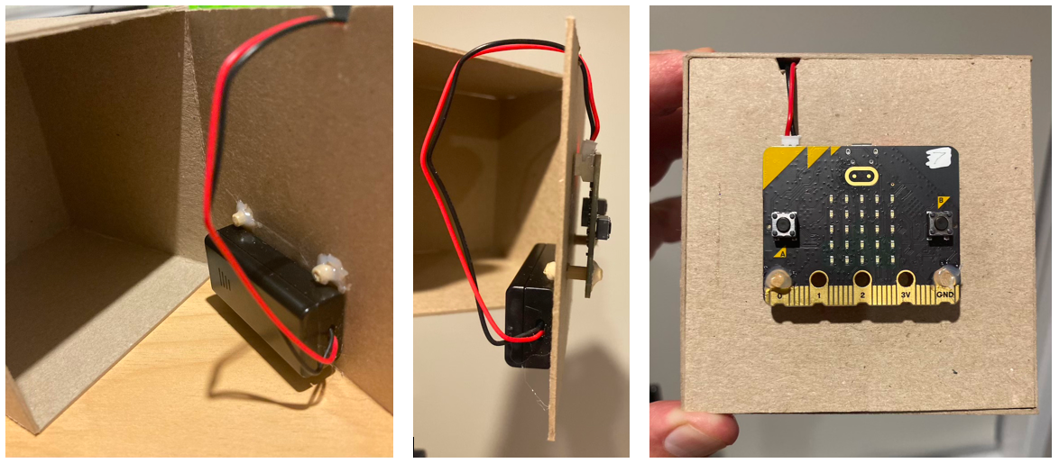

In both 1 and 2 above, students could paint/decorate/personalise the model how they wish or copy from images of real CubeSats found after an internet search.

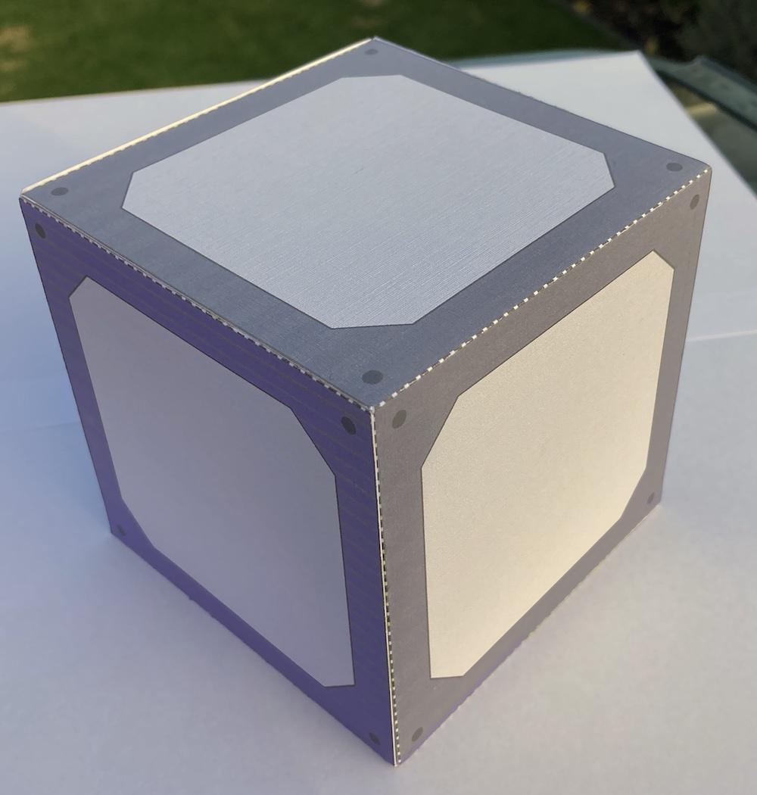

1. The basic CubeSat could be made according to the instructions in the student construction handout and join the three sections using PVA glue. The completed box is shown alongside. Instead of using the panels on sheet 2 of the template, students could make their own and attach them using a glue stick.

***Teaching suggestions***

This activity is in two parts that can be done individually or together. You can choose to do one of the parts and not the other depending on your teaching programme, resources and students’ interests or abilities.

This activity is ideally done after reading the article [What is a CubeSat?](https://www.sciencelearn.org.nz/resources/3156-what-is-a-cubesat)

The above discussion of construction alternatives gives a range of suggestions relating mainly to making the CubeSat. However, you could choose to focus only on making the sun sensor and not relate it specifically to the CubeSat. This is because the sun sensor and two other kinds of direction-finding sensors – the star pattern sensor and the horizon sensor – are used widely in satellites and spacecraft, not just CubeSats, so you could get students to find out about these sensors and how they are used.

Questions you could ask:

* What would be the advantage of a star pattern sensor over a sun sensor?
* What particular uses would a horizon sensor have?
* What drawbacks would the simple micro:bit sun sensor have? How do real sun sensors get over those drawbacks?

***Extension ideas***

* Once made, students could use the sun sensor to investigate light levels in various corners of the classroom and the playground or school. In this way, they are using the sun sensor with more of a scientific purpose.
* Ask students to modify the code to display numerical values of light intensity on the LED array as a scrolling display. Alternatively, they could develop code to transmit the light value to another micro:bit using its radio ability or to a computer using the USB cable and the micro:bit’s data logging ability. The [micro:bit website](https://microbit.org/) and the [MakeCode webpage](https://makecode.microbit.org/) contain extensive guidance to assist students (and teachers) if needed.
* Ask students to find out what methods a spacecraft/satellite uses to rotate to a desired attitude (orientation in space) once it has found the reference direction of the Sun or star pattern or horizon. Most will use thrusters, but CubeSats are tiny satellites and so thrusters would contribute significant mass and have limited fuel. Students could find out about the use of gyroscopes and magnetorquers.

**For students**

***Make a 1U CubeSat***

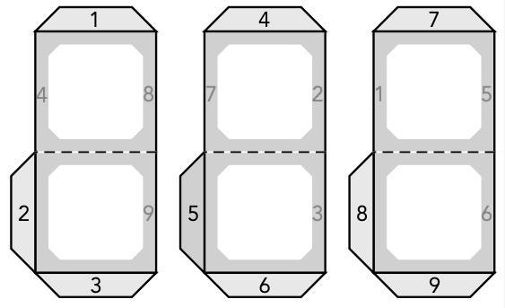

1. Use scissors to carefully cut out the three sets of two sides of the CubeSat. (If you are allowed, use a ruler and a craft knife to cut out the double sides instead of using scissors.)
2. Use a pencil or pen to number the tabs as shown in the diagram. Write the other shaded numbers on the *undersides* of the cardboard pieces where shown.
3. Use a ruler and the pointed end of the skewer to score along the dotted line between sides and along where each of the three tabs meet the sides. This makes it easier to do the next step.
4. Fold at the dotted line between each of the double sides and fold all the tabs. Make sure all folds have sharp creases. Check that folds are accurate by placing the three sets of folded sides together to see if they fit together neatly.
5. 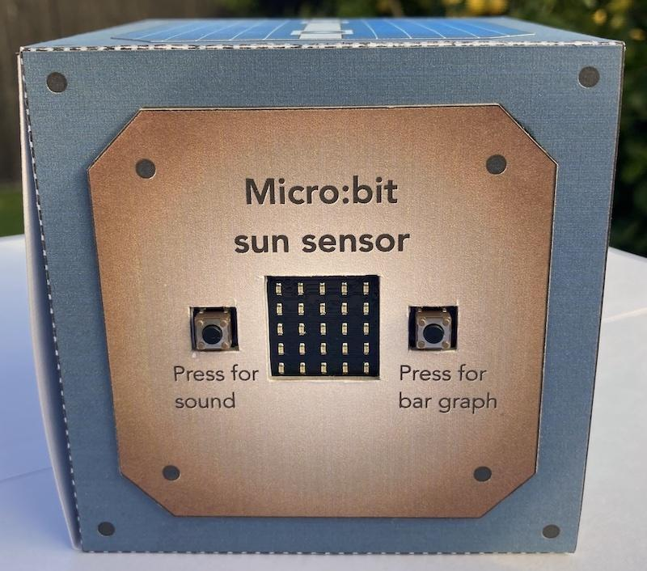In turn, apply glue to a numbered tab and hold it to the underside of the side with the same number. A suggested order to glue the tabs is tab 1 to underside 1, 8 to 8, 4 to 4, 7 to 7, 5 to 5 and 6 to 6. Finally, glue tabs 2, 3 and 9 to the corresponding numbers. Note: If you are going to mount the micro:bit to the CubeSat you should not glue tabs 2, 3 and 9. Instead, make the micro:bit side able to open again using tape or Blu Tack so you can access the battery and USB programming connections when needed.
6. Cut out the six panels in the second sheet and decide where you want to glue them to the CubeSat sides. The side with tabs 2 and 3 attached is the one to use for mounting the micro:bit.
7. Glue the micro:bit panel to a thicker piece of cardboard to provide more stiffness. Cut around the panel’s edge and cut out the squares for the push buttons and LED array. Glue the panel to the side of the CubeSat. Once dry, cut through the CubeSat cardboard where the LED array and buttons will be seen.  
   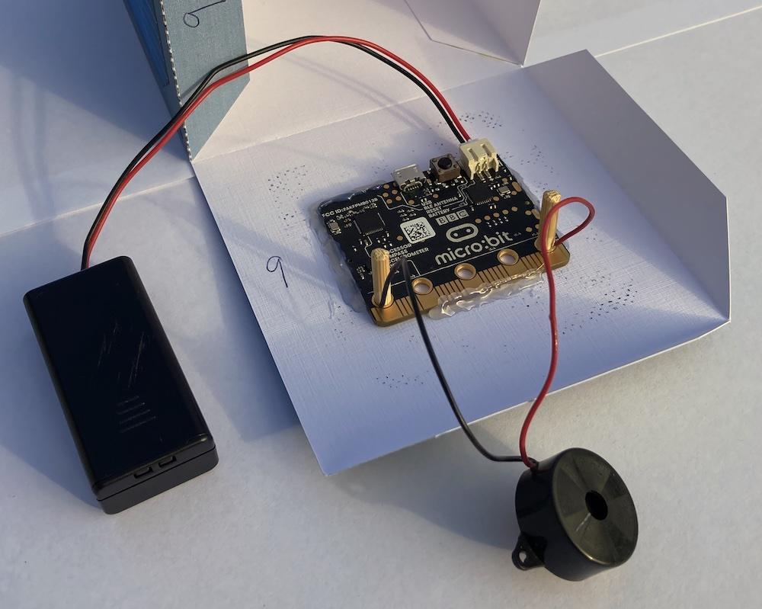
8. Attach the micro:bit to the inside using lines of hot glue around the edge of the micro:bit printed circuit board.
9. The pictures show inside and outside views of the completed micro:bit mounting. A small piezo speaker is attached to pins 0 and GND because a version 1 micro:bit is used here. A version 2 micro:bit does not need this since it has a piezo speaker already mounted on its printed circuit board. Two small lengths of 4 mm diameter skewer, which have been whittled down to make them slightly thinner, are used to hold the ends of the speaker wires firmly in the holes for the 0 and GND pins. The diagram shows where to connect a piezo speaker if using a version 1 micro:bit.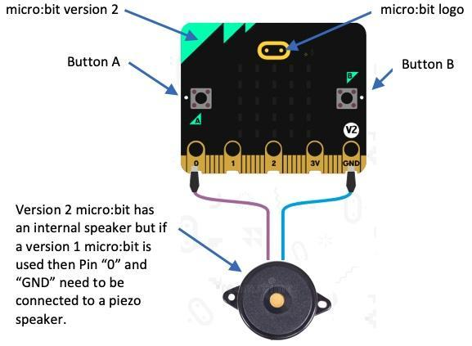

***Code a Micro:bit sun sensor***



1. 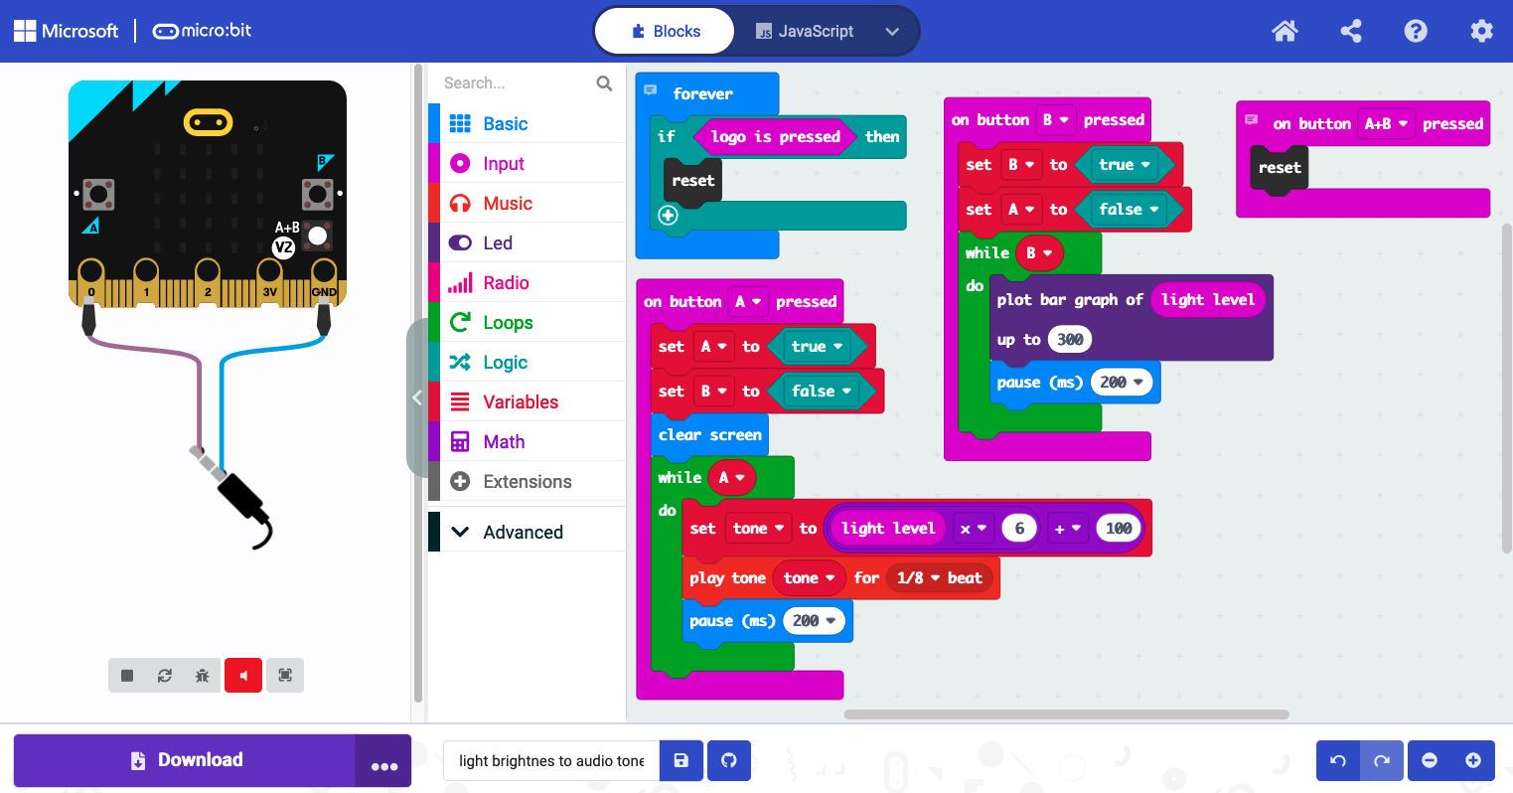Load the [micro:bit hex code file](https://static.sciencelearn.org.nz/documents/files/000/001/167/original/Microbit_sun_sensor_code_file.hex?1658105213) into the MakeCode editor at <https://makecode.microbit.org/>. To do this, click on the “import” button at the right of the web page just underneath the banner. Then click on the “import file” button and “browse” to where the .hex file is stored on your computer. Select the file and follow the prompts to import it into the MakeCode editor. When imported, the webpage should look something like this depending on your computer type and web browser:  
   If you are using a version 2 micro:bit, the MakeCode is fine as it stands. If version 1 is being used, you will need to delete the MakeCode block in the top left that starts with “forever”, otherwise the micro:bit will not work.

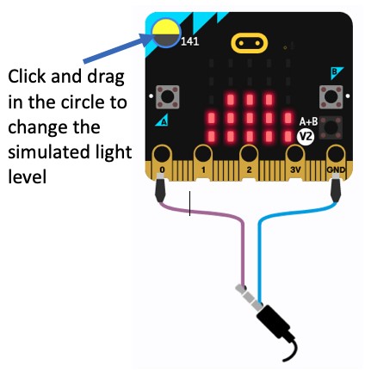

1. Download the code to the micro:bit following the directions for your computer type and web browser.

1. Explore using the sun sensor.
2. You can get to know how the code works by modifying it using the guidance below. The simulator in the left hand part of the editor’s web page will respond when you click on buttons A and B and adjust the simulator’s light level. This allows you to change the code without having to download the program to the micro:bit each time.
3. As an extension, modify the code to give a scrolling display on the LED array of the light level value (a number between 0 and 255) every 3 seconds.

***Modifying the code***

The annotated diagram below gives guidance on how you can modify the code to change how often light readings are taken, the sounds that are made and the LED bar graph’s scale. Not included in the diagram is a small block of code that resets the micro:bit when buttons A and B are pressed simultaneously.

