**ACTIVITY: Build a satellite for a mission**

**Activity idea**

In this activity, students build a fit-for-purpose satellite and send it into the correct orbit to gather observational data.

By the end of this activity, students should be able to:

* identify some of the essential components that satellites use
* match a payload component to a particular mission
* choose the orbit for a particular mission
* use Hub resources to inform the decisions they make
* analyse the data the satellite has collected (optional).

# For teachers

## Introduction/background

This activity supports students to use the [Build a satellite](https://www.sciencelearn.org.nz/embeds/149-build-a-satellite) interactive. The purpose of the interactive is to build a fit-for-purpose satellite.

To build a successful satellite, students need to know about some of the components that satellites use and the orbit the satellite occupies. The article [Building satellites for Earth observation](https://www.sciencelearn.org.nz/resources/3115-building-satellites-for-earth-observation) provides more information about components and orbits including specifics about the payload sensors. The components and their uses are also listed in the satellite components section of the student handout. Taking the time to learn about these details moves the interactive from a simple guessing game to a deeper learning experience.

The contexts for each mission – the why and how Earth observation satellites are used – are found in the following articles:

* [How do we find dark vessels on the ocean?](https://www.sciencelearn.org.nz/resources/3108-how-do-we-find-dark-vessels-on-the-ocean)
* [How are satellites helping albatross?](https://www.sciencelearn.org.nz/resources/3107-how-are-satellites-helping-albatross)
* [How do we know about Earth movements?](https://www.sciencelearn.org.nz/resources/3109-how-do-we-know-the-earth-has-moved)

A button in the interactive’s missions links to the appropriate article so they are easily accessed while using the interactive.

Upon successful mission launch, the satellite collects data for the user to view. As an image or graph, the data doesn’t have much meaning until it is interpreted. The following activities help students interpret the data while practising the science capabilities ‘Gather and interpret data’ and ‘Interpreting representations’.

* [Analysing satellite data for finding dark vessels](https://www.sciencelearn.org.nz/resources/3105-analysing-satellite-data-for-finding-dark-vessels)
* [Analysing satellite data for albatross research](https://www.sciencelearn.org.nz/resources/3104-analysing-satellite-data-for-albatross-research)
* [Analysing satellite data to track Earth movements](https://www.sciencelearn.org.nz/resources/3106-analysing-satellite-data-to-track-earth-movements)

A button in the interactive’s missions links to the appropriate activity so they are easily accessed while using the interactive.

***Notes about the interactive***

If using a tablet or iPad, use landscape orientation for optimal viewing of the game.

Use your device's sound controls to change the volume.

The three introductory videos in the game have video controls within them – including the ability to go full screen, and to turn sound and captions on or off.

This is a simulation so there may be small inaccuracies. The satellite components and orbits are not to scale.

## Teaching suggestions

1. Prior to using the interactive, observe and discuss the satellite components available for use in the interactive.
2. If desired, refer to the article that provides the context for a specific satellite mission.
3. Access the [Build a satellite](https://www.sciencelearn.org.nz/embeds/149-build-a-satellite) interactive. Click on the mission you wish to complete.
4. Watch the short video. Note: The video has captions that can be turned on or off. Each video has a written transcript for accessibility and literacy purposes. Transcript links:

* [Dark vessels satellite mission](https://www.sciencelearn.org.nz/videos/2108-dark-vessels-satellite-mission)
* [Albatross satellite mission](https://www.sciencelearn.org.nz/videos/2107-albatross-satellite-mission)
* [Earth movements satellite mission](https://www.sciencelearn.org.nz/videos/2109-earth-movements-satellite-mission)

1. Scroll down to learn more about the mission, how to build the fit-for-purpose satellite and select its orbit. Use the red buttons to access background information about the mission and/or about satellites.
2. Start the game.
3. Begin building the satellite by selecting essential components and dropping them onto the satellite outline. Hover over the component and select the three dots to find out more about the component and how much it weighs.
4. Finish the satellite build by adding a payload component that will collect the type of data the mission requires. Hover over the component and select the three dots to find out how it works and how much it weighs.
5. Once you’ve chosen all of the components, check to see how much the satellite weighs.
6. You can reset the build if you change your mind about any of the components or if the satellite is too heavy.
7. Once the build is complete, click the select orbit button.
8. Select the orbit that is suitable for the mission.
9. If desired, type in the satellite’s name.
10. Launch the satellite. Watch as Rocket Lab’s Electron rocket takes the satellite into space.
11. If the correct components and orbit are selected, the mission will be a success.
12. Click on the ‘View my data’ button to see actual data collected by a satellite. Use the scroll bar to view the entire image.
13. Click on the ‘Analyse data’ button to link to the supporting activity.
14. If the mission is not successful, the interactive will provide feedback regarding the reason – either an incorrect payload component or incorrect orbit. In some situations, a link is offered to the article [Building satellites for Earth observation](https://www.sciencelearn.org.nz/resources/3115-building-satellites-for-earth-observation). Use this to find the information needed to select the correct components. (If the mission is not successful due to changing the orbit, you will need to add the satellite’s name again.)

## Extension ideas

Students build a virtual satellite in the [Build a satellite](https://www.sciencelearn.org.nz/embeds/149-build-a-satellite) interactive. They can make a physical model of the satellite in the activity [Build a 3D satellite model](https://www.sciencelearn.org.nz/resources/3161-build-a-3d-satellite-model). Making a physical model will help students to see how parts of the satellite relate to each other and how the parts interact. Students will also consider why particular parts of the satellite are needed.

Find out about [MethaneSAT](https://www.sciencelearn.org.nz/resources/3130-methanesat-turning-data-into-action) – a purpose-built satellite that detects methane emissions. The article [Measuring methane from space](https://www.sciencelearn.org.nz/resources/3131-measuring-methane-from-space) explores some of MethaneSAT’s components and how scientists are working to ensure the data it collects is accurate.

# For students

***Satellite components***

These components are common in most satellites:

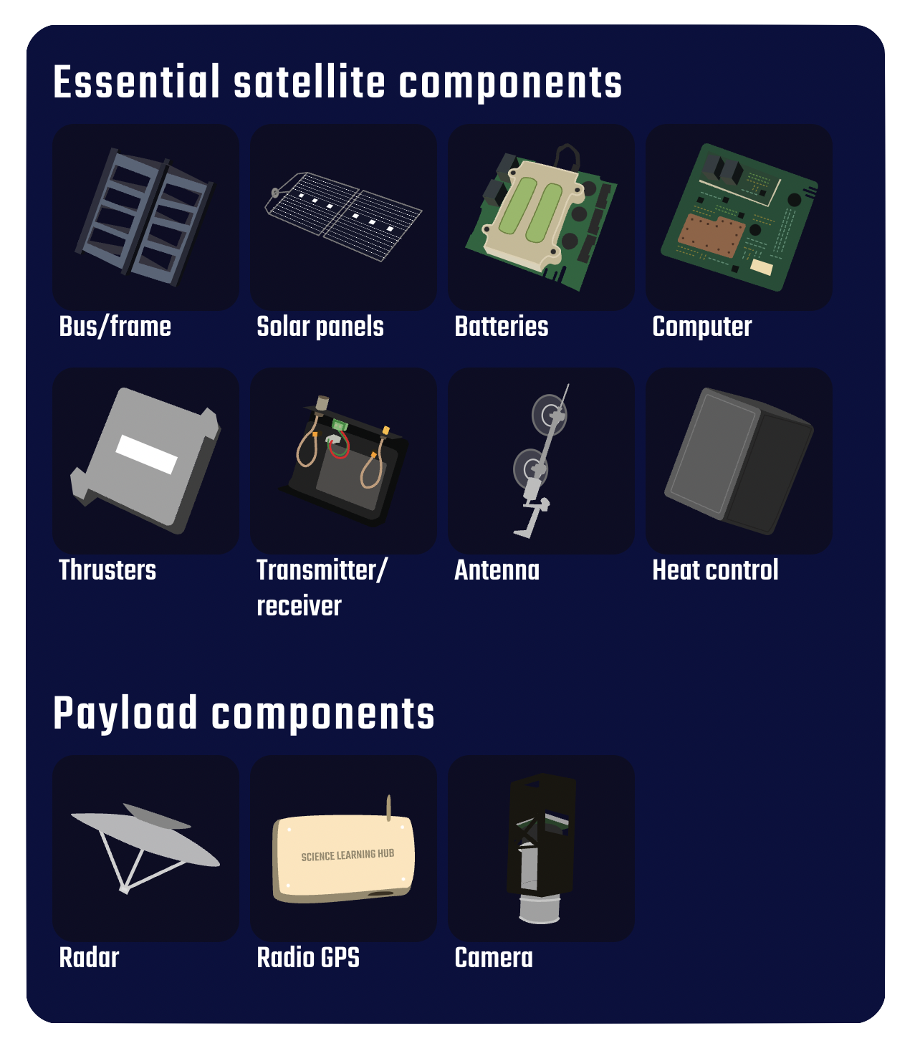

* **Bus/frame** – the frame and structure of the satellite. All other components are attached to it.
* **Solar panels** – to provide electrical energy for the satellite to operate.
* **Batteries** – to store energy from the solar panels so the satellite can operate.
* **Computer** – to control the operation of the satellite and collect, store and send data back to Earth.
* **Thrusters** – to move and position the satellite so the payload component and the antenna are pointing in the required direction.
* **Transmitter/receiver** – to get information from Earth to control the satellite and also to send data back to Earth.
* **Antenna** – the external part of the transmitter/receiver that converts information to radio waves (transmitter) and from radio waves (receiver).
* **Heat control** – to maintain an optimum working temperature. It covers the other components to protect them.

The satellite’s payload consists of one or more communication antennas, transmitters and receivers. These are some common components:

* **Radar** – this works as a transmitter and a receiver. It transmits pulses of microwave radiation towards the Earth’s surface. Each pulse bounces off objects on the Earth’s surface back to the radar detector.
* **Radio GPS** – this precise atomic clock continually transmits its time value to the Earth via radio. GPS trackers placed near tectonic plate boundaries communicate with at least four GPS satellites and use their time values to calculate the trackers’ positions on the Earth’s surface to within a few millimetres.
* **Camera** – a camera detects visible light coming from the Earth’s surface. It is more powerful than a standard digital camera – it has a larger and more accurate optical lens system and a larger electronic sensor chip.