**ACTIVITY: Labelling the human digestive system**

**Activity idea**

In this activity, students use online and/or paper resources to identify and label parts of the human digestive system.

By the end of this activity, students should be able to:

* identify and label some of the main structures in the digestive system
* understand the functions of the main structures in the digestive system
* use literacy skills to learn about and discuss the functions of the structures.

**For teachers**

***Introduction/background***

The human digestive system is responsible for the processes of ingestion and digestion, absorption of digestion products and the elimination of undigested materials.

The system itself is essentially a long muscular tube assisted by glands and organs.

These articles provide background information:

* [The human digestive system](https://www.sciencelearn.org.nz/resources/1829-the-human-digestive-system)
* [Large intestine function](https://www.sciencelearn.org.nz/resources/1832-large-intestine-function)
* [Food’s journey through the digestive system](https://www.sciencelearn.org.nz/resources/1849-food-s-journey-through-the-digestive-system)
* [Digestion – breaking the large into the small](https://www.sciencelearn.org.nz/resources/1830-digestion-breaking-the-large-into-the-small)

This activity can be used as a formative or summative tool for learning.

***What to do***

1. Watch the video [Digestion of food](https://www.sciencelearn.org.nz/videos/814-digestion-of-food).
2. Play the video a second time, but instead of watching it, use it as a voiceover to accompany the [written transcript](https://www.sciencelearn.org.nz/videos/814-digestion-of-food#transcript) below the video.
3. Glossary words for the video transcript are accessed just below the video title – click or touch ‘Glossary’. Select words of interest and download them to a Word document if desired.
4. Use the image [Human digestive system](https://www.sciencelearn.org.nz/images/2258-human-digestive-system) and the article [The human digestive system](https://www.sciencelearn.org.nz/resources/1829-the-human-digestive-system) for additional information.
5. Discuss the functions of the digestive structures and associated organs.

Complete the interactive [Label the human digestive system](https://www.sciencelearn.org.nz/labelling_interactives/14-labelling-the-human-digestive-system) or use the paper-based version in the student handout.

***Extension idea***

The labelling interactive highlights some of the parts of the human digestive system. It also touches on their functions. Ask students to use the image [Human digestive system](https://www.sciencelearn.org.nz/images/2258-human-digestive-system) to draw/create a more detailed version of the interactive – including descriptions of the functions.

***Label the human digestive system – answers***

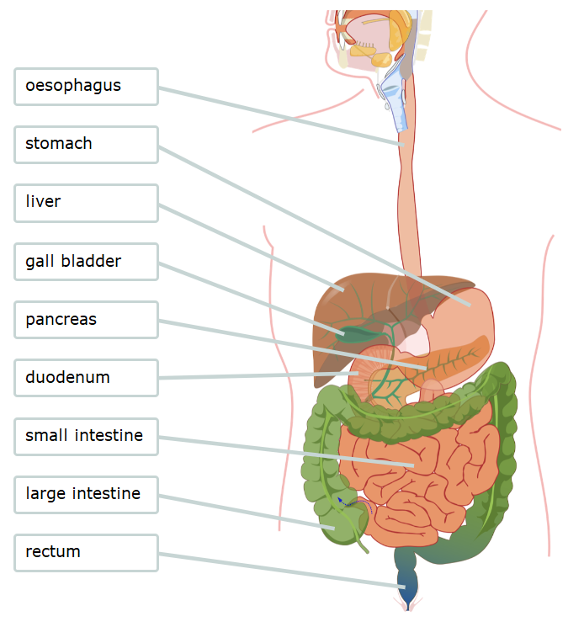

**For students**

***Label the human digestive system***

Use labels to identify the parts of the human digestive system.

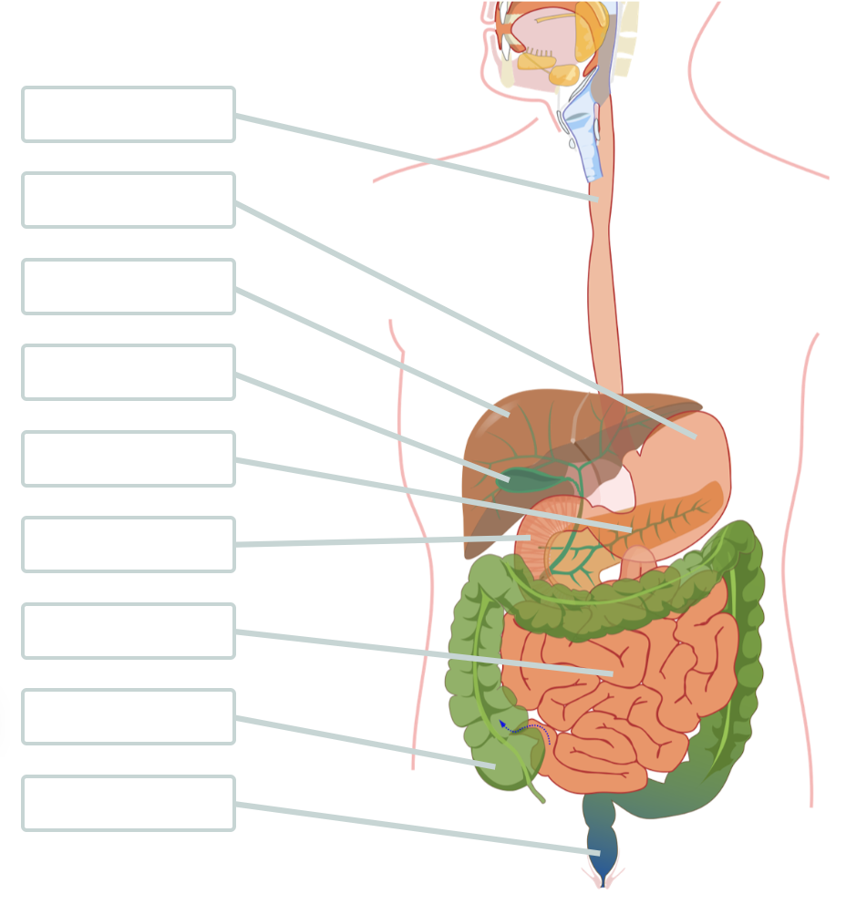

|  |  |
| --- | --- |
| **Labels** | **Description** |
| duodenum | Mixes bile and pancreatic enzymes with gastric juice from the stomach. |
| gall bladder | Stores bile produced by the liver and releases it into the duodenum. |
| large intestine | Muscular tube that absorbs excess water. |
| liver | Organ that processes nutrients and filters toxins from blood, produces bile and many other functions. |
| oesophagus | Muscular tube that contracts to move food from the mouth to the stomach. |
| pancreas | Organ that secretes digestive enzymes and produces hormones such as insulin. |
| rectum | Stores indigestible food matter for disposal. |
| small intestine | A long tube that is lined with tiny finger-like structures that maximise the absorption of nutrients. |
| stomach | Muscular J-shaped sac that churns food while it is mixed with acid and enzymes. |