**ACTIVITY: Labelling the parts of a pua/flower**

**Activity idea**

In this activity, students use online and/or paper resources to identify and label parts of a pua/flower.

By the end of this activity, students should be able to:

* identify and label some of the main parts of a pua/flower
* use te reo Māori and English to label the parts of a pua/flower
* use literacy skills to learn about and discuss the function of each part.

**For teachers**

***Introduction/background***

Pua/flowers are the reproductive structures of flowering plants. They have a number of different specialised parts involved in pollination, fertilisation and the production of seeds. Botanists, the scientists who study plants, use special vocabulary when naming flower parts.

The articles [Flower parts](https://www.sciencelearn.org.nz/resources/78-flower-parts) and [Te haenga me te ruinga o te kākano ❘ Pollination and seed dispersal](https://www.sciencelearn.org.nz/resources/3169-te-haenga-me-te-ruinga-o-te-kakano-pollination-and-seed-dispersal) have helpful background information about the plant parts and their purposes.

***What to do***

1. Begin a discussion about flowers with the image of [kōwhai flowers](https://www.sciencelearn.org.nz/images/79-a-favourite-angiosperm). Ask students to make observations of the pua/flowers. Observations begin with the words “I see”.
2. Ask students to make inferences about the pua/flowers. Inferences begin with the words “I think”.
3. Observe the image of a [cutaway kōwhai flower/pua](https://www.sciencelearn.org.nz/images/72-cutaway-kowhai). Discuss how this image supports the earlier observations and inferences.
4. Discuss the kupu/vocabulary for the flower parts, which appear on the labels. Information about the purpose of the flower parts is in the article [Flower parts](https://www.sciencelearn.org.nz/resources/78-flower-parts). The article [Te haenga me te ruinga o te kākano ❘ Pollination and seed dispersal](https://www.sciencelearn.org.nz/resources/3169-te-haenga-me-te-ruinga-o-te-kakano-pollination-and-seed-dispersal) contains basic information in te reo Māori. Specific kupu Māori are included in the image [Ngā wāhanga o te pua](https://www.sciencelearn.org.nz/images/4946-nga-wahanga-o-te-pua).
5. Observe the image [Inside a tulip](https://www.sciencelearn.org.nz/images/1310-inside-a-tulip). Ask students to make observations and inferences about this cutaway flower using some of the pertinent content vocabulary. The image [Identifying parts of a flower](https://www.sciencelearn.org.nz/images/5077-identifying-parts-of-a-flower) may help focus student ideas.
6. Use one or both of the labelling activities to identify the parts of a pua/flower. They can be completed online or use the paper-based version in the student handout.

* [Label the flower parts](https://www.sciencelearn.org.nz/labelling_interactives/15-label-the-flower-parts)
* [Tapahia ngā wāhanga o te pua](https://www.sciencelearn.org.nz/labelling_interactives/16-tapahia-nga-wahanga-o-te-pua)

***Label the flower parts – answers***

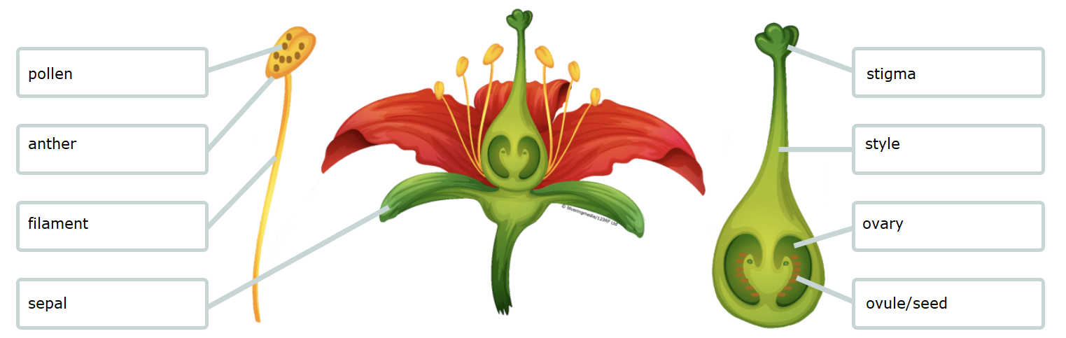

***Tapahia ngā wāhanga o te pua – whakautu***

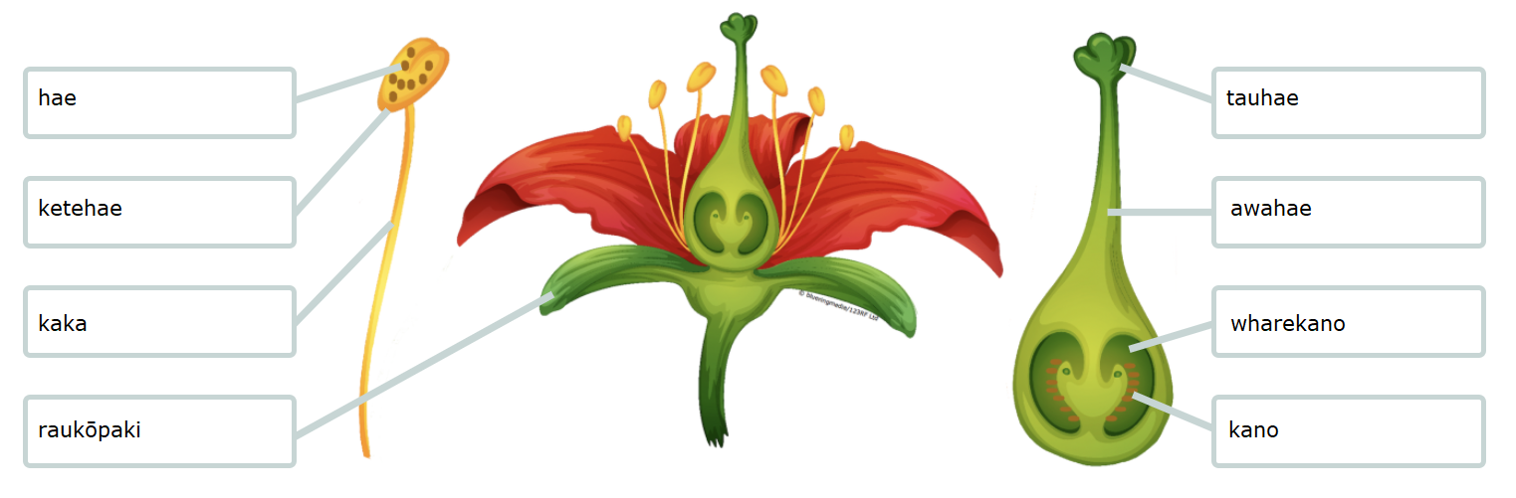

**For students**

***Label the flower parts***

Use the labels to identify the flower parts.

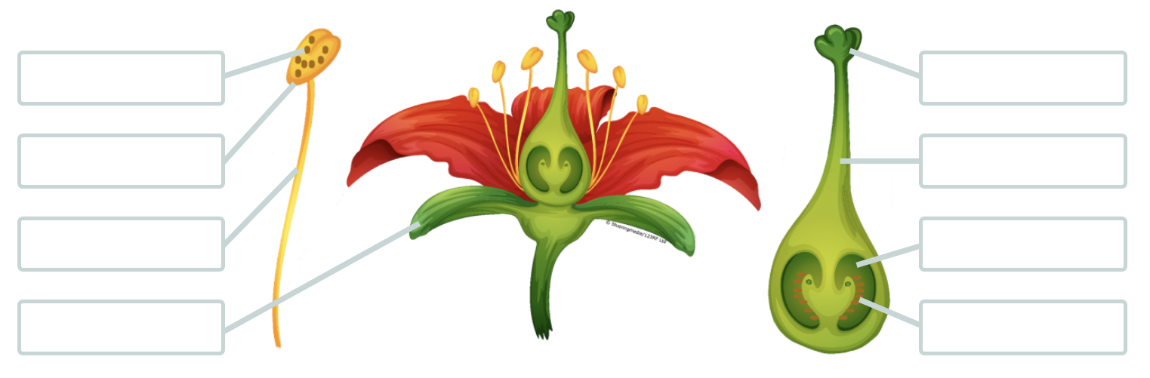

|  |  |  |  |
| --- | --- | --- | --- |
| **Label** | **Description** | **Label** | **Description** |
| anther | Where pollen is made and stored in pollen sacs. | pollen | Dust-like grains that contain male sex cells (gametes). |
| filament | The slender stalk that supports the anther. | sepal | Acts as a case to protect the flower bud before it opens. |
| ovary | Contains the ovules in the female part of the plant. | stigma | Female part that receives the pollen from another flower. |
| ovule/seed | Contains female sex cells (gametes) and develops into a seed after fertilisation. | style | The stalk that connects the stigma and the ovary. |

**Mo ngā ākonga**

***Tapahia ngā wāhanga o te pua***

Use the labels to identify ngā wāhanga o te pua.



|  |  |  |  |
| --- | --- | --- | --- |
| **Labels** | **Description** | **Labels** | **Description** |
| awahae | The slender stalk that connects the stigma and the ovary. | ketehae | Where pollen is made and stored (in pollen sacs). |
| hae | Dust-like grains that contain male sex cells (gametes). | raukōpaki | Acts as a case to protect the flower bud before it opens. |
| kaka | The slender stalk that supports the anther. | tauhae | Female part that receives the pollen from another flower. |
| kano | Contains female sex cells (gametes) and develops into a seed after fertilisation. | wharekano | Contains the ovules in the female part of the plant. |