Kaitiakitanga o te moana – unit plan
Introductory student documents
- Student overview – using SOLO taxonomy
- Ocean literacy – pre-survey
Ako: Learn about what kaitiakitanga is and what it means to you
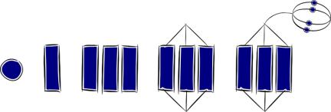 | I don’t know much about kaitiakitanga yet. | Use videos and text to delve into the concept of kaitiakitanga.  - Kaitiakitanga o te moana – looking after the environment  - Kaitiakitanga o te moana – concepts  - How different people show kaitiakitanga – videos and responses  - Taking care of our kupu
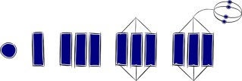 | I can identify that people may feel differently about land and resources.
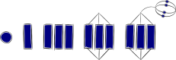 | I can describe the concept of kaitiakitanga.
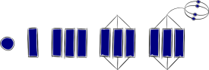 | I can use key words to explain the concept of kaitiakitanga o te moana.
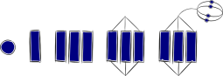 | I can use my understanding of the concept of kaitiakitanga o te moana to see how I/my school/local scientists/local iwi/the council together play a role in protecting Aotearoa New Zealand’s marine environments from the impacts of pest species.
Ako: Learn about ecology and biodiversity
 | I am not sure about what biodiversity is. | Use videos, text and art to explore science and ao Māori concepts related to ecology and biodiversity.  - Exploring biodiversity and whakapapa  - Food webs in Aotearoa New Zealand’s marine environment – three-level reading guide  - Marine biodiversity and food webs  - Investigating a marine organism
 | I know there are many different types of living things and that they are all related.
 | I can use my knowledge about marine organisms and ecology to draw food webs to show how living things affect and rely on each other.
 | I know that living things affect each other and that their environments impact them.
 | I understand that the marine ecosystem consists of many living things. These living things depend on each other, forming a delicate ecosystem. When humans or pests interfere with these ecosystems, stressors are added and living things belonging to Aotearoa New Zealand may become endangered.
Ako: Learn about how humans classify living things
 | I am not sure about how living things are grouped. | Humans have always named and sorted things into groups related on some factors common to each. New technologies help with scientific classification. Use videos and text to explore classification and whakapapa.  - Classifying and identifying  - Living organisms – create a mihi  - What can DNA in the environment tell us about an ecosystem? – teacher instructions, student questions and article PDF
 | I know living things are divided into different groups such as animals and plants.
 | I understand that there are different ways to groups living things.
 | I understand that grouping living things can be tricky and I can name some of the issues related to classification/taxonomy.
 | I can explain how using DNA can overcome some of the issues associated with taxonomy.
Ako: Learn about DNA and inheritance
 | I am not sure about what DNA is and how inheritance works. | A brief introduction to DNA and genetics from scientific and ao Māori perspectives.  - DNA and inheritance – prior knowledge  - Learning from past scientists – video and focus questions  - DNA and scientific discoveries – teacher notes  - Extracting DNA from a strawberry  - DNA as taonga  - Listening to the Land – using mātauranga Māori and Western science
 | I have a basic understanding of the structure of DNA.
 | I understand that some DNA is considered a taonga and requires tikanga when handled.
 | I can explore how our understanding of DNA has changed over time.
 | I understand how the discoveries of the structure of DNA and DNA sequencing are important for us today.
Ako: Learn about biosecurity, pest management and how eDNA can be used as a pest detector
 | I am not sure what biosecurity is/means. | Biosecurity is used to detect and control pests and diseases. There are many facets to pest management.  - Student SOLO overview – investigating a pest species  - Pest management and biosecurity – Tame Malcolm webinar  - Biosecurity statements – Venn diagram  - Make a wanted poster  - Traditional methods and modern solutions to pest control – three-level reading guide  - Indigenous pest control  - Using eDNA to detect and protect taonga freshwater species in Aotearoa – three-level reading guide  - Draw as a scientist  - Modelling eDNA in a marine ecosystem – teacher notes and student worksheet  - Species cards for modelling eDNA in a marine ecosystem  - Species tokens for modelling eDNA in a marine ecosystem  - DNA sequences for modelling eDNA in a marine ecosystem  - Mātauranga Māori and pest management – teacher notes and student worksheet
 | I can give a simple definition of biosecurity.
 | I understand what biosecurity is, what eDNA is and can list some New Zealand pests.
 | I can compare and contrast how different organisations deal with biosecurity, and I can explain how eDNA can be used in pest management and as a biosecurity tool.
 | I can hypothesise how scientists may use eDNA to assess whether a marine pest may have entered a local marine environment.
Ako: Learn how to communicate as a scientist
 | I find scientific language and images difficult to understand. | Experience with the science capabilities is key to building science literacy. There are multiple resources within this suite that expose students to:  - scientific vocabulary and reo Māori kupu  - diagrams and images  - visual and written text  - opportunities to interrogate and interpret information  - opportunities to present information in a variety of formats.
 | I can interpret, use or draw a diagram to illustrate my understanding of one scientific idea.
 | I can interpret scientific knowledge from a variety of sources and list my new facts.
 | I can interpret scientific knowledge and summarise what is being discussed in a larger text/video and can explain my learning in an attractive and compelling way.
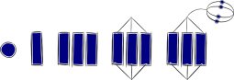 | I can justify my choice of presentation for a specific target audience and ensure that others can learn from my findings.

Acknowledgement: This unit plan was written by Gerd Banke, Nayland School and is part of Kaitiakitanga o te moana – a context for learning.

