**Kaitiakitanga o te moana – looking after the environment**

**Ako: Learn about kaitiakitanga and what it means to you**

**Mahi:**

Watch the LEARNZ video [Kaitiakitanga o te moana](https://vimeo.com/321670960?embedded=true&source=vimeo_logo&owner=18869783).

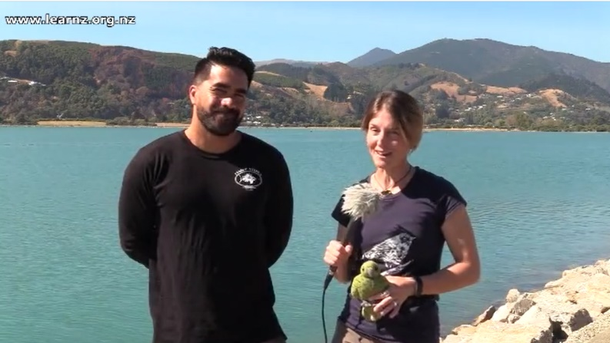

Answer the following questions:

1. What does kaitiakitanga mean?
2. How does this relate to looking after the marine environment?
3. What happened when Regan was young? What did the stingray do?
4. How can we all help?
5. What does our environment have within it?
6. What happens when it loses this?
7. What can we do to stop degradation of a place?
8. How do we get more mana?
9. What are taonga? And why may they be different?
10. What is the taonga species in our area? Have a think/search – what did you find?

**Acknowledgement:** This resource was written by Gerd Banke, Nayland School and is part of [Kaitiakitanga o te moana – a context for learning](https://www.sciencelearn.org.nz/resources/3384-kaitiakitanga-o-te-moana-a-context-for-learning).