**How different people show kaitiakitanga – videos and responses**

**Ako: Learn about kaitiakitanga and what it means to you**

People have different ways of showing kaitiakitanga. Watch these videos to see individual insights.

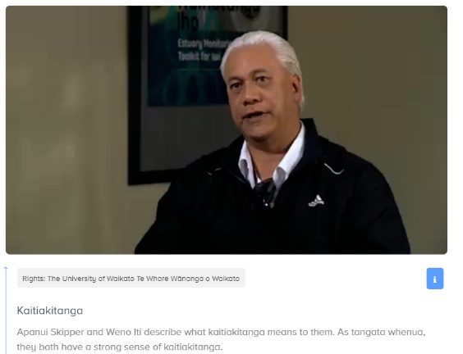

[**Kaitiakitanga**](https://www.sciencelearn.org.nz/videos/651-kaitiakitanga) **– Apanui Skipper and Weno Iti** – Science Learning Hub

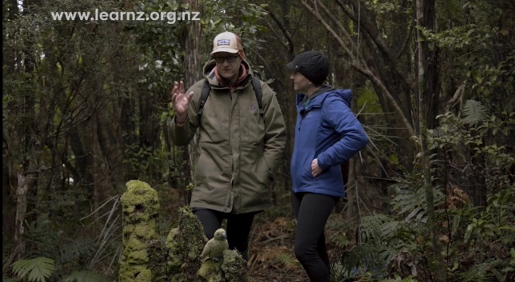

[**Where conservation began: LEARNZ Expedition Fiordland online field trip**](https://vimeo.com/460875224) – LEARNZ (about the work of Richard Henry)

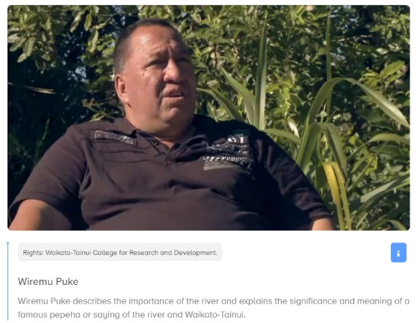

[**Wiremu Puke**](https://www.sciencelearn.org.nz/videos/247-wiremu-puke)– Science Learning Hub

**Mahi: How different people show kaitiakitanga – SOLO map**

**Video title: ……………………………………………………………………………**

**Location: ………………………………………………………………………………**

**People in the video: …………………………………………….…………………**

**………………………………………………………………………………….………...**

What new ideas/images/quotes did you learn/see/hear from the video?

What was this idea about?

Why do you think these ideas are important?

How do these ideas apply to your life?

What do these ideas make you wonder?

**Mahi: How different people show kaitiakitanga – relational**

Choose two videos and use quotes from the speakers to compare the similarities and differences in their ideas.

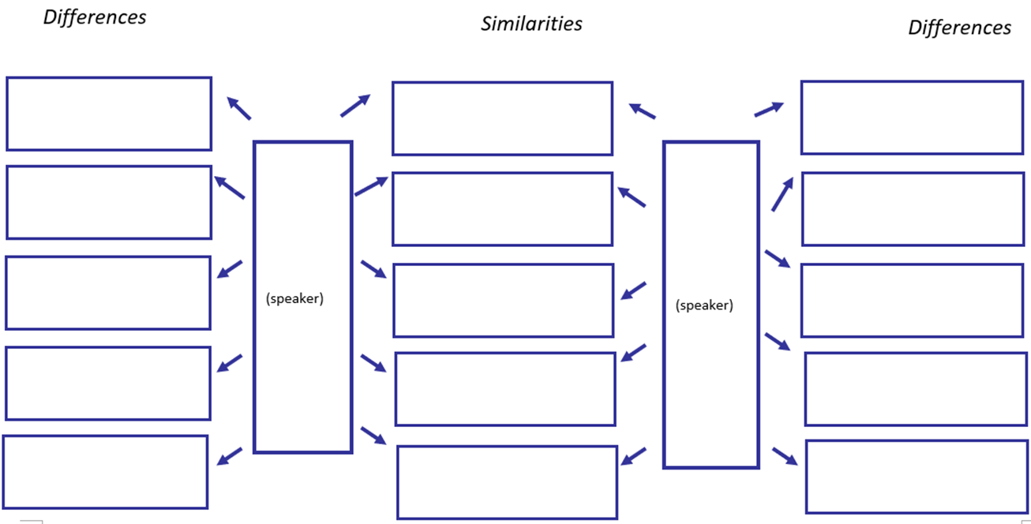

**Mahi: How different people show kaitiakitanga – Venn diagram**

Use the Venn diagram to compare and contrast the speakers’ views.

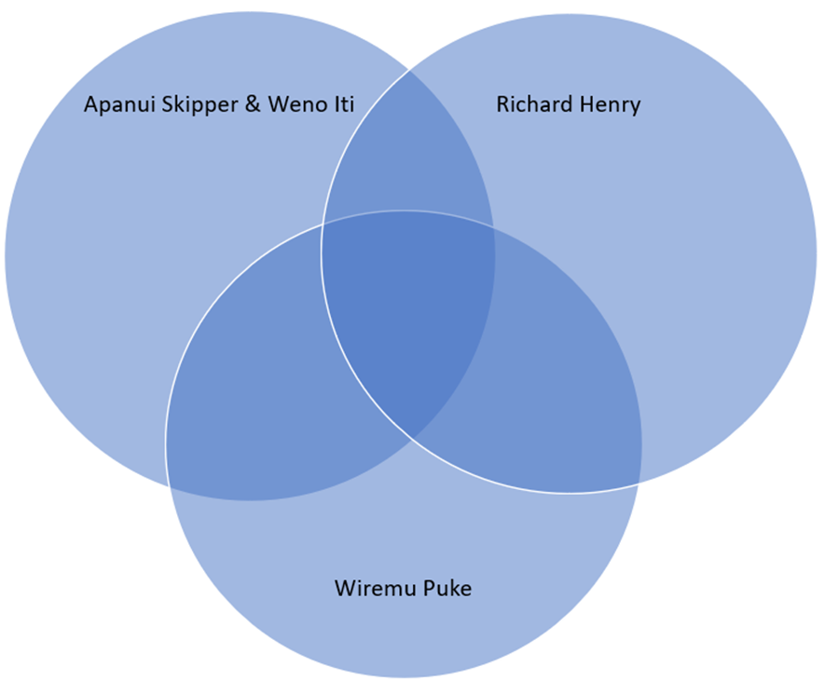

**Acknowledgement:** This resource was written by Gerd Banke, Nayland School and is part of [Kaitiakitanga o te moana – a context for learning](https://www.sciencelearn.org.nz/resources/3384-kaitiakitanga-o-te-moana-a-context-for-learning).