**Exploring biodiversity and whakapapa – videos and responses**

**Ako: Learn about ecology and biodiversity**

Biodiversity and whakapapa are complex concepts. Watch these videos to learn about aspects of biodiversity and its links with whakapapa.

He nohonga ngātahitanga ahau me te taiao.

We live as one with our natural world.

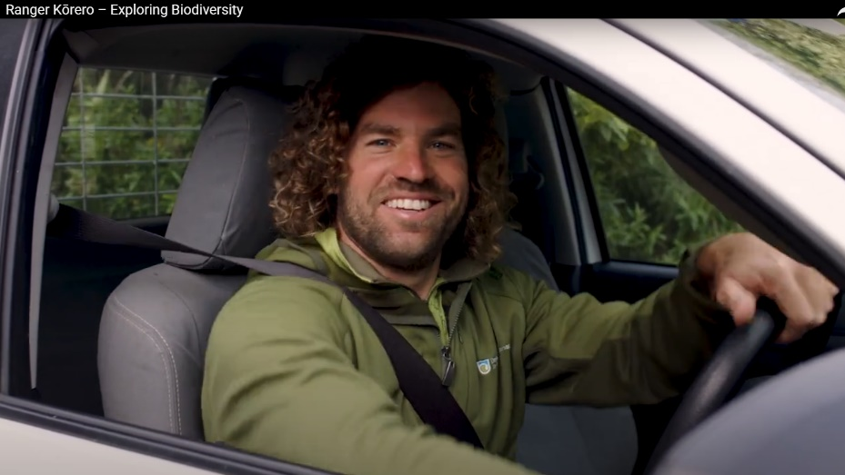

[**Ranger Kōrero – Exploring biodiversity**](https://www.youtube.com/watch?v=VDG8xxR83w0&t=12s&ab_channel=DepartmentofConservation) **– Dave, a biodiversity ranger** – Department of Conservation

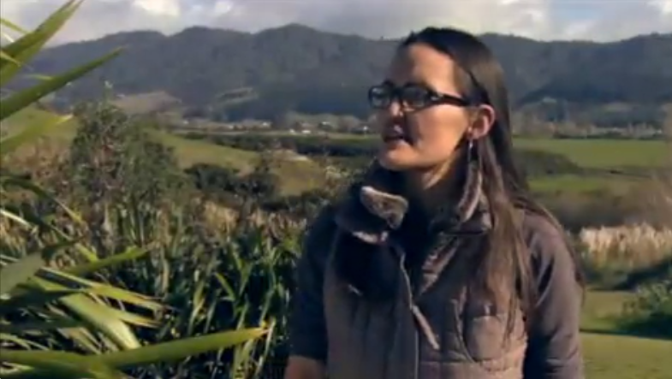

[**Whakapapa and biodiversity**](https://www.sciencelearn.org.nz/videos/258-whakapapa-and-biodiversity) **– Cherie van Schravendijk-Goodman** – Science Learning Hub

**Mahi: Reponses to the videos**

Use the following questions as prompts before watching the videos or to record information and ideas after watching them.

[**Ranger Kōrero – Exploring Biodiversity**](https://www.youtube.com/watch?v=VDG8xxR83w0&t=12s&ab_channel=DepartmentofConservation)– Department of Conservation

1. Why should we care about biodiversity?
2. What would happen if the kererū became extinct?
3. Roughly, how many indigenous species are there in Aotearoa?
4. Name some of these indigenous species.
5. Explain how Sophie and Sophie show kaitiakitanga.
6. Why should you care about biodiversity?

[**Whakapapa and biodiversity**](https://www.sciencelearn.org.nz/videos/258-whakapapa-and-biodiversity) **– Cherie van Shravanti-Goodman** – Science Learning Hub

1. What is ecology all about? Try and explain it in your own words.
2. What is whakapapa? Try and explain it in your own words.
3. Te ao Māori recognises that everything is connected through whakapapa. Explain how biodiversity and whakapapa are linked.
4. How will lack of biodiversity affect people? For example, Cherie mentions whitebait and its connection to the health and wellbeing of the river and the people.

**Acknowledgement:**This resource was written by Gerd Banke, Nayland School and is part of [Kaitiakitanga o te moana – a context for learning](https://www.sciencelearn.org.nz/resources/3384-kaitiakitanga-o-te-moana-a-context-for-learning).